Extra Practice 1
Master 5.27
Lesson 5.1: Using Models to Add Fractions
1. Use Pattern Blocks to show each sum.
Sketch the Pattern Blocks.
Write an addition equation for each picture.
a) + b) + c) +

2. Use fraction circles to show each sum.
Sketch the fraction circles.
Write an addition equation for each picture.
a) + b) + c) +

3. Is each sum greater than 1 or less than 1?
How can you tell?
a) + b) +
c) + d) +

4. Kelly exercised on Monday and Tuesday.
She recorded the amount of time she spent on each activity
as a fraction of one hour.
a) Calculate how much time Kelly spent on each activity over the two days. Record each answer as a fraction of one hour.
b) How many minutes did she spend on each activity?
c) How much time did she spend exercising over the two days?
Write your answer in 2 different ways.

Activity | Monday | Tuesday
Walking | h | h
Running | h | h
Stretching | h | h

Extra Practice Sample Answers
Extra Practice 1 – Master 5.27
Master 5.34
Lesson 5.1
1. a) + = =
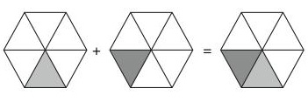
b) + = = 1
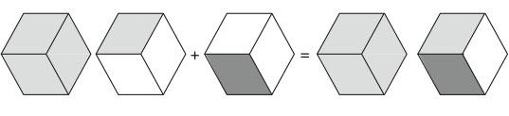
c) + = = 1
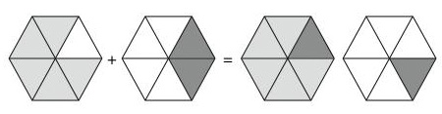
2. a)
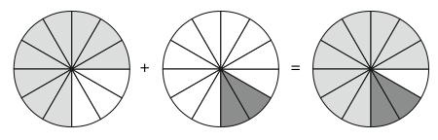
b) =
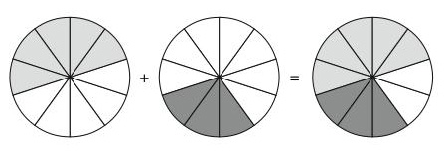
c) 1
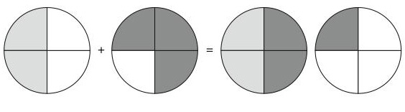

3. a) Less than 1: < and < , so + < + = 1
b) Greater than 1: is two-tenths greater than . is one-tenth less than .
So, + will be one-tenth greater than 1.
c) Greater than 1: is already greater than 1.
d) Greater than 1: is already greater than 1.
4. a) Walking: h; running: h; stretching: h
b) Walking: 25 min; running: 50 min; stretching: 15 min
c) 1 h or 90 min

