Extra Practice 1

Lesson 4.1: Investigating Circles
1. a) Mark the centre, a radius, and a diameter of the circle below.
b) Measure the circumference of the circle.
Explain how you found your answer.
c) Measure the radius and diameter of the circle.

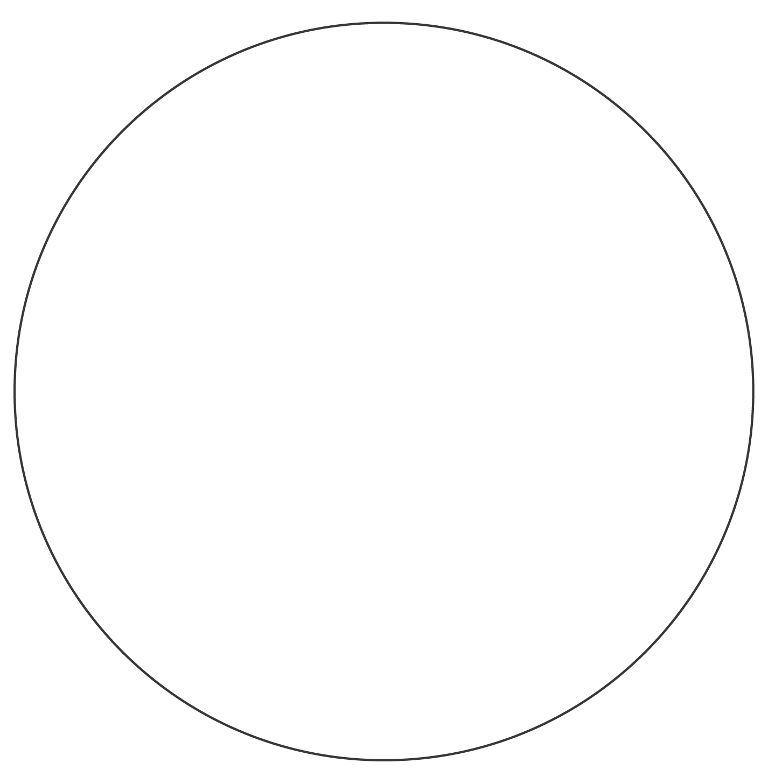

2. On each circle:
a) Mark the centre, a radius, and a diameter.
b) Estimate the lengths of the radius and diameter.
c) Measure the lengths of the radius and diameter to the nearest millimetre.
How do your estimates compare with the measurements?
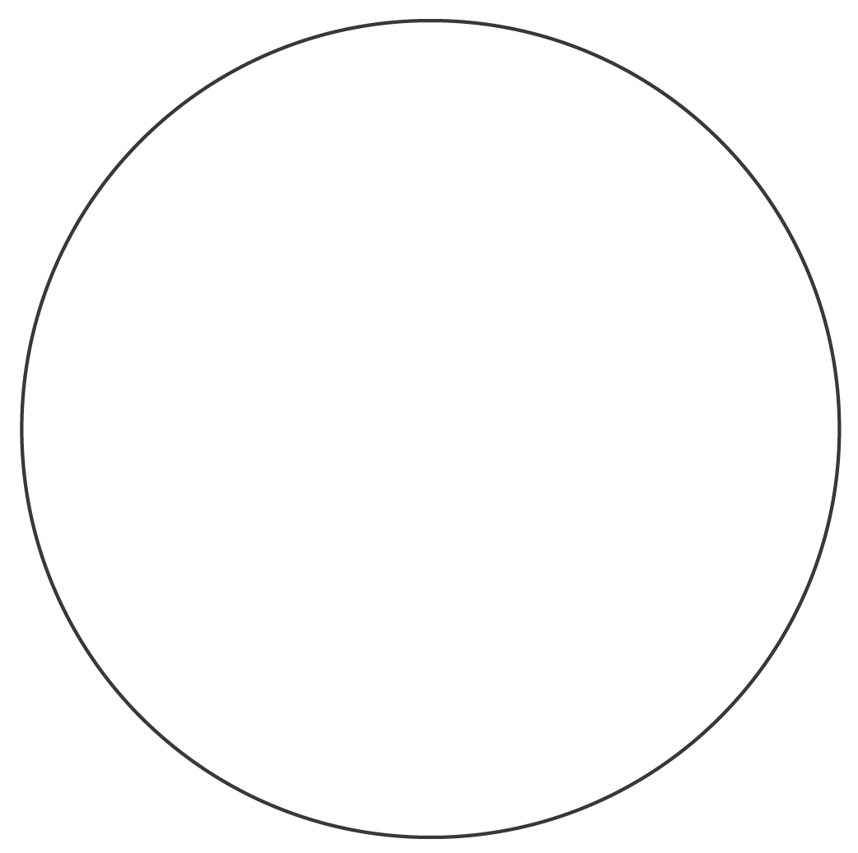
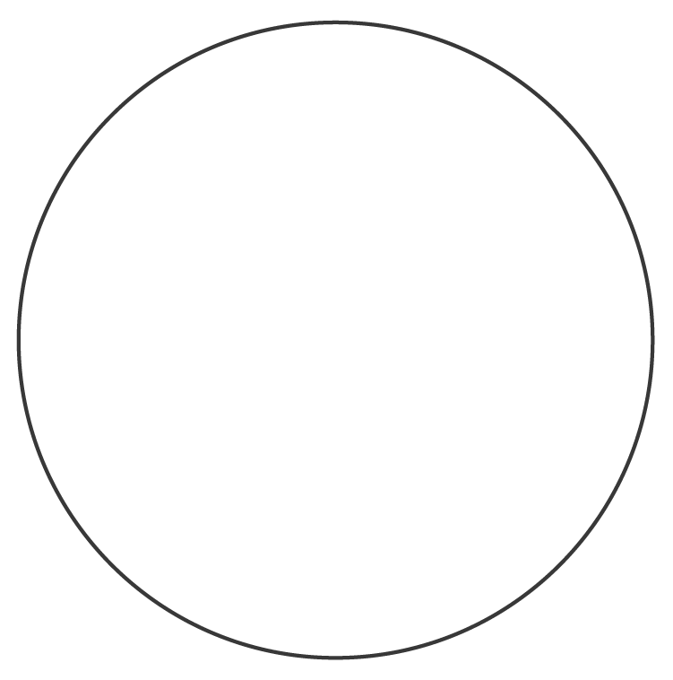
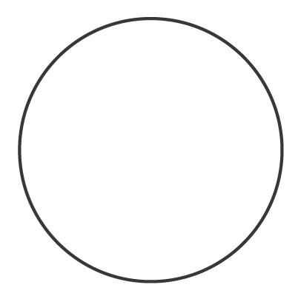
i) ii) iii)

Extra Practice Sample Answers
Extra Practice 1 – Master 4.24
Lesson 4.1
1. a)
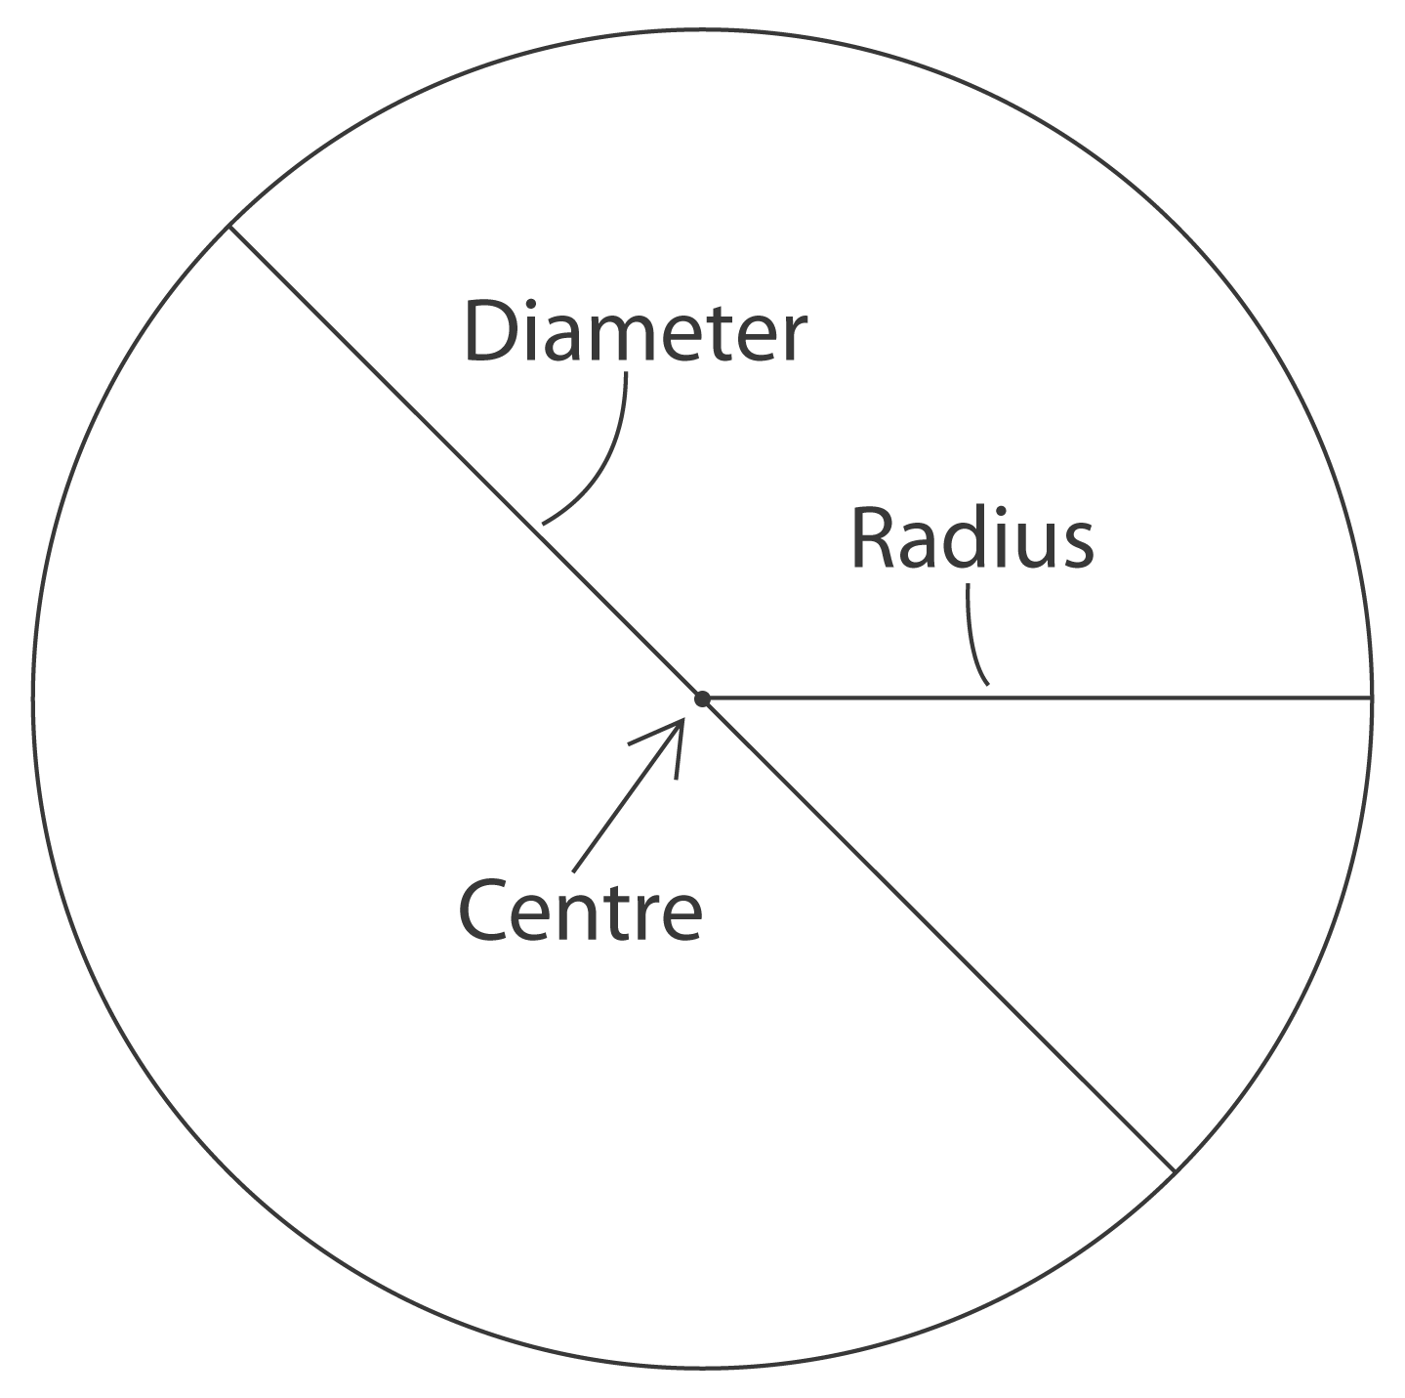
b) The circumference is about 18 cm. I placed a string around the circle,
then measured the length of the string.
c) r $\overset{˙}{=}$ 2.9 cm; d $\overset{˙}{=}$ 5.8 cm
2. a) For example:
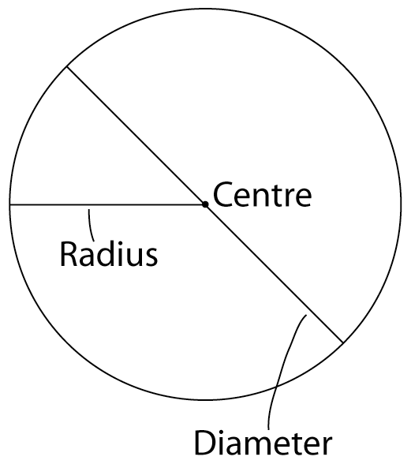
b) About 4 cm and 2 cm; about 3 cm and 1.5 cm;
about 2 cm and 1 cm
c) About 4.2 cm and 2.1 cm; about 3.1 cm and
1.5 cm; about 1.5 cm and 0.8 cm

