Extra Practice 1
Lesson 8.1: Parallel Lines
Master 8.24
1. Which line segments are parallel? How do you know?
a) b)
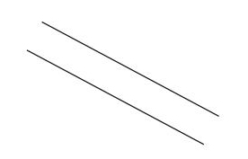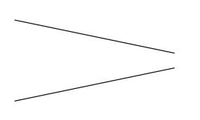

c) d)
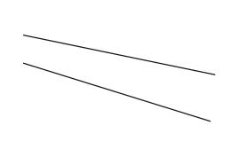
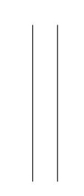

2. Look at the diagram below.
Find as many pairs of parallel line segments as you can.

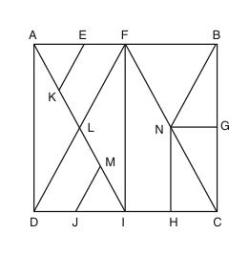

3. Draw line segment EF of length 4 cm.
Use what you know about parallel lines to draw square EFGH.
How you can check you have drawn a square?

Extra Practice 1 – Master 8.24
Lesson 8.1
1. Parts a and d; the lines never meet.
2. AD, FI, NH, and BC; KE, DF, JM, and NB; AB, NG, and DC; AI and FC
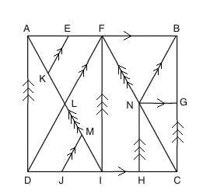
3.I use a ruler and a protractor to draw line segment GH parallel and equal to EF and 4 cm apart.

