Extra Practice 1
Lesson 2.1: Representing Integers
1. Write the integer modelled by each set of tiles.


a) b)

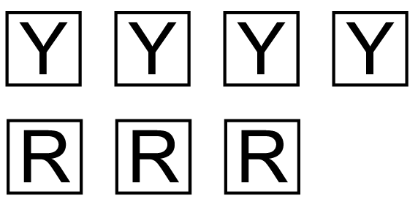

c) d)

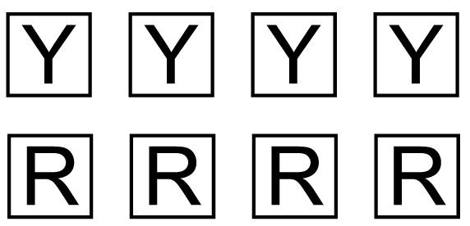
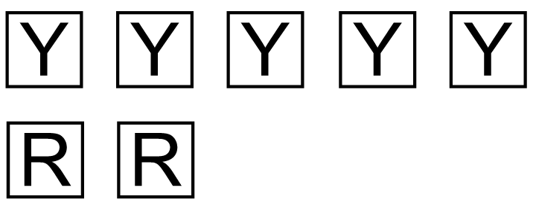
e) f)

2. Use coloured tiles. Draw two different models for each integer.
a) –7

b) +8

c) –2

d) +6

3. Which integer is modelled by each set of tiles?
a) 5 yellow tiles and 13 red tiles b) 28 yellow tiles and 24 red tiles

c) 15 yellow tiles and 8 red tiles d) 37 yellow tiles and 41 red tiles

4. a) You have 3 yellow tiles and want to model –4.
How many red tiles do you need?
b) You have 6 red tiles and want to model +7.
How many yellow tiles do you need?
c) You have 5 yellow tiles and want to model +2.
How many red tiles do you need?
d) You have 8 red tiles and want to model –5.
How many yellow tiles do you need?
Extra Practice Sample Answers

Extra Practice 1 – Master 2.18
Lesson 2.1
1. a) –4 b) +6 c) +1
d) –5 e) 0 f) +3
2. Answers may vary.

a)

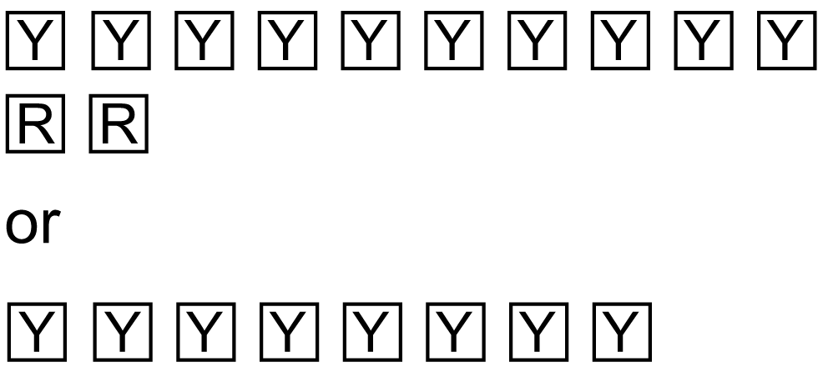
b)


c)

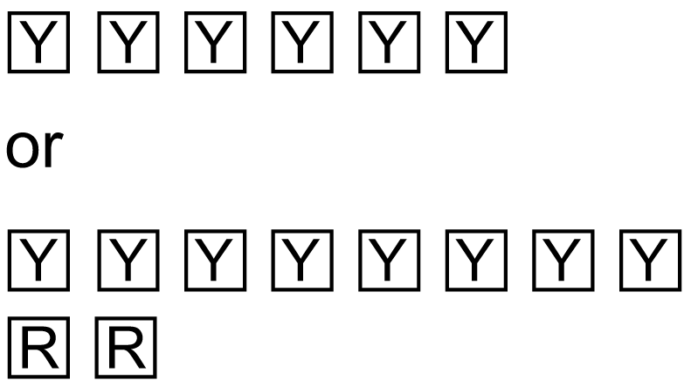
d)

3. a) –8 b) +4 c) +7 d) –4
4. a) 7 b) 13 c) 3 d) 3

