No number is divisible by 0!
Divisibility Rules
A whole number is divisible by:

2 if the number is even.
Ex. 32 74 88 96 All even numbers are divisible by 2

3 if the sum of the digits is divisible by 3.
Ex. 1035 $1+0+3+5=9$ $9¸3=3$ So 1035 is divisible by 3

4 if the number represented by the last 2 digits is divisible by 4.
Ex. 124 124 Multiples of 4: 4, 8, 12, 16, 20, 24…

5 if the ones digit is 0 or 5.
Ex. 5 20 45 350 All end with a 0 or 5 and are divisible by 5

6 if the number is divisible by 2 and by 3.
Ex. 1038 Divisible by 2, it is even
1038 $1+0+3+8=\text{12}$ $\text{12}¸3=4$ So 1038 is divisible by 3
1038 Divisible by 2 and 3, so divisible by 6

8 if the number represented by the last three digits is divisible by 8.
Ex. 1888 1888 888 is a multiple of 8
1040 1040 40 is a multiple of 8

9 if the sum of the digits is divisible by 9.
Ex. 5418 $5+4+1+8=\text{18}$ $\text{18}¸9=2$ So 5418 is divisible by 9

10 if the ones digit is 0.
Ex. 20 40 140 770 Numbers that end with a 0 are divisible by 10
You can use a Venn diagram to show numbers that are divisible by two or more numbers.
Let’s place these numbers in the Venn Diagram below:
2 5 6 9 12 25 32 40 41 55 70 105 315

This Venn diagram shows divisibility by 2 and by 5.

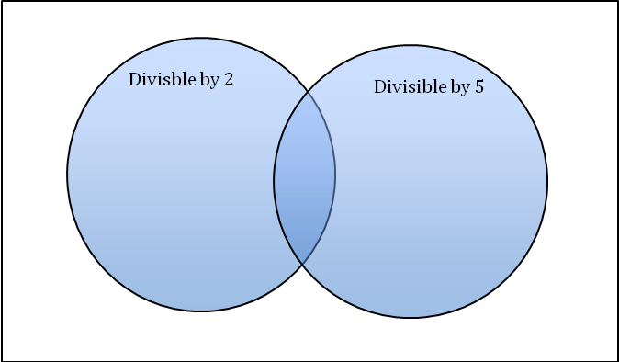
2
6
40
9
12
5
70
25
315
41
105
32
55

Multiples of 2 are in the left loop.
Multiples of 5 are in the right loop.
Multiples of both 2 and 5 are in the middle loop.
Numbers that are not multiples of 2 or of 5 are outside the loops.

You can also use a Carroll Diagram to show numbers that are divisible by two numbers.
Let’s place these numbers in the Carroll Diagram below:
6 10 12 18 29 36 45 126 162 204 325 402 711 802 963

This Carroll Diagram shows divisibility by 6 and by 9.

 | Divisible by 6 | Not Divisible by 6
Divisible by 9 | 18 36 126 162 | 45 711 963
Not Divisible by 9 | 6 12 204 402 | 10 29 325 802

You can use the divisibility rules to help list the factors of a number.

To list the factors of 156:
Try each rule in turn.
Then use long division to find the factor pair.

Divide by 2: 1562=78
Divide by 3: 1563=52
Divide by 4: 1564=39
156 is not divisible by 5.
Divide by 6: 1566=26
156 is not divisible by 7, 8, 9, or 10.
Use a calculator to check for divisibility by 10 and 12.
156 is not divisible by 11.
Divide by 12: 15612=13
Since the factors 12 and 13 are close in value, you have found all the factors.
In order, the factors of 156 are: 1, 2, 3, 4, 6, 12, 13, 26, 39, 52, 78, 156.

