You can use a graph to show a relation.

We can make a input/output table and a graph to show how $4n+2$ relates to n.

You can choose any input numbers, but it is easy if consecutive numbers are used.

Input  n | Output  $$4n+2$$
0 | 2
1 | 6
2 | 10
3 | 14
4 | 18
5 | 22

$$4n+2=4(0)+2=0+2=2$$
$$4n+2=4(1)+2=4+2=6$$
$$4n+2=4(2)+2=8+2=\text{10}$$
$$4n+2=4(3)+2=\text{12}+2=\text{14}$$
$$4n+2=4(4)+2=\text{16}+2=\text{18}$$
$$4n+2=4(5)+2=\text{20}+2=\text{22}$$
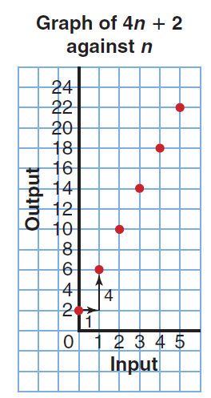
When your table is complete, you can plot the data on a graph.
The input data is plotted on the horizontal (x-axis).
The output data is plotted on the vertical (y-axis).

Planning is an important part of graphing your data.
The input increases by one, so each block represents one unit.
The output, however, increases by 4. In this case, a jump of 2 units
per block is an acceptable scale.

The graph shows how relates to n.

If lie a ruler along the points, we see that the graph is a set of points
that lie on a straight line.
When points lie on a straight line, we say that the relation is a
linear relation.

Important Parts of a Graph:
1. Title that relates to the problem/relation.
2. Titles for the input axis and output axis.
3. Numbers for the input axis and output axis.

Example

Ms. Lyons has 25 chocolate bars. She gives 3 chocolate bars to each student who stays after school to help prepare for the school concert.
a) Write a relation to show the number of chocolate bars that remain is related to the number of helpers.
b) Make a table to show this relation.
c) Graph the data. Describe the graph.
d) Use the graph to show these questions:
i)How many chocolate bars remain when 7 students help?
ii) When will Ms. Lyons not have enough chocolate bars?

a) Let s represent the number of students.
So, $\text{25}−3s$is related to s.
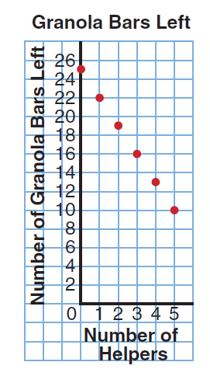
b) c)
Input  s | Output  $$\text{25}−3s$$
0 | 25
1 | 22
2 | 19
3 | 16
4 | 13
5 | 10

d) i) There will be 7 bars left when there are 6 helpers.
ii) Ms. Lyons will not have enough chocolate bars for
9 helpers.

