Extra Practice 2

Lesson 4.2: Circumference of a Circle
1. A circle has diameter 10.5 cm.
Calculate the circumference of the circle to the nearest millimetre.

2. A circle has radius 4.3 mm.
Calculate the circumference of the circle to the nearest millimetre.

3. A circle has circumference 12.6 m.
Calculate the diameter of the circle to the nearest centimetre.

4. Describe two different ways to find the circumference of a circle with radius 5 cm.

5. What is the circumference of the circle below? O is the centre of the circle.

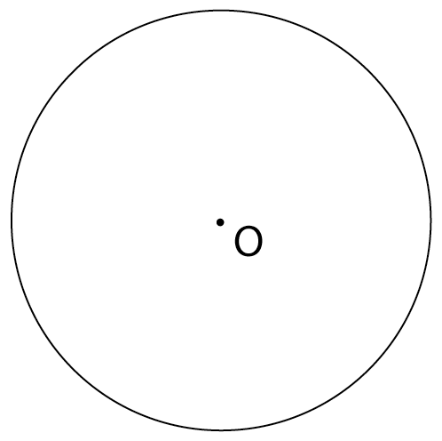

6. What is the radius of the circle below?

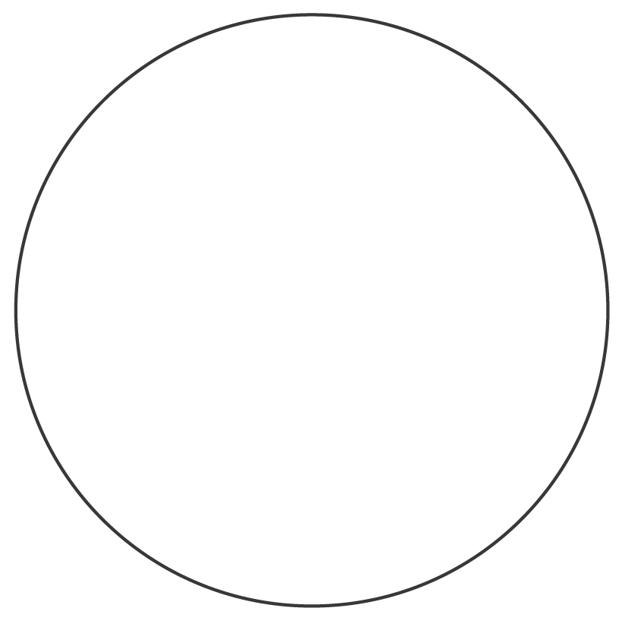

7. A circular tablecloth has diameter 1 m.
The designer wants to put a fringe around the edge of the cloth.
How much fringe should he buy, if fringe is sold by the tenth of a metre?
Explain.

Extra Practice 2 –
Lesson 4.2
1. About 33 cm
2. About 27 mm
3. About 4.01 m
4. Use C = 2πr or find d, then use C = πd.
C $\overset{˙}{=}$ 31.42 cm
5. About 12.6 cm

6. About 1.65 cm
7. 3.2 m; he must round up; if he rounds down, he will
not have enough fringe.

