Extra Practice 2
Master 1.23
Master 1.20
Lesson 1.2: More Patterns in Division
1. Which numbers are divisible by 0? By 6? By 9?
How do you know?
a) 92 b) 114 c) 216
d) 420 e) 636 f) 675
g) 1026 h) 1252 i) 1278
2. Draw a Venn diagram with 2 loops.
Label the loops “Divisible by 3” and “Divisible by 5.”
Place the numbers from 1 to 50 in the correct loop.
What is true about all the numbers in the region where the
loops overlap?
3. Use divisibility rules to find the factors of 132.
How do you know you have found all the factors?
4. Write three 4-digit numbers that are divisible by 9.
How did you choose the numbers?
5. Which of these numbers is 324 592 divisible by?
How do you know?
a) 2 b) 3 c) 4
d) 5 e) 6 f) 8
g) 9 h) 10 i) 0
6. Suppose you have 60 granola bars.
You must share the bars equally with everyone on the school bus.
How many granola bars will each person get, in each case?
a) There are 30 people on the bus.
b) There are 15 people on the bus.
c) There are 12 people on the bus.
d) There is no one on the bus.

Extra Practice Sample Answers
Extra Practice 2 – Master 1.23
Lesson 1.2
1. None of the numbers are divisible by 0 because no number can be divided by 0.
To be divisible by 6, the number must be divisible by 2 and by 3. So, it must be an even number, and the sum of its digits must be a multiple of 3.
The numbers divisible by 6 are 114, 216, 420, 636, 1026, and 1278.
To be divisible by 9, the sum of the digits must be a multiple of 9.
So, the numbers divisible by 9 are 216, 675, 1026, and 1278.
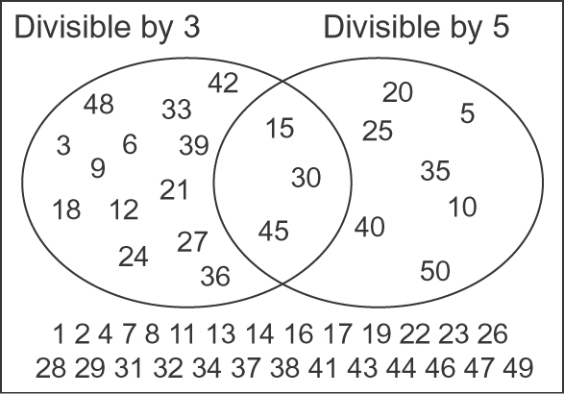
2.

The numbers in the region where the loops overlap are multiples of 15.
3. 132 is divisible by 1 and itself.
132 is even so it is divisible by 2. 132 ÷ 2 = 66
The sum of the digits of 132 is 6, so 132 is divisible by 3 but not by 9. 132 ÷ 3 = 44
132 is divisible by 4 because 32 is a multiple of 4. 132 ÷ 4 = 33
132 is divisible by 2 and by 3, so it is also divisible by 6. 132 ÷ 6 = 22
Looking at the quotients, I can see that 132 is divisible by 11. 132 ÷ 11 = 12
The factors of 132 are 1, 2, 3, 4, 6, 11, 12, 22, 33, 44, 66, 132.
4. 3717, 1134, and 9999; I wrote 4 digits each time so that the sum of the digits was a multiple of 9.
5. a) Yes, 324 592 is even.
b) No, the sum of the digits is not divisible by 3.
c) Yes, the number represented by the last 2 digits is divisible by 4.
d) No, the ones digit is not 0 or 5.
e) No, the number is not divisible by 3.
f) Yes, the number represented by the last 3 digits is divisible by 8.
g) No, the sum of the digits is not a multiple of 9.
h) No, the ones digit is not 0.
i) No, no number is divisible by 0.
6. a) 2 granola bars
b) 4 granola bars
c) 5 granola bars
d) I cannot share granola bars equally among no one.

