Extra Practice 2
Lesson 8.2: Perpendicular Lines
Master 8.25

1. Which line segments are perpendicular? How do you know?
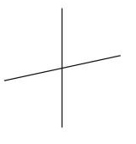

a) b)

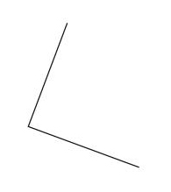
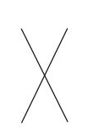
d) e)

2. Draw line segment GK of length 7 cm.
Mark a point S below GK.
Use any method to draw a perpendicular line through S.
How do you know the line you drew is perpendicular to the line segment?
3. Draw line segment ST of length 5 cm.
Use what you know about perpendicular lines to draw square STUV.
How you can check you have drawn a square?

Extra Practice 2 – Master 8.25
Lesson 8.2
1. Parts b and c; the lines intersect at right angles.
2. I used a Mira. The lines intersect at right angles.
3. I use a protractor and a ruler to draw line segments VS and UT perpendicular to ST through points S and T.
VS = UT = ST = UV = 5 cm

