Extra Practice 3

Lesson 4.3: Area of a Parallelogram
1. Calculate the area of each parallelogram.
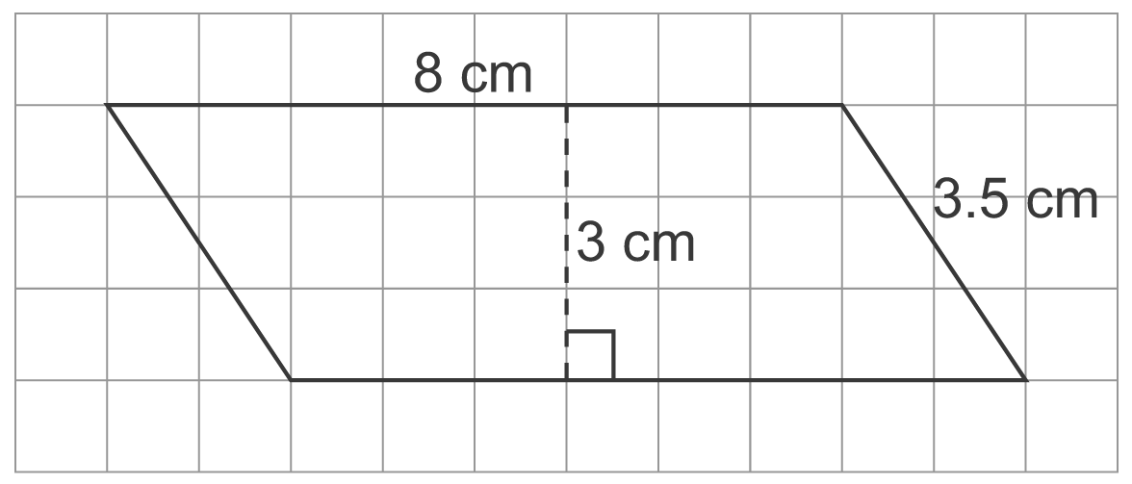
a)

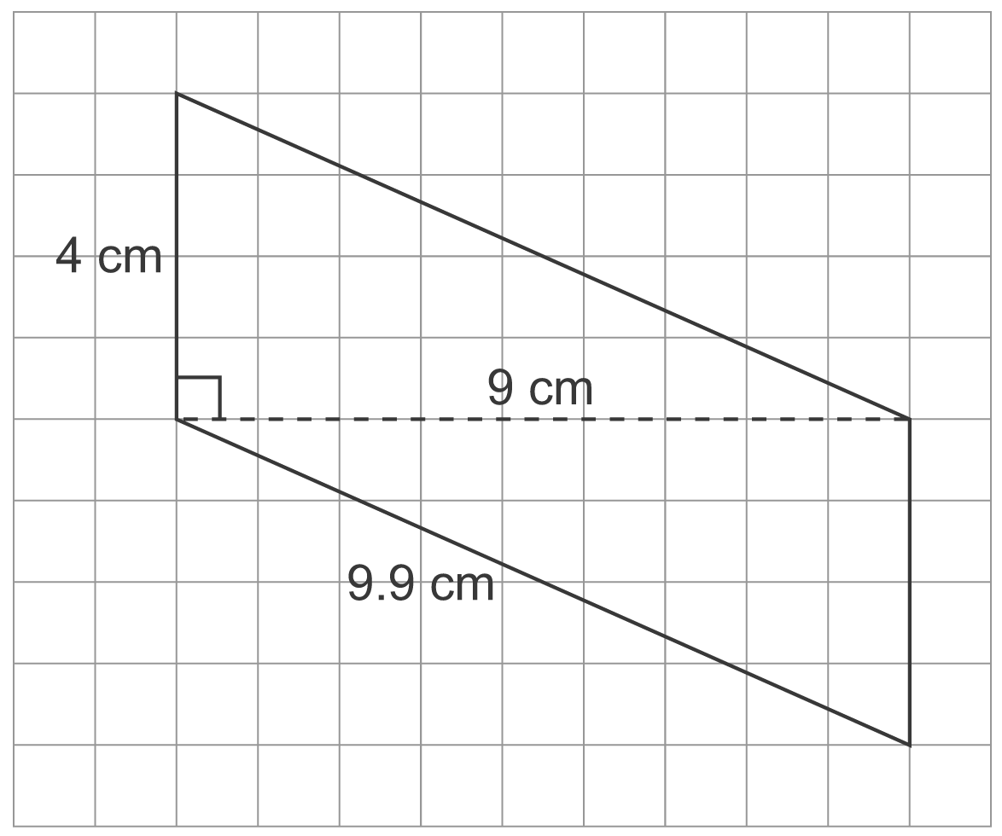

b)

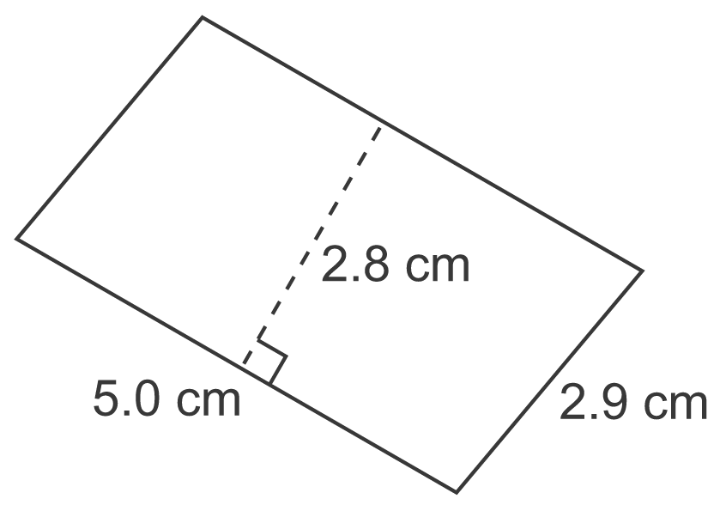
c)

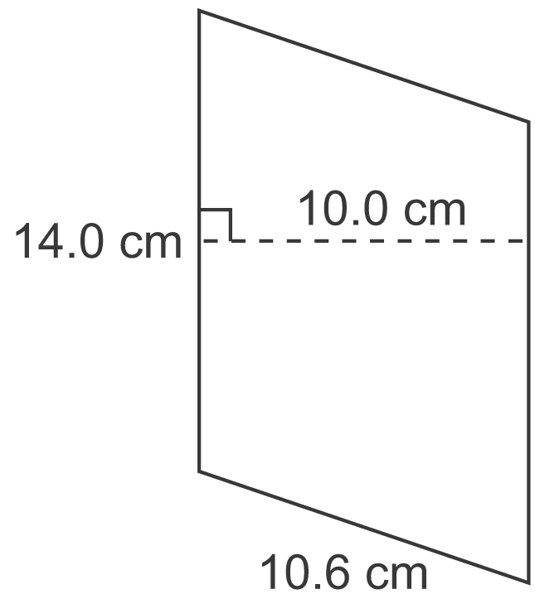
d)

2. The base of a parallelogram is 25 m. What is the height of the parallelogram for each area?
a) 100 m² b) 375 m² c) 225 m² d) 12.5 m²

3. Draw 3 different parallelograms with base 6.5 cm and height 4.0 cm.

4. On 1-cm grid paper, draw as many different parallelograms as you can
with area 24 cm².

Extra Practice 3
Lesson 4.3
1. a) A = 24 cm²
b) A = 36 cm²
c) A = 14.0 cm²
d) A = 140 cm²
2. a) h = 4 m b) h = 15 m
c) h = 9 m d) h = 0.5 m
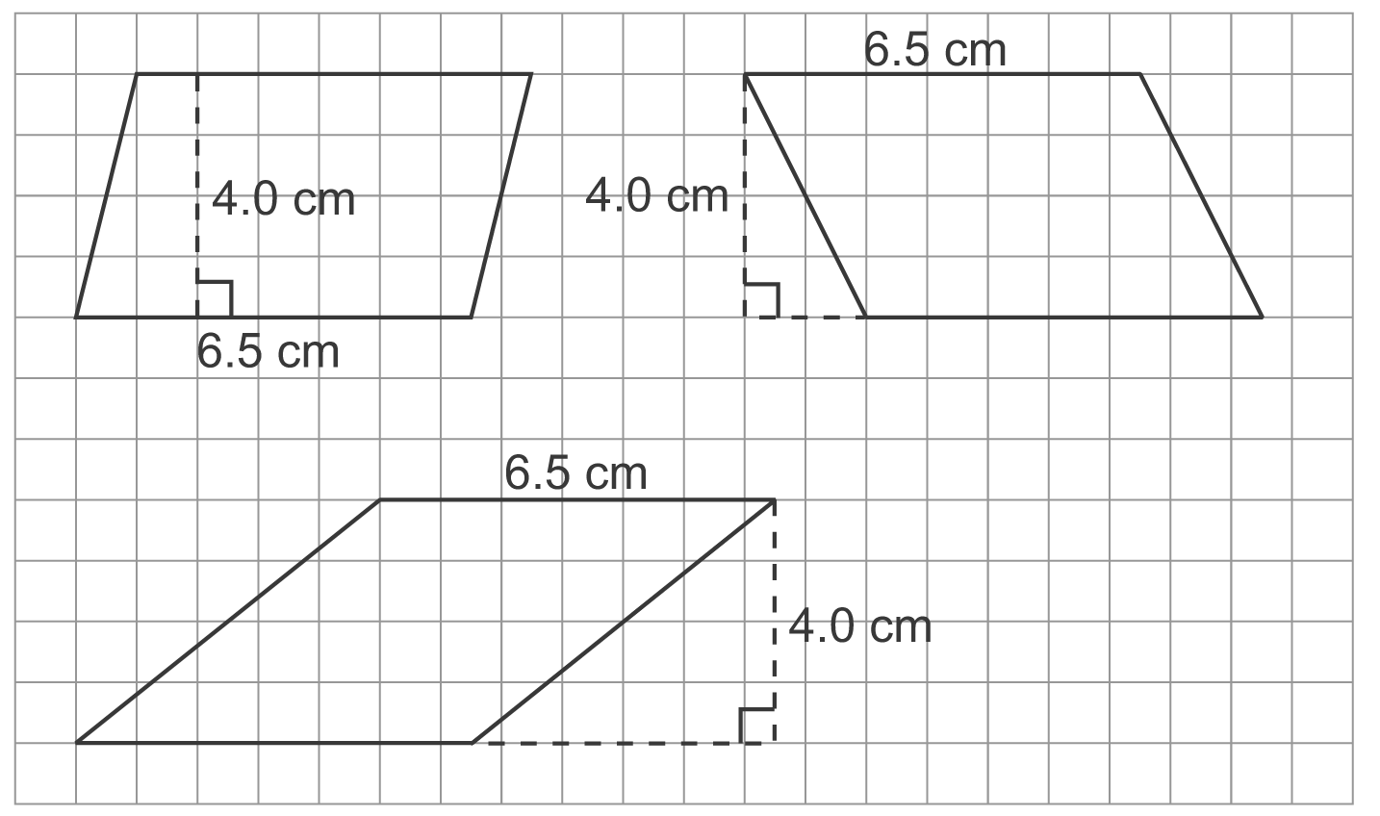
3.
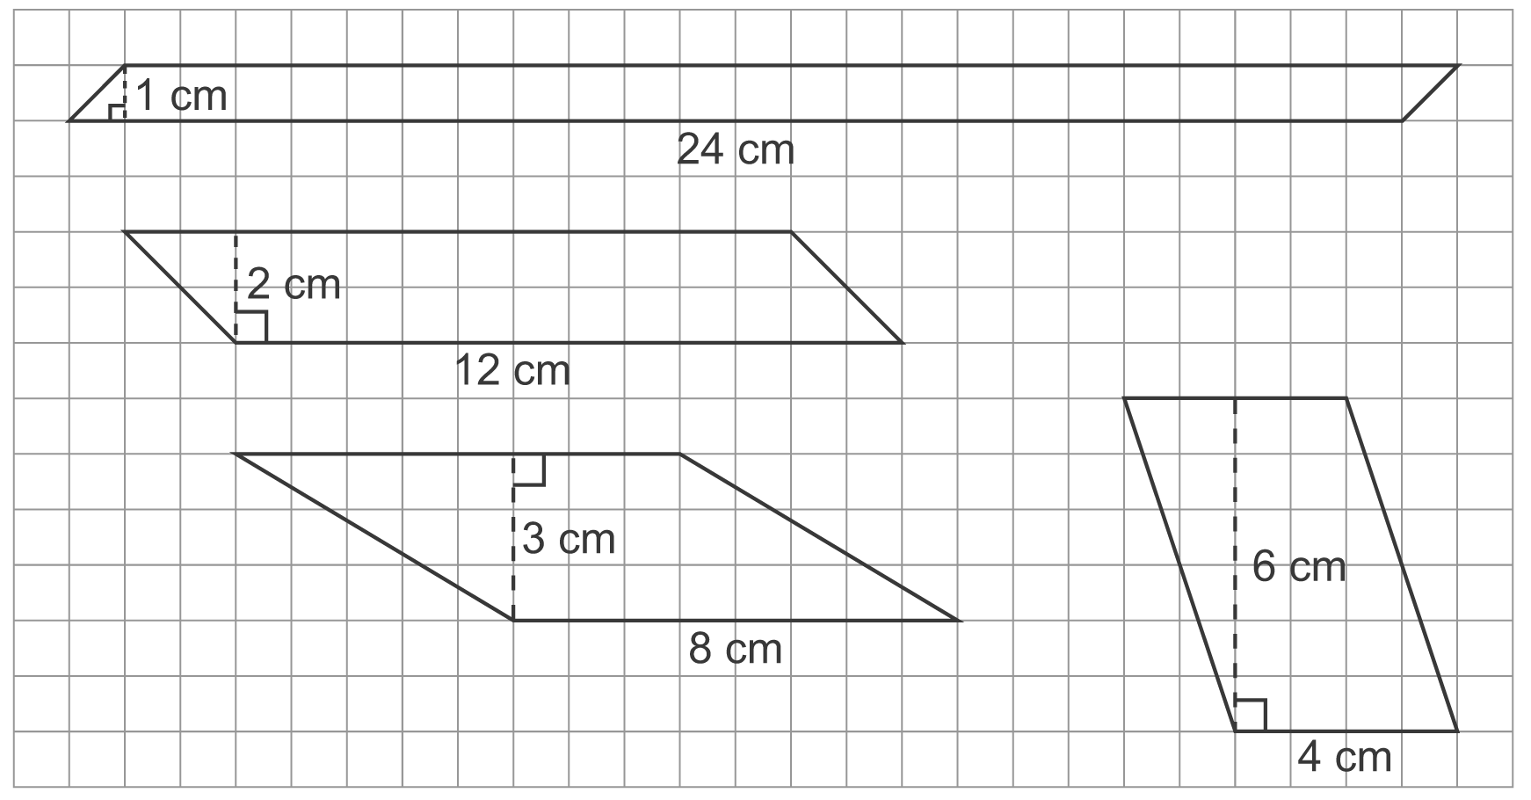
4. For example,

