Extra Practice 3
Lesson 8.3: Constructing Perpendicular Bisectors
Master 8.26

1. Draw any line segment MN.
Use a ruler to draw the perpendicular bisector.
How do you know you have drawn the perpendicular bisector of MN?

2. Draw a large obtuse ΔPQR.
Construct the perpendicular bisector of each side of the triangle.
Label point T where the bisectors meet.
Draw the circle with centre T and radius TP.

3. Draw a large circle.
Label its centre O.
Draw quadrilateral ABCD with vertices on the circle.
Construct the perpendicular bisector of each side of the quadrilateral.
What do you notice about the perpendicular bisectors?

4. Draw line segment PR of length 5 cm.
Use what you know about perpendicular bisectors to construct square PSRT.
How can you check you have drawn a square?

Extra Practice 3 – Master 8.26
Lesson 8.3
1. PQ divides line segment MN in two equal parts; line segments MN and PQ intersect at 90°.
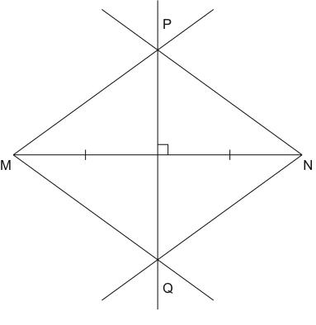

2.
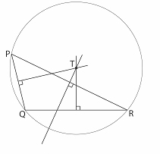
3. Each perpendicular bisector passes through the centre of the circle.
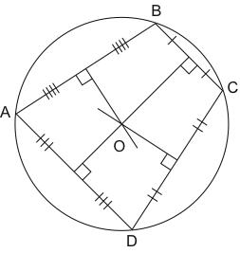
4. In a square, the diagonals are equal and they bisect each other at right angles.
PR is one of the diagonals of square PSRT.
I drew the perpendicular bisector of PR using the ruler and compass method.
Then I measured 2.5 cm above and below line segment PR and
marked points S and T on the perpendicular bisector.
