Extra Practice 4
Lesson 8.4: Constructing Angle Bisectors
Master 8.27
1. Draw obtuse ∠BCD = 176°.
a) How many different methods can you use to bisect the angle?
b) Describe each method.
Check that the bisector you drew using each method is correct.

2. Draw any obtuse ∠ABC.
Use a ruler and a compass to bisect the angle.
Measure the two parts of the angle.
Are they equal?

3. Draw a large ΔABC.
Construct the bisector of each angle.
What do you notice?

4. Draw rhombus BCDE.
Construct the bisector of each angle.
What do you notice?

Extra Practice 4 – Master 8.27
Lesson 8.4
1. a) I use a Mira; paper folding; the ruler and compass and the right triangle methods are more difficult to use because of the angle measure.
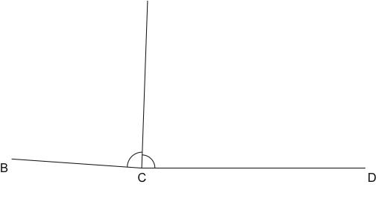
b) I fold the paper so that BC lies along DC. The fold line is the angle bisector.
Or: I place the Mira so that the reflection of BC lies along DC.
2. Yes, the angles are equal.
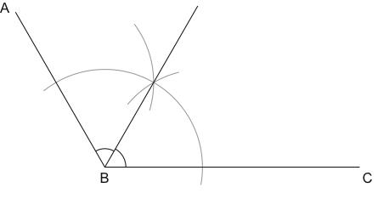
3. The angle bisectors meet at one point.
4. In a rhombus, the diagonals bisect angles in each vertex of the rhombus.
