Extra Practice 4

Lesson 4.4: Area of a Triangle
1. On 1-cm grid paper, draw two different triangles for each area:
a) 6 cm² b) 12 cm²
2. Use 1-cm grid paper.
a) Draw a triangle with area 8 cm².
b) Draw another triangle with the same base but double the
area of the first triangle. How does the height change?
c) Draw another triangle with the same base but one-half the
area of the first triangle. How does the height change?
3. The area of each triangle is given. Find each unknown measure.
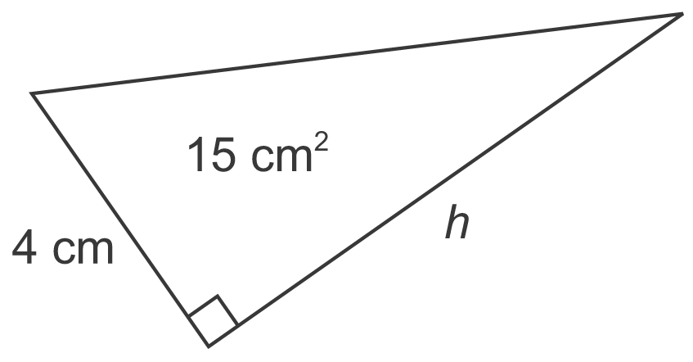
a)

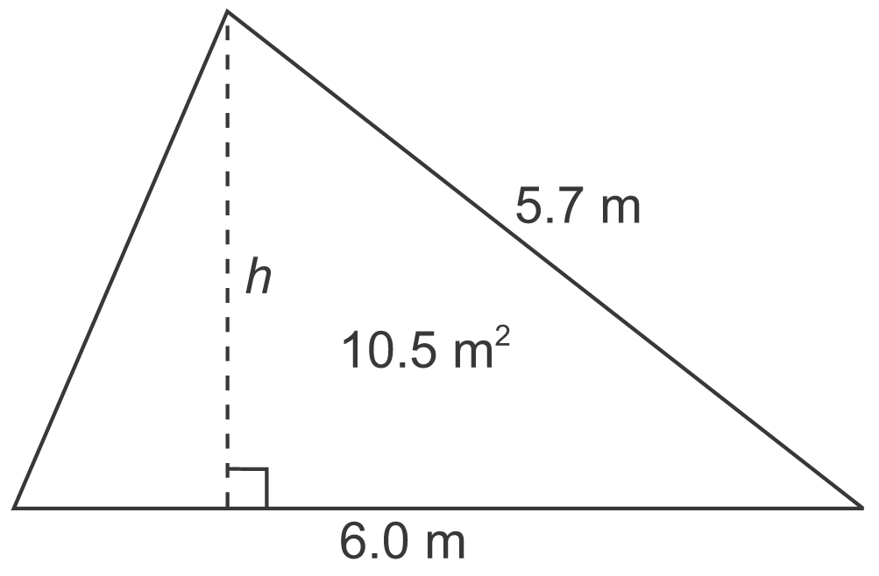
b)

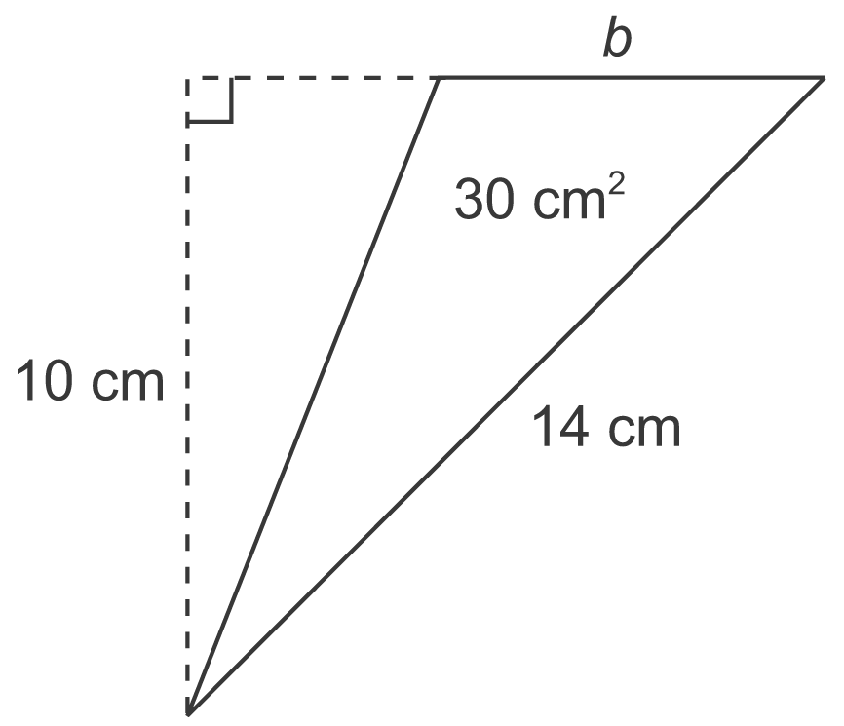
c)

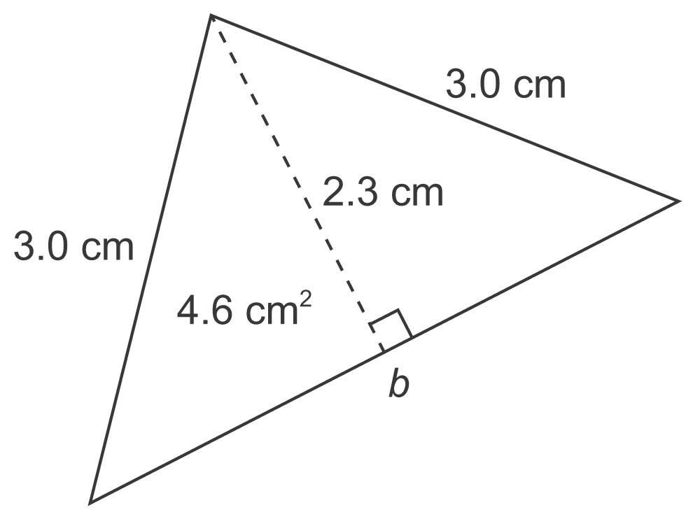
d)

Extra Practice 4 –
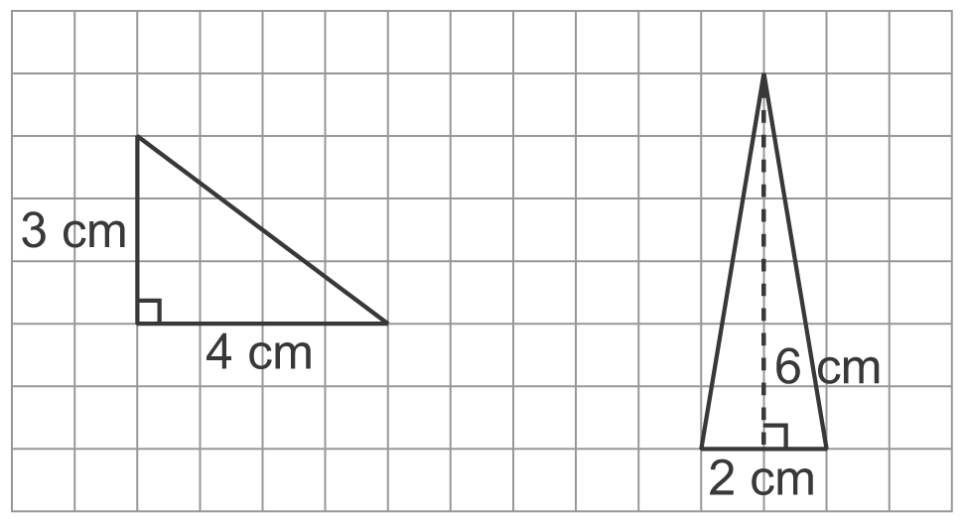
Lesson 4.4
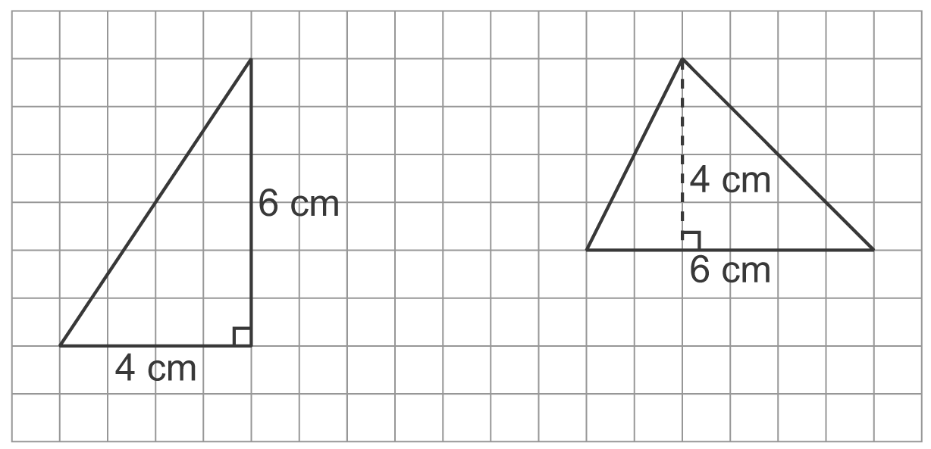
1. a)
b)

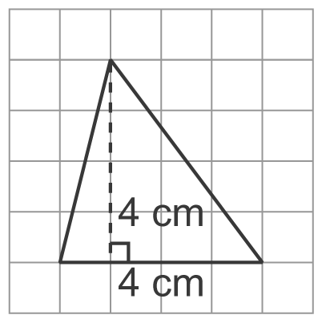
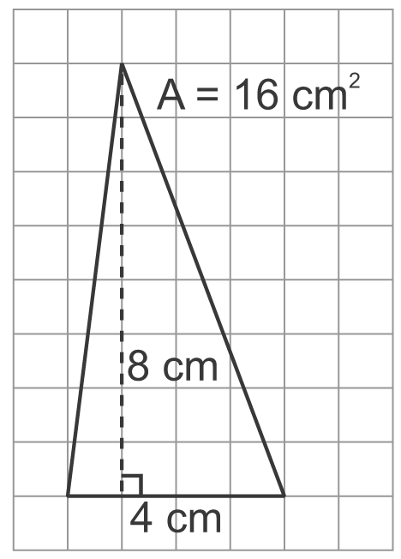
2. a) b)
The height doubles.
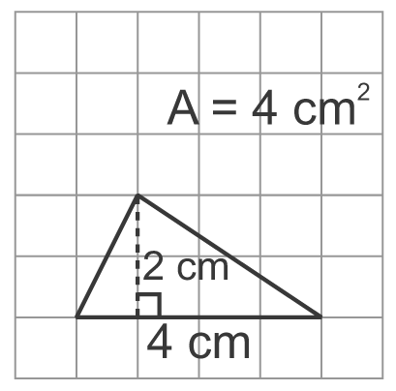
c)
The height is halved.
3. a) h = 7.5 cm b) h = 3.5 m
c) b = 6 cm d) b = 4 cm

