Extra Practice 6
Master 1.27

Lesson 1.6: Graphing Relations
1. Admission to the Carnival is $4.
Each game played costs an additional $2.
a) Write a relation to show how the total cost is related to the number
of games played.
b) Create a table of values to show the total cost if you play
0, 2, 4, 6, 8, or 10 games.
c) Graph the relation.
Describe the graph.
d) Use the graph to answer these questions:
i) How much would it cost to play 5 games?
ii) How many games could you play for $26?
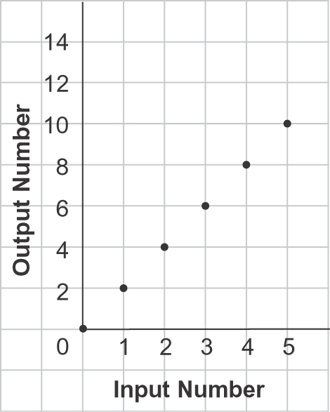
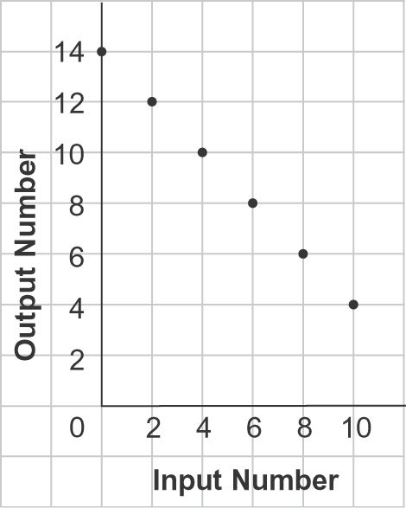
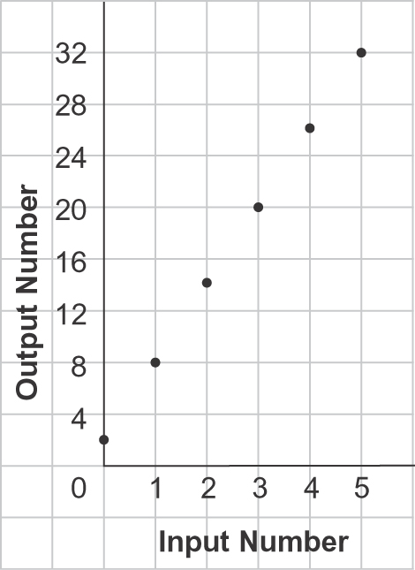
2. Describe a real-life situation that each graph below could represent.
a) b) c)
3. Jenny borrows $60 from her mother to get her hair highlighted.
She promises to pay her mother $4 each week until her debt is paid off.
a) Write a relation to show how the amount Jenny owes is related to the number of weeks.
b) Make a table for the amount owing after 2, 4, 6, 8, and 10 weeks.
c) Draw a graph to show the relation.
Describe the graph.
d) Use the graph to answer these questions.
i) How much does Jenny owe her mother after 12 weeks?
ii) When will Jenny finish paying off her debt?

Extra Practice Sample Answers
Extra Practice 6 – Master 1.27
Lesson 1.6
1. a) Let p represent the number of games played.
The relation is 4 + 2p related to p.
Number of Games Played  p | Total Cost  ($)  4 + 2p
0 | 4
2 | 8
4 | 12
6 | 16
8 | 20
10 | 24

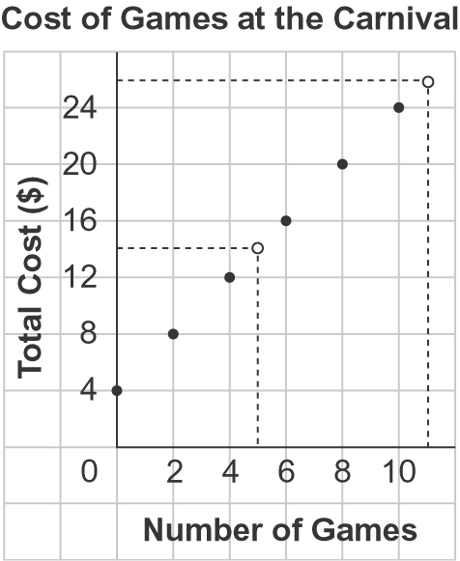
b) c)

The points lie on a straight line going up to the right. As the number of games played increases by 2, the total cost increases by $4.
d) i) $14 ii) 11 games
2. a) The number of eyes in the class related to the number of students
b) The number of boxes of cookies I have left related to the number I’ve sold if I started with 14 boxes
c) The number of books related to the number of boxes, if each box holds 6 books and there are 2 books not in a box
3. a) Let the number of weeks be n.
The relation is 60 – 4n related to n.
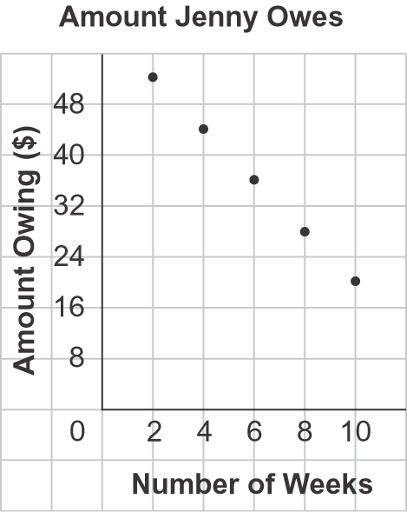
b) c)
Number of Weeks  n | Amount Owing  ($)  60 – 4n
2 | 52
4 | 44
6 | 36
8 | 28
10 | 20

The points lie on a straight line going down to the right. As the number of weeks increases by 2, the amount owing decreases by $8.
d) i) $12 ii) After 15 weeks

