Extra Practice 4
Lesson 5.4: Using Models to Subtract Fractions
Master 5.30
1. Subtract.
a) – b) – c) – d) –

2. Subtract.
Estimate first.
Sketch pictures to show each difference.
a) – b) – c) – d) –

3. Subtract.
Estimate first.
a) – b) – c) – d) –

4. Brandy spent of her summer vacation reading, watching her favourite movies,
visiting her grandparents, and twice the reading time playing with her friends.
a) What is the difference in the fractions Brandy spent with her grandparents
and playing with her friends?
b) Did she spend more time reading or watching movies? Explain your thinking.
c) Did Brandy have time to do anything else beside these activities?
Explain your thinking.

5. Glenn has of a cup of walnuts.
He needs of a cup of walnuts to make a loaf of banana bread.
Does Glenn have enough?
If your answer is yes, explain why it is enough.
If your answer is no, how much more does Glenn need?

Extra Practice 4 – Master 5.30
Lesson 5.4
1. a) b) c) d)

2. a) About ;
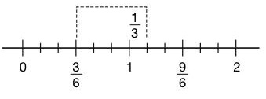

b) About ;
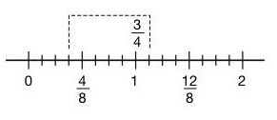

c) About ;
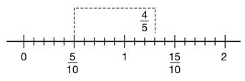

d) About ;
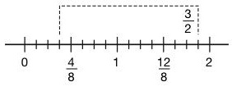

3. a) About ; b) About 1; c) About 1; d) About ;
4. a) – = =
b) Brandy spent more time reading: > .
c) + + + = = ; 1 – = ; Brandy was left with of her vacation for other activities.
5. No, < ; Glenn needs – = cup more walnuts.

