A prism has two congruent bases and is named for its bases.

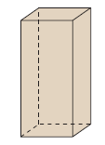
The two congruent sides are squares.

This is a rectangular prism.
Note:
Two faces meet at an edge.
Three or more edges meet at a vertex.

A pyramid has one base and the other faces are congruent triangles.
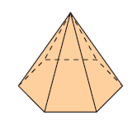
The base is a hexagon.

This is a hexagonal pyramid.

A net is a diagram that can be folded to make an object.

If we cut a figure along the edges and lay it flat, we will have a net.

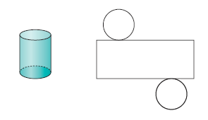
This is a cylinder and it’s net. This is a triangular prism and it’s net.
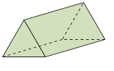
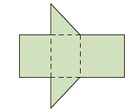

To determine if a diagram is a net for an object, look at each shape and at how the shapes are arranged.

A prism or pyramid is a closed figure. Each side of the base will have a face connected to it.

It is helpful to start with a base and then build the net from that base.

This is the net of a square pyramid including the measurements.
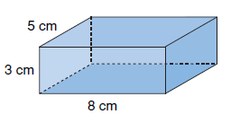
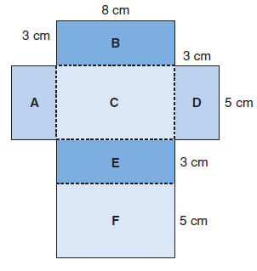

Try These:

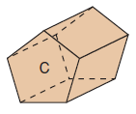
1. Name these figures.

a)
Pentagonal prism

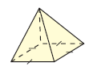
b)
Square based pyramid

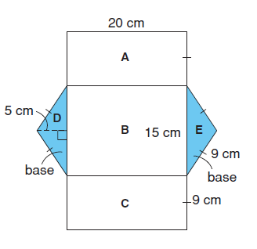
2. Draw the net and include measurements.

