Extra Practice 5

Lesson 4.5: Area of a Circle
1. Calculate the area of each circle.
Give the answers to one decimal place.
Estimate to check your answers are reasonable.

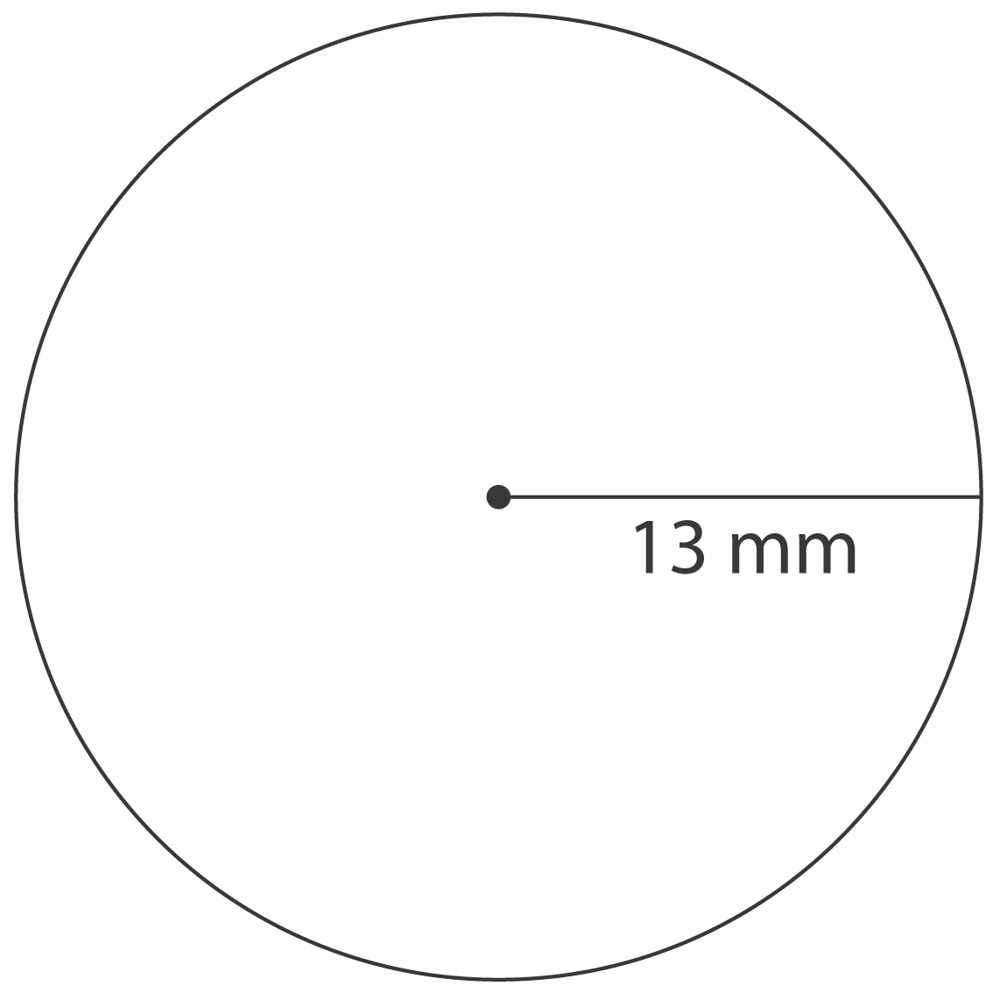
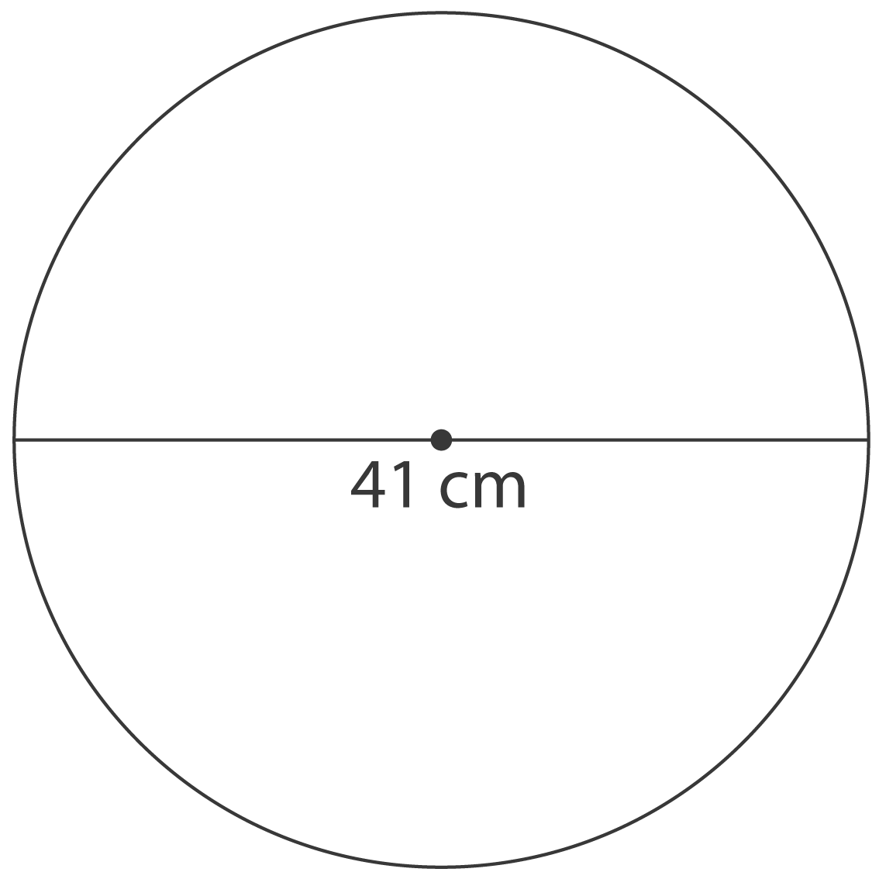
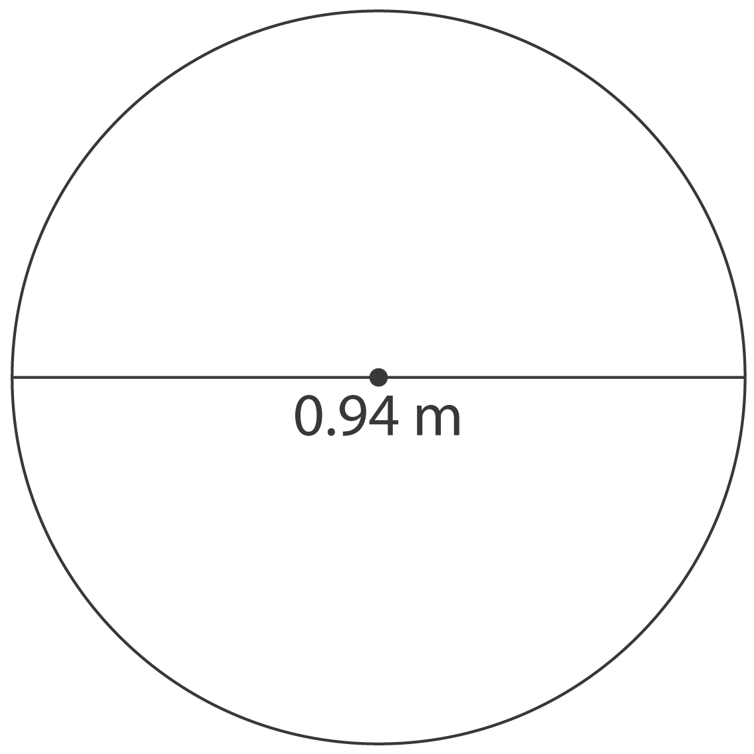
a) b) c)

2. A carpenter is making a circular tabletop with radius 0.5 m.
What is the area of the tabletop to the nearest tenth of a metre?

3. The diameter of a knob on a CD player is 0.78 cm.
a) What is the radius of the knob?
b) What is the circumference of the knob?
c) What is the area of the knob?

4. A quilter is making a circular tree skirt to go under a decorative tree.
The radius of the tree skirt is 1.75 m.
a) What is the area of the tree skirt?
b) Suppose the quilter doubles the radius of the tree skirt.
What happens to the area?
What is the new area?
c) Suppose the quilter triples the radius of the tree skirt.
How can you find the new area without using the area formula?
What is the new area?

5. The circular vent on a furnace has diameter 19.4 cm.
What is the area of the vent?

Extra Practice 5 –
Lesson 4.5
1. a) 530.9 mm²
b) 1320.3 cm²
c) 0.7 m²
2. 0.8 m²
3. a) 0.39 cm b) About 2.45 cm
c) About 0.48 cm²
4. a) About 9.62 m²
b) The area quadruples; about 38.48 m²
c) When the radius triples, the area increases 9 times; multiply the original area by 9: about 86.58 m²
5. About 295.6 cm²

