Extra Practice 5
Master 8.28

Lesson 8.5: Graphing on a Coordinate Grid

1. Write the coordinates of each point from A to H.

A _______________

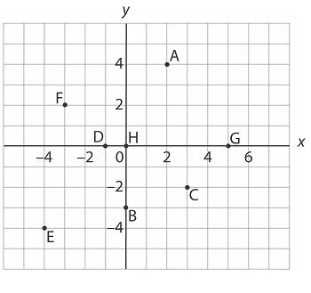
B _______________

C _______________

D _______________

E _______________

F _______________

G _______________

H _______________

2. For each point in question 1, name the quadrant or axis that contains the point.

3. What can be said about the coordinates of point P in each case?

a) P is in Quadrant 2.

b) P lies on the x-axis.

c) P is in Quadrant 4.

d) P lies on the y-axis.

e) P is at the origin.

f) P is in Quadrant 3.

4. a) Plot these points on a coordinate grid: K(–3, 4), A(4, 4), T(3, 2), E(–2, 2).

b) Join the points. Which shape is formed?

5. a) Plot these points on a coordinate grid: A(3, 5), B(–4, 5), C(–4, 2).

b) Find the coordinates of point D that forms rectangle ABCD.

Extra Practice 5 – Master 8.28
Lesson 8.5
1. A(2, 4), B(0, –3), C(3, –2), D(–1, 0), E(–4, –4), F(–3, 2), G(5, 0), H(0, 0)
2. A: Quadrant 1
B: y-axis
C : Quadrant 4
D : x-axis
E : Quadrant 3
F : Quadrant 2
G : x-axis
H : both x- and y-axes
3. a) Its x-coordinate is negative and its y-coordinate is positive.
b) Its y-coordinate is 0.
c) Its x-coordinate is positive and its y-coordinate is negative.
d) Its x-coordinate is 0.
e) Both its x- and y-coordinates are 0.
f) Both its x- and y-coordinates are negative.

4. a)
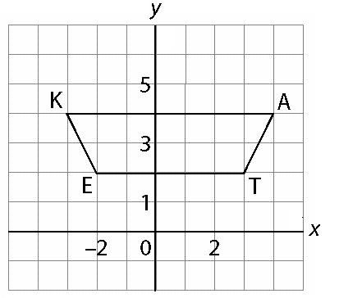
b) Trapezoid
5. a)
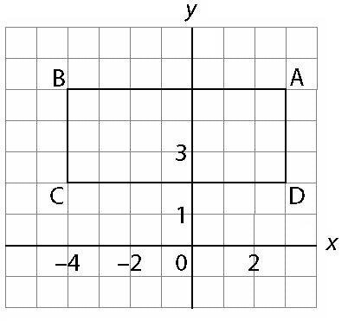
b) D(3, 2)

