Many grocery items come in different sized packages. We can compare unit rates to determine which item is the better buy.

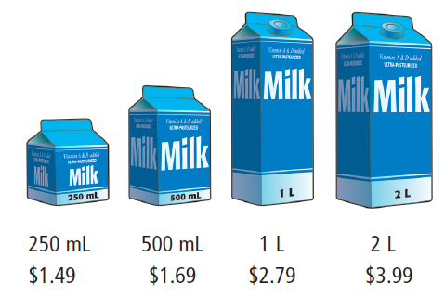
Which item is the best buy?
Let’s make the unit rates equivalent to 1L of milk.

$\$1\text{.}{\text{49}}/{\text{250}}\text{mL}=(\$1\text{.}\text{49}×4)/(\text{250}\text{mL}×4)=\$5\text{.}{\text{96}}/1L$

$\$1\text{.}{\text{69}}/{\text{500}}\text{mL}=(\$1\text{.}\text{69}×2)/(\text{500}\text{mL}×2)=\$3\text{.}{\text{38}}/1L$

$\$2\text{.}{\text{79}}/1L$

$\$3\text{.}{\text{99}}/2L=\frac{\$3\text{.}{\text{99}}/2L}{2}=\$1\text{.}{\text{995}}/1L≈\$2\text{.}{\text{00}}/1L$

$\$3\text{.}{\text{99}}/2L$The best buy is .

Which cereal is the better buy?
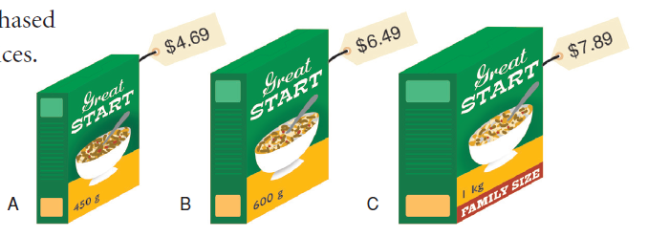
Note:
It is difficult to find the unit cost of 1g of something, so we must use 100g instead.

A $\$4\text{.}{\text{69}}/{\text{450}}g=\frac{\$4\text{.}{\text{69}}/{\text{450}}g}{4\text{.}\text{50}}=\$1\text{.}{\text{042222}}/{\text{100}}g≈\$1\text{.}{\text{04}}/{\text{100}}g$

B $\$6\text{.}{\text{49}}/{\text{600}}g=\frac{\$6\text{.}{\text{49}}/{\text{600}}g}{6\text{.}\text{00}}=\$1\text{.}\text{081}{\overline{6}}/{\text{100}}g≈\$1\text{.}{\text{08}}/{\text{100}}g$

C $\$7\text{.}{\text{89}}/1\text{Kg}=\$7\text{.}{\text{89}}/{\text{1000}}g=\frac{\$7\text{.}{\text{89}}/{\text{1000}}g}{\text{10}\text{.}\text{00}}=\$0\text{.}{\text{789}}/{\text{100}}g≈\$0\text{.}{\text{79}}/{\text{100}}g$
Cereal C is the best buy.

