This picture shows 4 circles, 6 squares, and 10 triangles.

Here are some ways you can use ratios, fractions, and percents to compare the shapes.

Part-to-Whole Ratios

The ratio of circles to all of the shapes is: 4 to 20 or 4:20

This part-to-whole ratio can be written as the fraction $\frac{4}{\text{20}}$ or $\frac{1}{5}$.

It can also be written as a percent. $\frac{4}{\text{20}}=\frac{\text{20}}{\text{100}}=\text{20}\text{\%}$

20% of the shapes are circles.

Part-to-Part Ratios

The ratio of circles to squares is: 4 to 6 or 4:6

4 and 6 are the terms of the ratio.

The ratio of circles to squares to triangles is: 4 to 6 to 10 or 4:6:10
This is called a three-term ratio.

A part-to-part ratio cannot be written in fraction or percent form, as it is not comparing one part to the whole.

Try these

1. Write each ratio.
Identify the ratios as part-to-part or part-to-whole.
Change each part-to-whole ratio into a fraction and a percent.

a) cars to vans b) footballs to baseballs c) bananas to fruit

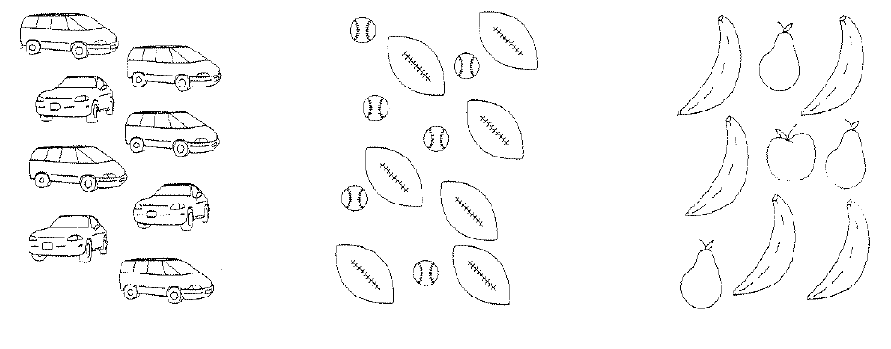
3:5 7:6 5:9
Part-to-part Part-to-part Part-to-whole
$\begin{aligned}\frac{5}{9}=0\text{.}\overline{5} \\ 0\text{.}\overline{5}×\text{100}=\text{55}\text{.}5\text{\%}\end{aligned}$

