There are three ways that we can compare ratios:
- Draw a picture.
- Use equivalent ratios with either the 1st or 2nd term being common.
- Use equivalent ratios with one of the terms being 1.

Examples

1. Recipe A for punch calls for 2 cans of concentrate and 3 cans of water.
Recipe B for punch calls for 3 cans of concentrate and 4 cans of water.
Use equivalent ratios to determine which punch is stronger.
Since we are looking for the stronger punch, we could make the amount of water the common term and then compare the number of cans of concentrate.
A$\text{Concentrate}:\text{Water}=2:3$
Multiples for 3 and 4:
Multiples of 3: 3, 6, 9, 12, 15, 18…
Multiples of 4: 4, 8, 12, 16, 20…
B $\text{Concentrate}:\text{Water}=2:4$

A $\text{Concentrate}:\text{Water}=2:3=(2×4):(3×4)=8:\text{12}$
Recipe B is stronger because it requires more concentrate than Recipe A.
B $\text{Concentrate}:\text{Water}=3:4=(3×3):(4×3)=9:\text{12}$

OR

We could also use equivalent ratios with one of the terms being reduced to 1.

A $\text{Concentrate}:\text{Water}=2:3=\frac{2}{3}:\frac{3}{3}=0\text{.}\overline{6}:1$
Recipe B is stronger because it requires more concentrate than Recipe A.

B $\text{Concentrate}:\text{Water}=3:4=\frac{3}{4}:\frac{4}{4}=0\text{.}\text{75}:1$

2. Erica makes her coffee with 2 scoops of coffee to 5 cups of water.
Jim makes his coffee with 3 scoops of coffee to 7 cups of water.
Draw a picture to determine who makes stronger coffee.

Erica Jim

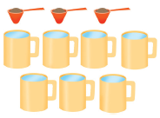

Find out how much water is used for 1 scoop of coffee.

Erica Jim
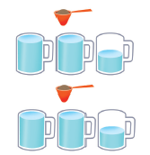
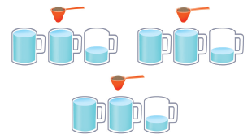

$\text{Coffee}:\text{Water}=1:2\frac{1}{2}$ $\text{Coffee}:\text{Water}=1:2\frac{1}{3}$

Jim makes the stronger coffee because he uses less water than Erica.

