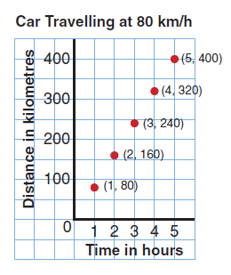
A rate is a comparison of two quantities measured in different units.

Some examples:

Apples are on sale for $1.45 for 10.
There are 500 sheets in one roll of paper towel.
Stephanie earns $5.00 an hour for baby-sitting.

The last two are unit rates.
Each rate compares a quantity to 1 unit.

We can use diagrams, tables and graphs to find unit rates.
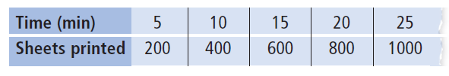
Example

A printing press prints 120 sheets in 3 minutes.
a) Express the printing as a unit rate.
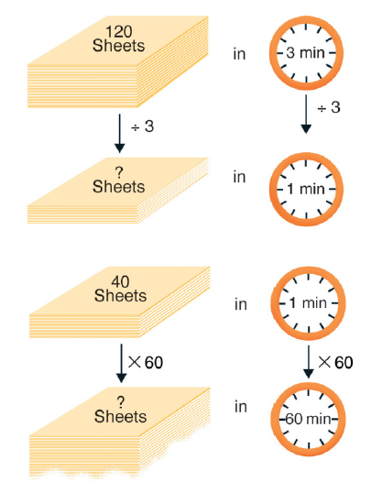
b) How many sheets are printed in 1 hour?

a) First write the rate.
(Use the idea of equivalent ratios to help find the unit rate.)

$$\text{12}{\text{sheets}}/3\text{min}=\frac{\text{12}{\text{sheets}}/3\text{min}}{3}=\text{40}\text{sheets}\text{/min}$$

b) We know that there are$4\text{sheets}\text{/min}$printed.
There is 60 minutes in 1 hour.

$$4\text{sheets}\text{/min}=(4\text{sheets}×\text{60}\text{/min}×\text{60})=\text{2400}{\text{sheets}}/{\text{hour}}$$

Try This:

1. Leo types 180 words in 3 minutes. Express as a unit rate.

$$\text{180}{\text{words}}/3\text{min}=\frac{\text{180}{\text{words}}/3\text{min}}{3}=\text{60}\text{words}\text{/min}$$

