Extra Practice 6

Lesson 4.6: Interpreting Circle Graphs
1. The circle graph shows Samson’s household budget for a month.

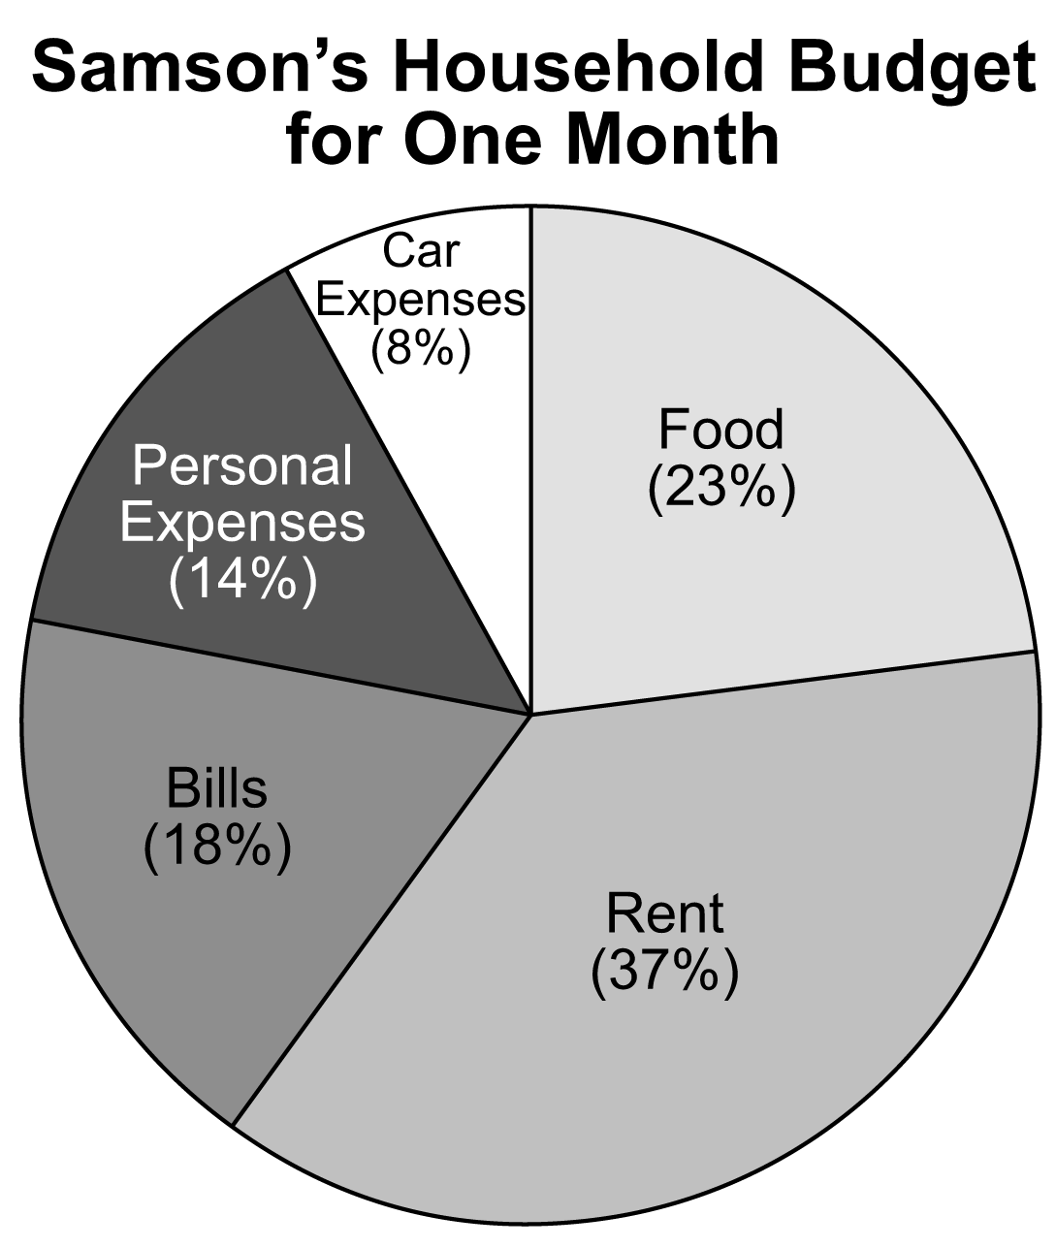

a) Samson takes home $2500 per month. How much does he budget for each item?

b) Samson gets a raise of $500 per month. How will this affect his food budget?
2. This circle graph shows how much time is spent in one day watching different types
of TV programs.

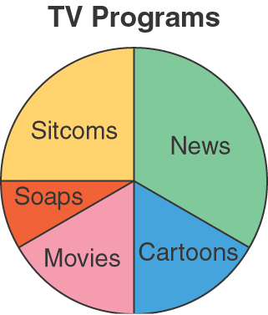

a) Which type of program is watched for the greatest amount of time?
b) Which two types of programs are watched for approximately the same amount of time?
c) Estimate the fraction of time spent watching sitcoms.
d) Suppose TV is watched for 1000 days.
Estimate how much time is spent watching sitcoms.

Extra Practice 6 – Master 4.29
Lesson 4.6
2. a) Food: $575; Rent: $925; Bills: $450;
Personal Expenses: $350; Car Expenses: $200
b) His food budget would increase by $115 to $690
per month.
2. a) News b) Movies and Cartoons
c) About d) About 250 days

