Extra Practice 6
Master 8.29
Lesson 8.6: Graphing Translations and Reflections
1. Trapezoid ABCD has vertices A(–1, –1), B(1, –1), C(1, 3), and D(–1, 1).
After a translation, the image of ABCD is A’(4, –3), B’(6, –3), C’(6, 1), D’(4, –1).
a) Draw ABCD and A’B’C’D’ on a grid.
b) Describe the translation.
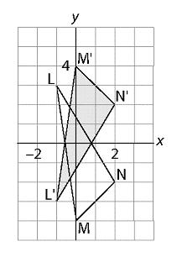
2. Identify each transformation.
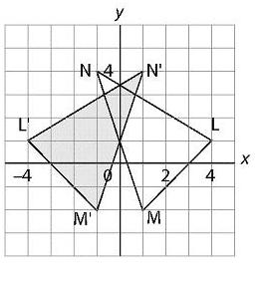
a) b)

3. Plot these points on a coordinate grid: A(1, 6), B(2, 4), C(4, 4), O(0, 0)
a) Draw the image of quadrilateral ABCO after a translation 2 units left
and 3 units up.
b) Draw its image after a reflection in the x-axis.
c) Draw its image after a reflection in the y-axis.
d) Draw its image after a reflection in the line through (0, 0) and (10, 10).
4. Plot these points on a coordinate grid: A(2, 1), B(–1, 2), C(1, 5).
a) Translate each point 3 units left and 4 units down to get
image points A’, B’, C’.
b) Write the coordinates of each point and its translation image.
What pattern do you see in the coordinates?
5. Plot the points in question 4.
a) Reflect each point in the x-axis to get image points A’, B’, C’.
b) Write the coordinates of each point and its reflection image.
What pattern do you see in the coordinates?
6. Plot the points in question 4.
a) Reflect each point in the y-axis to get image points A’, B’, C’.
b) Write the coordinates of each point and its reflection image.
What pattern do you see in the coordinates?
7. Plot the points in question 4.
a) Reflect each point in the line through (–10, –10) and (10, 10)
to get image points A’, B’, C’.
b) Write the coordinates of each point and its reflection image.
What pattern do you see in the coordinates?

Extra Practice 6 – Master 8.29
Lesson 8.6
1. a)
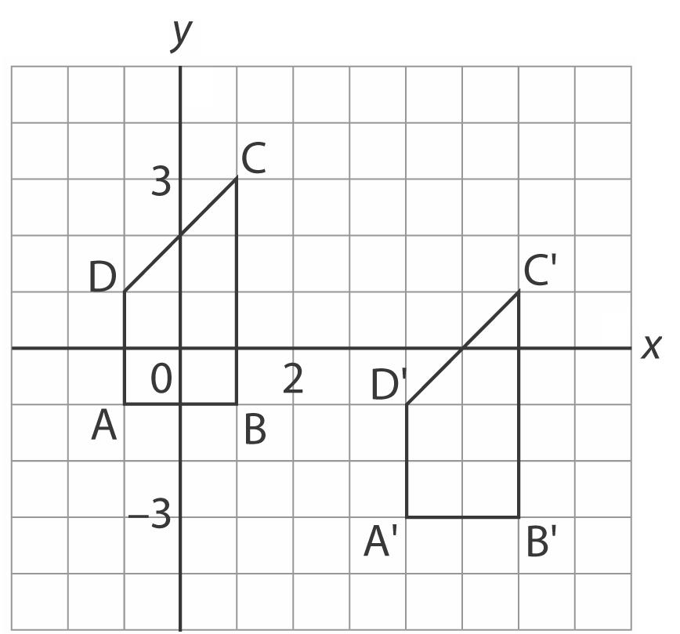
b) Translation 5 units right and 2 units down
2. a) Reflection in the y-axis
b) Reflection in the x-axis

3. a), b)
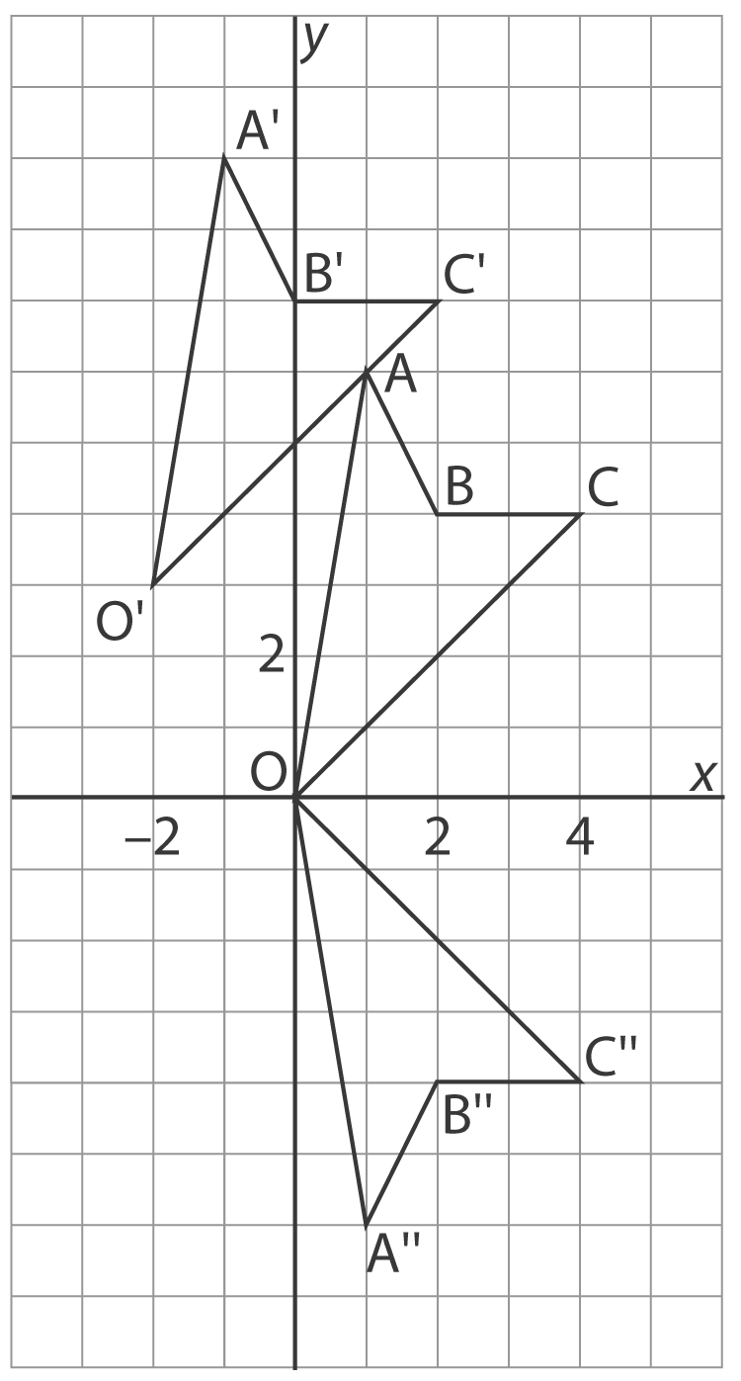
c), d)
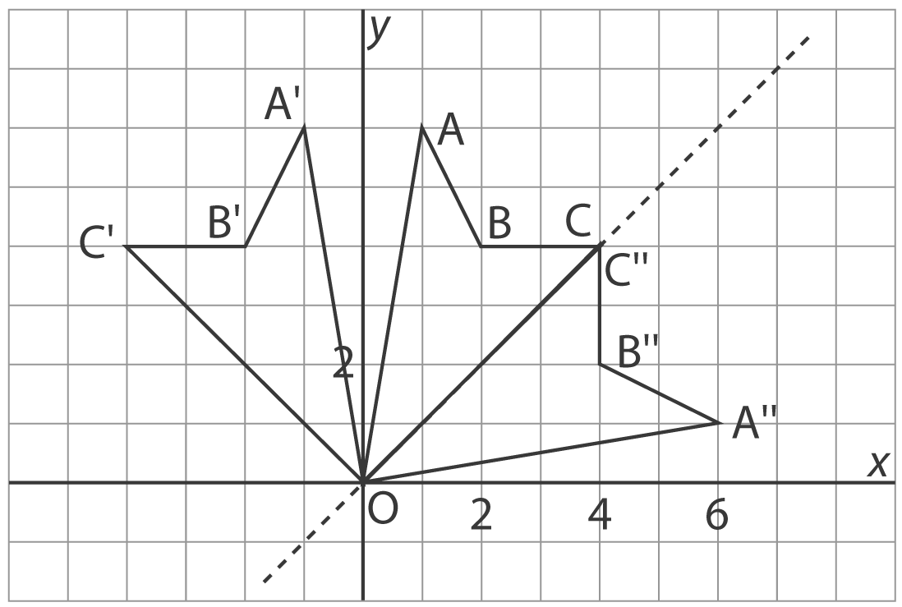
4. a)
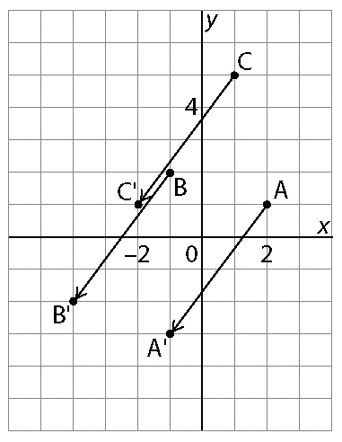
b) A(2, 1) →A’(–1, –3)
B(–1, 2) →B’(–4, –2)
C(1, 5) →C’(–2, 1)
The x-coordinates decrease by 3, the y-coordinates decrease by 4.
5. a)
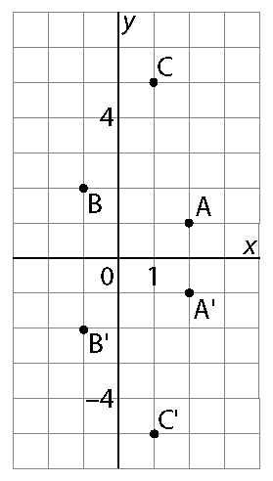
b) A(2, 1) →A’(2, –1)
B(–1, 2) →B’(–1, –2)
C(1, 5) →C’(1, –5)
The x-coordinates are unchanged; the sign of the y-coordinates changes.
6. a)
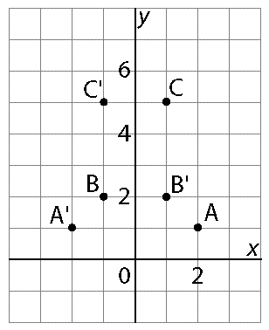
b) A(2, 1) →A’(–2, 1)
B(–1, 2) →B’(1, 2)
C(1, 5) →C’(–1, 5)
The sign of the x-coordinates changes; the y-coordinates are unchanged.
7. a)
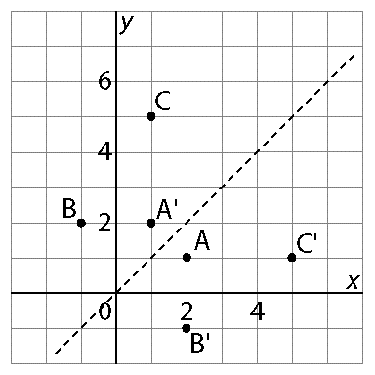
b) A(2, 1) →A’(1, 2)
B(–1, 2) →B’(2, –1)
C(1, 5) →C’(5, 1)
The x- and y-coordinates are interchanged.

