Extra Practice 6
Lesson 7.6: Tree Diagrams
Master 7.24
1. A popular game at the winter carnival is a spinner game called Tropical Orange. To play the game, a player spins the pointer on each of the spinners. To win, a player must get red on one spinner and yellow on the other spinner, because red and yellow make orange. Your teacher will give you blank spinners. Use an open paper clip as a pointer.
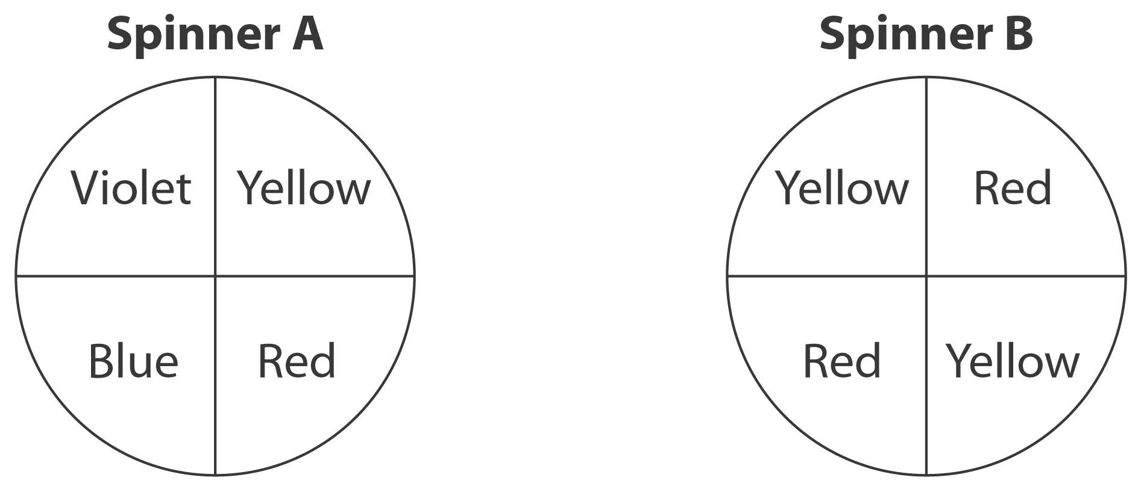

a) Make these spinners. Play the game 20 times. Record your results.
How many times did you make orange?
b) Combine your results with those of 9 other classmates.
How many times was orange made in 200 trials?
c) Use a tree diagram to list the possible outcomes for making orange.
d) What is the theoretical probability of making orange?
e) How do the probabilities in parts b and d compare?

2. A regular tetrahedron has four faces labelled 1 to 4. A die is labelled 1 to 6.
An experiment is: roll the tetrahedron and record the number on its face down, roll the die and record the number on its face up.
a) Draw a tree diagram to determine the possible outcomes.
b) Find the probability of each event.
i) rolling two even numbers ii) rolling two numbers whose sum is 6
iii) rolling a 4 iv) rolling two numbers whose difference is 0 or 1

3. Here is a spinner game called Sum Up. To play the game, a player spins the pointer on each spinner and then finds the sum of the two numbers.
Your teacher will give you blank spinners. Use an open paper clip as a pointer.
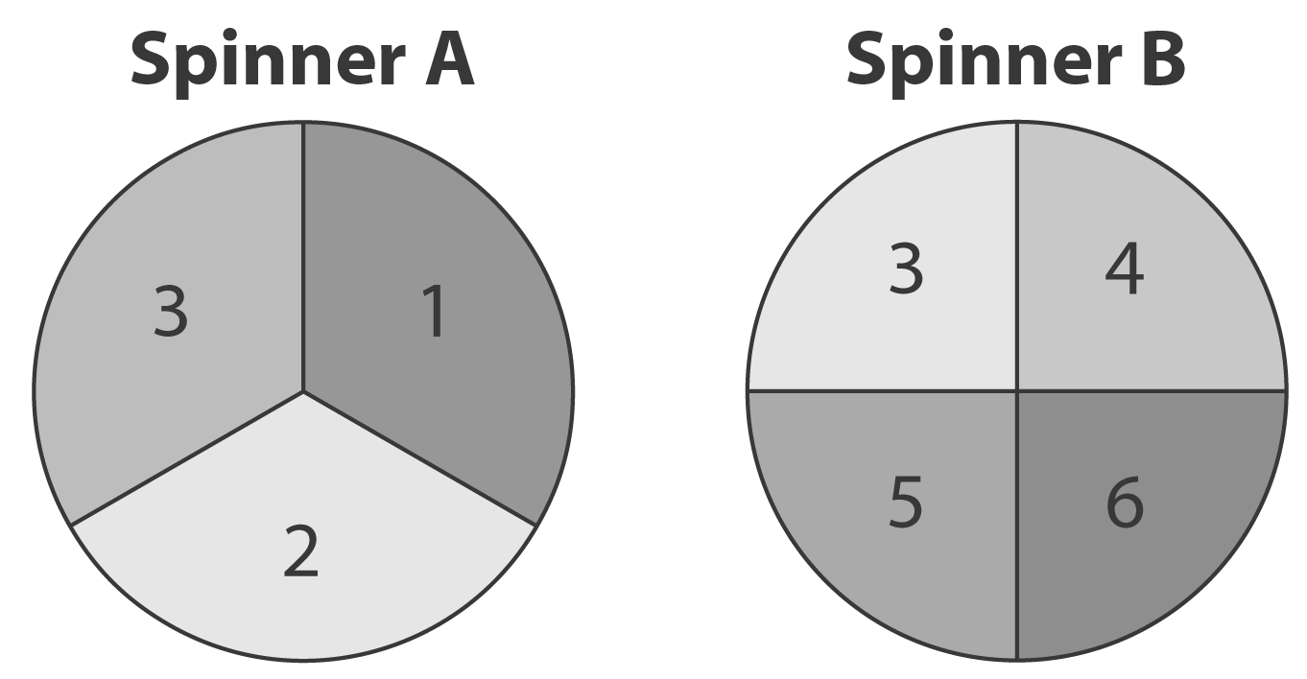
a) List the possible sums.
b) Play the game 20 times. Record the results.
c) Combine your results with those of 4 classmates.
What is the experimental probability of getting
each sum?
i) 9 ii) 6 or 8 iii) 5
d) Draw a tree diagram to list the possible outcomes.
e) What is the theoretical probability of getting each sum in part d?
f) Compare the theoretical and experimental probabilities of the events in
part d. What do you think might happen if you carried out this experiment 1000 times?

Extra Practice 6 – Master 7.24
1. a) Answers may vary. I made orange 6 times in 20 trials.
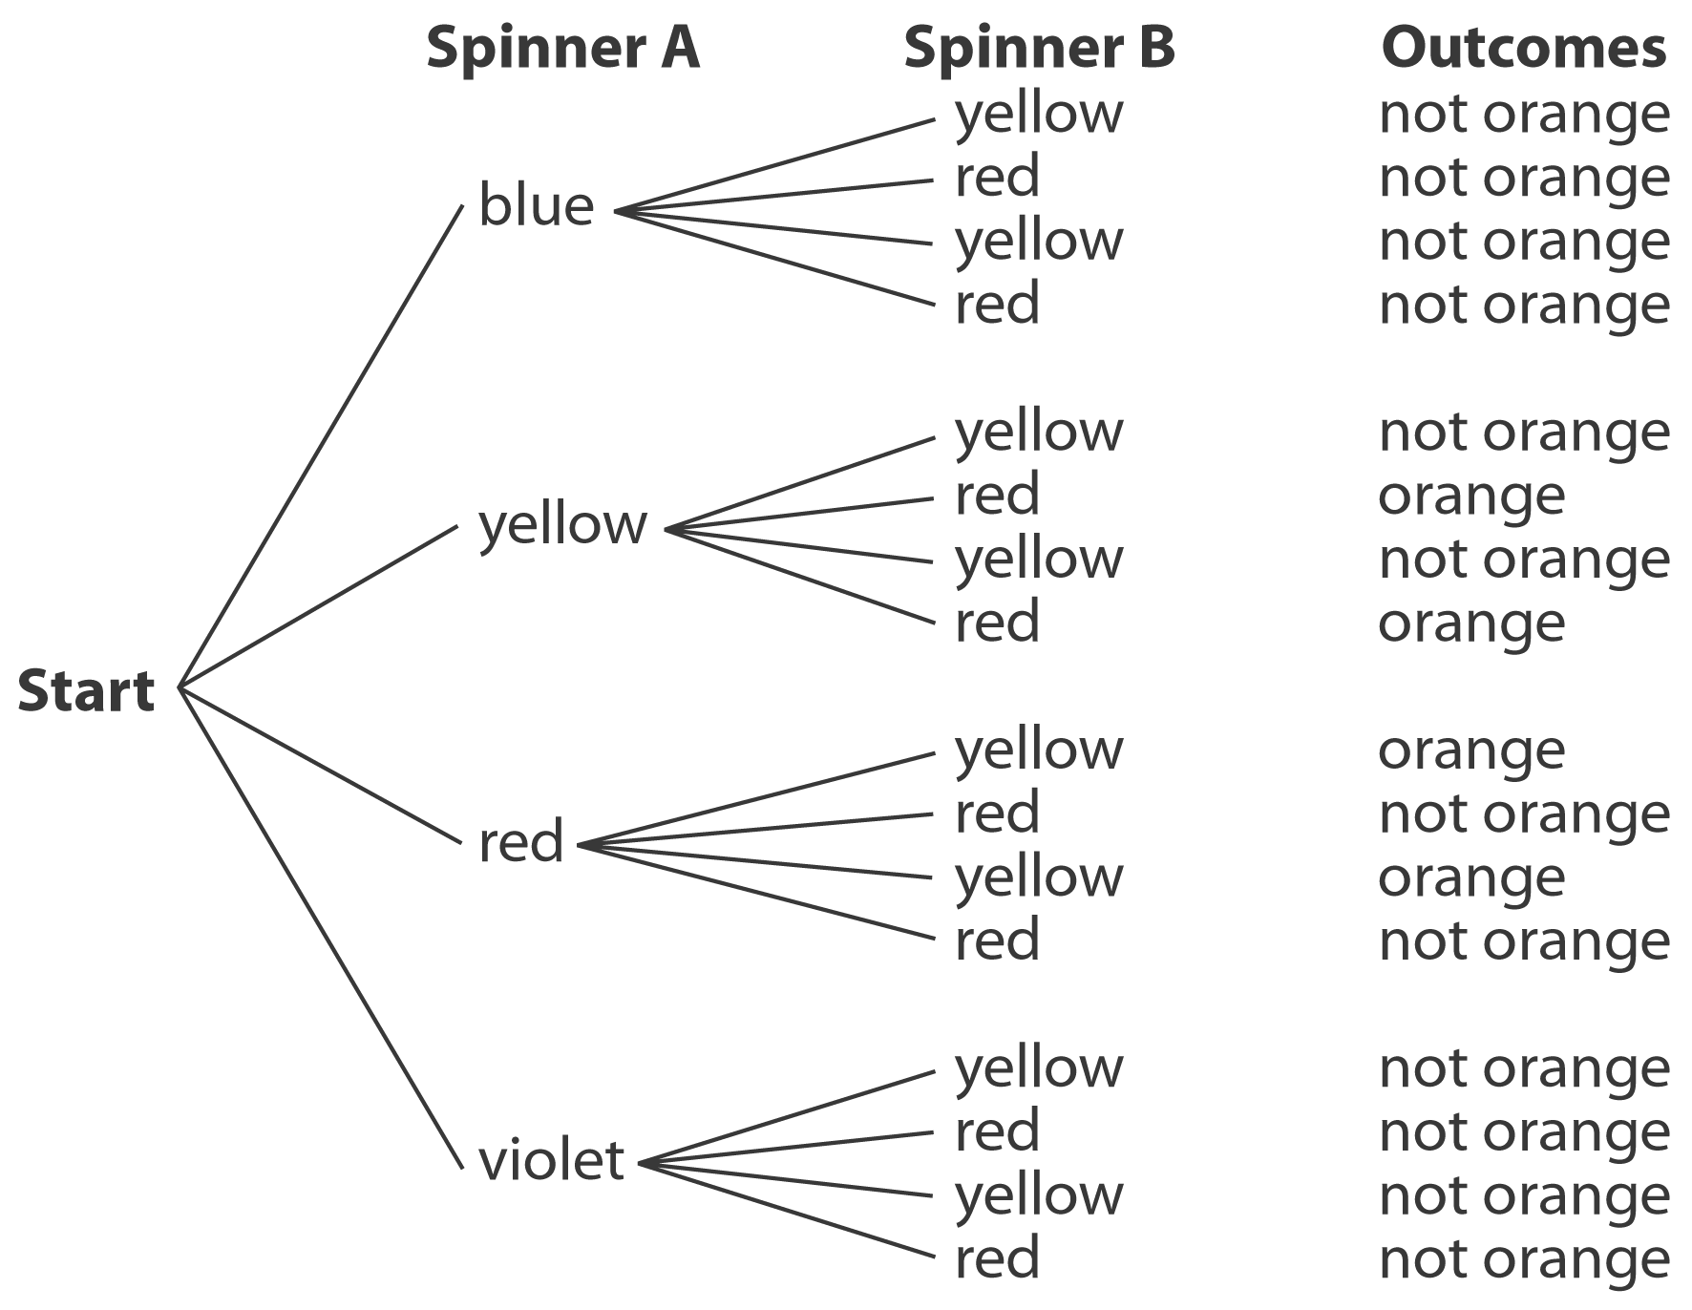
b) Answers may vary. Sample answer: In 200 trials, orange was made 47 times. The experimental probability of making orange is , or about 24%.
c)

d) There are 16 possible outcomes. There are 4 outcomes that make orange.
The probability of making orange is or 25%.
e) Answers may vary. The experimental probability of making orange is about 24% and the theoretical probability is 25%. They are very close in value.
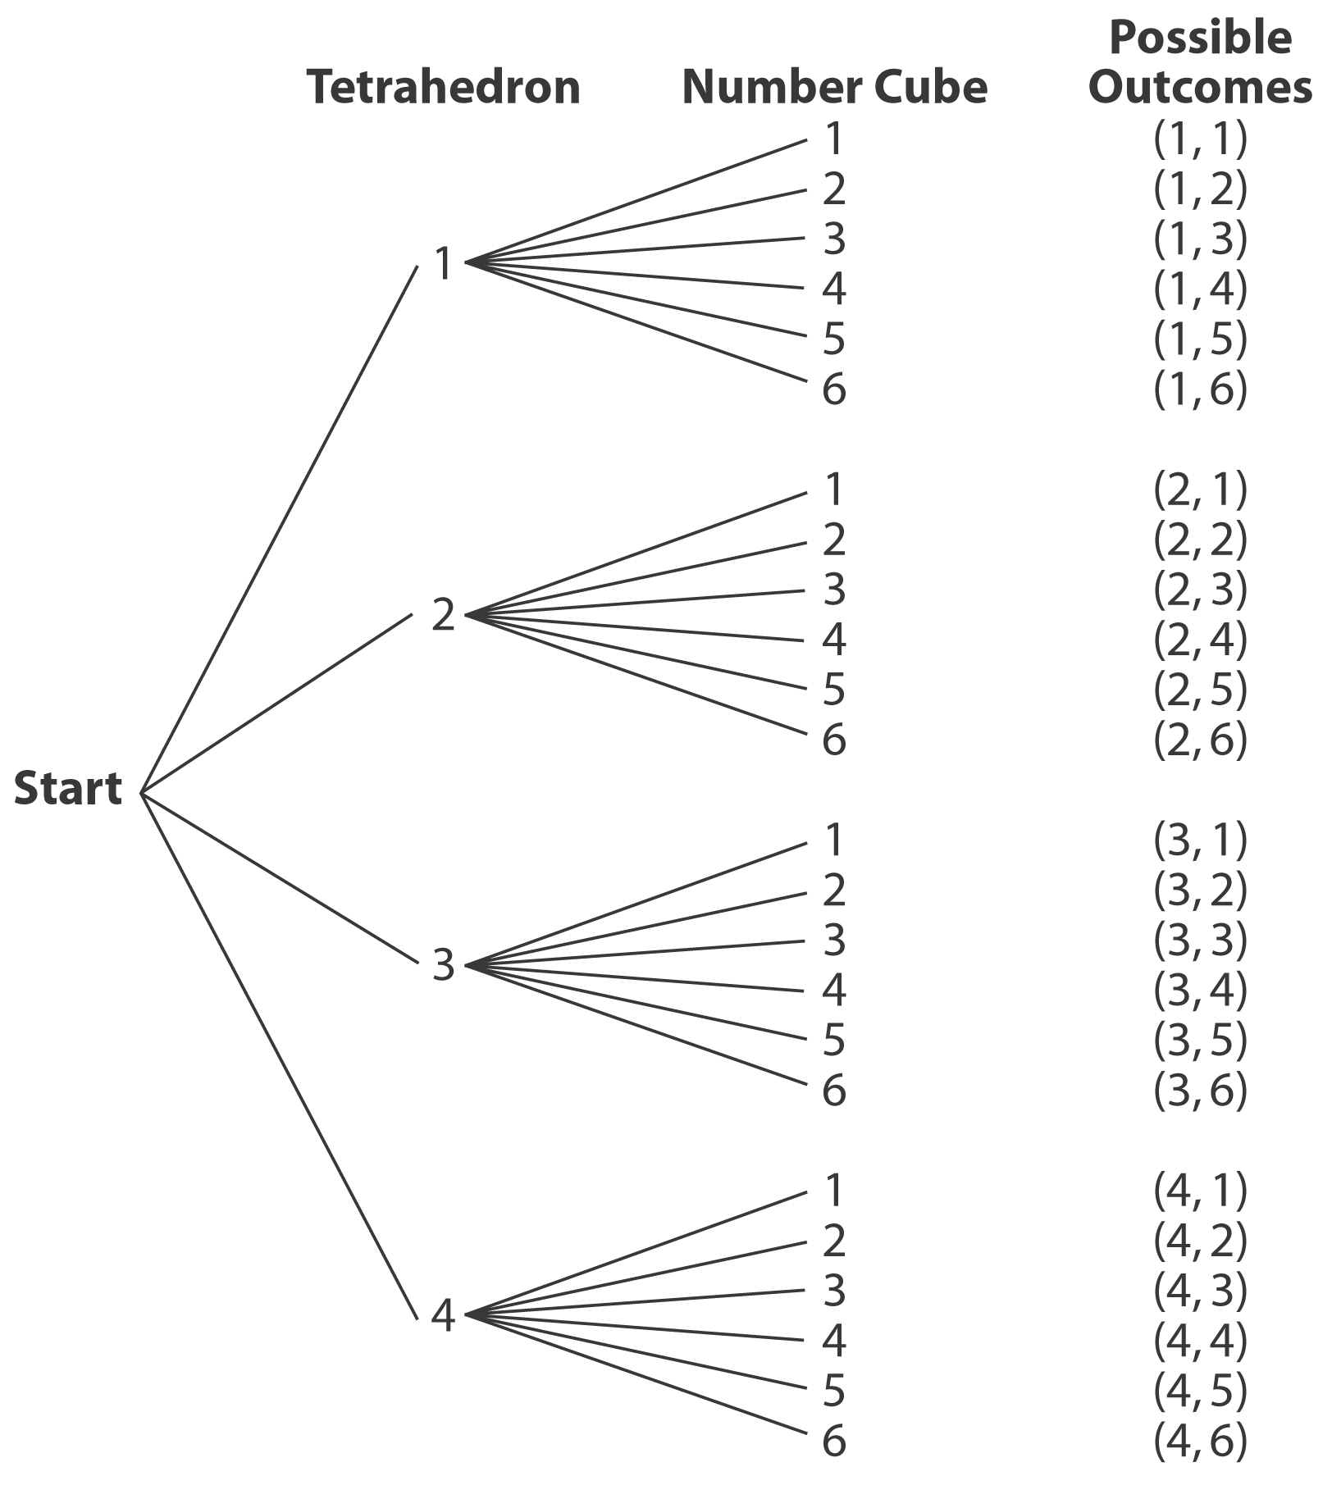
2. a)

b) There are 24 possible outcomes.
i) There are 6 outcomes with two even numbers:
(2, 2), (2, 4), (2, 6), (4, 2), (4, 4), and (4, 6).
The probability of rolling two even numbers is or 25%.
ii) There are 4 outcomes with numbers whose sum is 6: (1, 5), (2, 4), (3, 3), and (4, 2).
The probability of rolling two numbers whose sum is 2 is or about 17%.
iii) There are 9 outcomes with a 4: (1, 4), (2, 4),
(3, 4), (4, 1), (4, 2), (4, 3), (4, 4), (4, 5), and
(4, 6). The probability of rolling a 4 is or about 38%.
iv) There are 11 outcomes with numbers whose difference is 0 or 1: (1, 1), (1, 2), (2, 1), (2, 2),
(2, 3), ( 3, 2), (3, 3), (3, 4), (4, 3), (4, 4), and (4, 5).
The probability of rolling numbers whose difference is 0 or 1 is or about 46%.
3. a) The possible sums are: 4, 5, 6, 7, 8, 9
b) Answers may vary.
Sum | 4 | 5 | 6 | 7 | 8 | 9
Frequency | 2 | 2 | 5 | 7 | 4 | 0
c) Answers may vary.
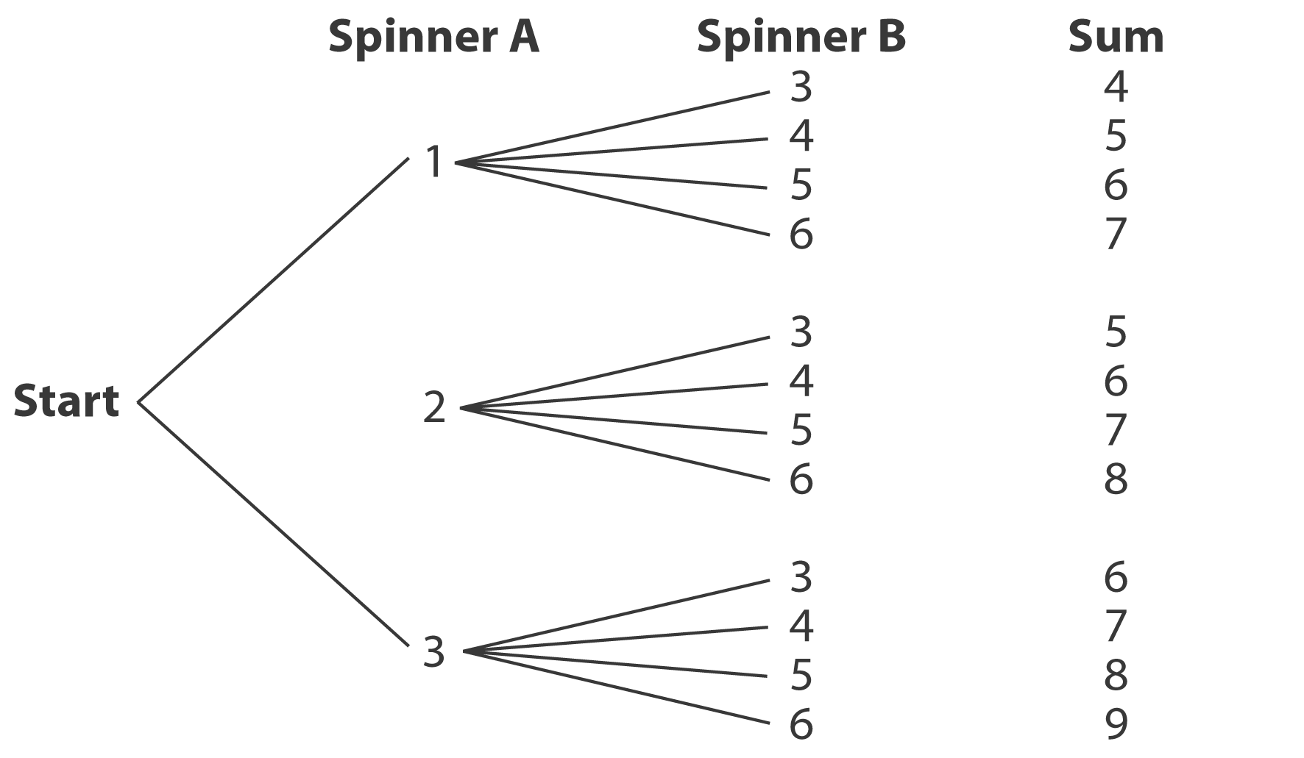
d)

e) There are 12 possible outcomes.
i) There is one outcome with sum 9: or about 8%.
ii) There are 5 outcomes with a sum of 6 or 8: or about 42%.
iii) There are 2 outcomes with sum 5: or about 17%.
f) Answers may vary. The values of the experimental probabilities are close to those of the theoretical probabilities. The theoretical and experimental probabilities will become closer in value if the experiment is repeated 1000 times.

