Extra Practice 7
Master 8.30
Lesson 8.7: Graphing Rotations
1. a) Which clockwise rotation is the same as a 90° counterclockwise rotation?
b) Which clockwise rotation is the same as a 270° counterclockwise rotation?
c) Which clockwise rotation is the same as a 60° counterclockwise rotation?
d) Why do we do not need to include “clockwise” and “counterclockwise” when
describing a 180° rotation?

2. In each diagram, ΔF’G’H’ is the image of ΔFGH after a rotation about the origin.
Identify each rotation.
a) b) c)
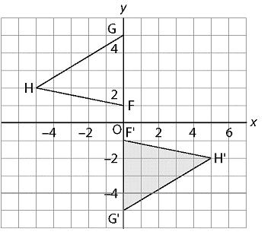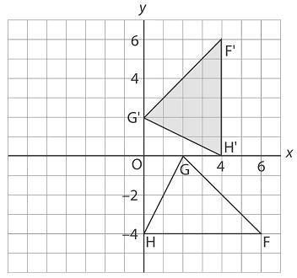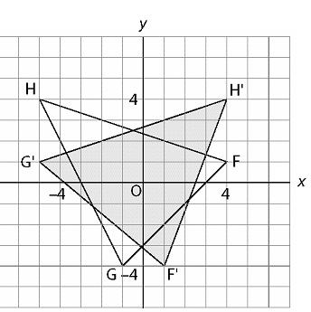

3. Plot these points on a coordinate grid: A(2, 1), B(–1, 2), C(1, 5)
a) Rotate each point +90° about the origin to get image points A’, B’, C’.
b) Write the coordinates of each point and its rotation image.
What patterns do you see in the coordinates?

4. Plot the points in question 3.
a) Rotate each point +180° about the origin to get image points A’, B’, C’.
b) Write the coordinates of each point and its rotation image.
What patterns do you see in the coordinates?
5. Plot the points in question 3.
a) Rotate each point +270° about the origin to get image points A’, B’, C’.
b) Write the coordinates of each point and its rotation image.
What patterns do you see in the coordinates?

6. Plot the points M(–2, 4), N(–5, 0), P(–4, –2), and Q(–1, –1) on a coordinate grid. Join the points to form quadrilateral MNPQ.
a) Reflect the quadrilateral in the x-axis. Then reflect the image in the y-axis.
b) Which rotation is equivalent to a reflection in the x-axis followed by a reflection in the y-axis?

Extra Practice 7 – Master 8.30
Lesson 8.7
1. a) 270° b) 90° c) 300°
d) Rotations are equivalent.
2. a) 180° about the origin b) 90° about the origin c) –90° about the origin
3. a)
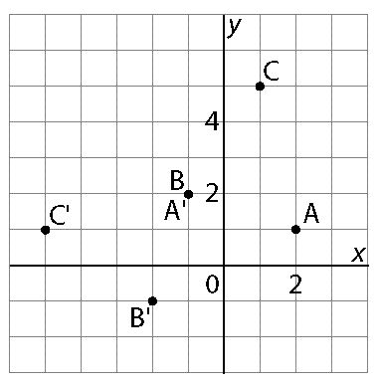
b) A(2, 1) →A’(–1, 2)
B(–1, 2) →B’(–2, –1)
C(1, 5) →C’(–5, 1)
The x- and y-coordinates are interchanged.
Then the x-coordinates change sign.

4. a)
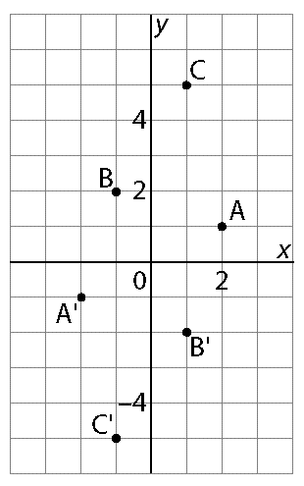
b) A(2, 1) →A’(–2, –1)
B(–1, 2) →B’(1, –2)
C(1, 5) →C’(–1, –5)
The x- and y-coordinates change signs.

5. a)
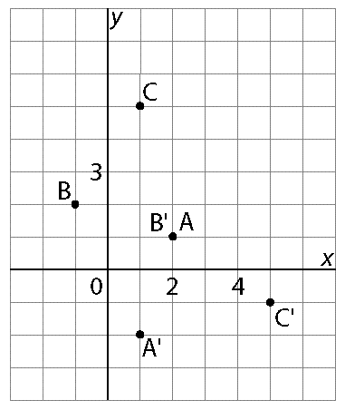
b) A(2, 1) →A’(1, –2)
B(–1, 2) →B’(2, –1)
C(1, 5) →C’(5, –1)
The original coordinates are interchanged.
Then the y-coordinates change signs.
6. a)
Point | After a reflection  in the x-axis | 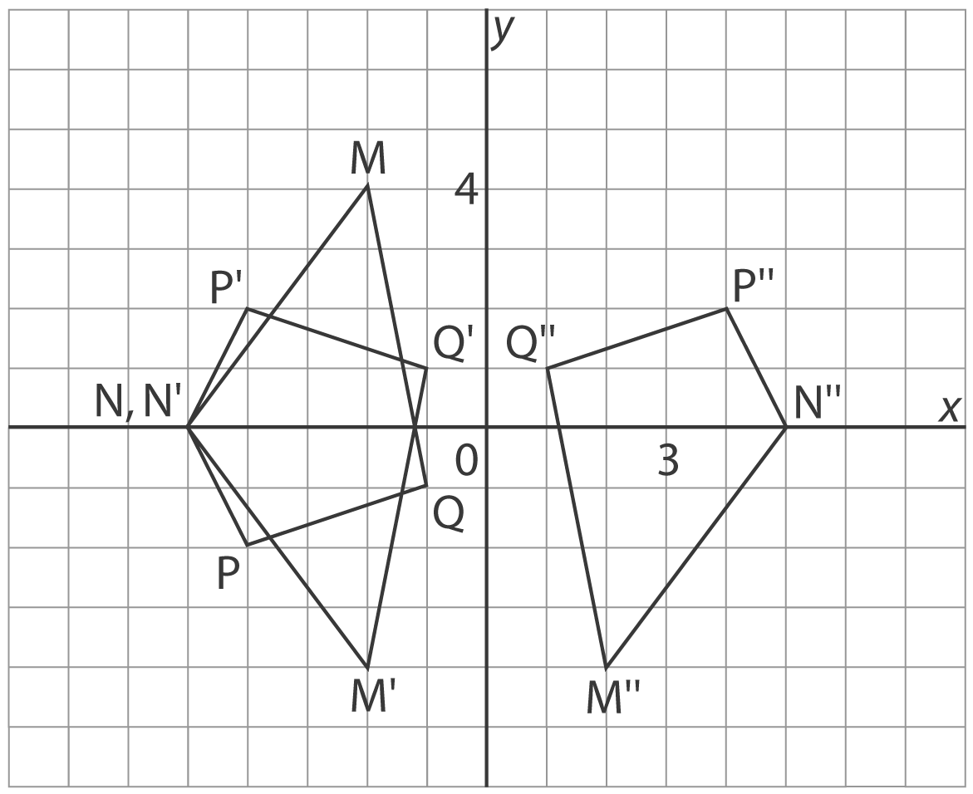  After a reflection  in the y-axis
M(−2, 4) | M′(−2, −4) | M′′(2, –4)
N(−5, 0) | N′(−5, 0) | N′′(5, 0)
P(−4, −2) | P′(−4, 2) | P′′(4, 2)
Q(−1, −1) | Q′(−1, 1) | Q′′(1, 1)

b) Rotation of 180°

