Each type of graph has its strengths and limitations.

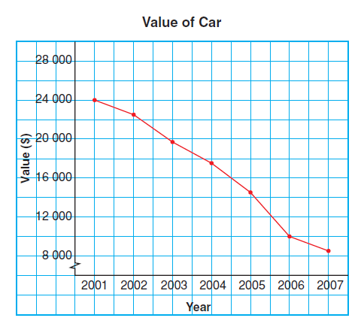
Line Graph – displays data that change over time. Line segments join data points on a line graph.

A line graph is:
- easy to read and draw
- can have a zigzag symbol on the vertical axis
when the data starts at a large number
- is best used to show data gathered over time
- can be used to estimate values between data
points and beyond data points

Double Bar Graph – displays two sets of data that can
be counted. The lengths of the bars are used to compare
and count the data.
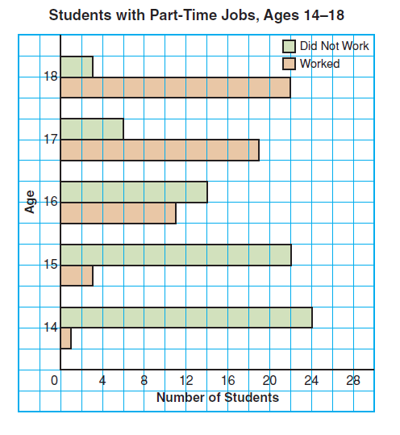
A double bar graph:
- is easy to read and draw
- can be used to directly compare two sets of data
- can only be used to show discrete data
- may be difficult to read depending on the scale used
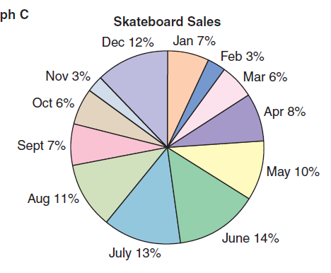

Circle Graphs – displays a set of data relating to a whole.
The size of the sectors help compare the data.

A circle graph is:
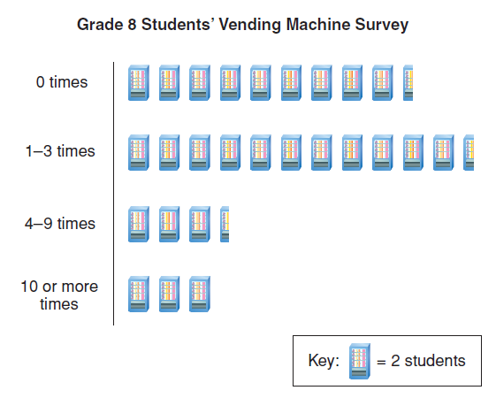
- sometimes difficult to draw and collect data from
- can only be used to display the data relating to a whole

Pictograph – displays data using pictures and displays
a key to read the information.
A pictograph:
- is visually appealing but difficult to draw
- sometimes difficult to read

Try This:

1. Use these graphs to answer the following:
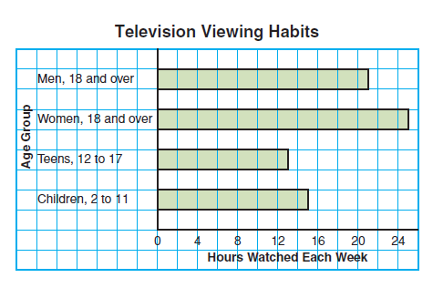
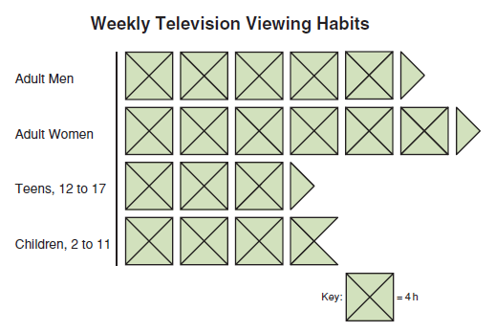

a) List three things you know from the bar graph.

- Women over 18 watch more tv than men over 18 by 4 hours
- Teens (aged 12 to 17) watch the least amount of tv a week
- Children (aged 2 to 11) watch 15 hours of tv a week.

b) List three things you know from the pictograph.

-Women watch the most tv
- Women watch more tv than men
- Teens watch the least amount of tv

c) What graph is more appropriate to display the data? Explain or justify your choice.

The bar graph is easier. It is easier to determine the number of hours of tv that each group watches.

