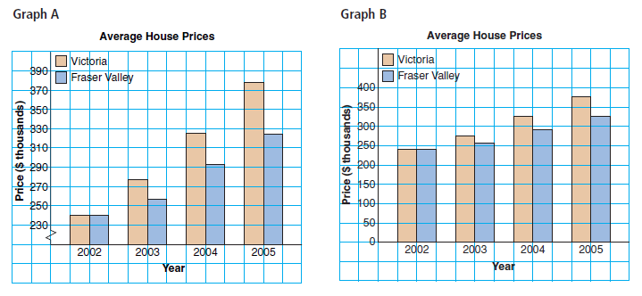
These two graphs show the same data, but they look very different and we may come to different conclusions about the data represented.

We learned that there are many ways to represent data. There are also many ways to misrepresent data in the different formats of graphs.

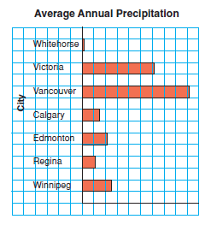
Look at these three bar graphs:
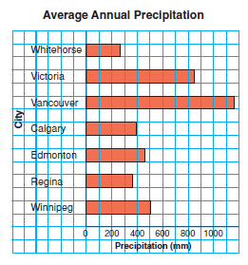
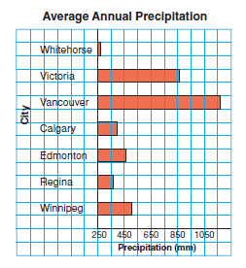
The graph on the left is misleading because it does not have any measurements on it.

The middle graph shows the same information, but the horizontal scale is labeled with the amount of precipitation, and the scale does not start at 0.

The graph on the right accurately shows the data. The horizontal scale starts at 0. The lengths of the bars are shown in the correct ratio. Vancouver has between 4 and 5 times more precipitation as Whitehorse.

Try These

Here are some graphs. What are some other ways that data can be misrepresented?

1. How is the data misrepresented?
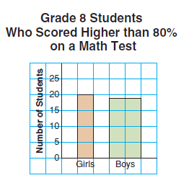

The wider bar creates the impression that many more boys than girls scored higher than 80%.

Make sure bars on the graph are the same width!

2. How is the data misrepresented?
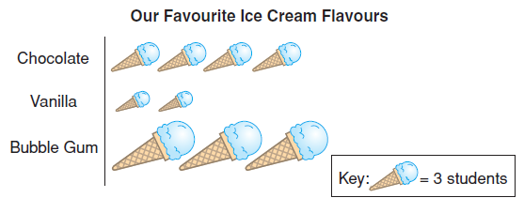
The symbols for the different flavors are different sizes. We get the impression that Bubble Gum is the favourite flavor.

Make sure pictograph symbols are the same!

3. Which graph best represents the data? Explain.
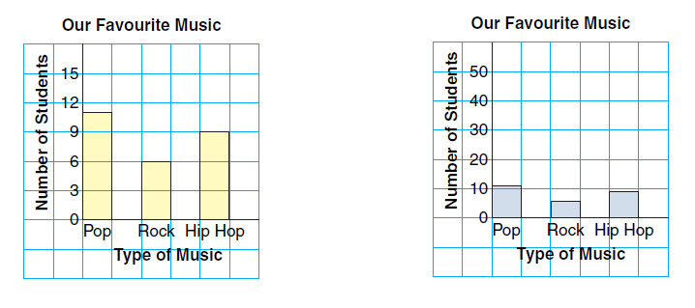
The first graph does!

The scale of the second graph is difficult to read and we cannot get accurate amounts for the number of students who like each type of music.

Use a scale that is easy to read!

4. How is the data misrepresented?
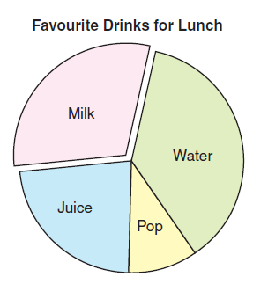
The sector for milk is not as large as the sector for water, but it is treated differently than the rest of the graph. We may assume that milk is the favorite.

Do not give any part of a graph special treatment!

