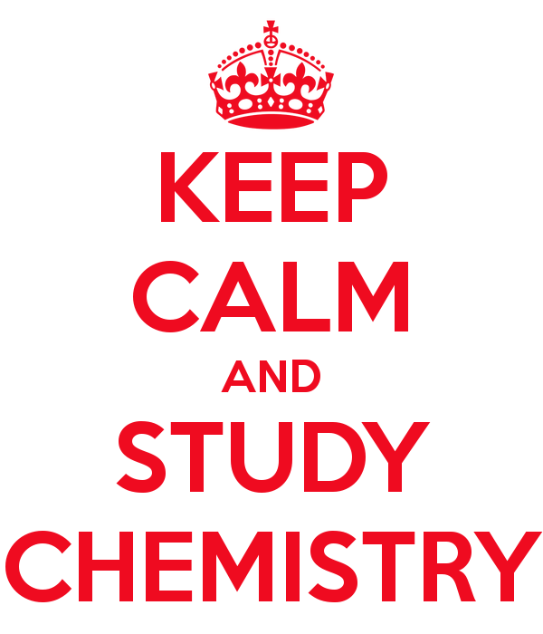
Chemistry Unit Review

Topic 1 – Exploring Matter

- How do attractive forces differ from solids to liquids to gases?
____________________________________________________________________________________________________________________________________________________________
______________________________________________________________________________

- List the difference between an element and a compound.
Element
Compound

- List the differences between the 4 types of mixtures. Include an example of each.

- What is one way to tell the difference between a solution and a colloid?
____________________________________________________________________________________________________________________________________________________________

Topic 2 – Changes in Matter

- What is the difference between a physical property and a chemical property?
____________________________________________________________________________________________________________________________________________________________

- Melting point, boiling point, hardness and density are all ways used to describe a substance. Explain what each of the following words mean.
Malleability
Ductility
Solubility
Density

- What is the difference between a qualitative and a quantitative property>
____________________________________________________________________________________________________________________________________________________________

- Understand the following diagram. These are all examples of ________________ changes (physical or chemical)?
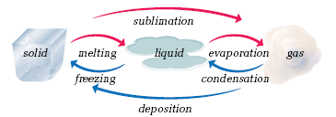
- List at least four examples of evidence that a chemical change has occurred.
____________________________________________________________________________________________________________________________________________________________

Topic 3 – What are Elements?

- Who were alchemists and how did they contribute to the science of Chemistry?
____________________________________________________________________________________________________________________________________________________________
- Who is Ernest Rutherford and what was his contribution to Chemistry?
____________________________________________________________________________________________________________________________________________________________

- Who was Niels Bohr and what was his contribution to Chemistry?
____________________________________________________________________________________________________________________________________________________________
- How did Anton Lavoisier contribute to the science of Chemistry? What nickname was he given?
____________________________________________________________________________________________________________________________________________________________

- Explain the Law of Conservation of Mass.
____________________________________________________________________________________________________________________________________________________________

- Explain the Law of Definite Composition. How does this explain why we balance by using coefficients (the large numbers in front) instead of adding in subscripts?
____________________________________________________________________________________________________________________________________________________________

- List the four parts of John Dalton’s Atomic Theory.
____________________________________________________________________________________________________________________________________________________________
____________________________________________________________________________________________________________________________________________________________

- Fill in the following chart about laws, theories, models and observations.
Law
Theory
Model
Observation

- Describe the difference between the atomic model that we use to learn about electron arrangement and the atomic model that is accepted today.
____________________________________________________________________________________________________________________________________________________________
______________________________________________________________________________

Topic 4 – Classifying Elements

- Fill in the following chart with details about metals, non-metals and metalloids. Include their location on the periodic table.
Metals
Non-metals
Metalloids

- List the four Chemical Families that we have talked about, give their location on the periodic table, and list some information about each.

Topic 5 – The Periodic Table

- Who is the Russian Chemist who developed the Periodic Table of Elements?
______________________________________________________________________________

- Are vertical columns called groups or periods? ________________________________________

- Are horizontal rows called groups or periods? _________________________________________

- On the Periodic table, how can you determine the number of protons?
______________________________________________________________________________

- On the Periodic table, how can you determine the number of neutrons?
______________________________________________________________________________

- On the Periodic table, how can you determine the number of electrons?
______________________________________________________________________________

- Rationalize why there are an equal number of protons and electrons in the atom.
______________________________________________________________________________
______________________________________________________________________________

- Where are protons and neutrons found in the atom? ___________________________________

Topic 6 – Chemical Compounds

- What are the two main differences between ionic and molecular compounds? (what they do with electrons, what they are made up of)
Ionic
Molecular

- Create a table/flowchart/concept map on this page that will help you write the chemical formulas and name both ionic and molecular compounds?

- Fill in the following chart with properties of ionic and molecular compounds.
Ionic
Molecular

- What is the 7+1 rule and why is it so important to know?
______________________________________________________________________________
______________________________________________________________________________
Topic 7 – Chemical Reactions

- What is the difference between a reactant and a product?
______________________________________________________________________________
______________________________________________________________________________

- What are four indications that a chemical reaction has occurred?
______________________________________________________________________________
______________________________________________________________________________
______________________________________________________________________________
______________________________________________________________________________

- What is the difference between a word equation and a chemical equation?
______________________________________________________________________________
______________________________________________________________________________

- Is energy absorbed or released when bonds are broken? ________________________________

- Is energy absorbed or released when bonds are formed? ________________________________

- What is the difference between endothermic and exothermic reactions?
______________________________________________________________________________
______________________________________________________________________________

- 6CO₂ + 6H₂O C₆H₁₂O₆ + 6O₂ is the chemical equation for what daily process? ______________

Topic 8 – Reaction Rates

- Explain the four ways to speed up reaction rates. Include why each way works.

- What are catalysts in your body called? ______________________________________________

- What are inhibitors and what do they do? Give an example of when inhibitors are used in life.
______________________________________________________________________________
______________________________________________________________________________

- What is corrosion?
______________________________________________________________________________
______________________________________________________________________________

- How can corrosion be prevented? What electrochemical process is involved?
______________________________________________________________________________
______________________________________________________________________________

- What is combustion?
______________________________________________________________________________
______________________________________________________________________________

- What are the products of combustion? ______________________________________________

Complete the chart by writing the correct formulas for the following compounds.

Name of Compound | Positive ion | Negative ion | Formula
- Sodium iodide | Na⁺ | I⁻ | NaI
- Silver sulfide | Ag⁺ | S²⁻ | Ag₂S
- Barium sulfate
- Lithium sulfide
- Sodium hydroxide
- Ammonium chlorate |  | ClO₃⁻
- Zinc sulfate | Zn²⁺
- Iron(III) phosphate | Fe³⁺
- Nickel (II) hydroxide | Ni²⁺
- Chromium (III) oxide | Cr³⁺
- Iron (III) sulfate
- Copper (II) nitrate
- copper (II) carbonate
- magnesium phosphide
- aluminum nitrate
- sodium phosphate
- aluminum sulfate
- aluminum sufide
- iron (III) sulfite
- ammonium carbonate

Naming Covalent Compounds Worksheet
Write the formulas for the following covalent compounds:

1) antimony tribromide __________________________________

2) hexaboron silicide __________________________________

3) chlorine dioxide __________________________________

4) hydrogen iodide __________________________________

5) iodine pentafluoride __________________________________

Write the names for the following covalent compounds:

6) P₄S₅ __________________________________

7) O₂ __________________________________

8) SeF₆ __________________________________

9) Si₂Br₆ __________________________________

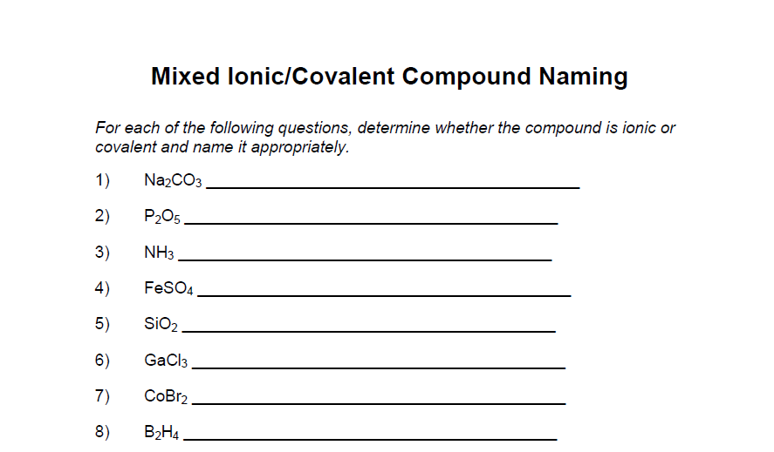
10) SCl₄ __________________________________

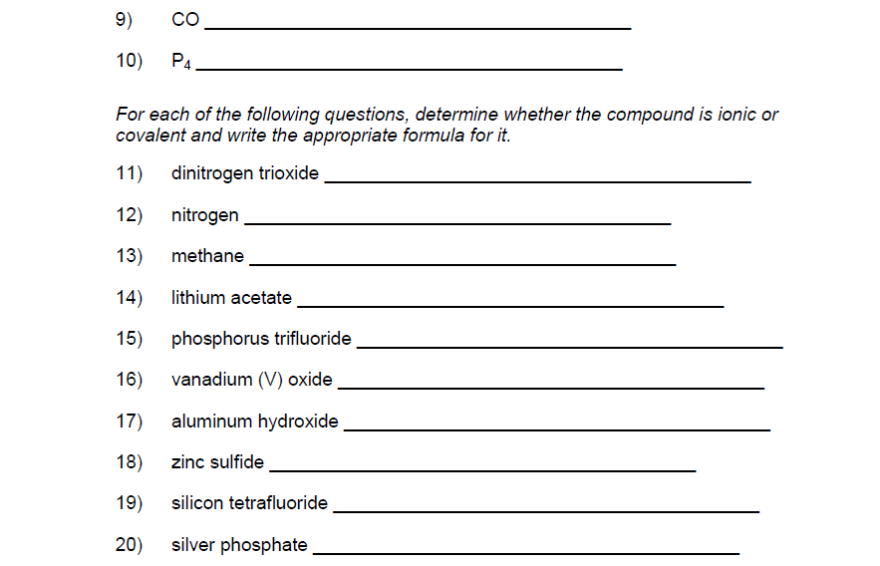

Other studying ideas:
  - Make flashcards of different vocabulary or concepts
  - Make concept maps like the ones given out at the beginning of the unit (but expand with details)
  - Create flowcharts for anything that can be seen as a process (how to name/write formulas for ionic and molecular bonds)
  - Create tables to visually sort out differences between things like bonding, metals/nonmetals/metalloids etc.

Even if you don’t find that you would study from these things for the PAT, making them is an active way to get the information into your head.

