G7 Practice Final Exam

For all questions, choose the BEST answer. For the TRUE/FALSE questions; enter “A” on the scantron sheet for TRUE or “B” for FALSE.

- True or False: One adaptation of a plant could be the way its seeds travel in order to assure reproduction in another area
- True or False: Forest fires always have a negative effect on the environment
- True or False: An ecologist studies only the biotic parts of an ecosystem
- True or False: The loss of a single species is not important in a habitat since habitats are so large.
- True or False: Primary succession is the gradual changes in the types of organisms in an area that already had a number of organisms living in it
- True or False: Biological control is a way of reducing the population an unwanted organism by increasing the population of a natural enemy of that organism
- True or False: An indicator species helps scientists determine the overall health of an ecosystem
- True or False: A permanent plot is used to measure the size of an ecosystem
- True or False: Quadrat sampling is a tool biologists use to help with monitoring ecosystems.

For questions 10 - 12 match the BEST term from this list with its description.

a) producers | b) omnivores | c) consumers | d) carnivores | e) herbivores

10. eat both plants and animals
11. make their own food
12. eat other organisms

For questions 13 - 16 indicate the process that is occurring at each of the places indicated on the water cycle.
a) condensation | b) transpiration | c) precipitation | d) run-off | e) evaporation
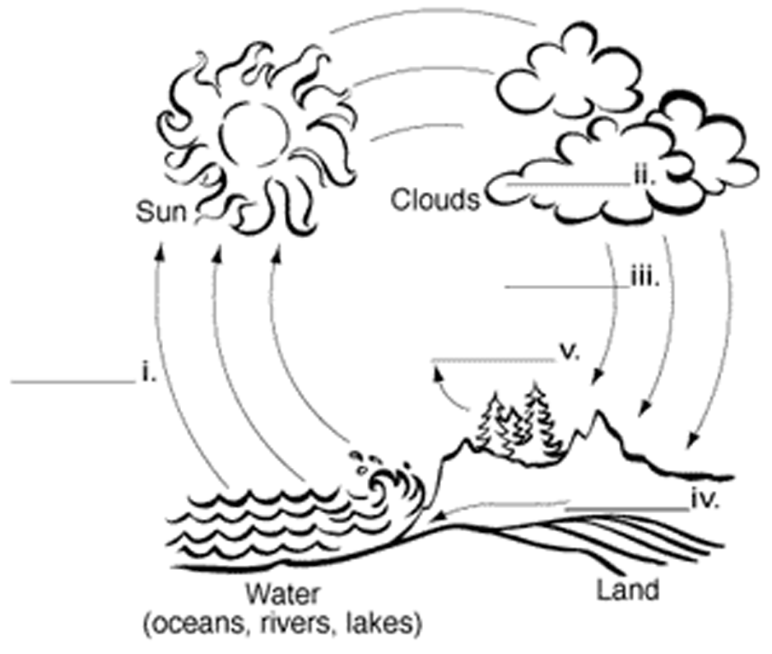
# 13
# 15
# 14
# 16

17. What does an ecologist study?
A) The relationships among organisms of the same species.
B) The relationships among organisms of different species.
C) The relationship between organisms and their habitat.
D) All of the above
E) A and B only

18. Tapeworms live in the intestines of humans. The tapeworms absorb nutrients from the foods humans eat. Based on this information, which of the following statements is true?
A) The host in this example is the tapeworm.
B) The tapeworm is harmed in this symbiotic relationship.
C) The human benefits in this parasitic relationship.
D) The host in this example is the human.
E) This is an example of a commensal relationship/

19. Which of the following would produce the smallest ecological footprint?
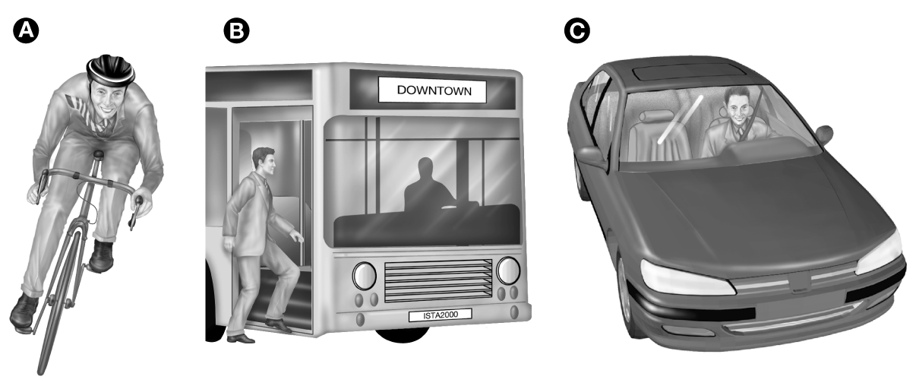

20. How does the typical North American's ecological footprint compare to those of the rest of the world?
A) The North American's is about one third as much as the rest of the world.
B) The North American's is about the same as much as the rest of the world.
C) The North American's is about three times as much as the rest of the world.
D) It is not yet possible to compare ecological footprints from different parts of the world.

21. The diagram below represents
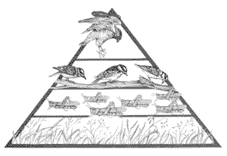
A) a food web
B) a food chain
C) symbiotic relationships
D) a pyramid of numbers
22. Which of the following are examples of abiotic parts of an environment?
A) air and plants
B) water and soil
C) soil and trees
D) air and animals

Use the chart below to answer the next three questions.
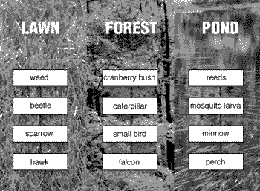
23. The primary consumers are
A) the weed, the cranberry bush and the reeds
B) the beetle, the caterpillar and the mosquito larva
C) the sparrow, the small bird and the minnow
D) the hawk, the falcon and the perch

24. Each of the columns under the headings - Lawn, Forest, Pond - can be best described as
A) a pyramid of biomass
B) a pyramid of numbers
C) predator – prey relationships
D) a food chain

25. The organisms that would have the most biomass are
A) the weed, the cranberry bush and the reeds
B) the beetle, the caterpillar and the mosquito larva
C) the sparrow, the small bird and the minnow
D) the hawk, the falcon and the perch

26. If all plants of a particular species die off, the plant is said to be
A) extinct
B) symbiotic
C) dominant
D) relocated
E) extirpated

27. There has been a sudden decline in the fish population of a local river. You begin your investigation by examining the present chemistry of the river water. You will compare your findings with the _______________________ collected five years prior.
A) baseline data
B) species counts
C) aquatic observations
D) acidity measurements

28. A mutual relationship has which of the following characteristics?
(a) two organisms of the same size
(b) organisms feeding another organism
(c) two organisms of the same species
(d) organisms benefitting from their relationship
29. Which causes the least impact on the environment?
(a) recycling
(b) recovering
(c) re-using
(d) reducing

30. Which of the following is not part of the niche for a species?
(a) the number of organisms
(b) what the species eats
(c) how the species interacts with other organisms
(d) how the species affects its environment

31. A mushroom breaks down a dead log to obtain nourishment. The mushroom would be classified as a
(a) herbivore
(b) predator
(c) decomposer
(d) scavenger
(e) producer
T/F 32. Greenhouse gases in the atmosphere help to reduce global warming.
T/F 33. Green plants take in carbon dioxide and give off oxygen as waste.
T/F 34. A food web shows energy transfers between organisms.

35. Adding organic matter to the soil _________________________ soil fertility.
- upsets
- increases
- decreases
- does not change

36. An embryo is a name for:
- a tiny new plant
- an ovule
- a pollen grain
- an egg cell

37. The layer of cells on a tree that transport sugar (food) in vessels is called:
- xylem
- cambium
- phloem
- heartwood
- bark

38. Pollen is produced in the:
- cones
- pistil
- anther
- stomata

39. ________ is a special kind of _________ that takes place through a semi-permeable membrane.
- Diffusion, osmosis
- Osmosis, diffusion
- Osmosis, equilibrium
- Absorption, osmosis

40. During cellular respiration: sugar + _______ → water + __________.
- carbon dioxide, oxygen
- oxygen, carbon dioxide
- carbon dioxide, water
- fertilizer, oxygen

41. Choosing certain plants with particular characteristics to reproduce with one another is called:
- genetic modification
- asexual reproduction
- selective breeding
- sexual reproduction

42. Which of the following is a type of sexual (2 parent) reproduction?
- grafting
- seeds
- cuttings
- layering

43. The production of food using the chlorophyll in chloroplasts is called:
- osmosis
- germination
- pollination
- photosynthesis

44. Which of the following is not needed for a seed to germinate?
- air
- proper temperature
- light
- moisture

45. Which three terms fit with: roots, stomata/pores, cones?
- absorbing water, releasing water and oxygen, reproduction
- absorbing water, photosynthesis, reproduction
- respiration, photosynthesis, reproduction
- respiration, photosynthesis, seed dispersal

T/F 46. Chemical control of pests is not only effective, it is environmentally friendly.
T/F 47. A planted forest is an example of a monoculture.

48. Which problem(s) are due to pesticide use?
- Creating resistant pest species
- harming non-target organisms
- residue build-up in soils
- all of the above
- a and b only

49. The sprouting of a seed is called:
- germination
- fertilization
- pollination
- biotechnology

50. Letting geese (which do not like strawberries) eat chickweed between the strawberry plants is
an example of:
- biological controls
- biotechnology
- crop rotation
- chemical control

51. Topsoil is either brown or black in colour. Its darkness depends on the:
- horizon
- moisture
- amount of organic matter
- erosion factor

T/F 52. Plants produce oxygen during photosynthesis.
T/F 53. Plants release water through stomata during the process of transpiration.
T/F 54. Soil spaces should be completely filled with water to improve growing conditions.

55. Anders Celsius improved thermometers by using evenly spaced lines that he called "degrees" as a way of giving more accurate readings. On what did he base his standards for comparison?
A) the properties of air
B) the properties of water
C) his sense of touch
D) his knowledge of ice

56. Bimetallic strips are used in the operation of a thermostat. What is their function?
A) break when the temperature is too high
B) curl as the metals gain/lose heat
C) expand and contract thereby pushing and pulling a switch to its on/off positions
D) all of the above

57. Which of the following has a temperature of 37°C?
A) boiling water at sea level
B) a slush of pure water and ice
C) a normal human body
D) a comfortable room

58. Which of the following demonstrates the Law of Conservation of Energy?
A) A battery’s chemical energy is converted to electricity which then produces heat and light.
B) One litre of 10°C water added to 1 litre of 20°C water makes 2 litres of 15°C water.
C) A termite mound transfers some of its stored heat energy to the termites- keeping them warm.
D) all the above
E) B and C only

59. Which of the following is true of thermal energy?
A) It is measured with a thermometer.
B) It is the average kinetic energy of the particles in a substance.
C) It is calculated mathematically.
D) It is measured in Kelvins.

60. As particles move more and more slowly, their temperature ___________________ .
A) drops.
B) rises.
C) remains the same
D) varies randomly

61. In which of the following examples would the temperature change?
A) an ice cube melts into liquid water
B) liquid water freezes into ice
C) water vapor condenses into a liquid
D) a kettle full of liquid water is heated
E) all the above

62. What change of state occurs when frost forms on food recently removed from the freezer?
A) deposition
B) sublimation
C) condensation
D) melting
E) evaporation

63. Which combination of colour and texture would absorb energy the best?
A) light-coloured and shiny texture
B) light-coloured and dull texture
C) dark-coloured and shiny texture
D) dark-coloured and dull texture

64. A material that reduces the flow of heat by conduction, convection, and/or radiation is _______.
A) a conductor
B) a radiator
C) an insulator
D) a solar collector
65. Which of the following describes an effective insulating material?
A) It would be fairly thick and would have lots of tiny air spaces in it.
B) It would be fairly thick conductor but have no air in it.
C) It would be a thin layer of air between glass sheets.
D) It would be a thin layer of metal or combination of metals.

66. The transfer of energy process that does NOT require matter is _______________________.
A) radiation
B) convection
C) conduction
D) all of the above

67. Through which of the following will convection most likely occur?
A) liquids and gases
B) solids and liquids
C) solids
D) gases
E) liquids

68. Which R-value would provide have the lowest thermal conductivity?
A) 2 RSI
B) 4 RSI
C) 12 RSI
D) 24 RSI

69. What causes natural convection currents?
A) the different densities of a fluid at different temperatures
B) placing a heat source at the top of the fluid
C) wind blowing
D) all of the above

70. ____________________ (the heat of melted rocks) can be used to generate electricity.
A) Wind energy
B) Geothermal energy
C) Nuclear energy
D) Solar energy

71. Solar collectors are parts of a(n) _______________________.
A) active solar heating system
B) radiant heating system
C) local heating system
D) passive solar heating system
E) central heating system

72. Fossil fuels are a
A) non-renewable natural resource.
B) renewable natural resource.
C) non-renewable manufacture resource.
D) renewable manufactured resource.

73. Asthma attacks triggered by air pollution would be considered a(n) __________ cost of burning fossil fuels.
A) economic
B) environmental
C) societal
D) none of the above

74. A lumber manufacturing company now burns waste wood to produce the electricity required to run its saws. This is an example of
A) recycling
B) reusing
C) reducing
D) recovering
E) cogeneration

75. Perfume is sprayed into the air at the front of a room. Its scent is soon observed at the back of the room. Which idea does this observation support?
A) Particles are always in motion.
B) Particles move from higher to lower concentrations.
C) Particles diffuse through a fluid.
D) all the above
E) A and C.

76. Gas particles move around the globe in convection currents because
A) warmer air rises and cooler air moves in to take its place
B) cooler air pushes warmer air up then it becomes warmed
C) as a fluid loses heat it becomes denser and sinks
D) A and B only
E) B and C only

77. What is the one thing that all of the following have in common?
- a snowflake - an automobile
- the Calgary Tower - a tree
A) They are all structures.
B) They are all natural structures.
C) They are all manufactured structures.
D) They are all frame structures.

78. What is the name used to describe a push or pull on a structure?
A) load
B) force
C) weight
D) mass

79. What term best describes the weight that a structure must support?
A) dynamic/live load
B) static/dead load
C) force
D) both A and B

80. Which of the following is not present in a frame structure, such as a house?
A) a skeleton of strong material
B) an interior that is mostly empty space
C) primarily mobile joints
D) walls that divide rooms but bear little load

81. On which of the following structures are mobile joints not found?
A) bicycle chain
B) human body
C) doors
D) desk chairs in a school
E) zippers

82. Why do buildings designed as shell structures have an advantage over those designed as frame structures?
A) Shell structures take up less space than frame structures.
B) Shell structures are constructed with greater ease then frame structures.
C) Shell structures are better able to compensate for structural flaws then frame structures.
D) Shell structures provide enclosed open space and use very little building material.

83. To spread the external forces acting on the plane throughout the structure, the designer has used a large number of :
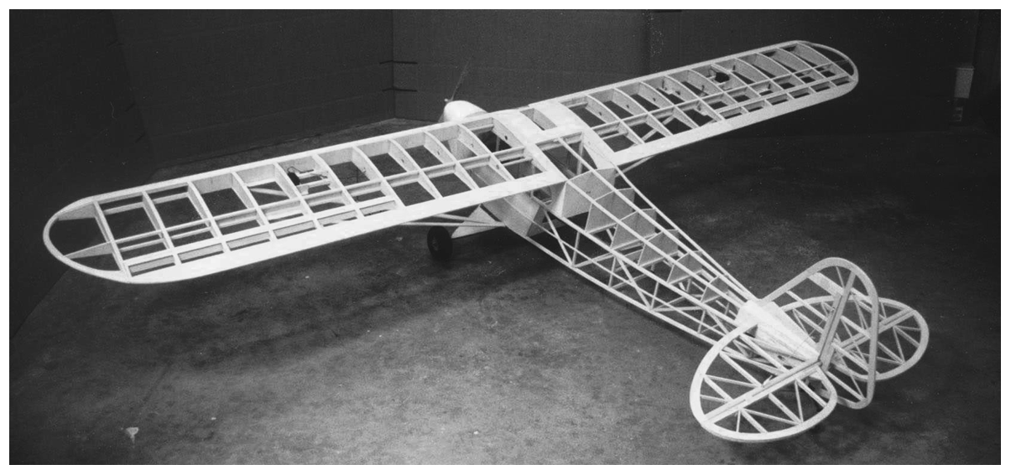
A) braces
B) beams
C) triangles
D) layers
E) arches

84. What is the name for a shape that can be folded to fit exactly on top of itself?
A) functional
B) symmetrical
C) asymmetrical
D) aesthetically pleasing

85. Why would a suspension bridge that needs to support 500 tonnes be designed to support 750 tonnes instead?
A) to make it aesthetically pleasing
B) to make it last a lot longer
C) to allow for a greater margin of safety
D) to allow for possible future traffic increases

86. Why is plywood stronger than normal wood? It is:
A) laminated
B) reinforced
C) functional
D) corrugated

87. What is the correct unit of measurement for weight?
A) joule
B) gram
C) kilogram
D) Newton

88. Bending a fresh finger-width twig causes its top layers to tear apart. These layers did not have a high enough ________________ to resist the forces applied to it.
A) torsion strength
B) compressive strength
C) tensile strength
D) shear strength

89. The center of the other side of the twig got all wrinkled and the bark split in several places. The force acting on the twig’s underside would be classified as a:
A) torsion strength
B) complementary force
C) tensile strength
D) shear force

90. A fresh twig will deform more than a dry twig of the same size because the it has:
A) lower shear strength
B) greater compressive strength
C) higher tensile strength
D) greater flexibility

91. You and your dog broke a plastic toy by twisting it. The toy did not have enough ___________ to resist the forces applied to it.
A) torsion strength
B) compressive strength
C) tensile strength
D) shear strength

92. Another toy (used for tug-of-war) had been bent back and forth sooooooo... many times it finally snapped due to structural:
A) fatigue
B) failure
C) stability
D) stress

93. Which of the following horizontal structures was developed to provide the lowest static load while still supporting an equal or greater dynamic load?
A) solid steel beams
B) cantilever
C) I-beam
D) simple beam
94. Structural failure caused by a compressive force would likely be classified as:
A) shearing
B) separating
C) deformation
D) buckling

95. You are meeting with a designer to plan a huge monument to your favourite teacher. What could you do to create stability?
A) Have a large base compared to its height.
B) Create a solid layer to build on.
C) Plan its symmetry around its center of gravity.
D) all of the above
E) A and B only

96. To form the long thin strands of “hair” on the statue you know it is best to choose a material that:
A) is brittle
B) has a low hardness
C) has a high plasticity
D) is ductile

97. Pieces of the monument’s surface material flake off. This happens because it has a low level of one kind of strength. Which one?
A) compressive strength
B) shear strength
C) tensile strength
D) torsion strength

98. Anna is using a Mohs scale set of minerals to test some rock samples. Which would she find has the greatest hardness value?
A) quartz
B) feldspar
C) calcite
D) diamond

99. Which of the following is not a method used to identify minerals.
A) crystal shape
B) hardness
C) cleavage
D) family

100. What term describes the powdery mark left behind when a mineral is scratched along a piece of unglazed porcelain?
A) colour
B) lustre
C) streak
D) residue

101. All minerals share the following characteristics EXCEPT that of ____________________.
A) being formed by natural processes
B) being formed from living organisms
C) being solids
D) having the atoms within the mineral arranged in a pattern

102. Mica will peel off in flat sheets. This is an example of the physical characteristic called _______.
A) hardness
B) streak
C) fracture
D) cleavage

103. Calcite will scratch gypsum. This is an example of the physical characteristic called ________.
A) hardness
B) streak
C) fracture
D) cleavage

104. While on a field trip to the Rocky Mountains, Parmeet finds a sedimentary rock containing sediments of several sizes. This rock was probably:
A) sandstone
B) conglomerate
C) shale
D) granite

105. Which two processes form sedimentary rocks from deposited rock particles?
A) heating and cooling
B) compaction and compression
C) compression and melting
D) compaction and cementation

106. What material forms metamorphic rocks?
A) igneous rocks
B) sedimentary rocks
C) parent rocks
D) all of the above
E) A and B only

107. Which rock family could NOT contain a fossil ?
A) igneous intrusive
B) sedimentary
C) igneous extrusive
D) metamorphic

108. Magma that cools slowly forms ____________________ rock.
A) extrusive metamorphic
B) extrusive igneous
C) intrusive metamorphic
D) intrusive igneous

109. When lava cools at Earth's surface, ____________________ igneous rocks are formed.
A) extrusive
B) metamorphic
C) intrusive
D) coarse-grained

110. Mineral grains in igneous rocks become flattened as they change to metamorphic rocks due to _____.
A) high pressure
B) high heat
C) chemical changes
D) both a and b

111. Sedimentary rocks form because of all of the following EXCEPT ____________________.
A) sediments becoming pressed and cemented together
B) crystals solidifying from magma
C) sediments falling out of solution
D) water evaporating, leaving crystals behind

112. Which of the following is not a form of mechanical weathering?
A) frost wedging
B) breakage due to gravity
C) wind or water carrying rock particles
D) acid rain

113. Soil erosion would NOT be slowed by ____________________.
A) using trash cover
B) growing trees along the edges of fields
C )crop rotation
D) adding organic fertilizer or compost to the soil

114. Growing the same crops in the same fields year after year ____________________.
A) enriches the soil
B) increases the amount of topsoil
C) uses up all the nutrients in the soil
D) improves plant growth

115. Features created by water erosion and sedimentation are referred to as:
A) pot and kettle terrain
B) bedrock
C) erratics
D) fluvial land forms

116. Why weren't scientists willing to accept the Theory of Continental Drift?
A) the continents didn't fit exactly like jig-saw pieces
B) the theory could not explain why the continents moved
C) fossil evidence indicated that the theory was wrong
D) rocks on a different continents could not be matched to help explain the theory

117. When oceanic and continental plates collide, the heavier oceanic plate is forced under the lighter continental plate. What term describes these areas?
A) subduction zones
B) convergence zones
C) transverse zones
D) divergence zones

118. What is the name of the supercontinent that formed over 200 million years ago? Hint: This supercontinent eventually broke up into the present day continents.
A) Pangaea
B) Rhodesia
C) Gondwanaland
D) Rhodinia

119. New crust is formed at:
A) convergent boundaries
B) transform boundaries
C) divergent boundaries
D) all of the above

120. A group of scientists is on board a ship off the coast of Nova Scotia. They are using sonar to map the ocean floor. What are they depending on to obtain their data?
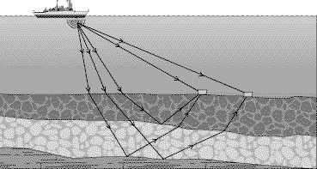
A) magnetic fields
B) sound waves
C) water waves
D) remote TV images

121. The crust and upper mantle make up Earth's ____________________.
A) lithosphere
B) outer core
C) shield
D) inner core

122. Plates move apart at ____________________ boundaries.
A) convergent
B) stable
C) divergent
D) volcanic

123. ____________________ are formed when two continental plates collide.
A) Volcanoes
B) Transform faults
C) Mountain ranges
D) Rift valleys

124. Three seismographs are needed to accurately locate an earthquake’s ______ on the Earth’s surface.
A) focus
B) epicentre
C) seismic waves
D) origin

125. Ben is drawing a map of the mountain ranges of the world. Which of the following should he not include on his map?
A) Alps
B) Urals
C) Appalachians
D) Mount Vesuvius

126. What is an upward section of folded rock known as?
A) anticline
B) ridge
C) syncline
D) fault line

127. When an organism’s particles are gradually replaced by minerals that preserve its form it referred to as a:
A) trace fossil
B) indicator fossil
C) cast fossil
D) petrified fossil

128. What are tracks, burrows, and other evidence of animal activity known as a:
A) petrified fossil
B) cast
C) trace fossil
D) original remains

129. All of the following EXCEPT ____________________ would have a good chance of being preserved as a fossil.
A) jellyfish
B) shark teeth
C) animal bones
D) shells

130. a scientist that studies early life using fossils is a:
A) paleontologist
B) ecologist
C) volcanologist
D) geologist

