Grade Seven Review Package

Unit One

1. What is a habitat?
2. The three forms of symbiosis are parasitism, mutualism, and commensalism. Define each of these terms and provide an example of each type of relationship.
3. Define the relationship between a host and a parasite. Give one example.
4. Explain one way in which seeds are adapted to help plants reproduce
5. The feet of a robin are an example of an adaptation. Like other perching birds, robins have feet with three front toes, one long hind toe, and a specialized tendon that automatically locks their hind toes around a branch on landing. Describe two other adaptations that help organisms survive and reproduce.
6. List four ways to reduce the size of your ecological footprint.
7. Why is it important to reduce, re-use, and recycle?
8. If you found cats, mice, and corn in the same ecosystem, what role would each be playing in the food chain?
9. Use the following scenario to answer the next question(s).
You design a composting investigation to find out which materials will decompose and how long it will take for decomposition to occur. You use large clay pots set on saucers and fill the pots with stones, soil, test material, more soil, and water. You then cover the tops of the pots with a piece of window screen. Each day, you moisten the soil with water. Every week you use a magnifying glass to examine the test materials for signs of decomposition. The test materials you use include: banana peels, paper, grass clippings, aluminum foil, orange peels, eggshells, and carrot peels
a) Identify the manipulated variable.
b)Identify the responding variables, and explain how they can be measured.
10. Jesse takes a walk through a meadow on a spring day. She inhales the crisp, fresh air and notices some birds perched in a tree. Her boots become wet since the ground was dampened by last night's rain. She walks on hoping to catch a glimpse of a field mouse. Identify 3 biotic and abiotic parts in this description.
11. What role do predators play in a complex ecosystem? Explain your answer using a specific example of a predator and its prey.
12. At the beginning of every food chain there must be a producer. What does a producer do? What is its relationship to a consumer? Explain your answer with an example.
13. What factors do you need to examine in order to understand an organism's niche?
14. Explain how a human being depends on sunlight, air, water, and soil.
15. Name three ways in which humans contribute to species extinction.
16. Explain why sampling is an important activity when biologists are studying a particular area.
18. Explain why energy flow is important in an ecosystem.
19. Use the following visual to answer the next question(s).
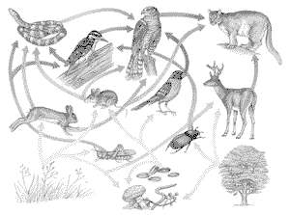
20. Examine the food web, and list three food chains that are present.What is the top carnivore in this food web? Explain your answer. Pick out two producers and two consumers and show their connection.

Unit Two

1. What is the difference between diffusion and osmosis?
2. List three functions of roots.
3. Suggest two adaptations you would likely see on a plant found in a warm, moist, dark forest.
4. Name and sketch each of the two types of root systems. Explain the advantage of each type of root system.
5. What makes plants green? What does this substance do?
6. What is the main function of root hairs?
7. Explain how transpiration and osmosis help water move up the plant.
8. What is respiration?
9. What is the difference between a perennial and an annual plant?
Using your understanding of adaptation, identify one likely survival strategy for a perennial plant and one likely survival strategy for an annual plant.
10. Name the labelled parts on the diagram and give the function of each part.
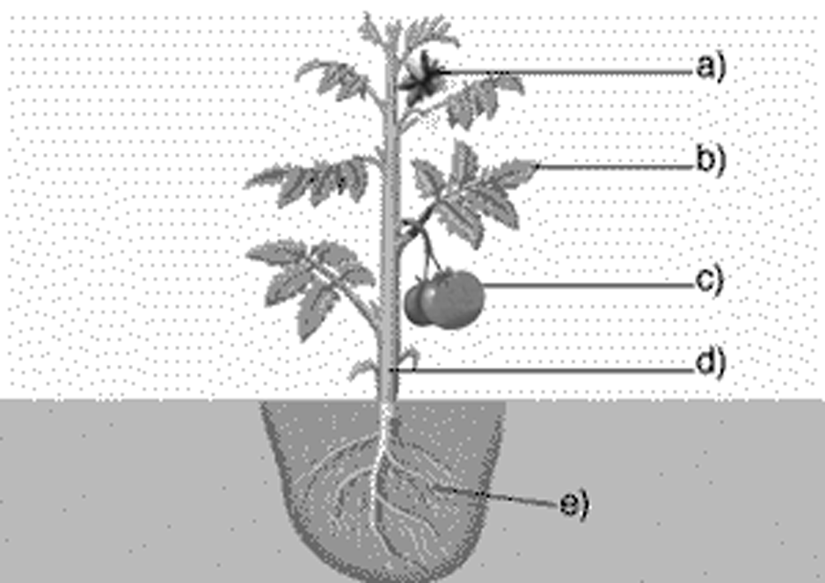

11. How are xylem and phloem the same? How are they different?
12. What is the difference between pollination and fertilization?
13. What is the difference between sexual and asexual reproduction? Identify one advantage of vegetative reproduction and one advantage of sexual reproduction for a plant.
14. What is a gene? What is genetic modification?
15. Identify two conditions that will discourage germination of seeds in storage.

Unit Three

1. What is temperature? What are two common ways of estimating temperature?
2. What is a bimetallic strip? What happens when a bimetallic strip is heated? Explain why.
3. According to the particle theory, how is the temperature of a substance related to the motion of its particles? What two factors make it difficult for scientists to directly test this idea?
4. What is the difference between temperature and thermal energy?
5. The thermal energy of a substance depends on three factors. Name them. Explain which has the greater thermal energy, a lake or a tub of water, when both are at 20°C.
6. What is kinetic energy? What two types of objects have high kinetic energy? Provide two examples of objects with low kinetic energy.
7. Define energy. How is it different from matter? What SI unit is used to measure energy?
8. Use the particle theory of matter to explain why a gas will expand more than a solid when both are heated.
9. Explain how the same temperature of 0°C can simultaneously be the melting point and freezing point of water.

10. Joy and Alonzo are playing tennis on a sunny day. They are well-matched, and both play the sport with enthusiasm. Joy is wearing white clothes, and Alonzo is dressed in black.
- Who will likely feel hotter by the end of the game? Explain your reasoning.
- If both were wearing white, what type of material would allow one of them to feel cooler than the other? Why?
11. What is the purpose of wrapping insulating material around an object?
12. Using a stainless steel ladle, Mr. K is stirring a pot of hot soup on the stove. The ladle handle becomes warmer until, finally, it is too hot for him to hold. Use the particle theory to explain what happened.
13. All materials are made of tiny particles. Why, then, are some substances better heat conductors than others?
- Why do fluids rise when they are warmed?
- Name the five features of an energy transfer system. What factor reduces the efficiency of an energy transfer system and why?
16. Give two examples of each of the following:
a) a mechanical energy source
b) a chemical energy source
- an electrical energy source
17. When buying a car most people are interested in the colour, brand, price, and how well it performs. What are three other questions that a consumer who is concerned about the environment might ask?
18. Sometimes, touch is useful when a rough estimate of temperature is required and accuracy is not critical. Suggest one advantage and one disadvantage of using touch to measure temperature.
19. Use the particle theory of matter to predict what would happen to the metal ball if you heated it and tried to push it through the ring.
20. Draw a diagram of a burning candle. Show the convection currents created by its flame. Label the diagram to show the flow of warm air, cool air, and cooling air.
21. The liquid in a laboratory thermometer rises or falls in response to temperature changes in its surroundings, regardless of its scale. Why, then, is it important to have a scale on a thermometer?
22. You are conducting an investigation to test whether hot water cools faster than hot oil. You use a thermometer to measure the temperature of each as they cool to room temperature.
23. The melting point of iron is 1535ºC. Its boiling point is 2861ºC. In what state would iron be at 1800ºC? Explain your reasoning.
24. Water has a freezing point of 0ºC and a boiling point of 100ºC. Mercury has a freezing point of -39ºC and a boiling point of 357ºC. Explain why mercury is a better choice than water for use as a liquid inside thermometers.

Unit Four

1. Winnipeg is often threatened in the spring by the flooding of the Red River. In order to protect property, authorities have built large dams made up of thousands of sandbags. Sometimes the sandbags are not effective in controlling the water. List two ways that sandbag dams could fail.
2. Identify the most appropriate type of structure for each of the following applications:
a) computer monitor
b) wooden bookshelf
c) roller coaster Explain how fasteners such as nails, staples, screws, and rivets can weaken a structure at the same time as they strengthen it.
d) space capsule
3. Explain why the material used in shell structures does not have to be especially strong.
4. State the most appropriate method of joining each of the following materials.
a) two pieces of cloth
b) pieces of wood in layers
c) pieces of a puzzle
d) pieces of metal
5. Sam weighs 70 kg. and Amanda weighs 50 kg. Convert their respective body weights to newtons. Show your formula.
6. Why do an egg-sized lump of lead and an egg-sized piece of foam have different masses?
7. What is the difference between mass and weight?
8. Explain how a balance works to determine an object's mass.
9. Explain how gravitational forces can affect a structure over time.
10. Explain how external and internal forces are related.
11. Explain why you would want to keep your stance as wide as possible and try to crouch as low as possible in a tug of war.
12. Explain why it is possible to "steer" with no hands on a fast-moving bicycle.
13. What is composite material?
14. Study the three diagrams shown here. These diagrams illustrate the forces between the particles in graphite, steel, and rubber.
a) Identify which is which: ____ graphite ____ steel ____ rubber
b) Explain what helped you identify steel.
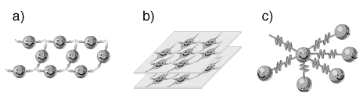
15. Name the forces acting on the teeter-totter. Use the letters from the diagram to identify where each occurs.
Draw and label a second diagram showing two ways that the teeter-totter might be strengthened to resist forces acting on it.
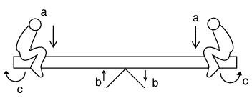
16. Sketch each of the following components of structures.
a) column b) beam c) panel
17. Strength is not always a critical design consideration. Describe three situations in which strength would be important and three in which it would not be important. Provide reasons for your answers.
18. You are asked to conduct an investigation comparing the rate of metal fatigue among three different metal wires: copper, steel, and gold. You bend each kind of wire back and forth until it breaks, counting the number of bends.
a) Identify one controlled variable in this investigation.
b) Identify the manipulated variable.
c) Identify the responding variable.
19. What is a cantilever?
20. Look at your hand, and then list four of its functions.
21. Use your knowledge of external and internal forces to explain what happens when you make a snowball.

22. Describe three differences between structure A and structure B that make A more stable than B.
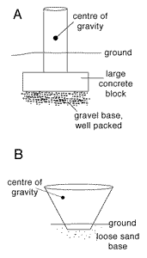

Unit Five

1. Your teacher gives you two unlabelled mineral samples, saying only that one is halite and one is quartz. Describe two tests you could conduct to determine which is which. Explain how each test would identify the mineral.
2. How can your fingernail be used to tell the difference between a sample of talc and a sample of quartz ?
3. What is Moh’s Hardness scale?
4. You are asked to talk to a Grade 6 class about the rock cycle. How would you define the rock cycle in simple terms to these students?
5. How is extrusive rock formed?
6. What are the two key factors involved in the formation of metamorphic rock? Can this process take place on Earth's surface? Explain your answer.
7. How does the freeze-thaw period in early spring cause weathering? What is this process called?
8. What do scientists now think may be causing Earth's plates to move?
9. Explain how can P and S waves be used to determine the location of an earthquake.
10. Explain the difference between the focus of an earthquake and its epicentre.
11. What is a subduction zone?
12. What is the principle of superposition? How do geologists use this principle?
13. What is the difference between geological eras and geological periods?
14. Draw a diagram of the rock cycle. Label the diagram with the following terms:
melting (magma), cooling, weathering and erosion, heat and pressure, sediments, compaction and cementation, sedimentary rock becoming metamorphic rock
15. Write the letter that best indicates where the following terms would fit on the diagram provided. Give the diagram an appropriate title. (Hint: What kind of soil is shown in this cross section?)
____ silt and clay | ____ decaying organic matter
____ parent rock | ____ weathered rock fragments
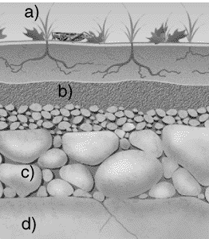

16. Draw a sketch of the Earth relating the inner core, outer core, mantle, crust.
18. Identify three types of fossils.
19. What is the difference between anticline and syncline?
20. Use the diagram provided to answer the following questions.
a) Which is the oldest rock?
b) Which is the youngest rock?
c) How can you tell that the rock is older than the fault?
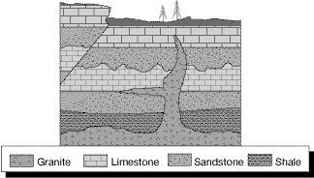

21. What is the difference between relative dating and absolute dating?
22. What was Pangaea?
23. What is the difference between erosion and weathering?
24. A geologist finds fossils of sea horses near the top of a mountain. What could you infer about the geological history of that mountain?
25. List two things that you would look for in order to decide whether a mountain range is old or young.
26. Your cottage is built near the site of an old resort hotel that opened in 1901. The hotel burned down in 1956, but people digging in the area still occasionally find old bottles and refuse in former dumps around the property.
- How could you use the principle of superposition to study the types of garbage that were discarded at the hotel site over its 55 years of operation?
- Where would you be likely to find the oldest items?
27. While walking along a beach, you discover an interesting white rock. From its colour, you infer that it is either calcite or quartz. There is a broken glass bottle nearby. How can you use the bottle to identify the rock?
28. Scientists have found that the Atlantic Ocean is getting wider by about 2 cm every year, about the same speed as your fingernails grow. How much wider is it now than when you were born?

