PAT Sample Questions (NO CALCULATOR) PART A

1. -3 - (-4) + (-10) 2. -7 - 11 + (-9) 3. 12 - (-15) - 7

4. What is the value of 2³ + 2⁰? 5. What is the value of 4² + 2⁵ + 3⁰?

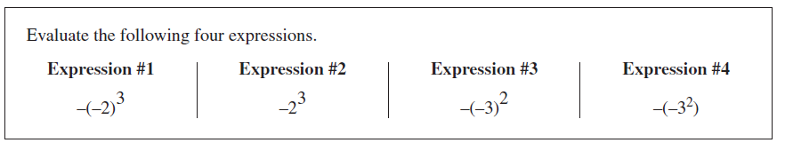

6.

Which numbered expression shown above has the largest value and what is that value?

7. What is the value of 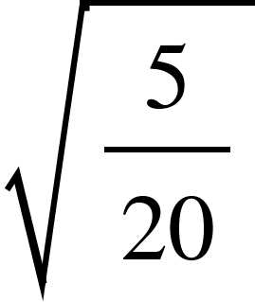expressed as a fraction in simplest form?

8. What is the value of 13.2 + 0.05 - 5.45?

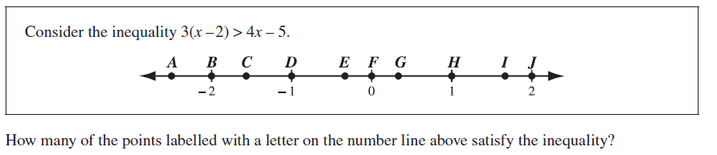
9.

10. To the nearest whole number, what is the approximate square root of 200?

11. What is 150% of 60? 12. What is 200% of 300?

13. In simplest form, what is the value of 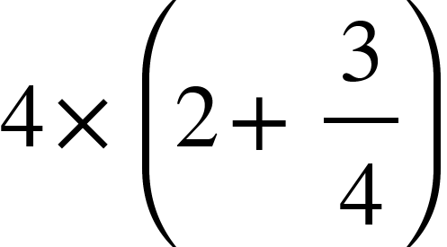?

14. Simplify, then evaluate 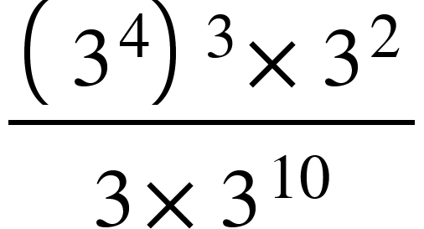.

15. What is the value of 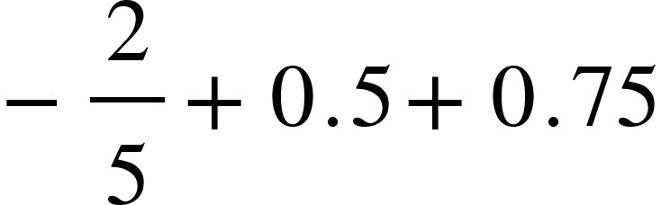expressed as a fraction in simplest form?


16. Which point best represents the location of 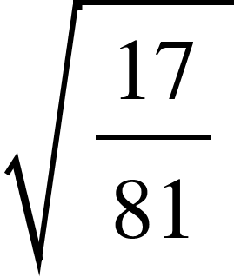on the number line shown above?

17. What is the value of 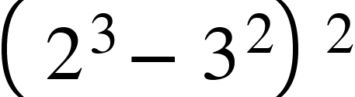?

18. What is the value of 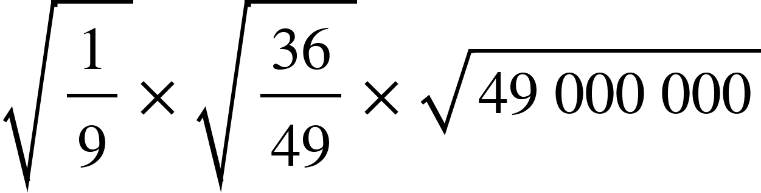?

19. 14.8 + 0.02 - 5.83 20. 2.1 + 0.09 - 1.61 21. 21.8 - 1.6 + 9.7

22. 5² + 5⁰ 23. 2⁴ + 2³ + 2² + 2¹ + 2⁰ 24. ⅛ + ¼ + 3 ½

25. 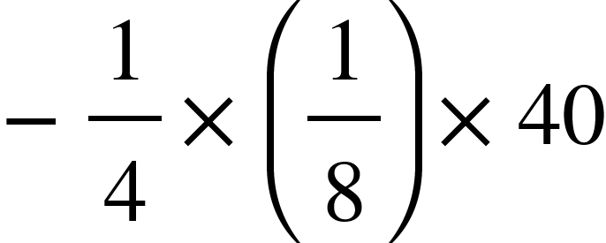 26. 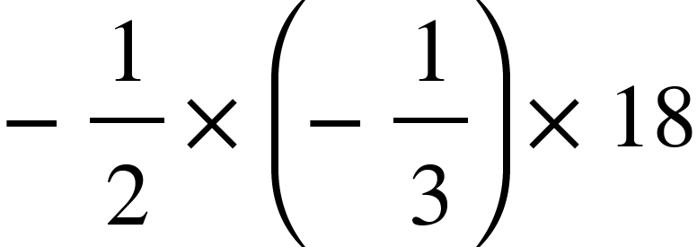 27. 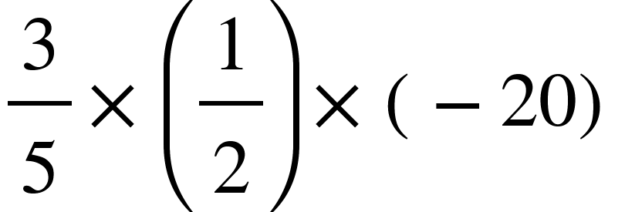

28. What is the value of 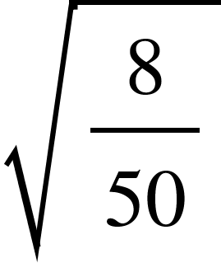expressed as a fraction in simplest form?

29. To the nearest whole number, what is the approximate square root of 160?

30. What is 250% of 40? 31. What is 75% of 160?

32. 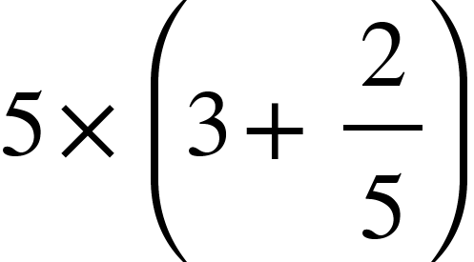 33. 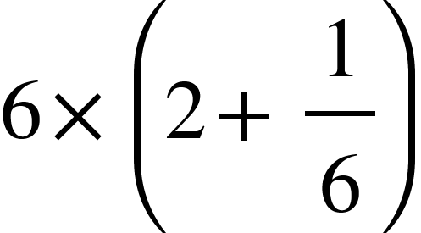 34. 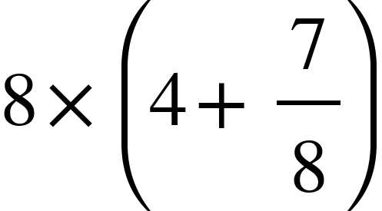

What is the integer answer to the following questions:

35. 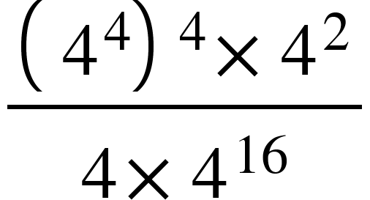 36. 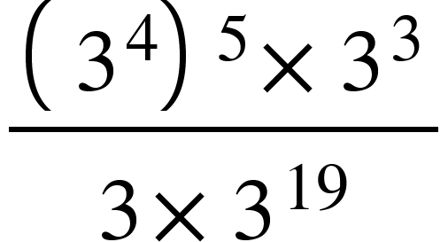 37. 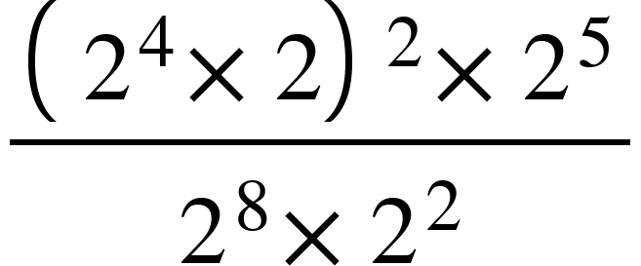

38. 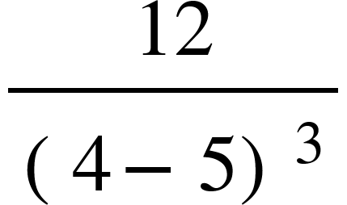 39. 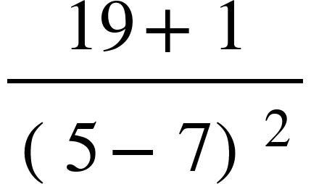 40. 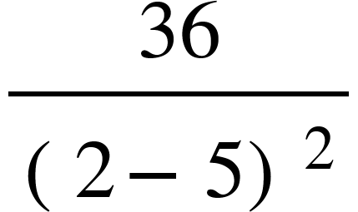

41. 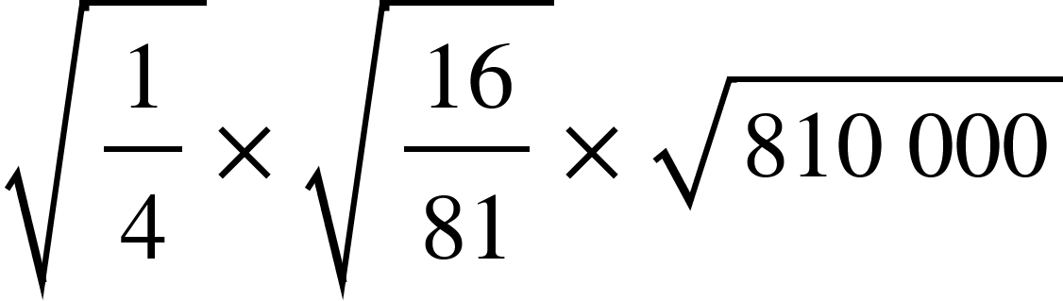 42. 