UNIT 5 - YEAR END REVIEW #1

- Anna is using a Mohs scale set of minerals to test some rock samples. Which would she find has the greatest hardness value?
A) quartz
B) feldspar
C) calcite
D) diamond

- Which of the following is not a method used to identify minerals.
A) crystal shape
B) hardness
C) cleavage
D) clarity

- What term describes the powdery mark left behind when a mineral is scratched along a piece of unglazed porcelain?
A) colour
B) lustre
C) streak
D) residue

Use the following Table to answer questions 4 and 5:
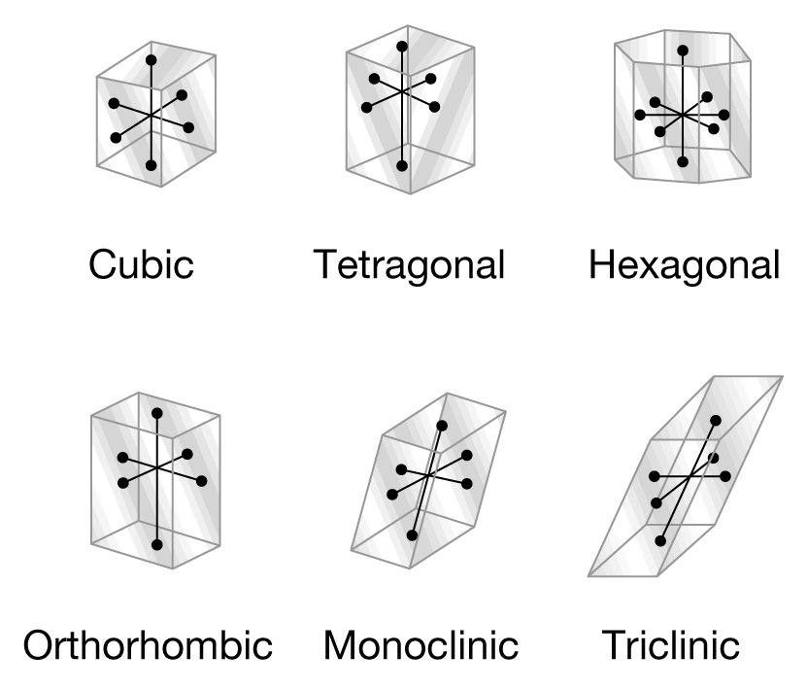

- According to the Table, in general a crystal is ____________________.
A) a solid
B) a cube
C) liquid
D) none of the above

- As shown in the Table, crystals may be ____________________.
A) cubic
B) monoclinic
C) tetragonal
D) all of these

- One of the softest minerals is ____________________.
A) topaz
B) quartz
C) talc
D) amethyst

- All minerals share the following characteristics EXCEPT that of ____________________.
A) being formed by natural processes
B) being formed from living organisms
C) being solids
D) having the atoms within the mineral arranged in a pattern

- Muscovite mica will peel off in flat sheets. This is an example of the physical characteristic called ____________________.
A) hardness
B) streak
C) fracture
D) cleavage

- Calcite will scratch gypsum. This is an example of the physical characteristic called ____________________.
A) hardness
B) streak
C) fracture
D) cleavage

- While on a field trip to the Rocky Mountains, Parmeet finds a sedimentary rock containing sediments of various sizes. Which of the following rocks did Parmeet probably find?
A) sandstone
B) conglomerate
C) shale
D) granite

- Which two processes form sedimentary rocks?
A) heating and cooling
B) compaction and compression
C) compression and melting
D) compaction and cementation

- What material forms metamorphic rocks?
A) igneous rocks
B) sedimentary rocks
C) parent rocks
D) all of the above

- What term describes a cross-section of soil?
A) soil horizon
B) soil zone
C) soil profile
D) soil map

- A farmer finds that his fields yield poorer crops every year. What could be the cause?
A) leaching
B) lack of crop rotation
C) erosion of topsoil
D) all of the above

- Which has the largest particle size?
A) silt
B) sand
C) gravel
D) clay

- Which is not responsible for rock formation?
A) glaciation
B) deposition
C) rock cycle
D) lustre

- Which of the following is not a rock family?
A) gneiss
B) sedimentary
C) igneous
D) metamorphic

- Which of the following is found with sedimentary rocks?
A) volcanoes
B) fossils
C) compost
D) magma

- Magma that cools slowly forms ____________________ rock.
A) extrusive metamorphic
B) extrusive igneous
C) intrusive metamorphic
D) intrusive igneous

- Foliated rocks are distinguished by ____________________.
A) flaking
B) banding
C) weathering
D) cementation

- A classification of metamorphic rocks would include whether they are ____________________.
A) chemical or organic
B) intrusive or extrusive
C) foliated or nonfoliated
D) basaltic or granitic

- A rock is always ____________________.
A) made of molten material
B) a mixture of minerals
C) formed by heat and pressure
D) either igneous or sedimentary

- The crystals that form in slowly cooling magma are ____________________.
A) tiny
B) invisible
C) colourful
D) large

- When lava cools at Earth's surface, ____________________ igneous rocks are formed.
A) extrusive
B) metamorphic
C) intrusive
D) coarse-grained

- Mineral grains in igneous rocks become flattened as they change to metamorphic rocks because of ____________________.
A) pressure increases from overlying rocks
B) heat increases
C) changes in chemistry
D) both a and b

- Sedimentary rocks form because of all of the following EXCEPT ____________________.
A) sediments becoming pressed and cemented together
B) crystals solidifying from magma
C) sediments falling out of solution
D) water evaporating, leaving crystals behind

- What term describes the eroded sediments that pile up along the sides of a glacier?
A) debris
B) moraine
C) striations
D) erratic

- Which of the following is not a form of mechanical weathering?
A) frost wedging
B) gravity
C) wind
D) acid rain

- Soil erosion can be slowed by ____________________.
A) no-till farming
B) cutting trees from the middle of fields
C) plowing at least three times a year
D) farming on steeper slopes

- Growing the same crops in the same fields year after year ____________________.
A) enriches the soil
B) increases the amount of topsoil
C) uses up all the nutrients in the soil
D) improves plant growth

- Frost wedging is caused by ____________________.
A) acids freezing on rocks
B) water and oxygen reacting
C) water freezing and thawing
D) rocks colliding with each other

- Chemical weathering ____________________.
A) involves a change in size
B) breaks apart rocks without changing their chemical composition
C) occurs when water, naturally formed acids, air, and other substances react with the minerals in rocks
D) none of the above

- Shelter belts of trees protect soil from erosion caused by ____________________.
A) lack of rain
B) too much rain
C) wind
D) snow

- Boulders carried by glaciers will gouge ____________________ into the rock over which they are moving.
A) cracks
B) striations
C) cirques
D) till deposits

- Which two factors determine the amount of erosion water causes?
A) speed and direction of the water
B) amount and direction of the water
C) speed and amount of the water
D) amount and volume of the water

- Why weren't scientists willing to accept the Theory of Continental Drift?
A) the continents didn't fit exactly like jig-saw pieces
B) the theory could not explain why the continents moved
C) fossil evidence indicated that the theory was wrong
D) rocks on a different continents could not be matched to help explain the theory

- When oceanic and continental plates collide, one plate is forced under the other. What term describes the areas where these plates overlap?
A) subduction zones
B) conduction zones
C) convection zones
D) subvection zones

- What is the name of the supercontinent that formed over 200 million years ago? Hint: This supercontinent eventually broke up into the present day continents.
A) Pangaea
B) Rhodesia
C) Gondwanaland
D) Rhodinia

- Which of the following partially explains earthquakes?
A) convergent boundaries
B) transform boundaries
C) movable plates
D) all of the above

- A group of scientists is on board a ship off the coast of Nova Scotia. They are using sonar to map the ocean floor. What are they depending on to obtain their data?
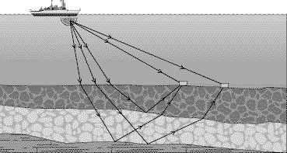
A) magnetic fields
B) sound waves
C) water waves
D) remote TV images

- The crust and upper mantle make up Earth's ____________________.
A) lithosphere
B) asthenosphere
C) shield
D) continents

- Plates move apart at ____________________ boundaries.
A) convergent
B) stable
C) divergent
D) volcanic

- The boundaries between two colliding plates are called ____________________.
A) divergent
B) convergent
C) a transform fault
D) lithosphere

- The layer inside Earth that is comprised of material that can flow like a liquid yet also retain solid properties is the ____________________.
A) inner core
B) outer core
C) mantle
D) crust

- Matching ____________________ on different continents are evidence for continental drift.
A) river systems
B) rock structures
C) weather patterns
D) wind systems

- In order to complete a convection current, the rising material must eventually ____________________ Earth.
A) stop inside
B) cool
C) sink back into
D) warm

- ____________________ are formed when two continental plates collide.
A) Volcanoes
B) Transform faults
C) Mountain ranges
D) Rift valleys

- Fossil evidence found in Antarctica indicates ____________________.
A) desert environments
B) a warm climate
C) the climate has always been cold
D) there are no fossils in Antarctica

- What type of seismic wave can travel through all states of matter?
A) primary or P wave
B) secondary or S wave
C) surface wave
D) L wave

- Which seismic wave causes the most movement?
A) primary or P waves
B) secondary or S waves
C) surface waves
D) seismic waves

- Earthquakes are measured on a device called a:
A) seismogram
B) seismograph
C) seismetrometer
D) seismotron

- Primary waves travel at about 6 km/s through Earth's crust. The distance from Windsor to Toronto is about 370 km. About how long would it take for primary waves to travel between these two cities?
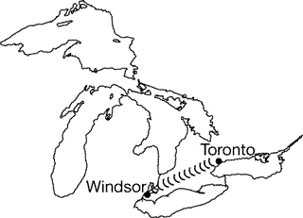
A) 62 s
B) 6 min
C) 376 s
D) 2220 s

- Most earthquakes happen ____________________.
A) without warning
B) in areas where earthquakes have occurred in the past
C) along plate boundaries
D) all of the above

- The ____________________ waves are the first to reach a seismograph after an earthquake.
A) surface
B) secondary
C) primary
D) tsunami

- ____________________ seismographs are needed to accurately locate an earthquake epicentre.
A) Two
B) Five
C) Four
D) Three

- Which term describes volcanoes that are not currently erupting?
A) active
B) dormant
C) sleeping
D) extinct

- What is the name that was given to this volcanic region that surrounds the Pacific Ocean?
A) zone of fire
B) area of fire
C) ring of fire
D) rim of fire

- Kilauea in Hawaii is the world's most ____________________ volcano.
A) dormant
B) active
C) violent
D) granitic

- Ben is drawing a map of the mountain ranges of the world. Which of the following should he not include on his map?
A) Alps
B) Urals
C) Appalachians
D) Mount Vesuvius

- What is the upward or top section of folded rock known as?
A) anticline
B) ridge
C) syncline
D) fault line

- What may form when two tectonic plates push against each other?
A) synclines and anticlines
B) folds
C) faults
D) all of the above

- What kind of mountains are the Canadian Rockies?
A) thrust fault mountains
B) fault block mountains
C) complex mountains
D) reverse fault mountains

- When organisms are preserved, in full or part, as fossils, what are they known as?
A) trace fossils
B) moulds
C) casts
D) original remains

- What are tracks, burrows, and other evidence of animal activity known as?
A) moulds
B) casts
C) trace fossils
D) original remains

- All of the following EXCEPT ____________________ would have a good chance of being preserved as a fossil.
A) jellyfish
B) shark teeth
C) animal bones
D) shells

- Which is more likely to be preserved as a fossil?
A) bear fur
B) salamander's skin
C) insect shell
D) leech

- Which is the correct order of geological time beginning with the largest division and ending with the smallest?
A) era, eon, period
B) period, era, eon
C) eon, era, period
D) era, period, eon

- A scientist wants to find the age of a bone fragment she has found. Using radiocarbon dating, she determines that one eighth of the original carbon-14 is left in the bone tissue. She knows that carbon-14 has a half-life of 5730 years. What is the approximate age of the fragment?
A) 5730 years
B) 11 460 years
C) 17 190 years
D) 22 920 years

Your job as a scientist at a research facility is to accurately determine the absolute age of rocks. Data collected by the use of radiometric dating at the facility has produced the following results.
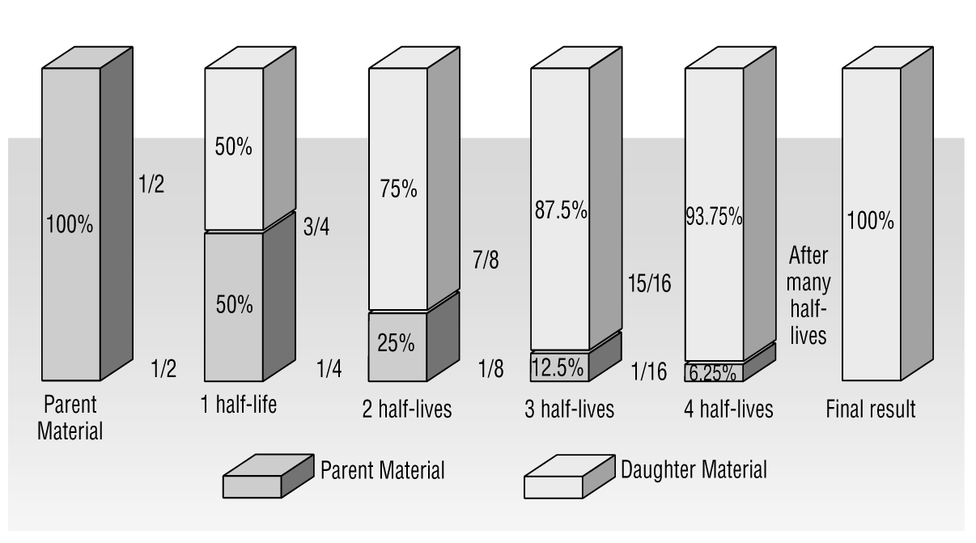

- What will the remaining percent of parent material be after five half-lives?
A) 0%
B) 3.12%
C) 3.125%
D) 3.13%

- When a species becomes ____________________, there are no longer any living members of its kind.
A) extinct
B) dominant
C) specialized
D) isolated

- When a species becomes ____________________, there are no longer any living members of its kind.
A) extinct
B) dominant
C) specialized
D) isolated

- Determining the age of a rock layer in relation to other rock layers is called ____________________.
A) absolute dating
B) radiometric dating
C) relative dating
D) radiocarbon dating

- Species today are becoming extinct at a greater rate than in the past because of activity by ____________________.
A) volcanoes
B) humans
C) plate tectonics
D) all of the above

- What technique uses a rock's position in the strata and nearby index fossils to determine the age of the rock?
A) absolute
B) approximate
C) exact
D) relative

- Which of the following best describes petroleum?
A) petroleum can be easily manufactured in factories
B) petroleum is considered a renewable resource
C) petroleum is considered a non-renewable resource
D) petroleum is easily found throughout the world

- Which of the following is a fossil fuel?
A) coal
B) oil
C) natural gas
D) all of the above

