UNIT 2- YEAR END REVIEW #1

1. The following are well known medicinal remedies:
I. codeine
II. quinine
III. aspirin
IV. morphine
Which of the above is found in the opium poppy?
A) I
B) II
C) III
D) IV
E) III and IV
F) I and IV

2. Which of the following is not one of the seven major food crops?
A) sorghum
B) barley
C) oats
D) cassava

3. Plants release which of the following substances?
A) water
B) oxygen
C) carbon dioxide
D) nitrogen
E) A and B
F) A, B, and C

4. Water is pushed up the plant by which of the following processes?
A) osmosis
B) transpiration
C) respiration
D) A and B

5. Why are root crops an important food crop in many parts of the world?
A) They require little rainfall.
B) They grow quickly.
C) They may be stored for lengthy periods of time.
D) All of the above

6. Which of the following is not a function of stems?
A) transpiration
B) support
C) transportation of nutrients
D) storage

7. Misha noticed that roots have the following functions:
I. Absorption of water and minerals.
II. Support and anchoring of the plant.
III. Food storage.
Which of these functions will help the plant in times of scarcity?
A) I
B) II
C) III
D) all of the above

8. How does water get into plants?
A) It is pulled by transpiration and pushed by osmosis.
B) It is pulled by osmosis and pushed by transpiration.
C) It is pulled by osmosis and transpiration.
D) It is pushed by osmosis and transpiration.

9. What is a function of roots?
A) To keep the soil together.
B) To keep soil from sliding down slopes.
C) To release excess water from the plant.
D) A and B

10. Which of the following is the growing part of the tree stem?
A) xylem
B) phloem
C) bark
D) cambium

11. When do guard cells swell to open the stomata?
A) When water is plentiful to slow the gas exchange needed for photosynthesis.
B) When water is scarce to slow the gas exchange needed for photosynthesis.
C) When water is plentiful to increase the gas exchange needed for photosynthesis.
D) When water is scarce to increase the gas exchange needed for photosynthesis.

12. Which part of the plant is responsible for absorbing water?
A) roots
B) stems
C) leaves
D) flowers
E) A and C

13. Where does most photosynthesis occur?
A) roots
B) stems
C) leaves
D) flowers

14. Like animals, plants have adaptations that help them grow and survive in different environments. Arif
wants to create a desert environment in an indoor garden space. Which of the following plant adaptations do not belong in his desert garden?
A) a leaf shape that reduces evaporation
B) a stem that carries out photosynthesis
C) roots exposed to the air
D) leaves have a heavy wax coating

15. What kind of tissue are the xylem and phloem?
A) storage
B) transport
C) structural
D) reproductive

16. A student made the following notes about a plant.
I. The plant is covered in spines.
II. The plant has a long, deep root system.
III. The plant stems and leaves are hard and waxy.
What type of climate is this plant best suited for?
A) hot and humid climate
B) moist and warm climate
C) dry climate
D) cold climate

17. Choose the list of processes that best corresponds with the list "roots, cones, leaves".
A) absorbs water, photosynthesis, reproduction
B) absorbs minerals, reproduction, photosynthesis
C) respiration, reproduction, transpiration
D) osmosis, reproduction, pollination

18. Rosemary is a farmer that would like to raise corn in Northern Alberta. She made a list of traits
common to domestic corn varieties.
I. They require a long hot growing season.
II. They produce many cobs per plant.
III. The cobs may be large with many large tasty kernels.
Which of these traits would Rosemary most likely want to change with selective breeding to meet the
needs of her farm?
A) I
B) II
C) III
D) I and II

19. Josie saw a beautiful plant at a friend's house. She asked for two cuttings, one for her father and one for
herself. The cat ate most of the leaves off of her cutting. The roots of her father's plant grew much faster
than her plant. Why was this the case?
A) Her father took better care of his plant than Josie did.
B) Her father's cutting was stronger than her cutting.
C) More leaves allow for greater food production to support root growth.
D) Leaves interfere with root growth.

20. Which of the following is the part of the plant that attracts insects and other animals to help with
pollination?
A) roots
B) stems
C) leaves
D) flowers

21. A rose breeder crossed a rose of one colour with a rose of another colour. This process is an example
what process?
A) genetic modification
B) asexual reproduction
C) selective breeding
D) grafting

22. In science class one day, Mr. Brown cut three pieces of leafy stem off of a coleus plant.
I. One was put in water.
II. One was put in soil.
III. One was put in a hormone solution
What type of asexual reproduction was investigated in this class?
A) cuttings
B) grafting
C) layering
D) cross-pollination

23. At a berry farm, the stem of a raspberry plant was bent over and covered in soil. Soon this stem rooted
in the soil and became a new plant. What is this technique called?
A) cuttings
B) grafting
C) layering
D) cross-pollination

24. Bees feed on nectar produced by a plant. In doing so, they help the plant with which type of
pollination?
A) self-pollination
B) cross-pollination
C) artificial pollination
D) all of the above

25. What is a fruit?
A) The tasty outer covering of the plant that provides food for the seed.
B) The part of the plant that is edible and carries seeds inside.
C) The product of asexual reproduction.
D) The growing ovary that swells and protects the developing seeds until they are ripe.
E) B and D

26. Seeds may be stored as long as they are kept under which conditions?
A) warm and moist
B) warm and dry
C) cool and moist
D) cool and dry

27. Which of the following is needed by a seed to germinate?
A) moisture
B) soil
C) sunlight
D) fertilizer
E) A and B

28. What is the part of the seed that is a tiny new plant?
A) cotyledon
B) embryo
C) ovule
D) seed coat

Ref: Use the following scenario to answer the next question(s). The given bar graph shows the results of a germination study.
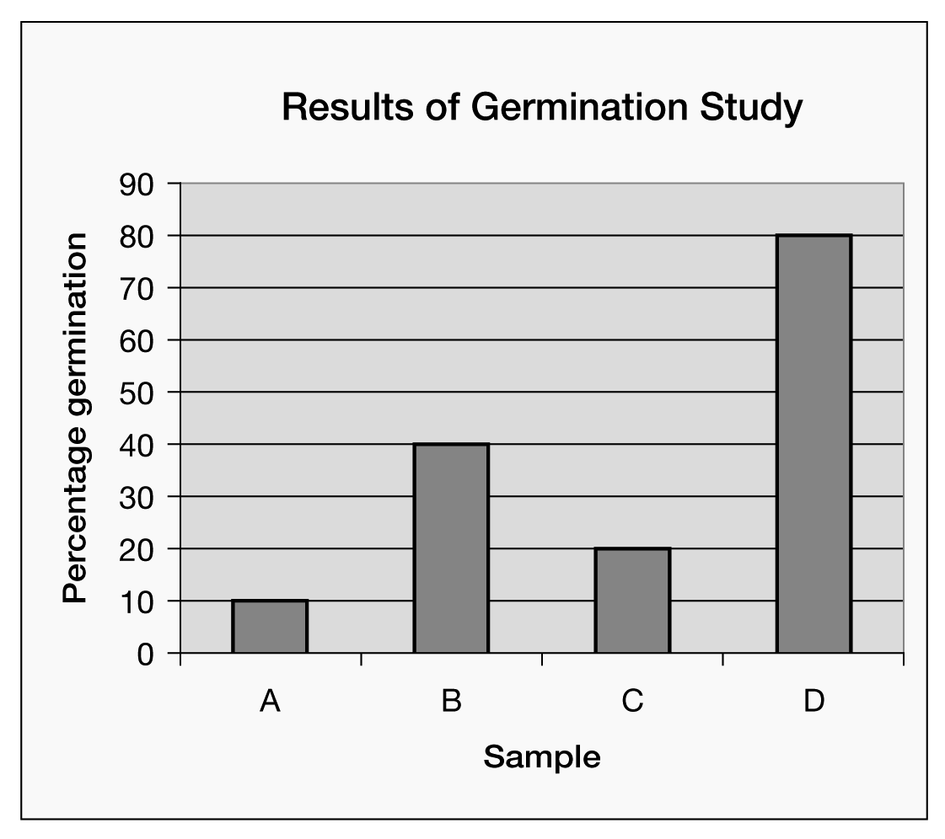

29. The conditions in 'D' were most likely …
A) warm, dry and dark
B) warm, dry and light
C) warm, moist and dark
D) cool, moist and dark

30. The conditions in 'B' were most likely …
A) warm, dry and dark
B) warm, dry and light
C) warm, moist and dark
D) cool, moist and dark

31. What do the ovaries in a flower contain?
A) eggs
B) sperm
C) pollen
D) stamens

32. Which of the following is not a reason to worry about the sustainability of agriculture and forestry?
A) Some small areas like national parks have been preserved.
B) 20 million hectares of land in Alberta is in monoculture.
C) Most of the native grasslands have been cultivated.
D) Farmers have become more dependent on chemical fertilizers and pesticides.

33. Which of the following conditions may be controlled in a greenhouse?
A) climate
B) soil
C) light
D) all of the above

34. Why is Lois Hole important to Alberta agriculture?
A) She identified a biological control for the lygus bug.
B) She developed special hardy seed varieties that could thrive in the Alberta climate.
C) She pioneered genetic modification techniques for Canola plants.
D) She developed innovative irrigation techniques for areas with little rainfall.

35. Which of the following is a true statement about agriculture?
A) Farmers are much more dependent on mechanical technology today than in the early 1900s.
B) Farmers are much less dependent on mechanical technology today than in the early 1900s.
C) Pests no longer need to be controlled by farmers.
D) There is less monoculture in modern agriculture than in the early 1900s.

36. A natural ecosystem has …
A) the same species at different ages.
B) the same species that are all the same age.
C) a diversity of species that are all the same age.
D) a diversity of species at different ages.

37. Why is slash burn no longer a process used in reforestation?
A) The slash burn method created a great deal of smoke and led to health and safety problems.
B) Better methods were found to recycle nutrients and minerals to the soil.
C) Quicker ways were found to eliminate debris from logging.
D) More labour-intensive ways to remove debris help save money.

38. Bethany has joined a reforestation team for the summer. Which of the following would not be part of
reforestation work?
A) Mowing of competing trees in order to protect newly planted trees
B) Fertilization of young trees
C) Selective harvest
D) Planting by hand
E) Controlling fires

39. Which of the following technologies increases erosion?
A) summer fallowing
B) shelterbelts
C) using forages in a crop rotation
D) zero-tillage

Spencer was concerned about the soil quality in one of his fields. He sent a soil sample away to be tested and received the following information:
Substance | Level
salt | above normal
nitrogen | low
phosphorous | above normal
potassium | high
40. What is the best course of action for Spencer to follow in order to remedy his soil problems and rebuild
the health of the soil?
A) Plant alfalfa and let it grow for at least three years. Monitor irrigation closely.
B) Reduce irrigation and summer fallow this season.
C) Reduce irrigation, plant wheat, and add nitrogen fertilizer.
D) Reduce irrigation, plant wheat, add nitrogen, and summer fallow next year.

41. A gardener notices that her tomato plants grow large and leafy, but have few flowers and fruit. What
does this problem tell her about her soil?
A) There is sufficient phosphorous, but not enough nitrogen or potassium.
B) There is sufficient nitrogen, but not enough phosphorous or potassium.
C) There is sufficient potassium, but not enough phosphorous or nitrogen.
D) There is a nitrogen deficiency

42. Which of the following is an advantage of summer fallowing land?
A) Soil is exposed and loosened.
B) Weeds are controlled.
C) The farmer has fewer acres to produce crops.
D) The farmer will cultivate the soil more often.

43. Irrigation has been widely used in many parts of the world to maximize yields.
Over time the use of irrigation may begin to decrease yields because of …
A) salinization.
B) wind erosion.
C) water erosion.
D) A and B

44. Growing plants without soil is called …
A) greenhouse cultivation
B) zero-tillage
C) hydroponics
D) aquaponics

45. Growing plants without soil is called …
A) greenhouse cultivation
B) zero-tillage
C) hydroponics
D) aquaphonics

46. Which of the following is the most important reason to conserve the soil?
A) Healthy soil means a steady and plentiful food and fibre supply for the future.
B) We do not have the technology to produce plants without soil.
C) Soil erodes.
D) We need soil for yards and houses.

47. Soil is a mixture of weathered rock and what material?
A) sand
B) decayed organic matter
C) moss
D) minerals

48. Soil is a mixture of weathered rock and organic matter, but a more complete description would also
include...
A) clay.
B) air, water, and mineral fragments.
C) bacteria.
D) water and oxygen.

49. Which of the following can slow soil erosion?
A) zero-till farming
B) cutting trees from the middle of fields
C) plowing at least three times a year
D) farming on steeper slopes

50. What is the organic matter in humus made of?
A) plant remains
B) animal remains
C) bacteria and fungus
D) all of the above

51. The uppermost horizon in a soil profile has more of this than the other horizons have.
A) humus
B) sediment
C) mineral
D) rock

52. How long can it take for soil to evolve?
A) five to ten years
B) thousands of years
C) one year
D) billions of years

53. Shelter belts of trees protect soil from erosion caused by which of the following?
A) lack of rain
B) too much rain
C) wind
D) snow

54. Where does soil erosion occur?
A) where animals eat away all the plants
B) where groundwater evaporates
C) where rainfall is low
D) all of the above

55. Crop rotation allows the soil to recover which of the following?
A) water
B) plants
C) nutrients
D) horizons

56. Which of the following does not describe a problem with pests?
A) Insects dine on plant parts.
B) Weeds steal moisture, nutrients, space, or light from the crops.
C) Microscopic actinomycetes decompose plants.
D) Fungi cause infections in plants.

57. Cliff needs to control grasshoppers in his fields. Which of the following actions would have the least
negative impact on the environment.
A) Summer fallow the land.
B) Encourage grasshopper-eating bluebirds to nest on and around his pastures.
C) Apply an insecticide, plough under the forage, and plant canola.
D) Apply an insecticide, plough up the pasture, and grow grain.

58. Which of these pest control methods does not belong with the others?
A) Cleaning machinery carefully before going to a different field.
B) Crop rotation.
C) Spraying with pesticides.
D) Cutting weeds along edges of property.

59. Most consumers like the idea of eating organic food. Very few consumers insist on organic food. Why?
A) Organic food is often not as good as the non-organic food.
B) Organic food is not as appealing even though it often costs less.
C) Organic food is often more expensive than non-organic food.
D) People are afraid of finding worms in their food.

60. What is organic food?
A) Food that is grown in soil rather than using hydroponic technology.
B) Food that is grown without chemical pesticides.
C) Food that is grown without chemical pesticides or fertilizers.
D) Food that is grown in a crop rotation.

61. Which statement best describes the term "pest"?
A) A weed that competes for soil and water.
B) A plant that does not affect humans.
C) Any living thing that humans feel is unwanted
D) Bees, ants, birds

62. Find the match for this word sequence: weed, fungus pest, insect pest.
A) spreads disease, eats crop, robs from the crop
B) robs from the crop, spreads disease, eats the crop
C) robs from the crop, eats the crop, spreads disease
D) eats the crop, spreads disease, robs from the crop

63. Why do the powerful roots of dandelions make them good pests?
A) They are deep and hard to remove completely.
B) They creep under the surface of the soil and emerge in other places.
C) They release chemicals that slow down the growth of other plants.
D) All of the above
E) A and C
F) B and C

64. Thomas found a graph that shows the relationship between bluebirds and grasshoppers, a common insect pest. According to the graph, which of the following statements is not correct?
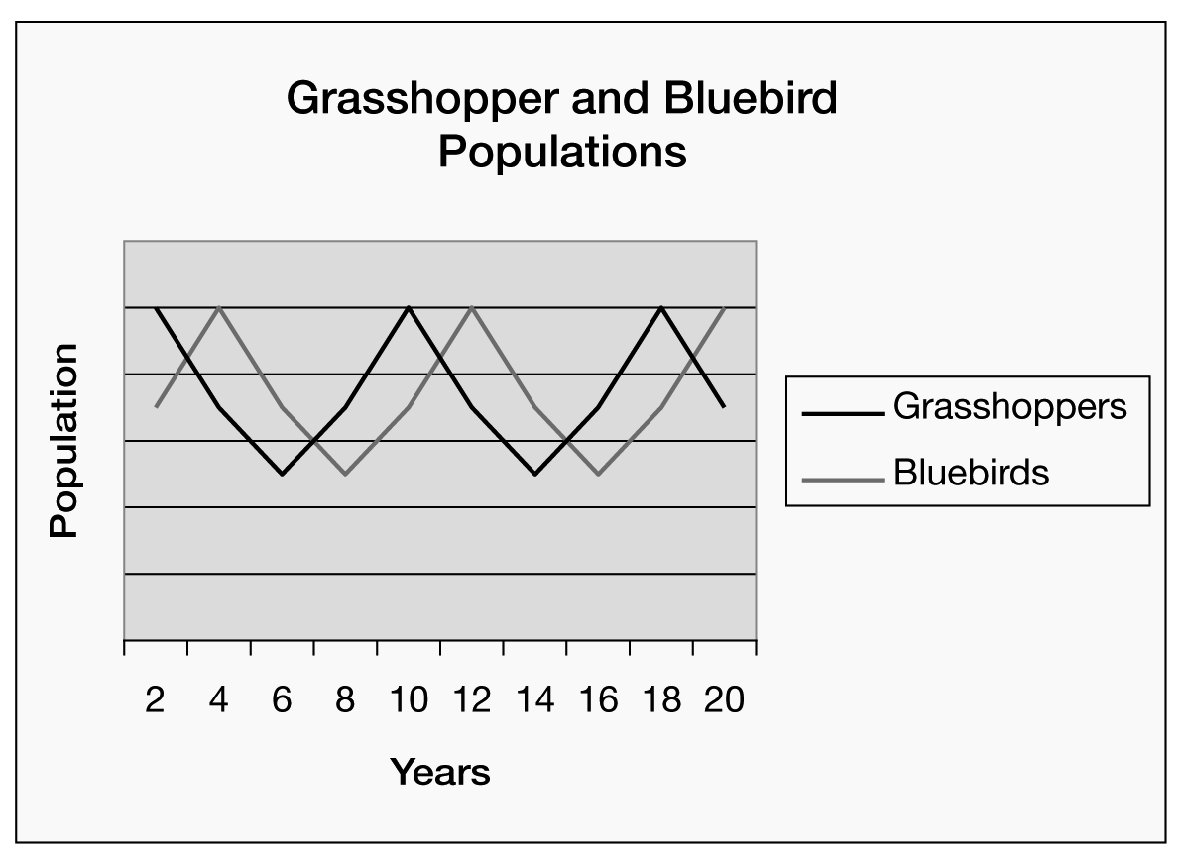

A) The grasshopper population is affected by the bluebird population.
B) The bluebird population is affected by the grasshopper population.
C) If there were no bluebirds, the grasshopper population would increase.
D) If there were no grasshoppers, the bluebird population would decrease.
E) all of the above

65. Why is crop rotation an effective way to control pest populations?
A) Different machinery is used for different crops.
B) More cultivation is required in order to plant different crops every year.
C) Pest populations do not have the chance to establish themselves in a field before the crop is changed.
D) All of the above.

