Plants Practice Quiz
1. Plants prevent the process that moves soil from place to place, because their roots hold the soil in place. This process is called
- Erosion
- Respiration
- Weathering
- Protection
2. The structure in seed plants that contains an embryo, that will form a new plant is the
- Root
- Stem
- Seed
- Leaf
3. The structure in seed plants that provides a pathway for the movement of water and nutrients for the plant is the
- Flower
- Stem
- Leaf
- Root
4. The structure in seed plants that allows water to exit the plant is the
- Flower
- Stem
- Leaf
- Cone
5. The function of the root is to
- Absorb water
- Support
- Produce food
- Reproduce
6. Moving water up a plant from the roots to the leaves occurs by a combination of different processes. The main process that draws water up from the plant roots is
- Osmosis
- Diffusion
- Xylem
- Transpiration
7. The process described in questions 6 takes place in the
- Leaves
- Stem
- Flowers
- Roots
8. Osmosis is the diffusion of water particles when there is a difference in concentration. When the concentration of water in the soil is greater than the concentration of water in the roots of the plant, water particles will move to the
- Stem tissue
- Leaf cells
- Root hairs
- Stem tubes
9. It is during this stage in a seed plant’s life cycle that it has flowers.
- Seed
- Seedling
- Adult
- Germination
10. Plants can reproduce without seeds. Stems can produce new plants. Stems that grow underground and reproduce without seeds are called
- Runners
- Rhizomes
- Suckers
- Bulbs
11. Some growers attach a part of one plant to another, and the two plants grow together. This reproductive technique is called
- Sorting
- Grading
- Cutting
- Grafting
12. Grasses have very deep roots. This helps them to adapt when what occurs?
- Flooding
- Drought
- Predation
- Competition
13. When moistened and then squeezed, this type of soil will stick together forming a tight ball.
- Sandy
- Clay
- Loam
- Sediment
14. This type of soil is dark brown or black and absorbs water very well.
- Sandy
- Clay
- Loam
- Sediment
15. When earthworms are moving through the soil they eat it, grind it, digest it and mix it. Their mucus helps stick the particles together and their tunnels provide
- Protection
- Minerals
- Moisture
- Air

16. The practice of planting a particular crop in a field every year, to match the nutrients the soil has for this particular crop is called
- Monoculture
- Crop rotation
- Summer fallow
- Zero tillage

17. Spreading manure over cropland is a technique growers use to improve the yield of different crops. This action adds nutrient to the soil.
- Salt
- Calcium
- Vegetation
- Organic matter

18. A plant that is chosen because it is more resistant to disease is an example of
- Personal preference
- Selective preference
- Genetic engineering
- Selective breeding

19. Biological control is one way to reduce the effect of pests on plants. To keep a pest’s numbers under control, these biological controls would likely be used.
- Invasive species
- Natural predators
- Pesticide
- Companion planting

20. The roots of a plant perform several functions, including all of the following EXCEPF
- Hold the soil together
- Photosynthesis
- Support and anchor the plant
- Absorb water and minerals
- Store food
21. The leaves are the plant’s food factories. During the day, the plant uses carbon dioxide and water. When there is no light, the plant releases carbon dioxide and takes in oxygen. This process is called
- Photosynthesis
- Transpiration
- Respiration
- Osmosis
22. Sexual reproduction occurs in many plants. The plant reproductive parts are contained in the flower. The seed is formed once the plant has been pollinated. The cotyledon is a vital part of the “seed in storage”. Its function is to
- Protect the embryo
- Fertilize the egg
- Provide food
- Enable the seeds to disperse
23. Starting new plants from cuttings is an example of
- Germination
- Grafting
- Sexual reproduction
- Vegetative reproduction

24. Asexual reproduction is a process that requires
- only one parent, and produces many offspring, all different
- only one parent, and produces offspring identical to the parent
- two parents, and produces offspring identical to parents
- two parents, and produces many offspring, all different
25. Which of the following is an ADVANTAGE of sexual reproduction over asexual reproduction?
- It requires two parents
- It produces fewer offspring
- It produces greater variety in the offspring
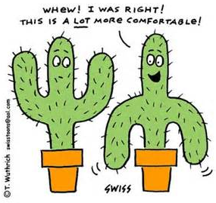
- It only requires one parent

26. In the diagram, which parts for the female part of the flower?
- W and Y
- V and X
- 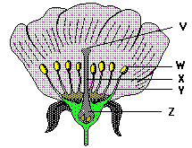W, Y and Z
- V, X and Z
27. In the flower diagram, what is the name of part W?
- Anther
- Ovary
- Filament
- Style
28. The function of part V (in the flower diagram) is to
- Produce pollen
- Attract insects
- Carry the flower’s scent
- Receive the pollen

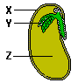

29. In the diagram above, what is the main function of part X?
- To protect the seed until suitable conditions for germination occur
- To give the seed its characteristic colour
- To stop animals from eating the seeds
- Supplying food for the seed
30. The main function of part Z in helping the new plant grow is to
- Give the seed its shape
- Supply food for animals that want to eat the seeds
- Stop the seed from collapsing from the pressure of the surrounding earth
- Act as food reserves until the growing plant can support itself
31. Using ladybugs to control aphids is an example of
- Biological controls
- Companion planting
- Insect controls
- Pesticide controls

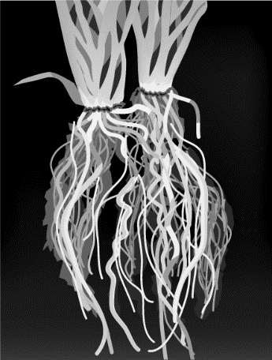
32. The plant to the right is best adapted to which of the following conditions?
- Areas where water is scarce
- Areas where water is abundant or close to the surface
- Areas with clay soil
- Areas where it is cold and dry

33. The development of a seed into a new plant is called
- Germination
- Fertilization
- Dispersal
- Pollination

34. Which of the following is not needed by a seed to germinate?
- Moisture
- Nutrients
- Warmth
- Sunlight

