Final Exam

Multiple Choice
Identify the choice that best completes the statement or answers the question.

unit 1

1. (1 point)
What is the least digit you would add to 873 to make the number divisible by 10?

a. | 2 | b. | 3 | c. | 5 | d. | 7

2. (1 point)
Which number is divisible by 3 but not divisible by 6?

3422, 3431, 3423, 3427

a. | 3427 | b. | 3423 | c. | 3431 | d. | 3422

3. (1 point)
Identify the variable in the algebraic expression 5 + 9x.

a. | 9x | b. | 5 | c. | x | d. | 9

4. (1 point)
If n represents any term number, write a relation for the term.

Term Number |  | 1 | 2 | 3 | 4 | 5 | 6
Term |  | 8 | 9 | 10 | 11 | 12 | 13

a. | n + 2 | b. | n + 8 | c. | n + 7 | d. | 7n

5. (1 point)
Use algebra. Write a relation for the Input/Output table.

Input x | 1 | 2 | 3 | 4 | 5
Output | 15 | 14 | 13 | 12 | 11

a. | 15 – x | b. | x + 11 | c. | x – 16 | d. | 16 – x

6. (1 point)
A baker starts off with 8 pies.
He bakes 2 additional pies every hour.

Write a relation to show how the number of pies is related to the number of hours spent baking.

a. | 8t + 2 | b. | 2t | c. | 8 + 2t | d. | 6t

7. (1 point)
Write an equation for the sentence.

A number divided by 4 is 6.

a. | 4 – n = 6 | b. | n – 4 = 6 | c. | = 6 | d. | = 6

8. (1 point)
Write an equation for the sentence.

A number divided by 4 is 8.

a. | 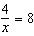 | b. | 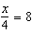 | c. | x – 4 = 8 | d. | 4 – x = 8

unit 2

9. (1 point)
Let one white tile represent +1 and one black tile represent −1.

What integer is modeled by this set of tiles?



a. | +5 | b. | –2 | c. | +12 | d. | +2

- (1 point)
Let one white tile represent +1 and one black tile represent −1.


What sum does this set of tiles model? Write the addition equation.

a. | (−4) + (+3) = –1 | c. | (+4) + (+3) = +3
b. | (−3) + (+4) = +1 | d. | (+3) + (+4) = +7

11. (1 point)
Use a number line to add: (+6) + (–3). Write the addition equation.

a. | 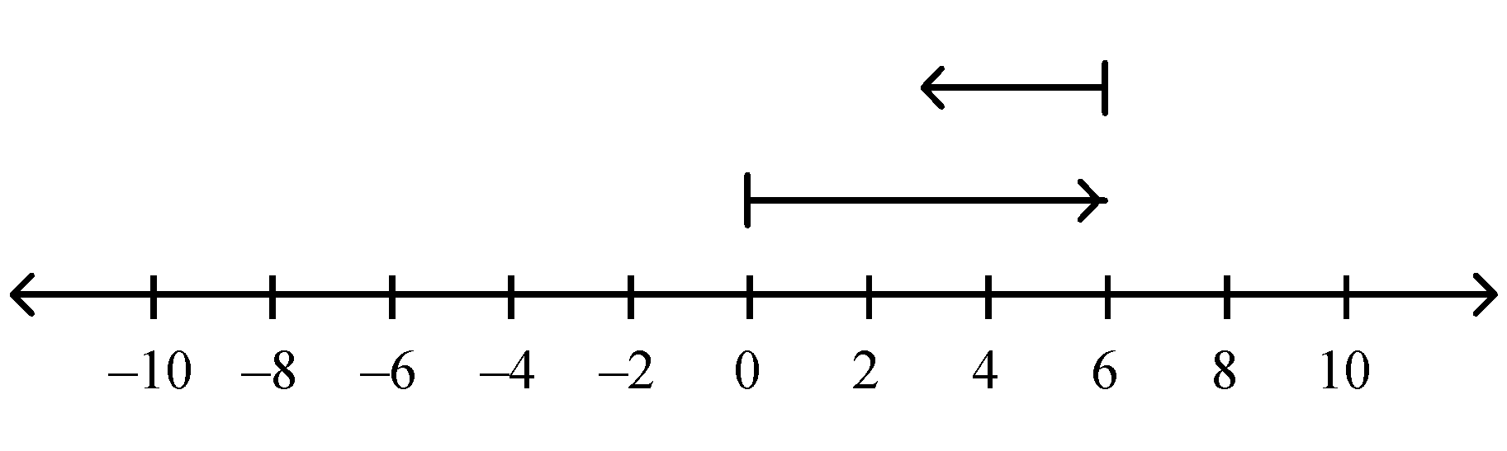  (+6) + (–3) = +3
b. | 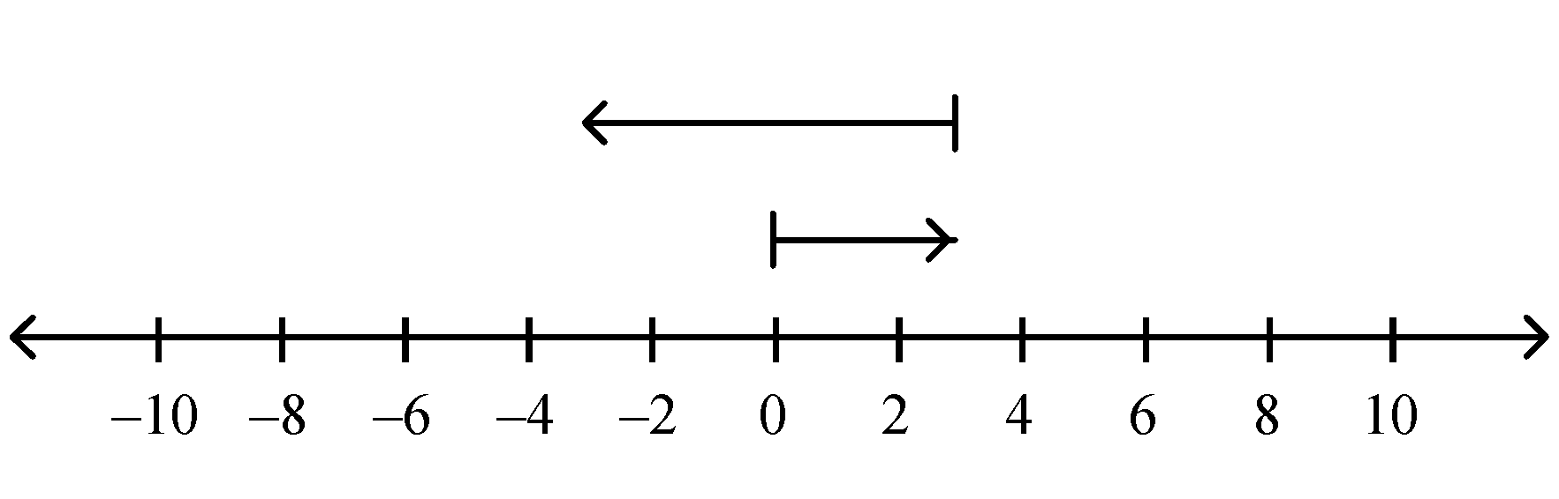  (+6) + (–3) = –3
c. | 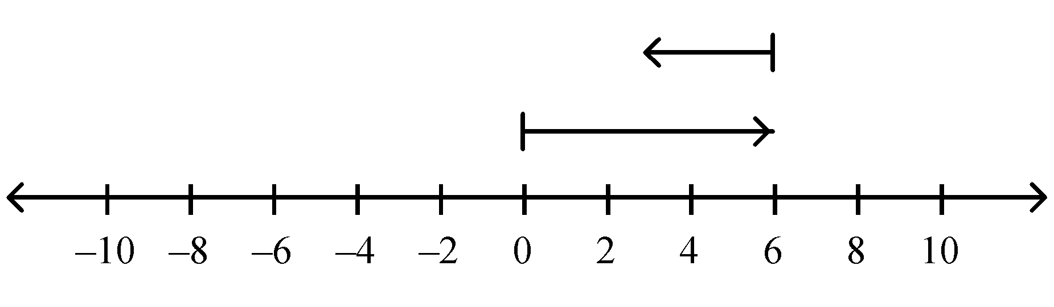  (+6) + (–3) = +9
d. | 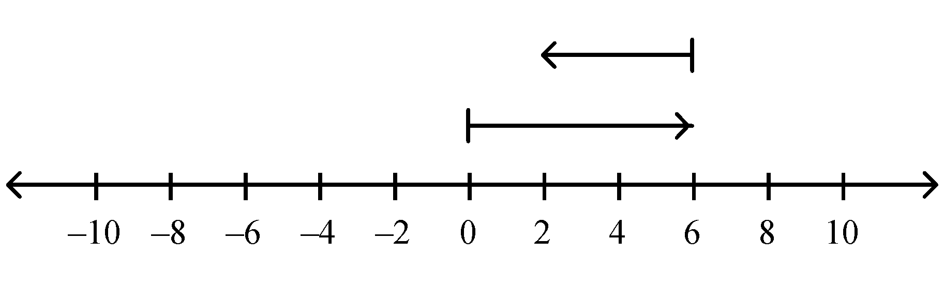  (+6) + (–3) = +2
12. (1 point)
Let one black tile represent −1.

Write the subtraction equation modeled by this diagram.
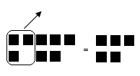

a. | (+8) − (+3) = +5 | c. | (−8) − (−3) = +5
b. | (−8) − (−3) = −5 | d. | (+8) − (+3) = −5

13. (1 point)
Use a number line to subtract.
(+3) (+5)

a. | 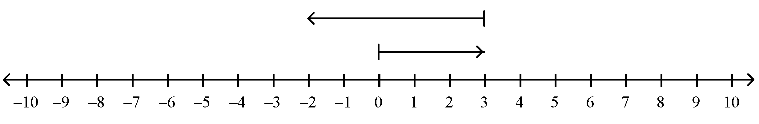
b. | 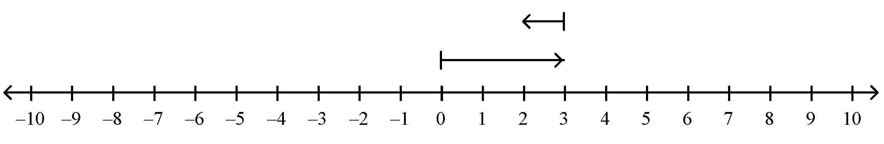
c. | 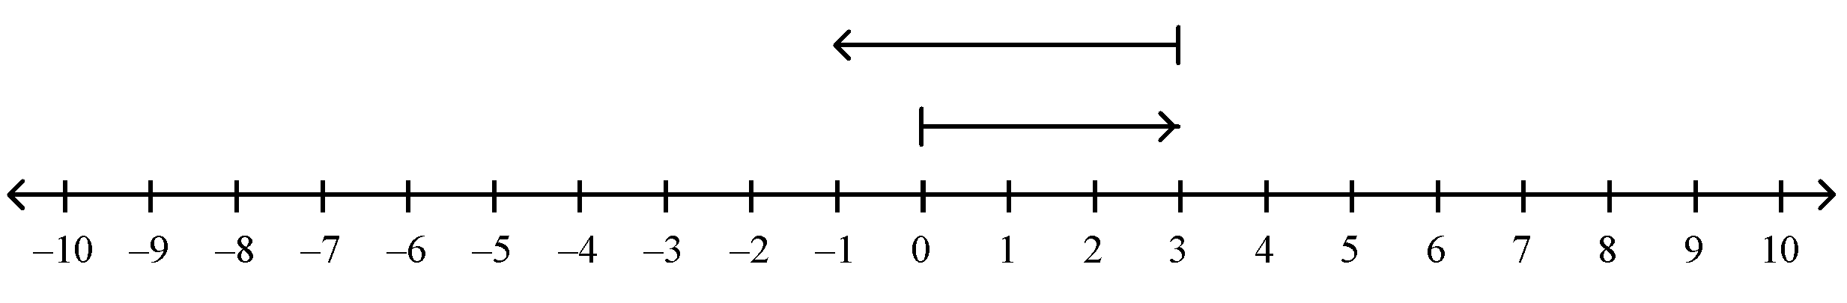
d. | 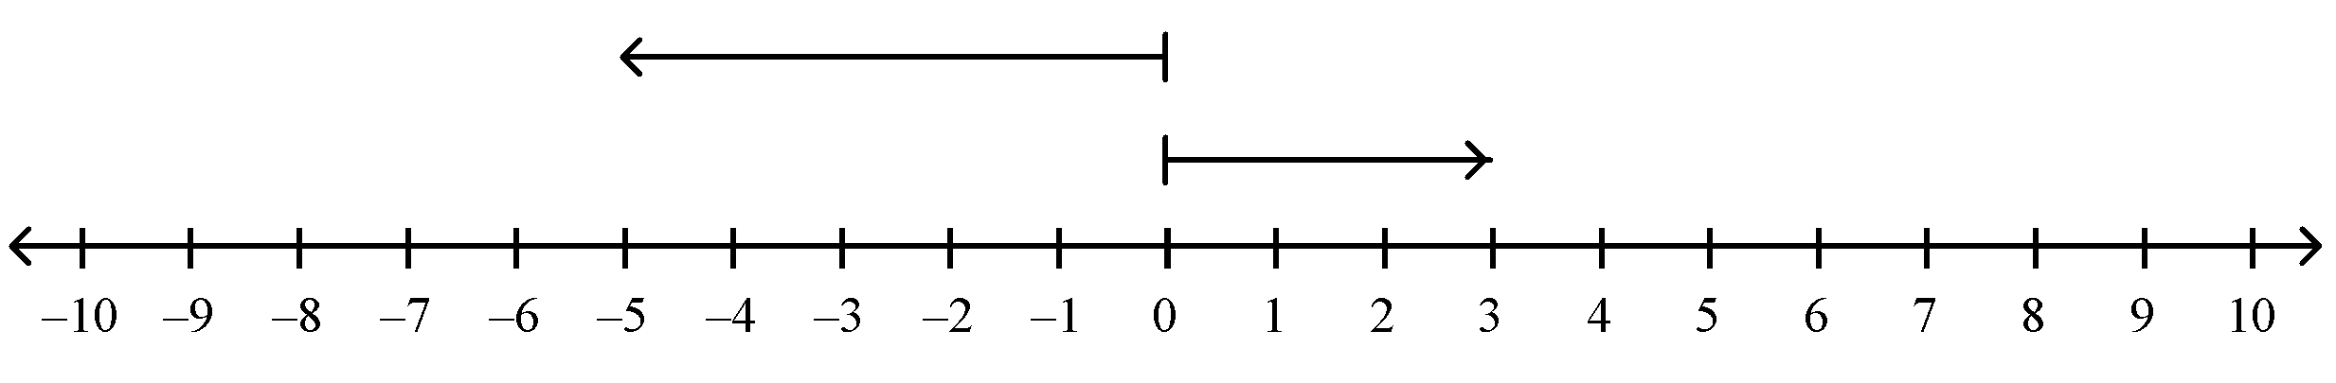

unit 3

14. (1 point)
Write as a decimal.

a. | 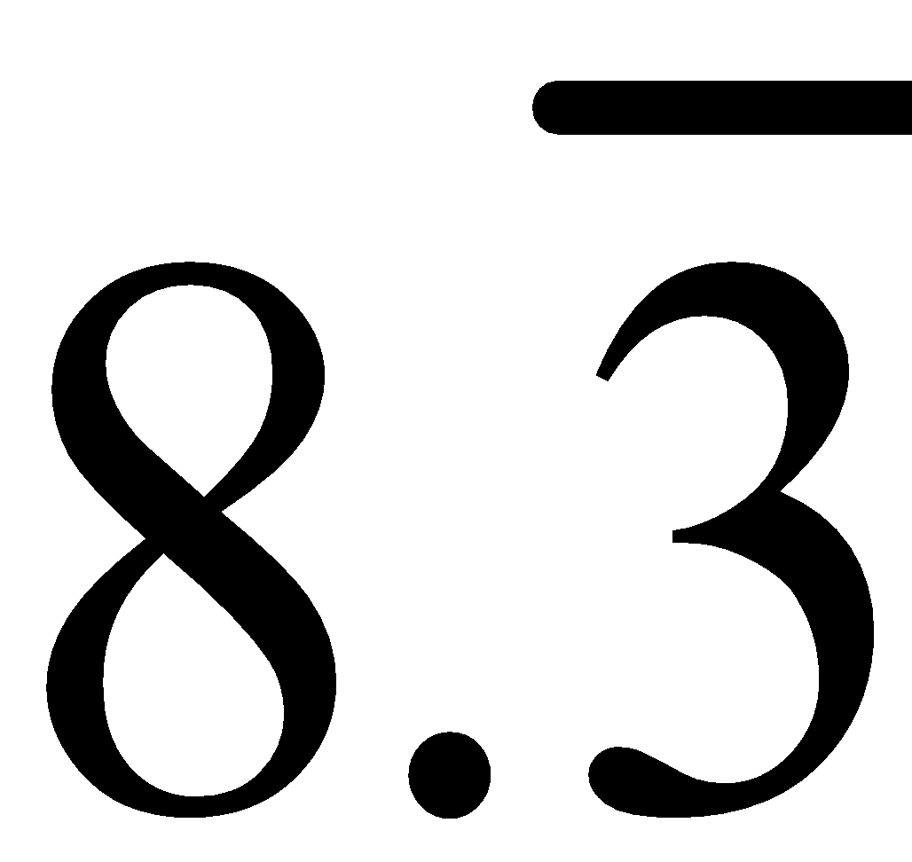 | b. | 0.12 | c. | 1.2 | d. | 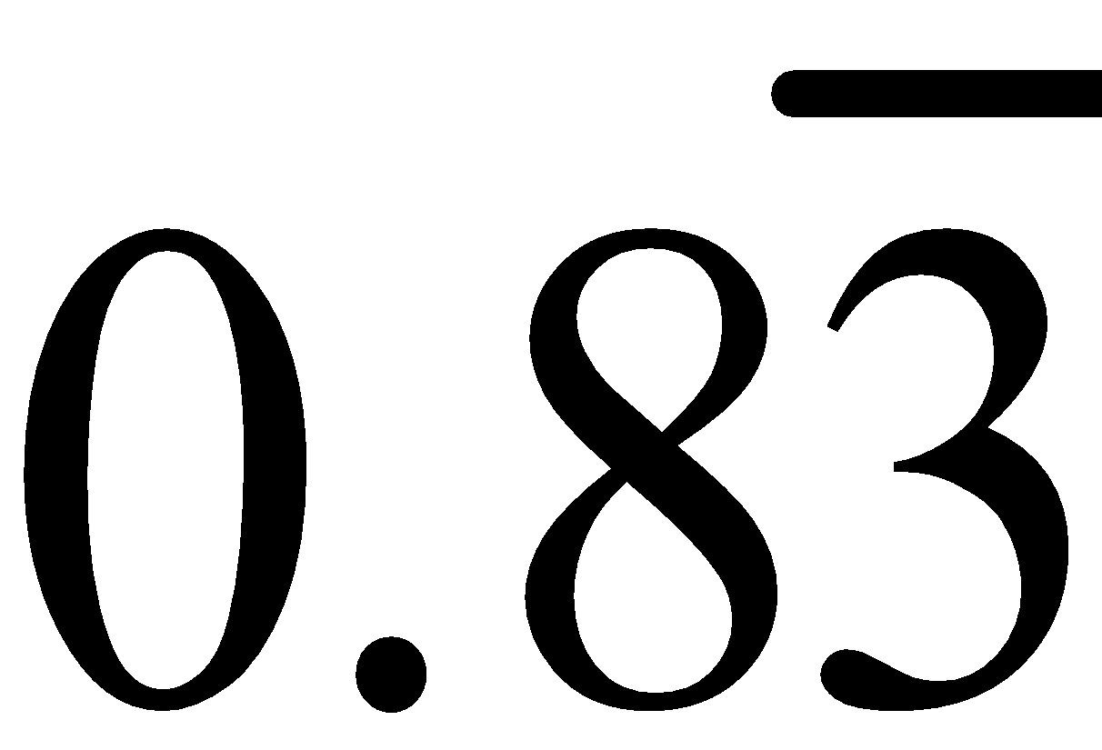

15. (1 point)
Write 0.28 as a fraction in simplest form.

a. | 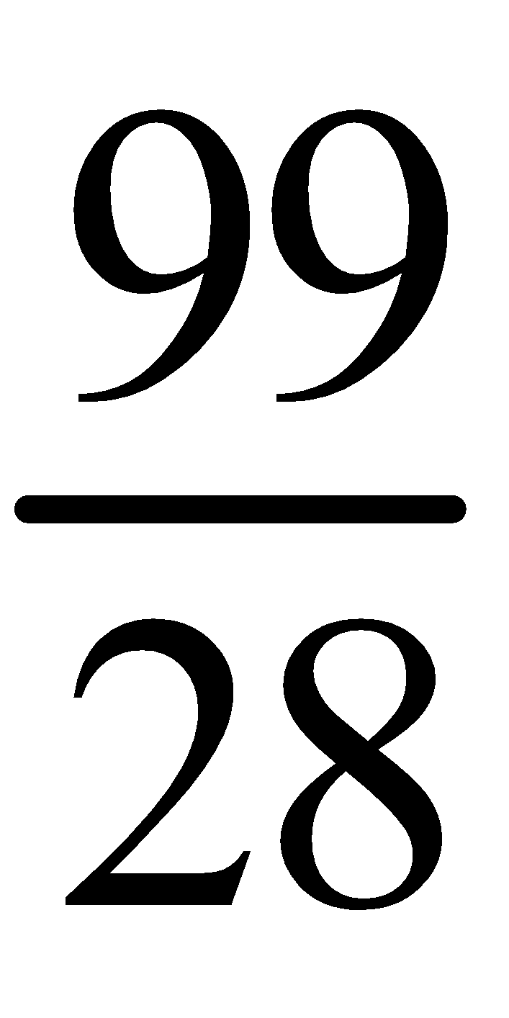 | b. | 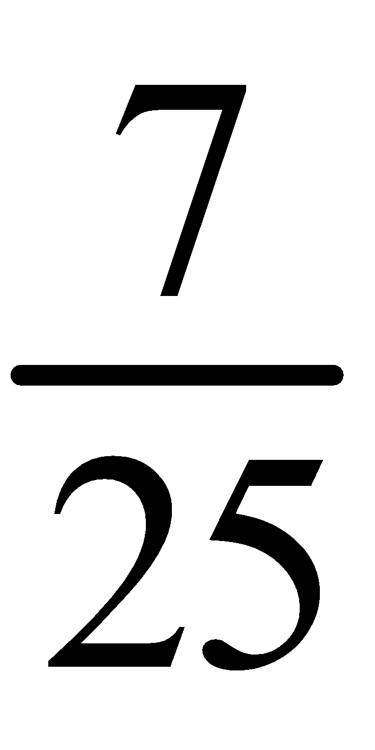 | c. | 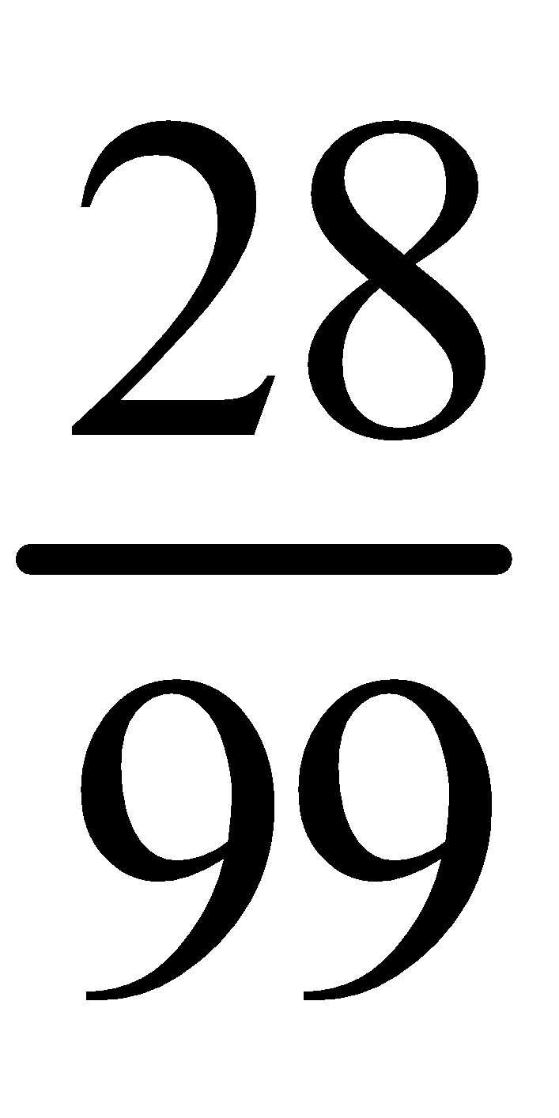 | d. | 

16. (1 point)
What is the greatest number in the set?

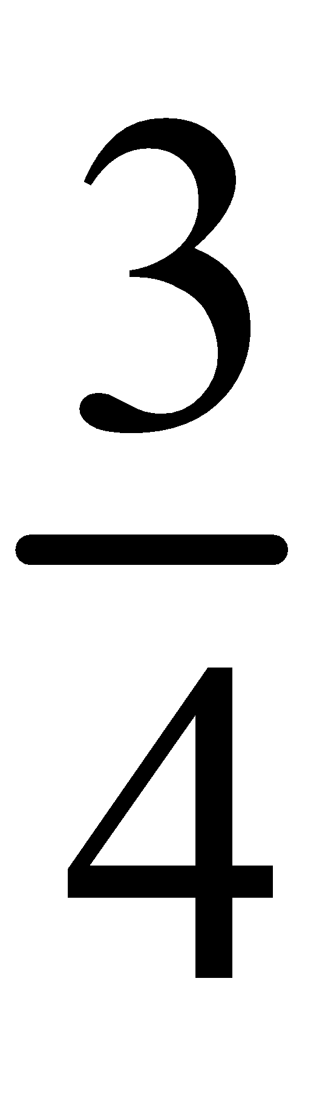, , 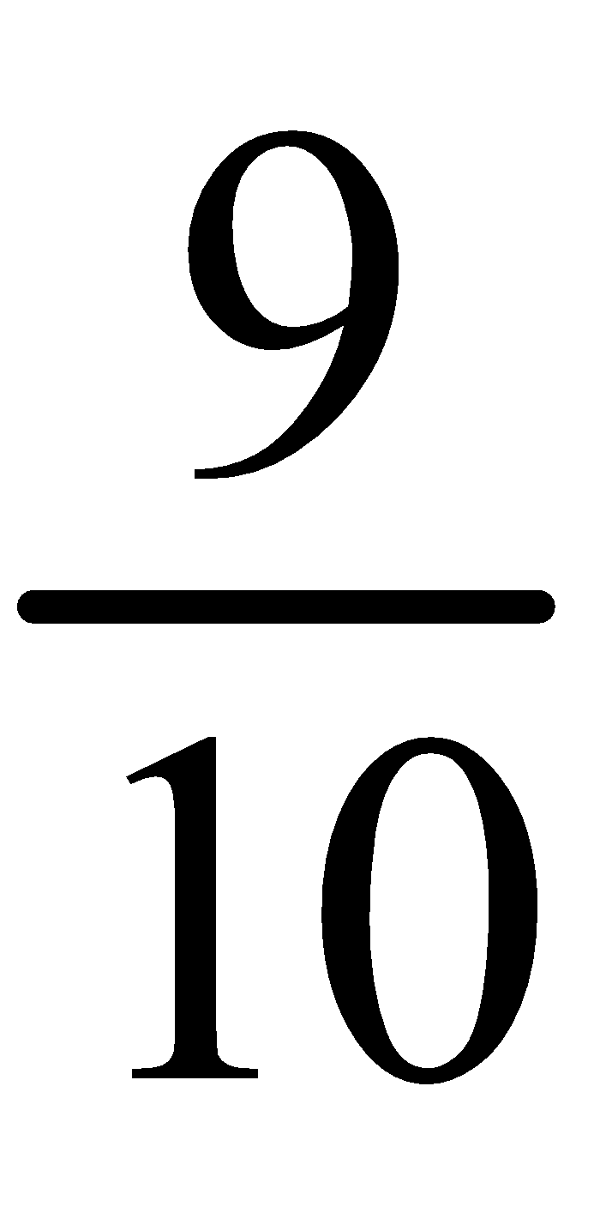, 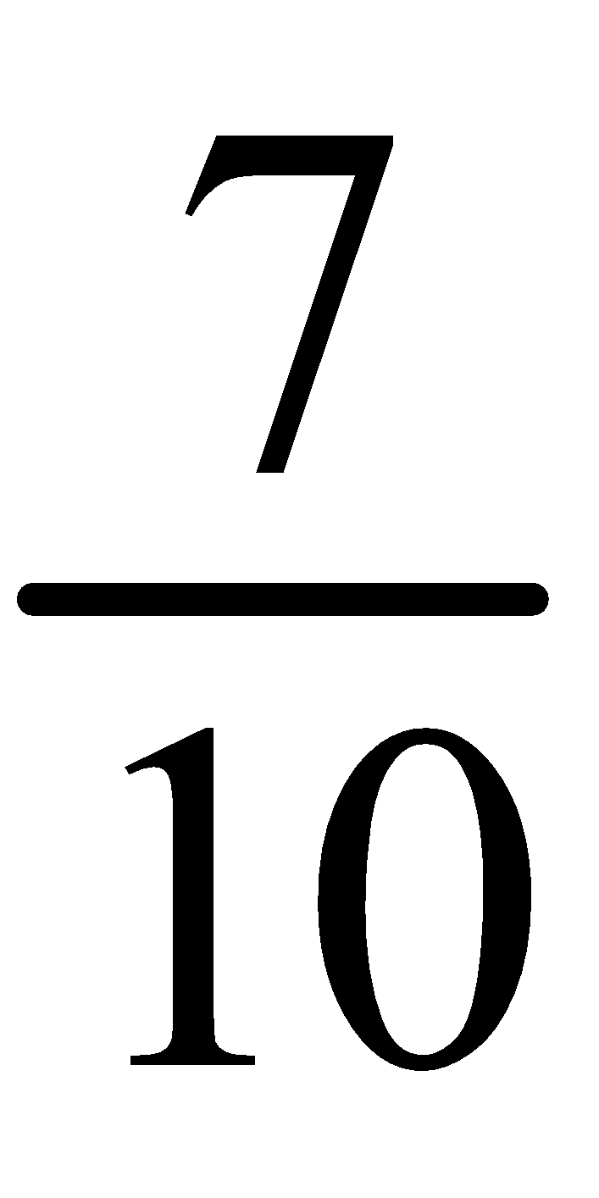

a. |  | b. |  | c. |  | d.

17. (1 point)
Which of the following numbers is closest to 0?

0.11, , 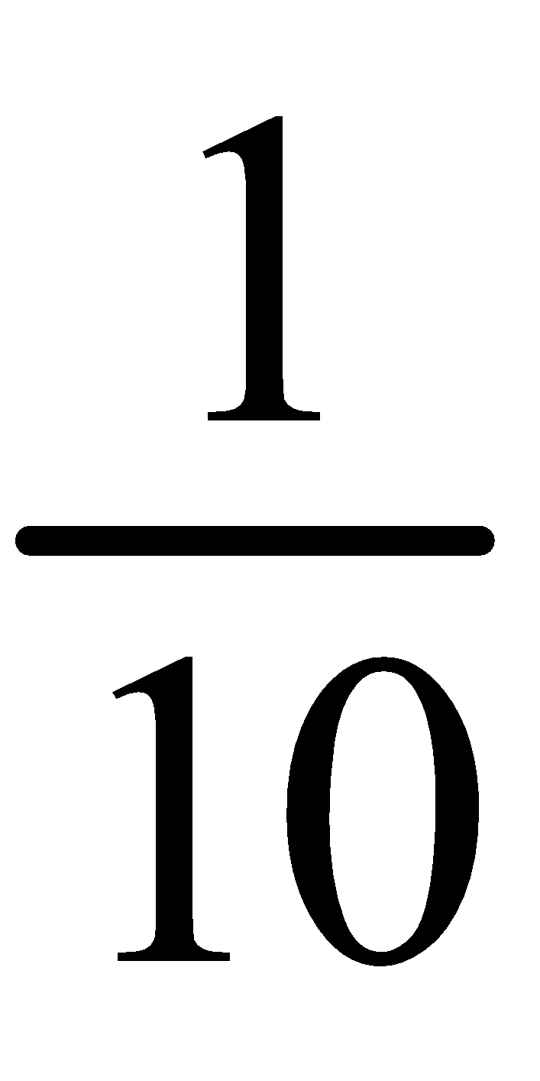, 0.2

a. |  | b. | 0.11 | c. | 0.2 | d.

18. (1 point)
Subtract.

9.123 – 5.77

a. | 3.353 | b. | 8.546 | c. | 4.353 | d. | 4.647

19. (1 point)
Calculate.

6.35 – 3.81 + 1.53

a. | 4.07 | b. | 1.01 | c. | 11.69 | d. | 5.07

20. (1 point)
Write a multiplication equation for the picture.
Each small square represents 0.01.

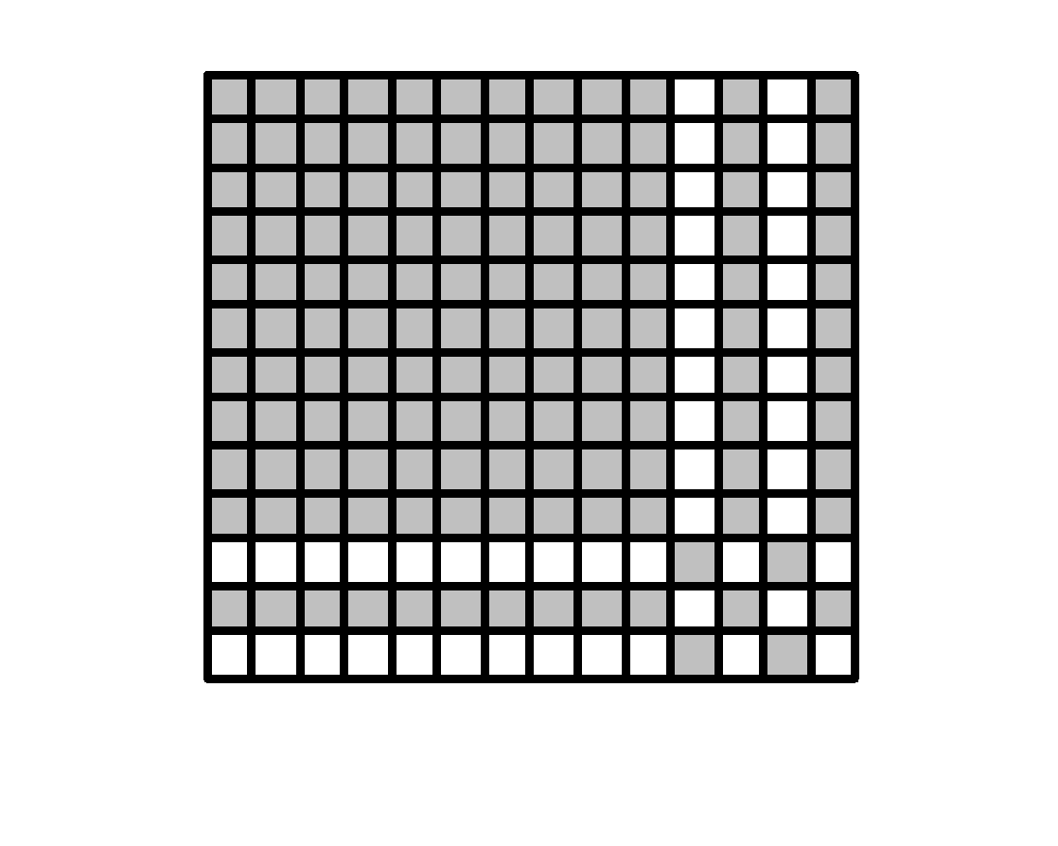
a. | 1.1 × 1.2 = 1.36 | c. | 1.4 × 1.5 = 1.96
b. | 1.3 × 1.4 = 1.82 | d. | 1.5 × 1.6 = 2.10

21. (1 point)
Write a division equation based on the diagram of Base Ten Blocks.
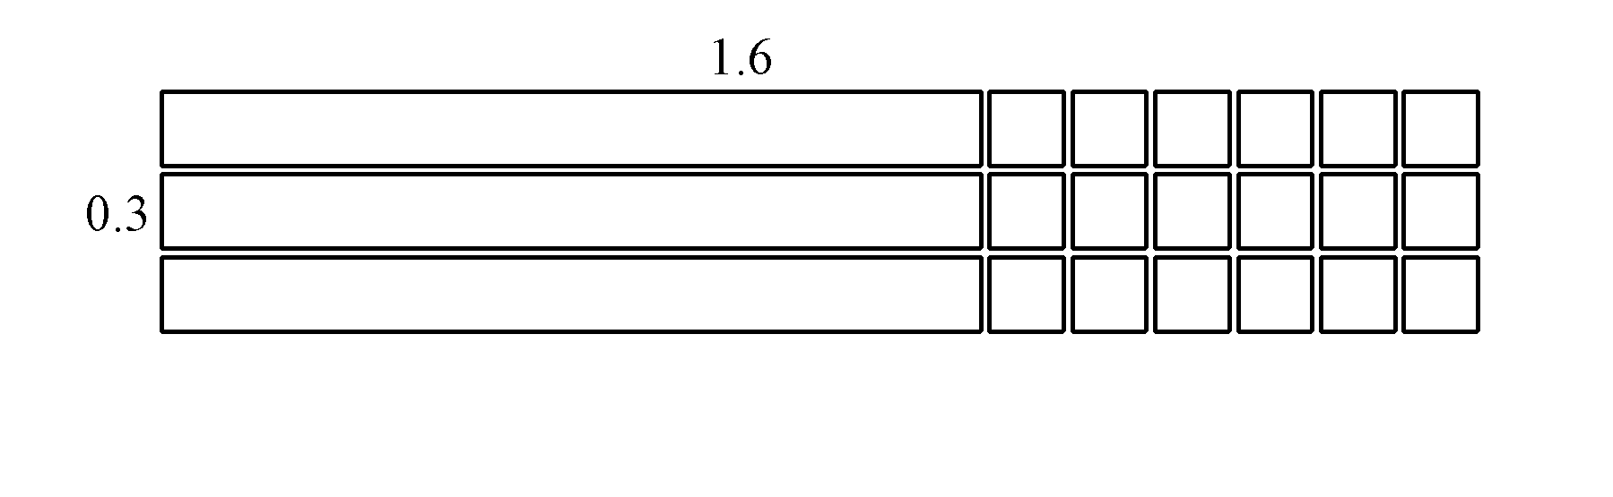
a. | 0.48 ÷ 0.3 = 1.6 | c. | 0.3 ÷ 1.6 = 0.1875
b. | 0.48 ÷ 0.3 = 0.16 | d. | 1.6 ÷ 0.3 = 2.1

22. (1 point)
Evaluate.

a. | 23 | b. | 3.24 | c. | 6.64 | d. | 14.5

23. (1 point)
Write as a percent.

a. | 400% | b. | 40% | c. | 20% | d. | 200%

24. (1 point)
What fraction of the diagram is shaded? Write the fraction as a percent.

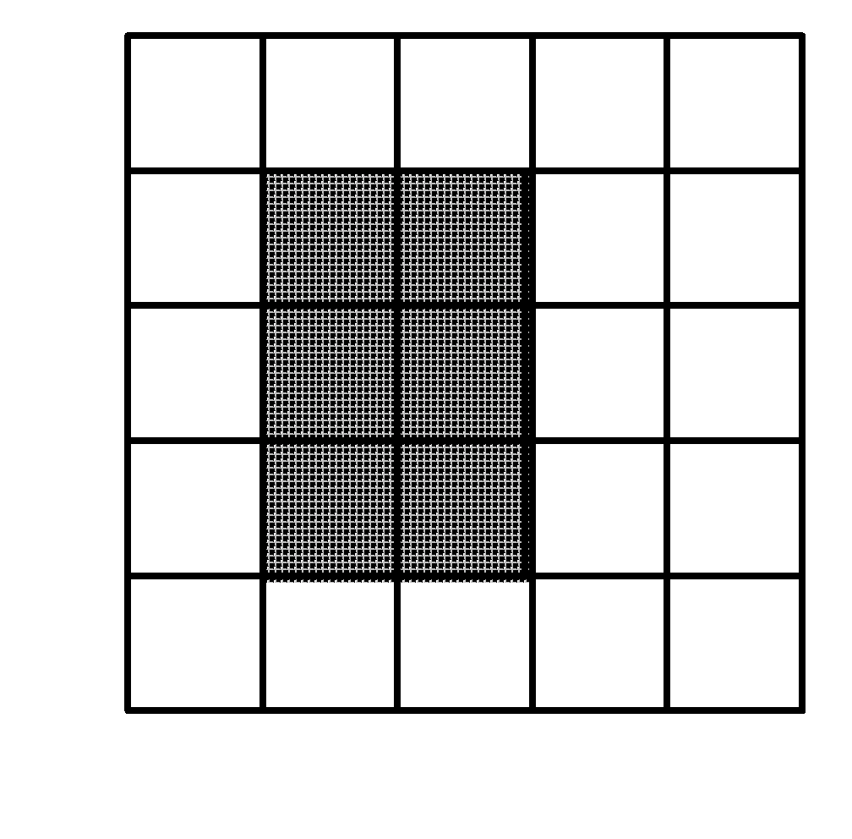
a. | 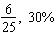 | b. | 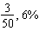 | c. | 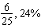 | d. | 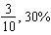

25. (1 point)
There were 10 students on a field trip.
While outside, 50% of the students wore jackets.
How many students wore jackets?

a. | 6 students | b. | 8 students | c. | 7 students | d. | 5 students

26. (1 point)
Everyone in Stuart's class has to do a science project.
Out of the 40 students, 60% have completed their projects.
How many students have completed their projects?

a. | 24 students | b. | 16 students | c. | 64 students | d. | 20 students

unit 4

27. (1 point)
A circle has diameter 49.7 m. What is the radius?

a. | 149.1 m | b. | 24.85 m | c. | 16.6 m | d. | 99.4 m

28. (1 point)
Estimate the circumference of this circle.
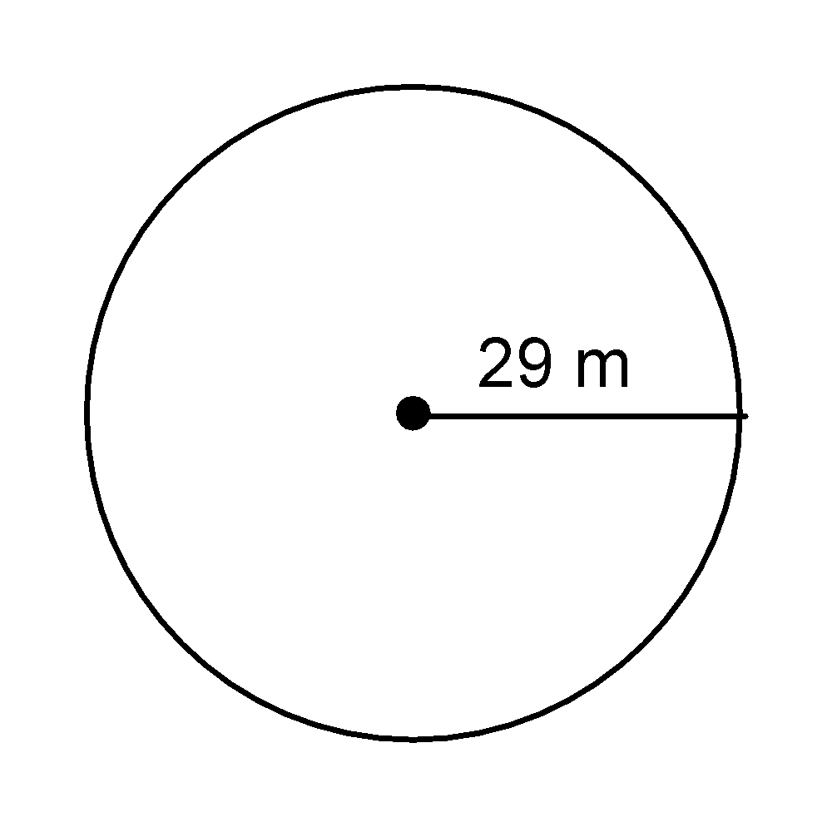
a. | 174 m | b. | 87 m | c. | 32 m | d. | 44 m

29. (1 point)
Find the area of this parallelogram.

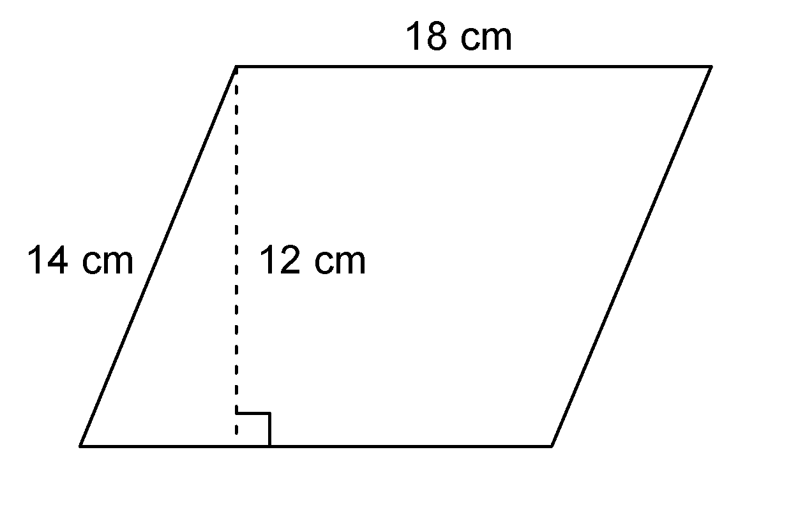
a. | 216 cm² | b. | 252 cm² | c. | 168 cm² | d. | 64 cm²

30. (1 point)
Find the area of this triangle.
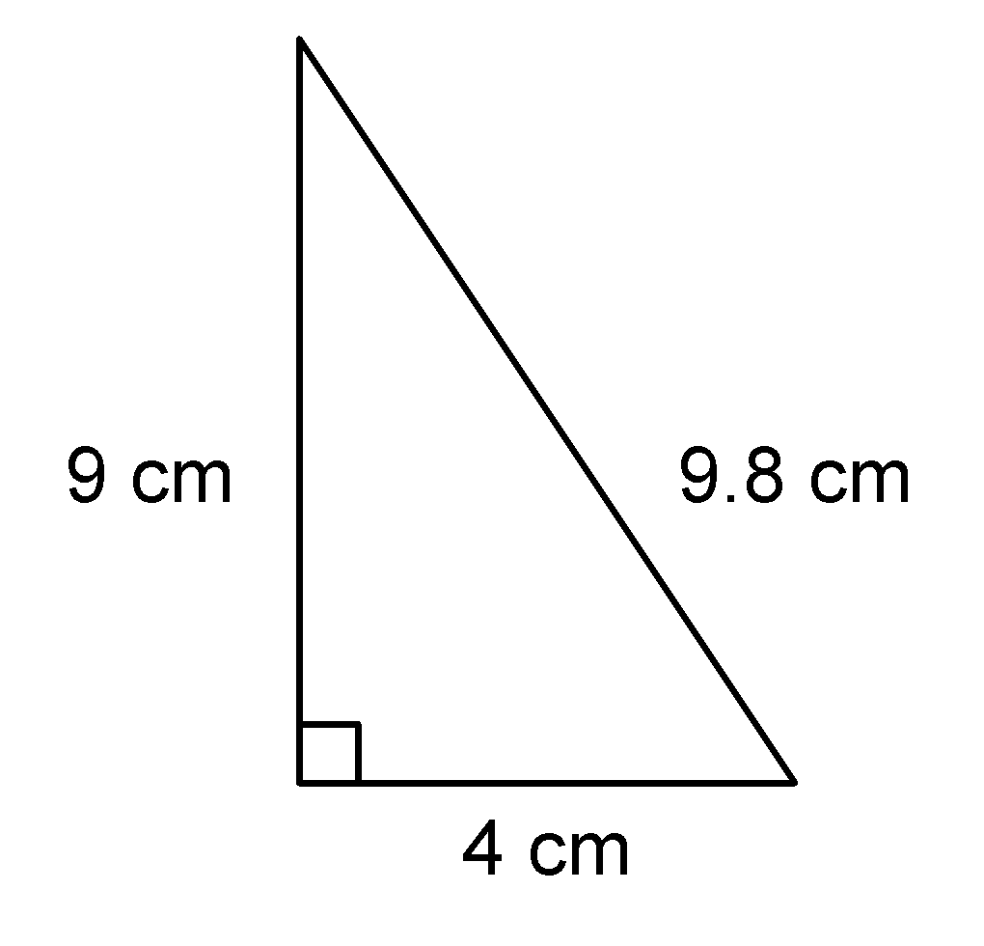

a. | 39.2 cm² | b. | 19.6 cm² | c. | 18 cm² | d. | 36 cm²

31. (1 point)
A circle has radius 20 mm. Find the area.
Round your answer to the nearest square mm.

a. | 126 mm² | b. | 63 mm² | c. | 1257 mm² | d. | 3949 mm²

32. (1 point)
The circle graph shows the breeds of registered dogs at the Clover City Kennel Club.
What percent of dogs are Labrador Retrievers or German Shepherds?

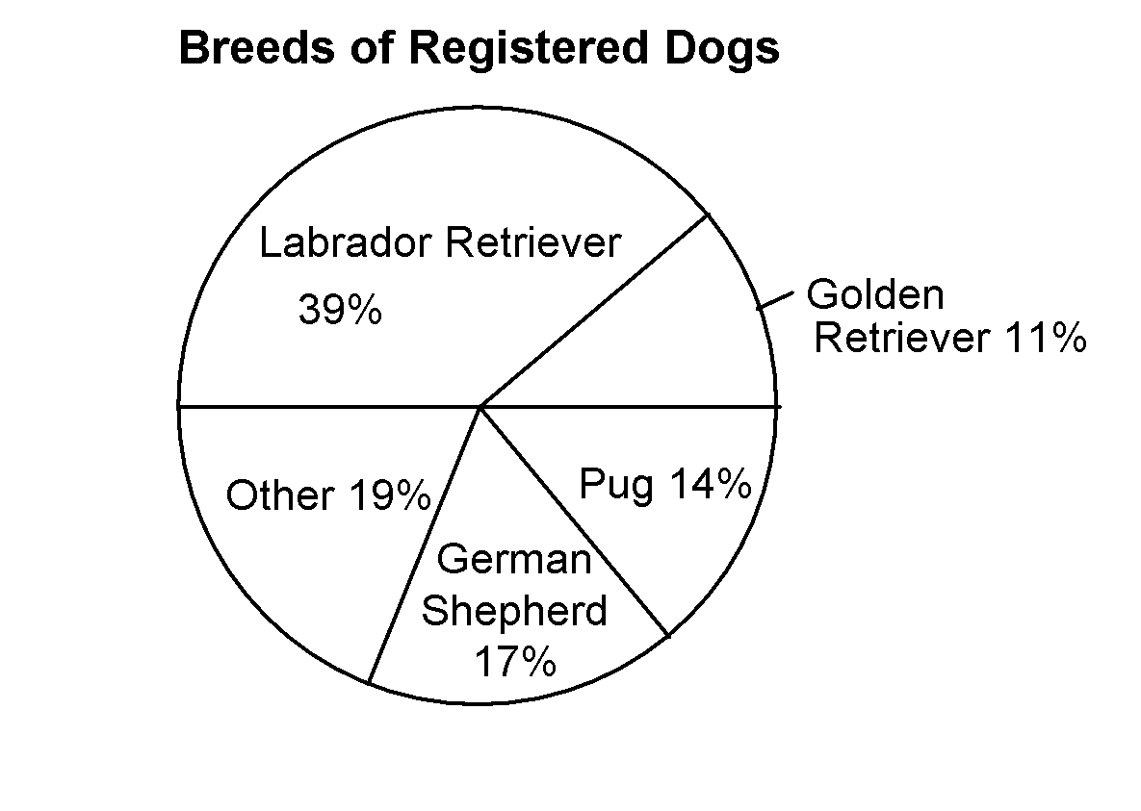

a. | 56% | b. | 53% | c. | 50% | d. | 46%

33. (1 point)
The table shows the number of students who attended the last football game.
If the data were displayed in a circle graph, what percent of the graph would represent the 6th graders?

Grade | Number of Students
6 | 203
7 | 123
8 | 125

a. | 45% | b. | 38% | c. | 55% | d. | 40%

unit 5
.

34. (1 point)
What fraction of this circle is shaded?
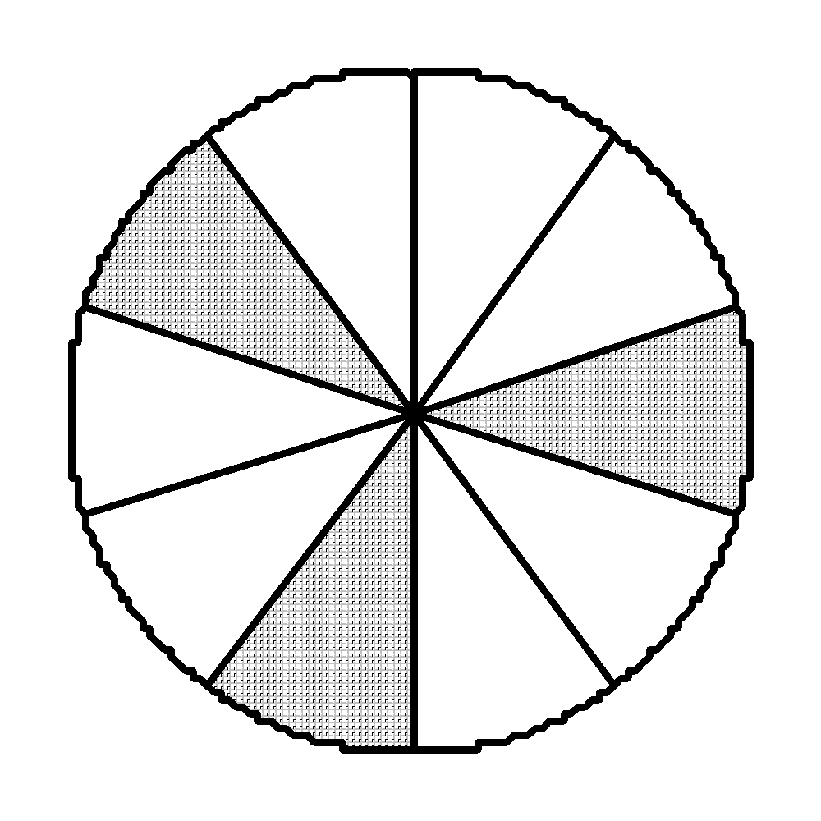

a. |  | b. |  | c. |  | d.

35. (1 point)
Find the sum of the fractions modeled by these fraction circles.
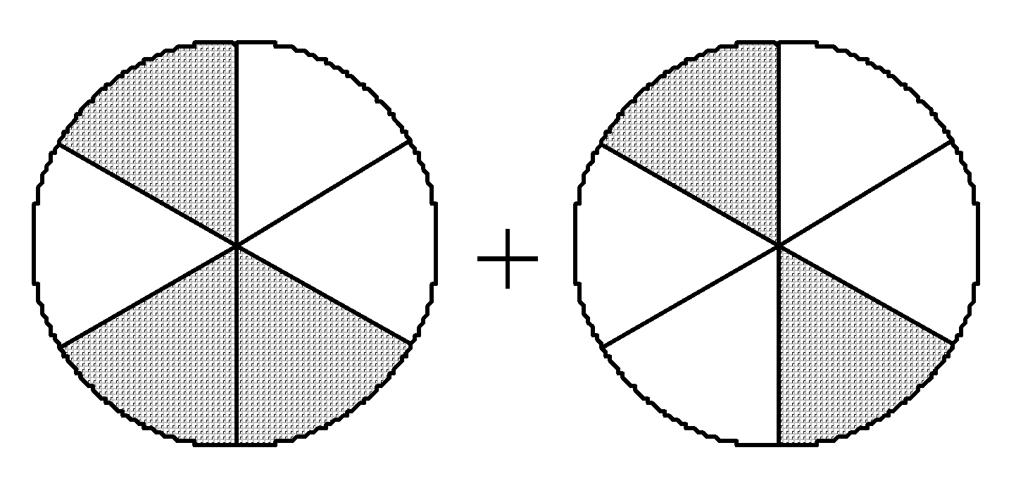

a. |  | b. |  | c. |  | d.

36. (1 point)
Write an addition equation for this picture.
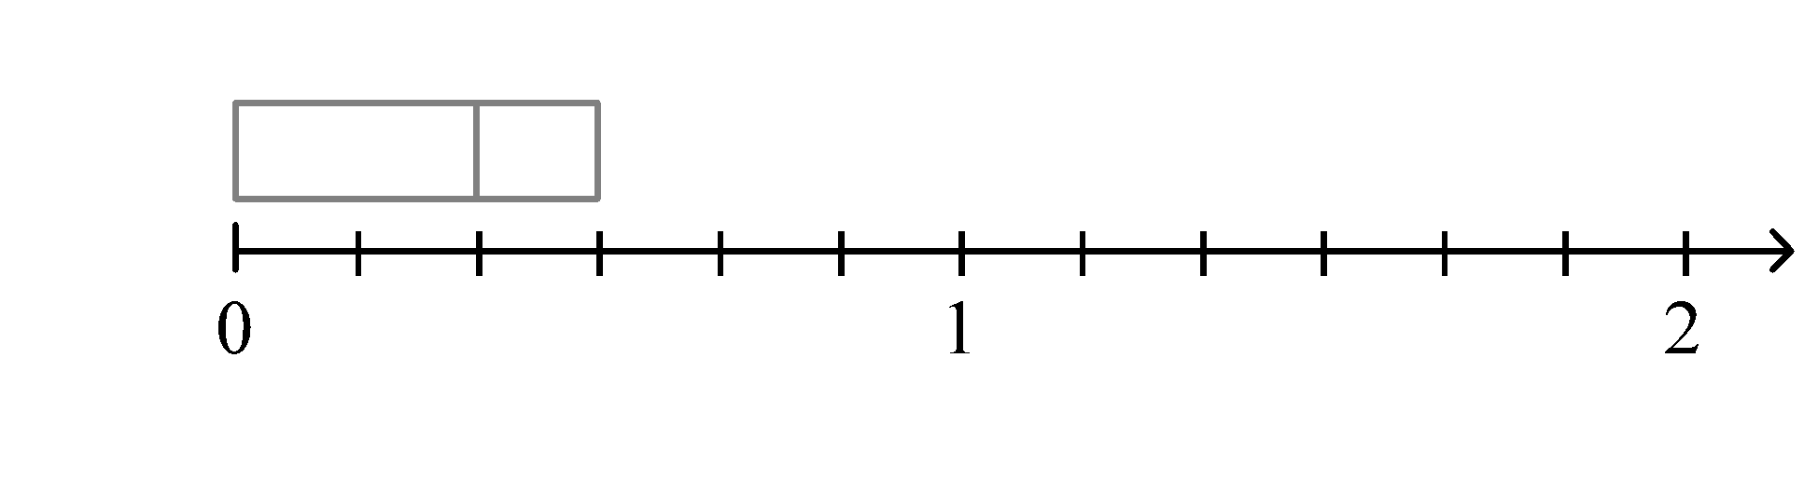

a. | 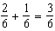 | b. | 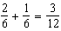 | c. | 2 + 1 = 3 | d. | 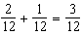

37. (1 point)
Find a common denominator for and .

a. | 6 | b. | 5 | c. | 3 | d. | 8

38. (1 point)
You cut vegetables for a stew.
You have cup carrots, cup onions, and cup peppers.
About how many cups of vegetables do you have in all?

a. | 1 cup | b. | 2 cups | c. | 3 cups | d. | cup

39. (1 point)
Write a subtraction equation for this picture.
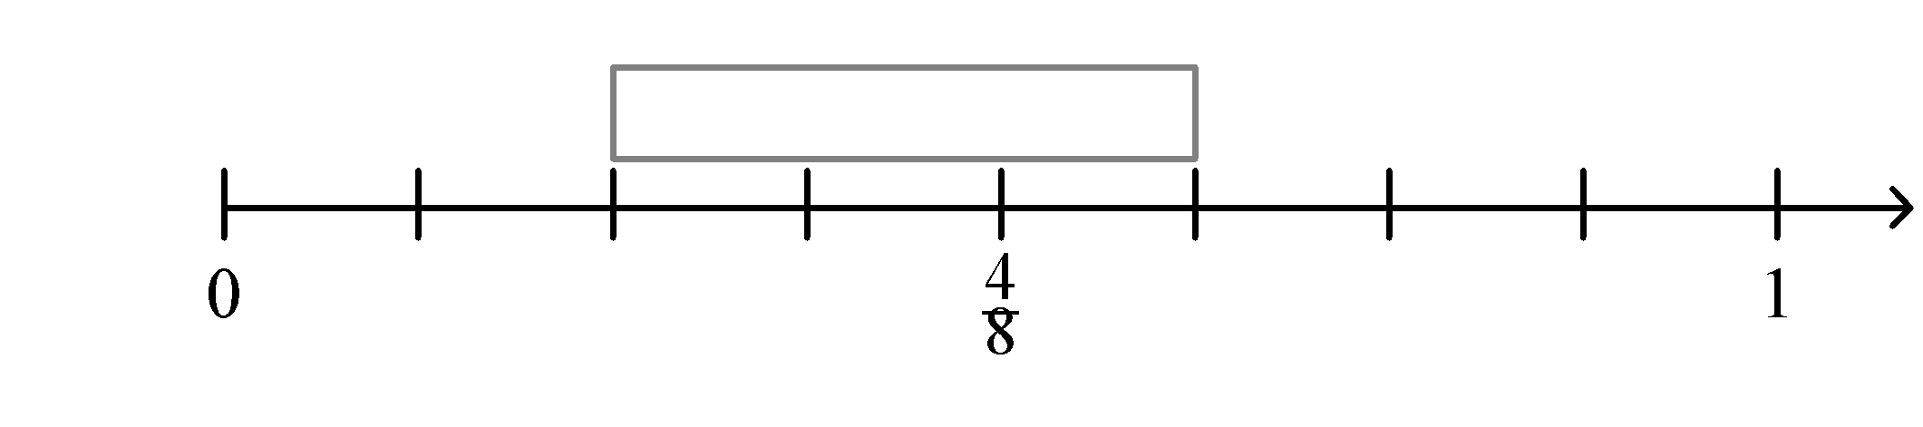

a. | 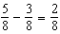 | c. | 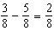
b. | 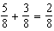 | d. | 5 − 3 = 2

40. (1 point)
Which subtraction equation is incorrect?

P: 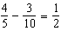
Q: 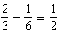
R: 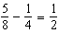
S: 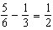

a. | P | b. | Q | c. | R | d. | S

41. (1 point)
Find the sum of the fractions modeled by these 3 fraction circles.
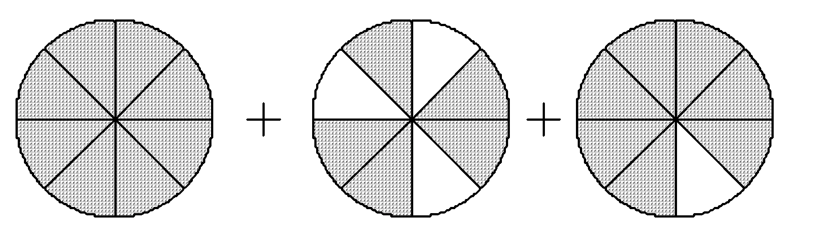

a. |  | b. |  | c. |  | d. | 16

42. (1 point)
Find the sum of the fractions modeled by these 2 strips.
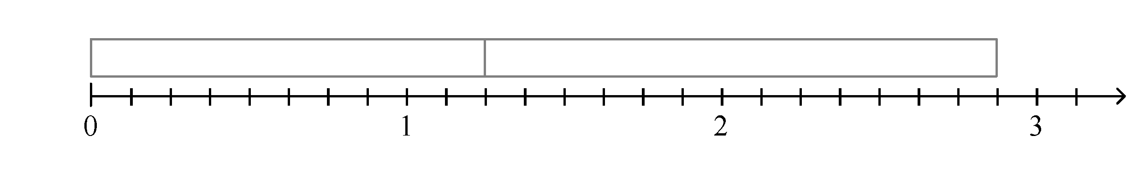

a. |  | b. |  | c. |  | d.

43. (1 point)
What is the lowest common denominator for the fraction parts in and ?

a. | 20 | b. | 9 | c. | 14 | d. | 10

44. (1 point)
Subtract: 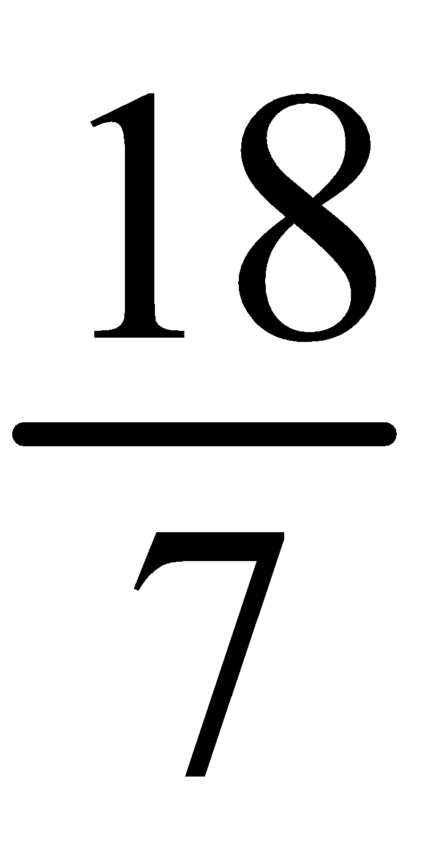 − 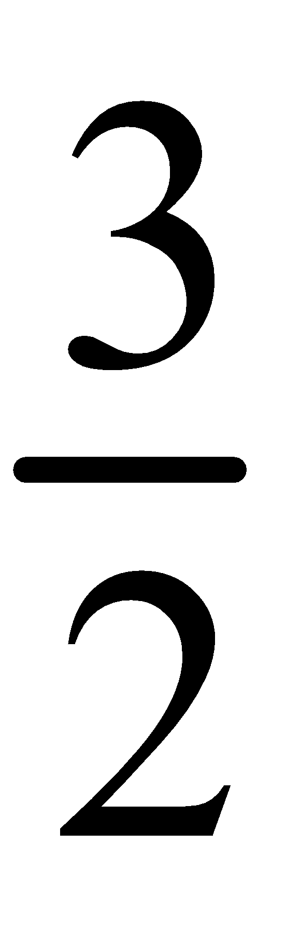

a. | 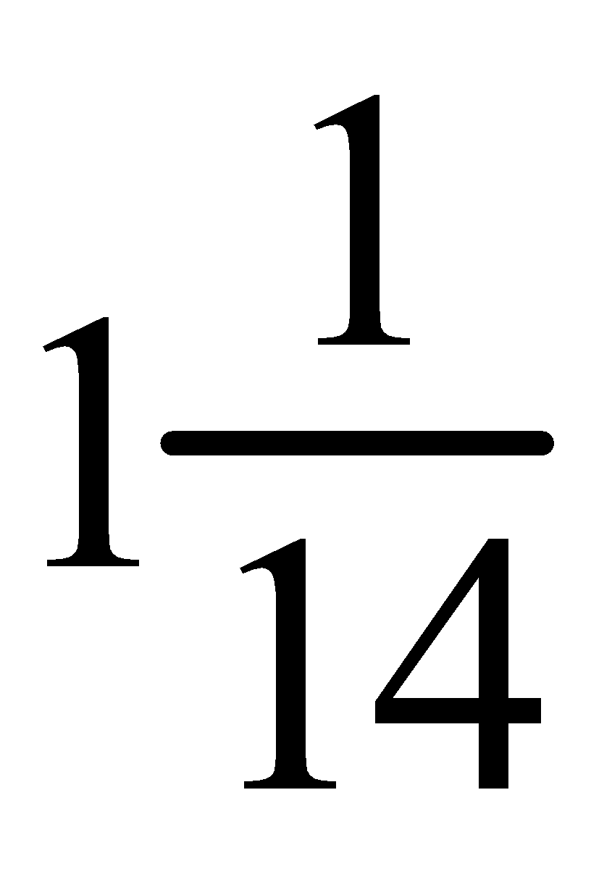 | b. |  | c. | 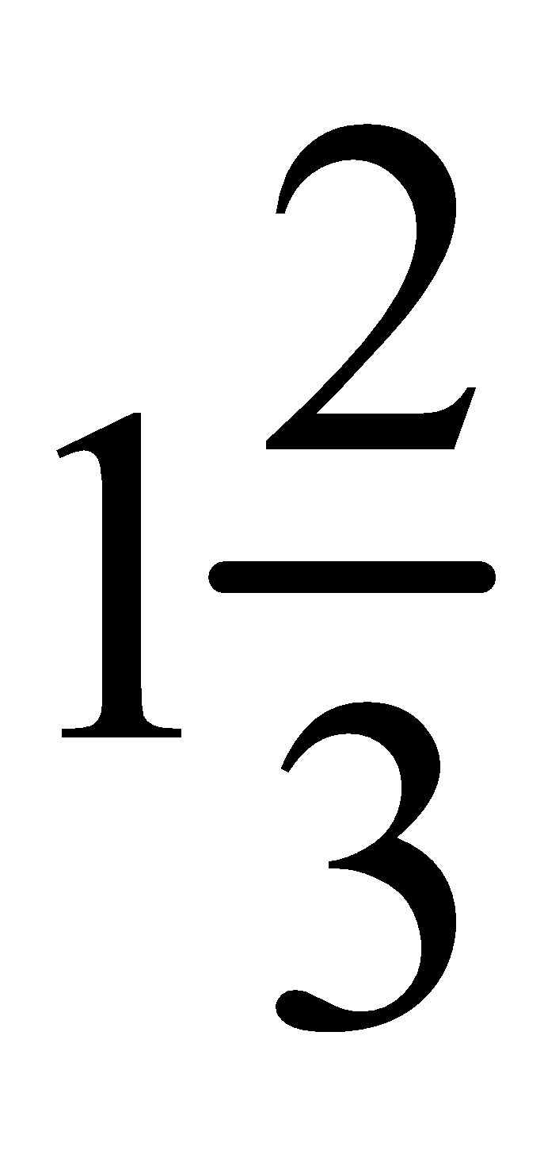 | d. | 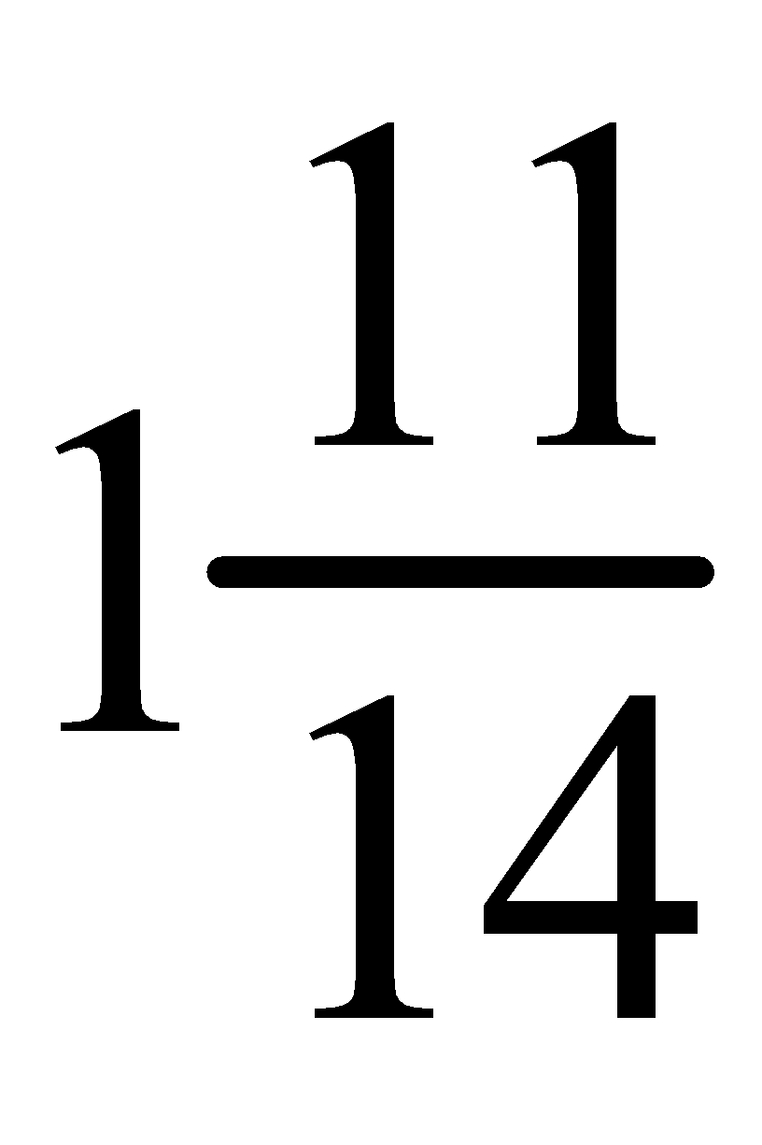

unit 6

45. (1 point)
Which are equations?

P: 10 − 5x = 2 Q: 3x + 9

R: 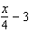 S: 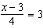

a. | P and S | b. | P and Q | c. | R and S | d. | Q and R

46. (1 point)
Find the value of x that makes this equation true.

a. | 4 | b. | 10 | c. | 20 | d. | 7

47. (1 point)
The 2 pans of the scales are balanced. Find the value of the unknown mass B.
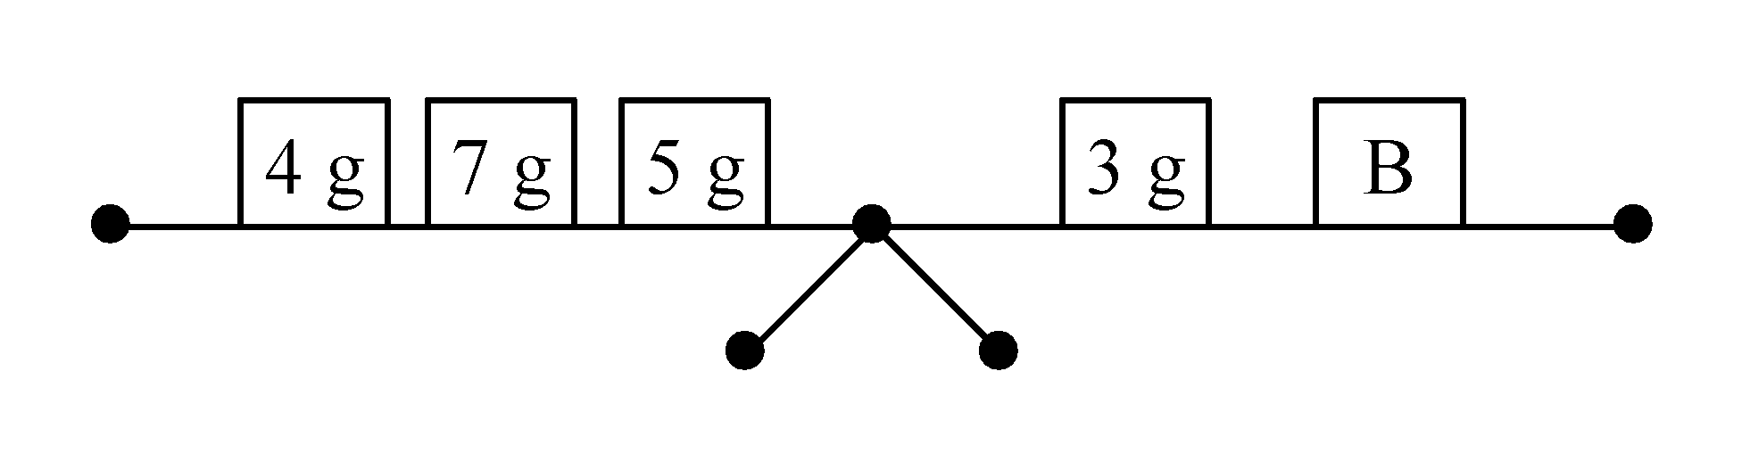

a. | 13 g | b. | 5 g | c. | 11 g | d. | 47 g

48. (1 point)


Identify the tiles that model 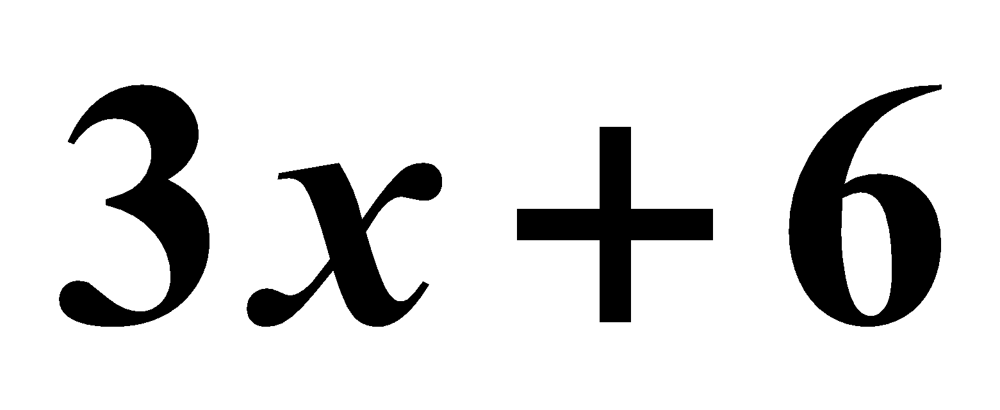.

a. | 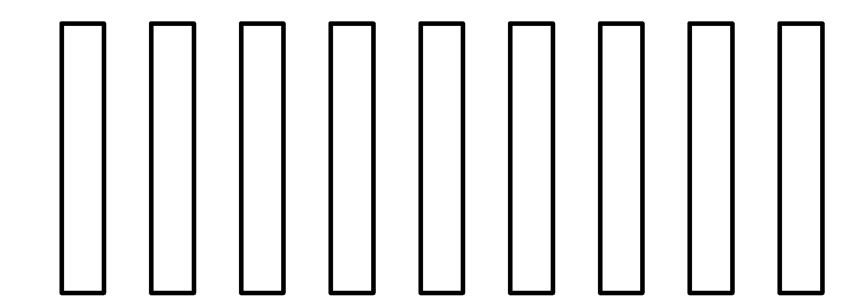 | c. | 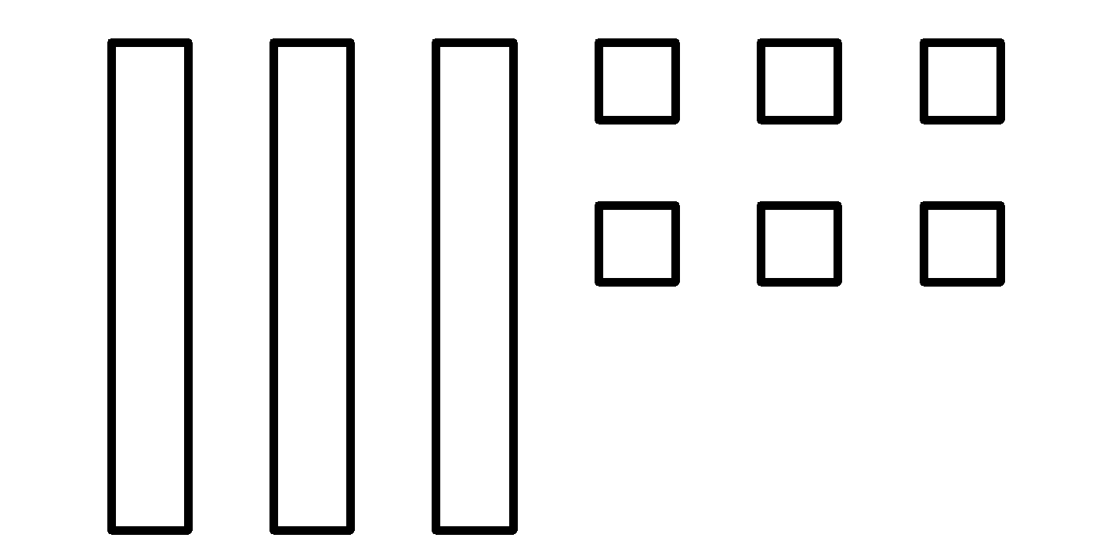
b. | 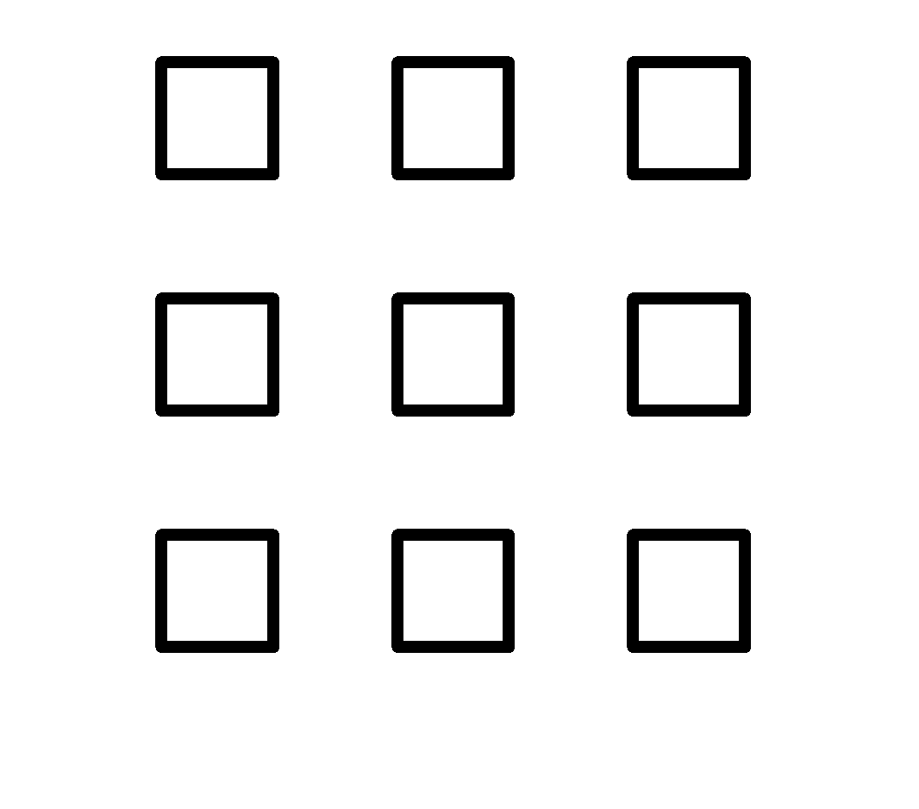 | d. | 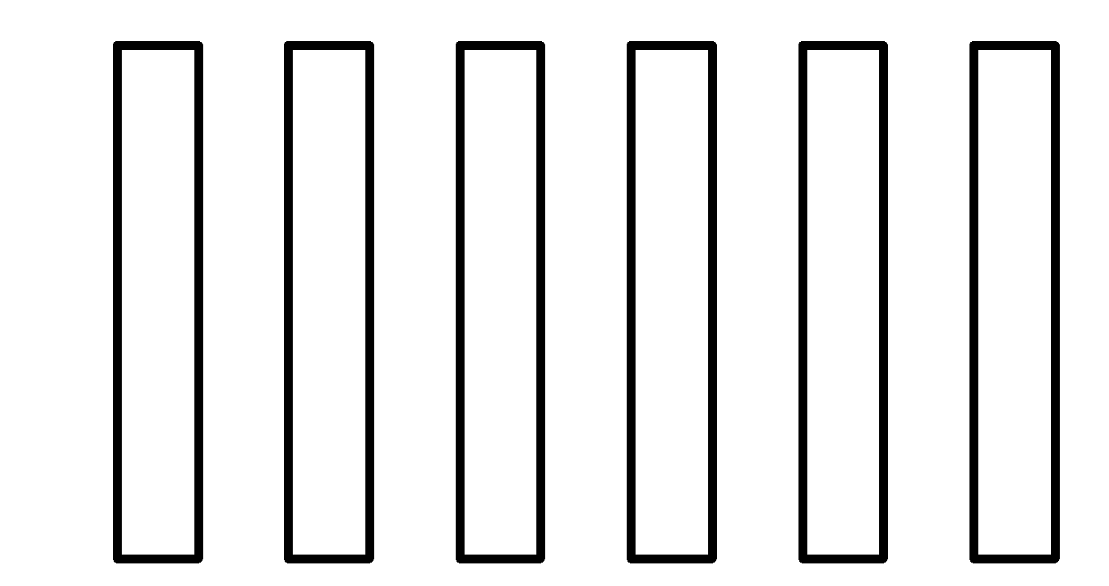

49. (1 point)
A white square represents +1, a black square represents −1, and a rectangle represents the variable x.

Write an expression modeled by this picture.

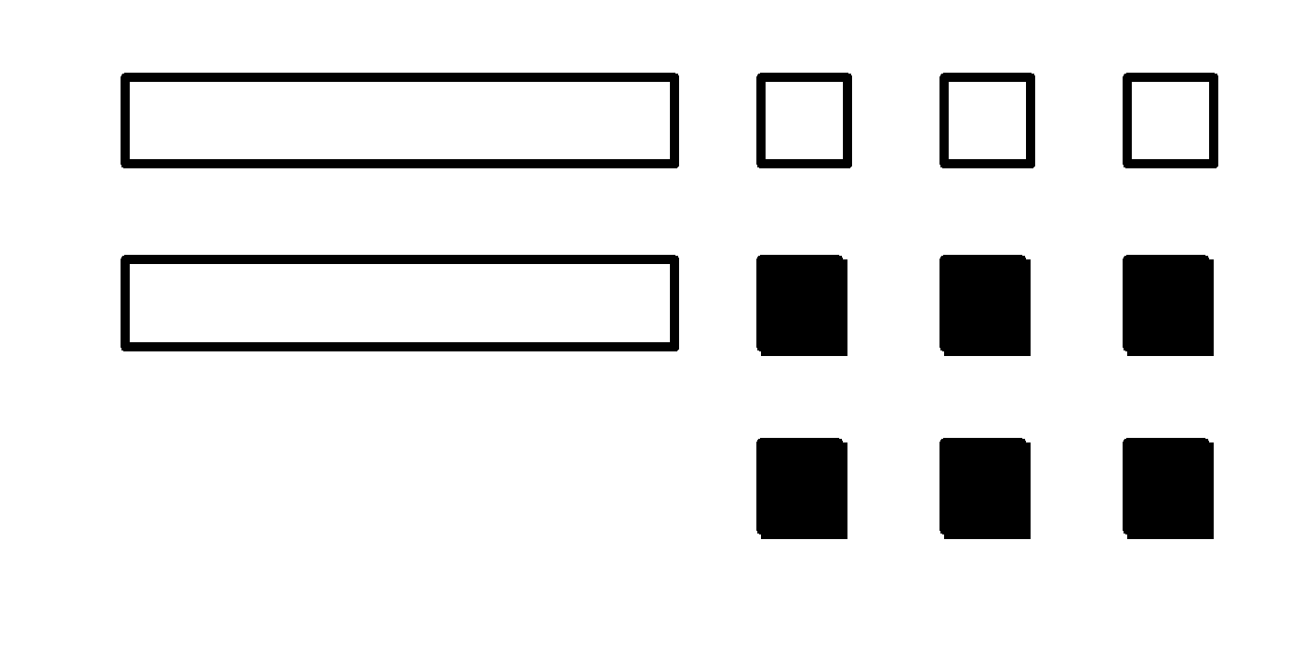

a. |  | b. |  | c. |  | d.

50. (1 point)
Solve this equation: x − 2 = 10

a. | 12 | b. | 8 | c. | 5 | d. | 11

51. (1 point)
Solve this equation: 2x − 5 = 7

a. | 6 | b. |  | c. | 4 | d. | 10

52. (1 point)
Write an equation to find this number: 9 more than double the number is 15.
Then solve the equation.

a. | 2x + 9 = 15, x = 3 | c. | 2x − 9 = 15, x = 12
b. | 2x + 9 = 15, x = 12 | d. | 2x − 15 = 9, x = −3

53. (1 point)
Solve this equation: 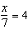

a. | 28 | b. | 11 | c. | 3 | d. | 2

54. (1 point)
Liam is solving an equation modelled by algebra tiles.

On the left side of the line representing the equal sign, there are 1 x-tile, 4 positive unit tiles, and 3 negative unit tiles.
On the right side, there are 7 positive unit tiles and 5 negative unit tiles.

What is the value of x?

a. | 1 | b. | –5 | c. | 5 | d. | 19

unit 7

55. (1 point)
Find the mean of this set of data: 7, 9, 11, 13

a. | 11 | b. | 20 | c. | 40 | d. | 10

56. (1 point)
Find the mode of this set of data: 28, 9, 9, 26, 28, 17, 28, 23

a. | 9 | b. | 21 | c. | 24 | d. | 28

57. (1 point)
Find the range of this set of data: 16, 20, 20, 28, 31, 32, 35, 39

a. | 20 | b. | 23 | c. | 29.5 | d. | 24

58. (1 point)
Find the median of this set of data: 5, 58, 15, 3, 59, 20, 11, 52, 5

a. | 15 | b. | 18 | c. | 25 | d. | 14

59. (1 point)
Identify the outlier of this set of data: 14, 37, 18, 21, 11, 16, 24, 12

a. | 37 | b. | 18 | c. | 11 | d. | 21

60. (1 point)
Ms. Farquand keeps a record of sick leave taken by her staff.

The table shows the number of sick days taken last year by 9 employees.

Employee | Number of Sick Days
Earl | 4
Chantal | 2
Sarita | 5
Ryan | 1
Simone | 7
Davin | 5
Javier | 8
Marty | 2
Martina | 6

Find the mean number of sick days.

Round to 2 decimal places, if necessary.

a. | 3.78 | b. | 4.44 | c. | 3.67 | d. | 3.11

61. (1 point)
A game involves spinning this spinner.
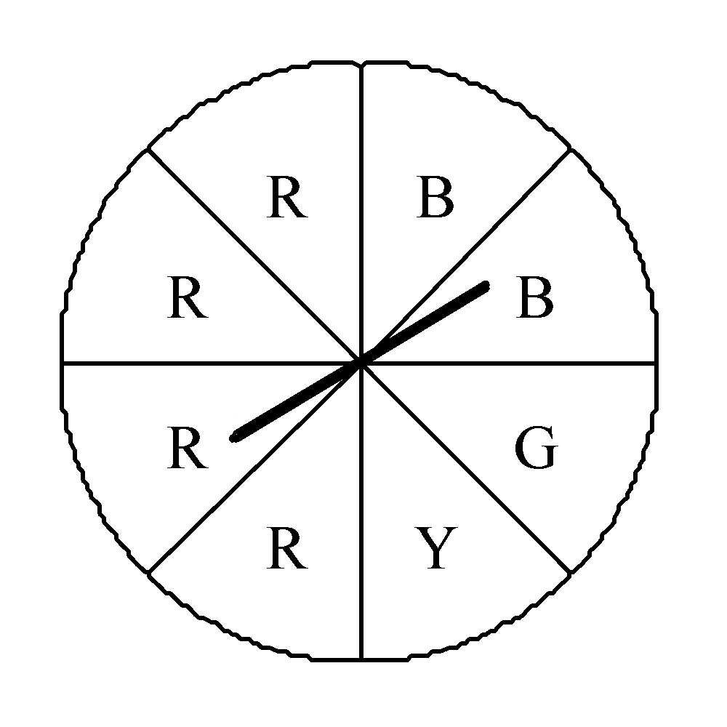

What is the probability of the pointer landing on R?

a. |  | b. | 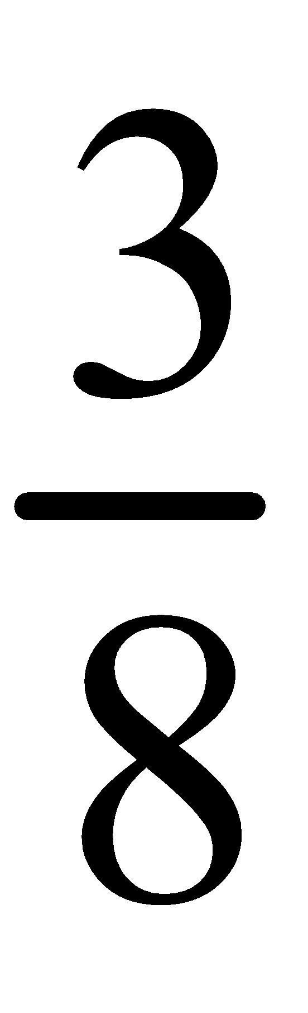 | c. | 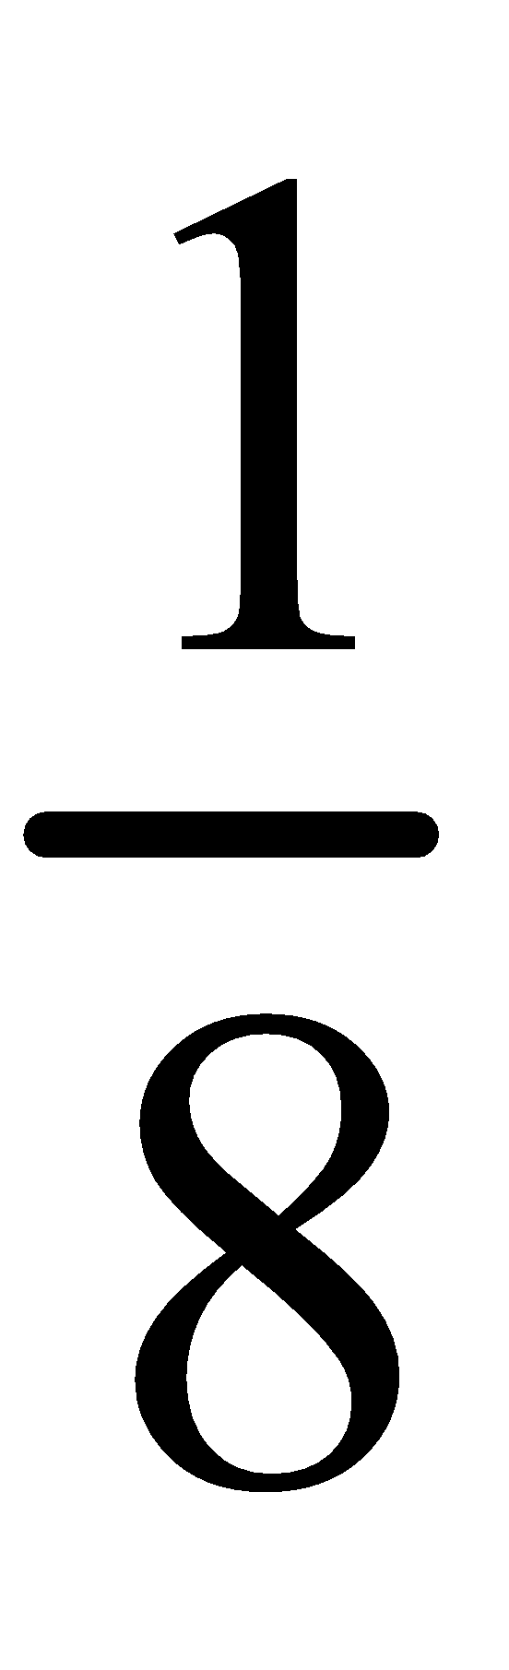 | d. | 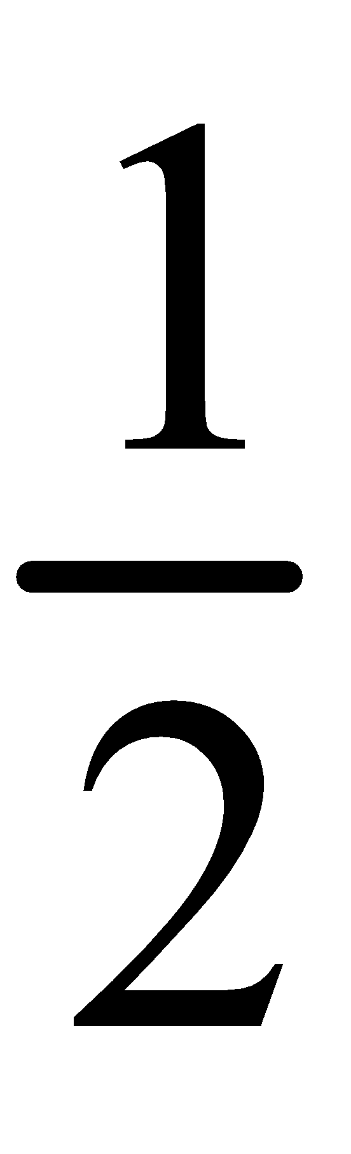

62. (1 point)
A die labelled 1 to 6 is rolled.

Find the probability of rolling a number greater than 2.

a. |  | b. | 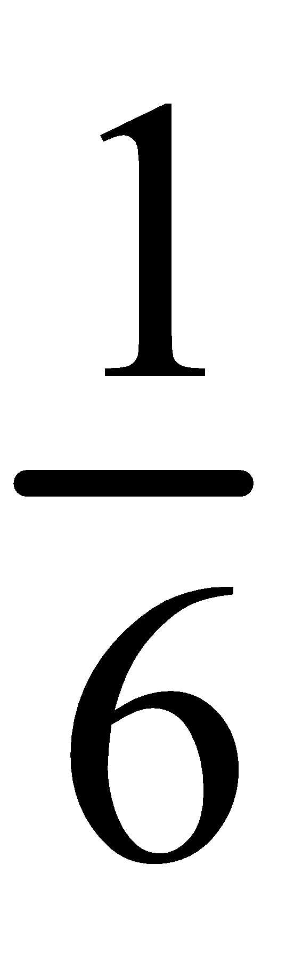 | c. | 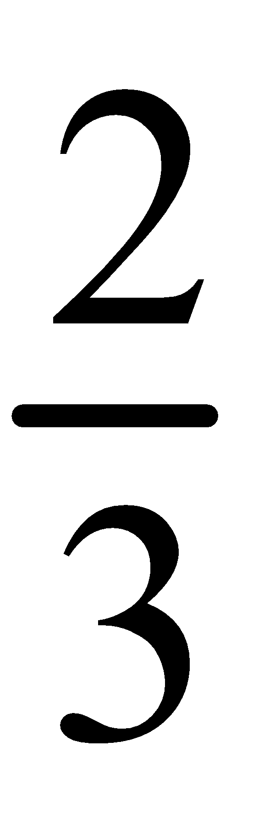 | d. | 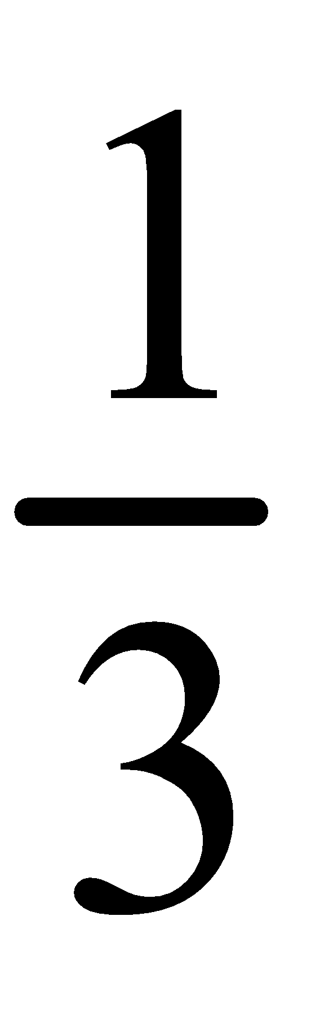

63. (1 point)
Jill wants to buy either a ball pen or an ink pen.
Both pens come in 5 styles.

Find the number of possible choices.

a. | 8 | b. | 11 | c. | 10 | d. | 7

64. (1 point)
Use a tree diagram to find how many ways you can arrange the letters in STEM.

a. | 24 ways | b. | 10 ways | c. | 25 ways | d. | 23 ways

unit 8

65. (1 point)
How many pairs of parallel line segments are in this diagram?
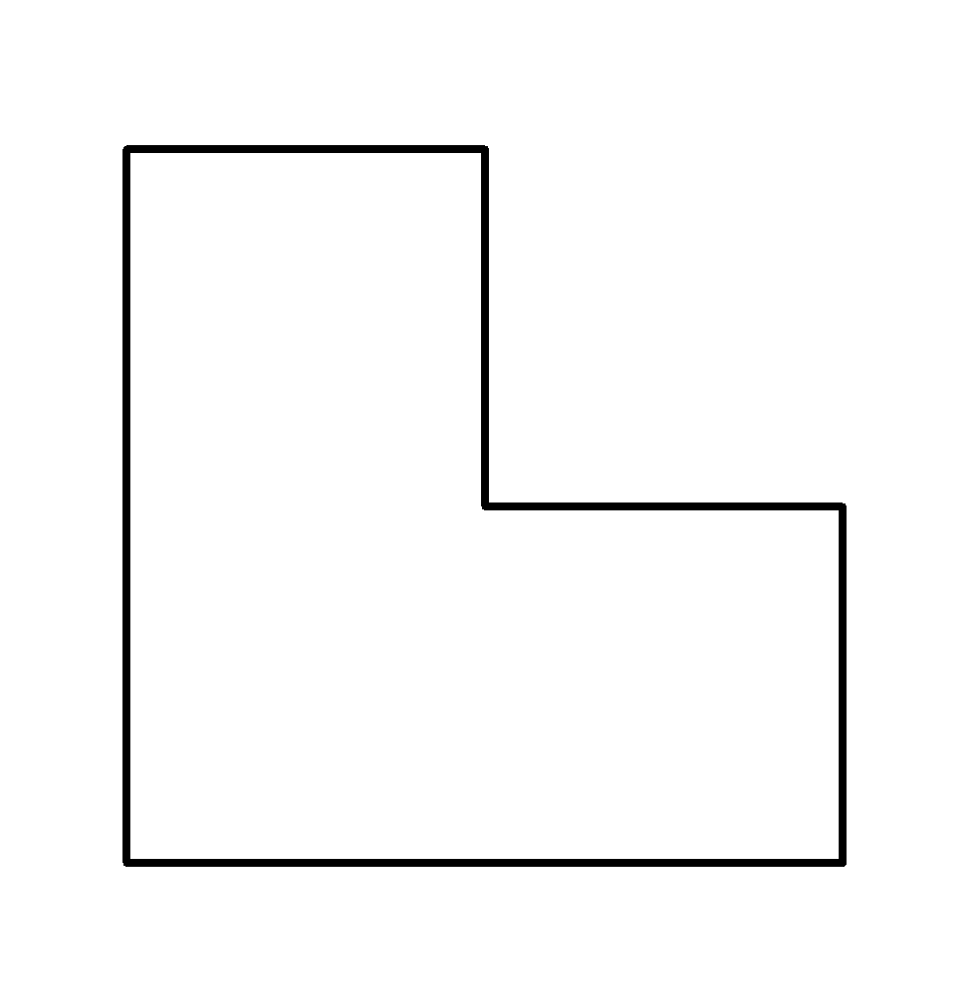

a. | 2 | b. | 3 | c. | 4 | d. | 6

66. (1 point)
Which statements are true for the line segments in this diagram?
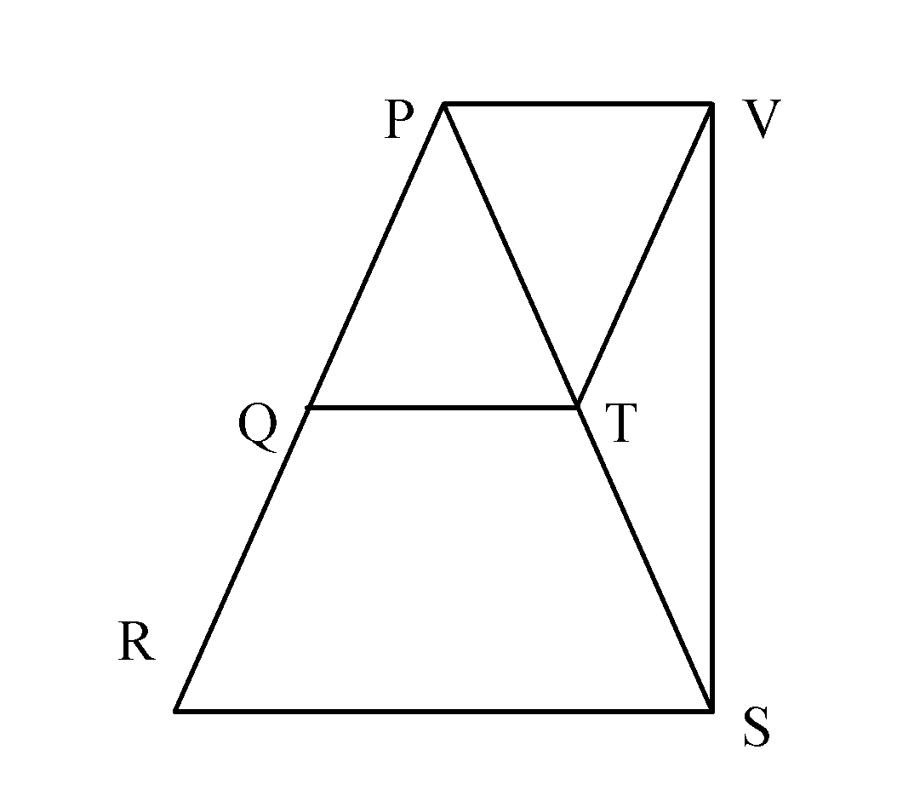

i) | Line segment PV is parallel to line segment QT.
ii) | Line segment PQ is parallel to line segment VS.
iii) | Line segment QR is parallel to line segment VT.
iv) | Line segment QT is parallel to line segment RS.

a. | statements i, ii, and iii are all true | b. | statements i, ii, and iv  are all true | c. | statements  i, iii, and iv  are all true | d. | all of these statements are true

67. (1 point)
Which diagram shows perpendicular line segments?

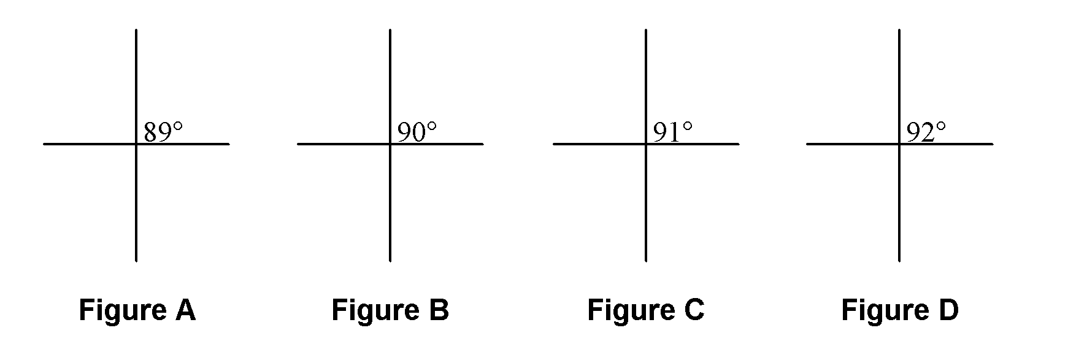

a. | Figure A | b. | Figure B | c. | Figure C | d. | Figure D

68. (1 point)
Which diagrams do not have perpendicular line segments?

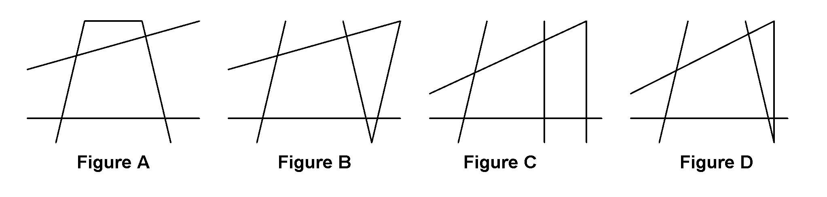

a. | Figures A and B | c. | Figures B, C, and D
b. | Figures A, B, and C | d. | all of these

69. (1 point)
Which diagram shows the construction of a perpendicular bisector?

a. | 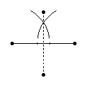 | b. | 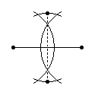 | c. | 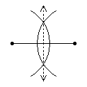 | d. | 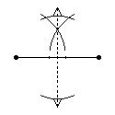

70. (1 point)
Which diagram shows the construction of the bisector of this angle?

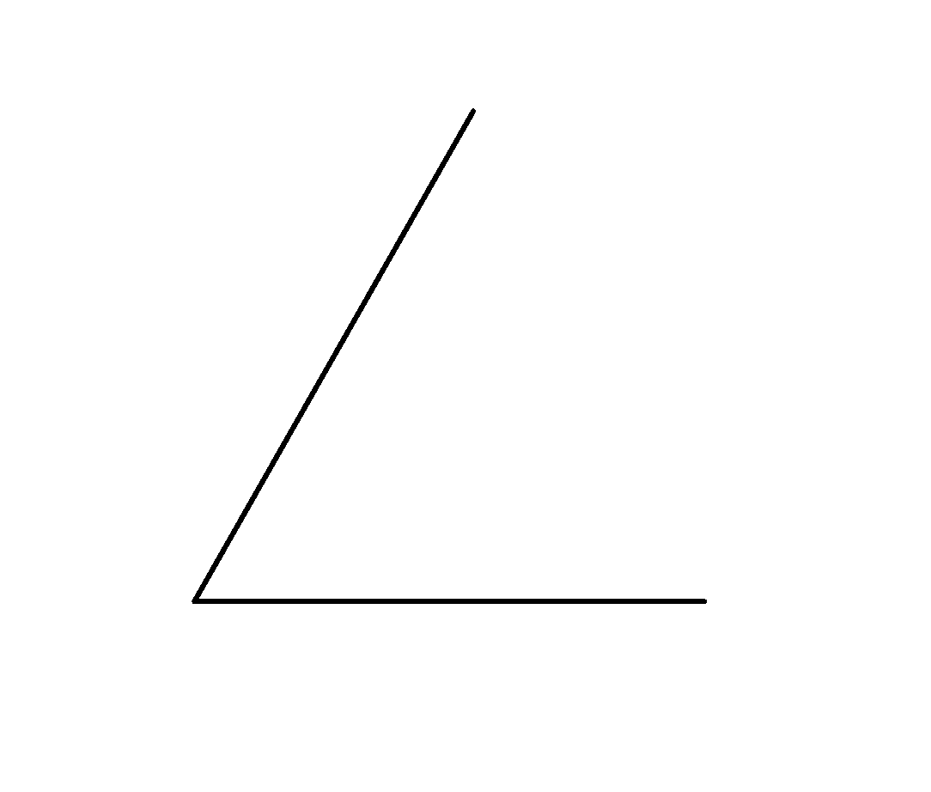

a. | 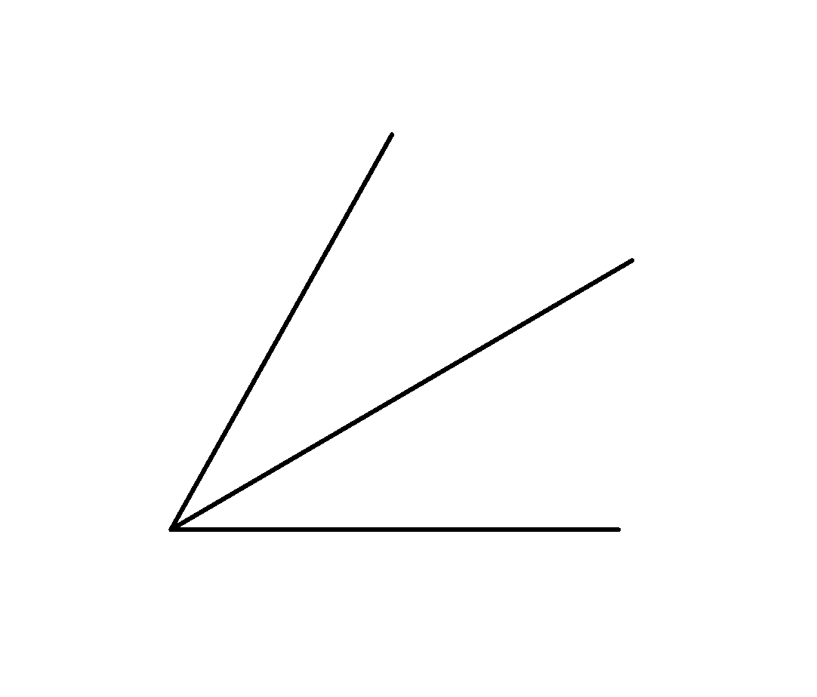 | c. | 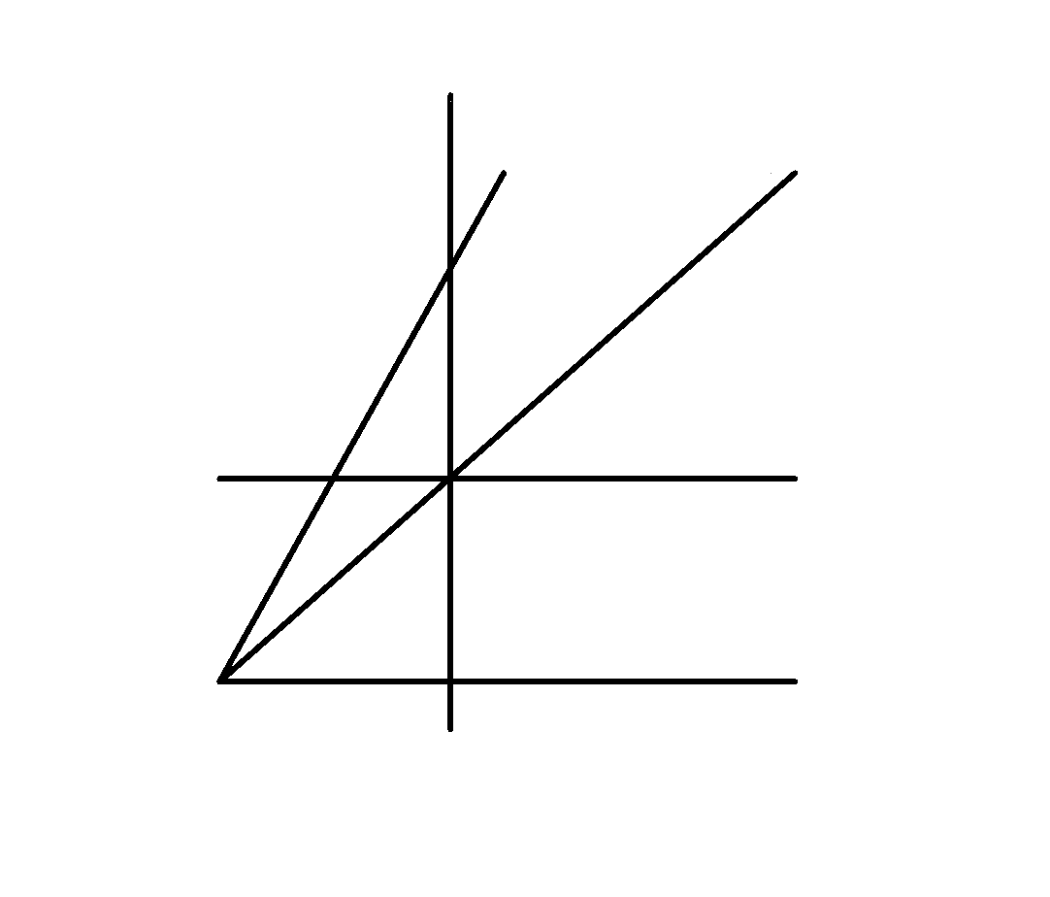
b. | 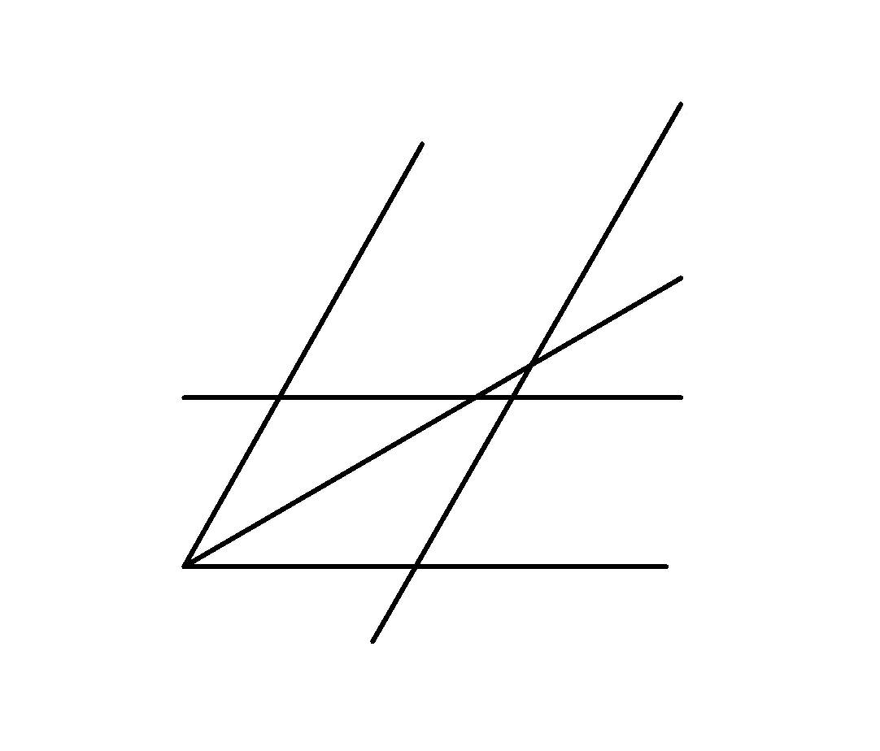 | d. | 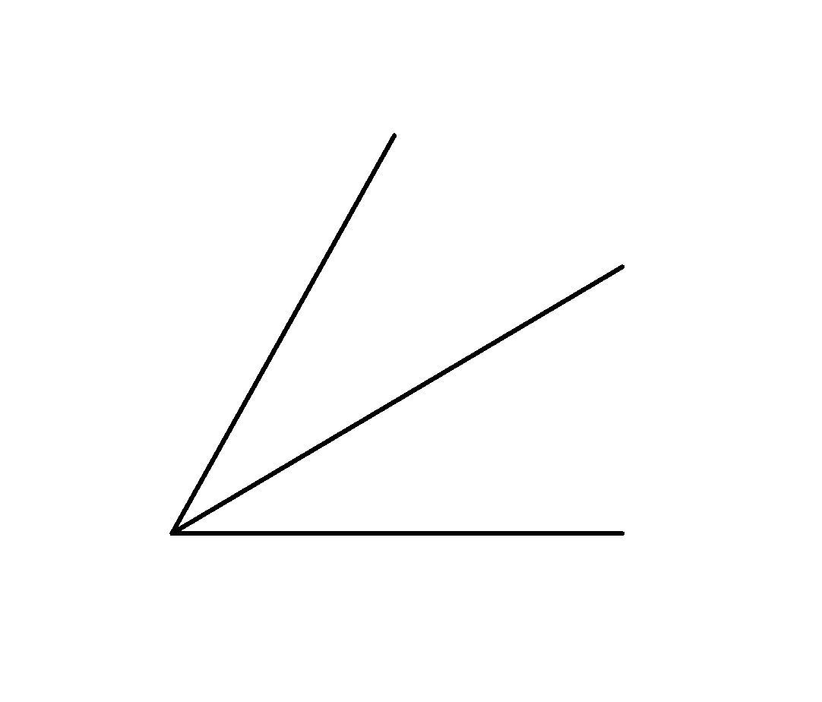

71. (1 point)
Use the Coordinate Grid diagram.

In which quadrant is point A?

Write the coordinates of point A.

Coordinate Grid
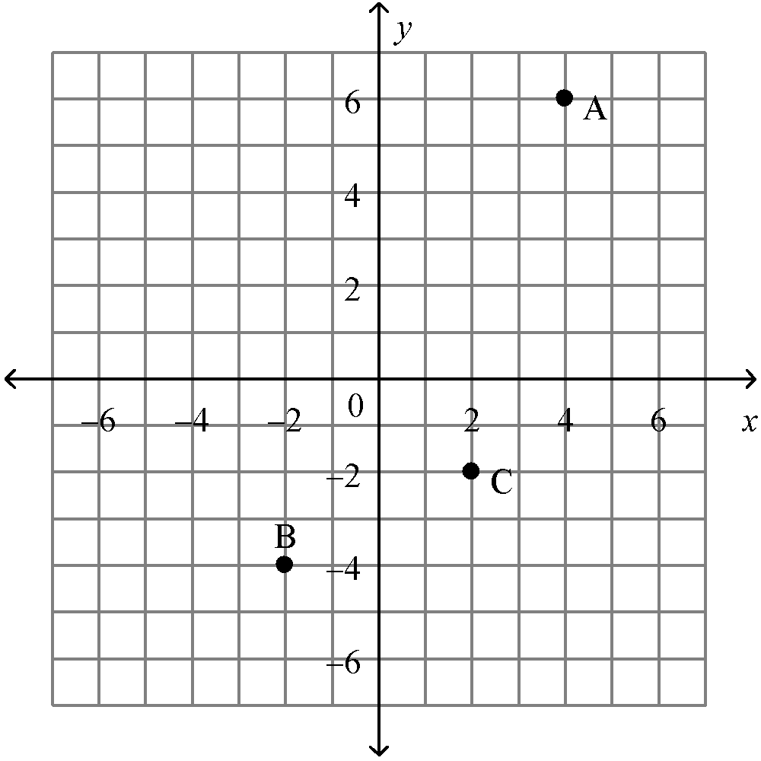

a. | quadrant 2; ( 6, −4) | c. | quadrant 3; (−4, −6)
b. | quadrant 1; (4, 6) | d. | quadrant 1; (6, 4)

72. (1 point)
Name the point with coordinates (–4, 2) on this grid.

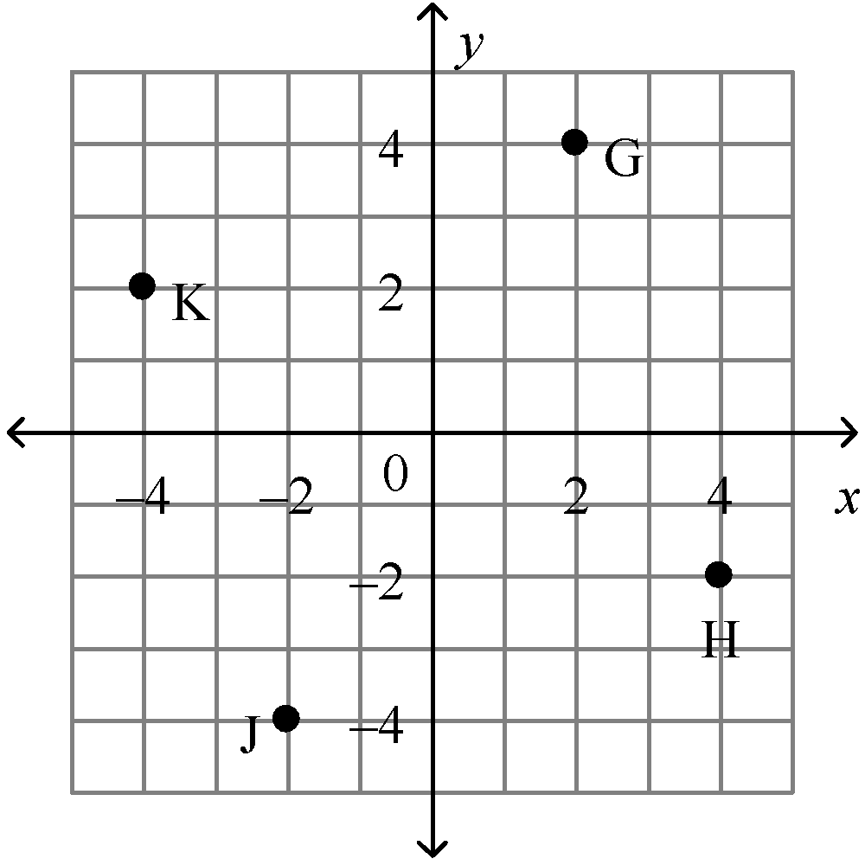

a. | K | b. | G | c. | H | d. | J

73. (1 point)
Rectangle ABCD has vertices A(–2, –2), B(–2, 0), C(0, –2), and D(0, 0).

The rectangle is translated 3 units left and 3 units up.

Draw and label rectangle ABCD and its translation image rectangle .

a. | 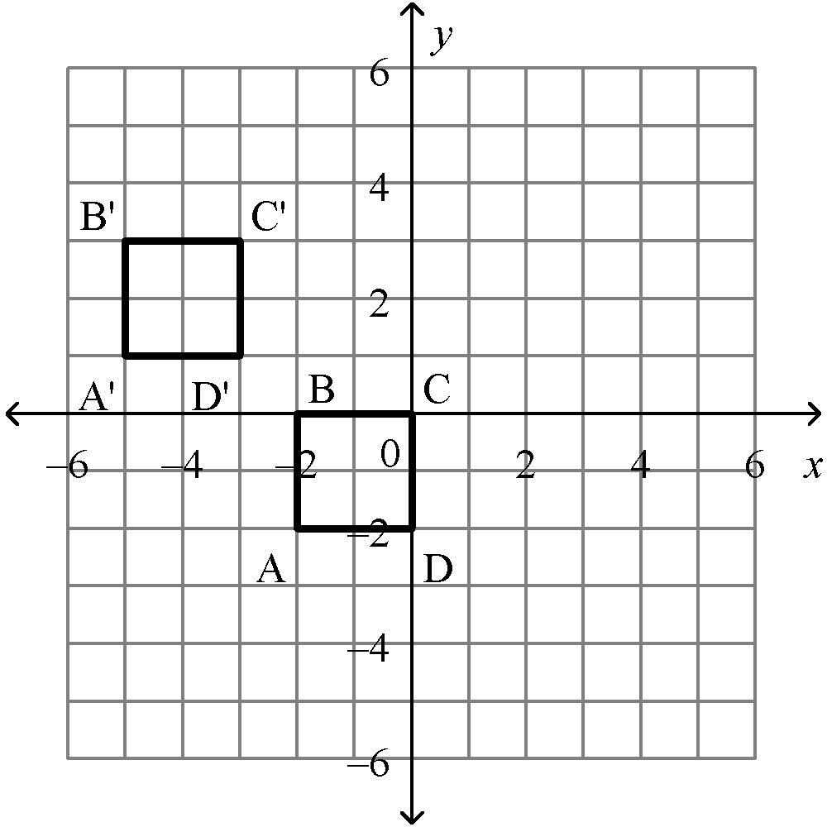 | c. | 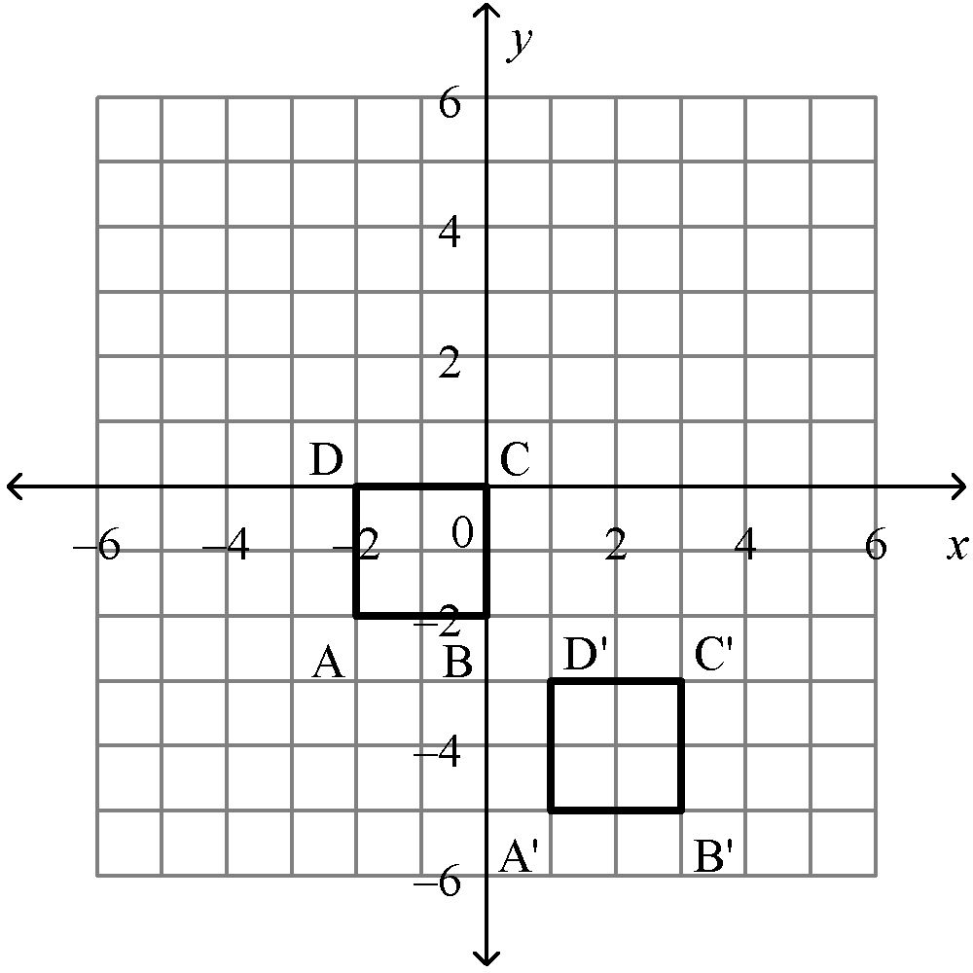
b. | 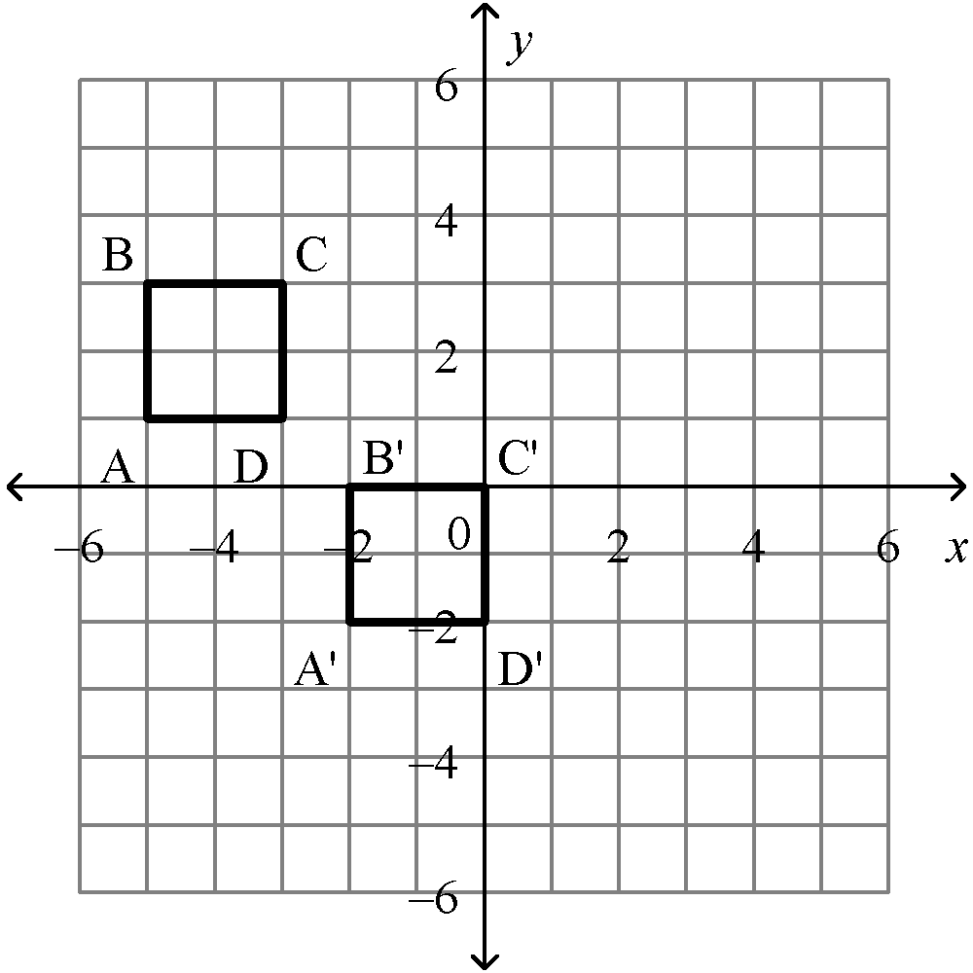 | d. | 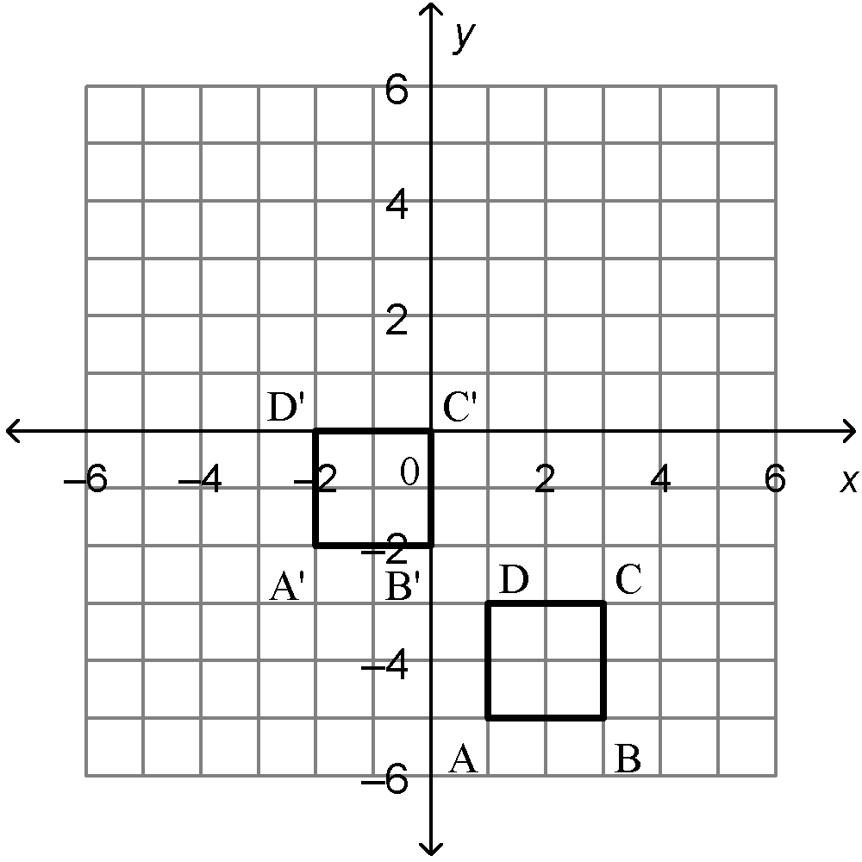

74. (1 point)
has vertices F(4, −4), G(5, −1), and H(2, −2).

The triangle is reflected in the x-axis.

Which diagram shows and its reflection image ?

a. | 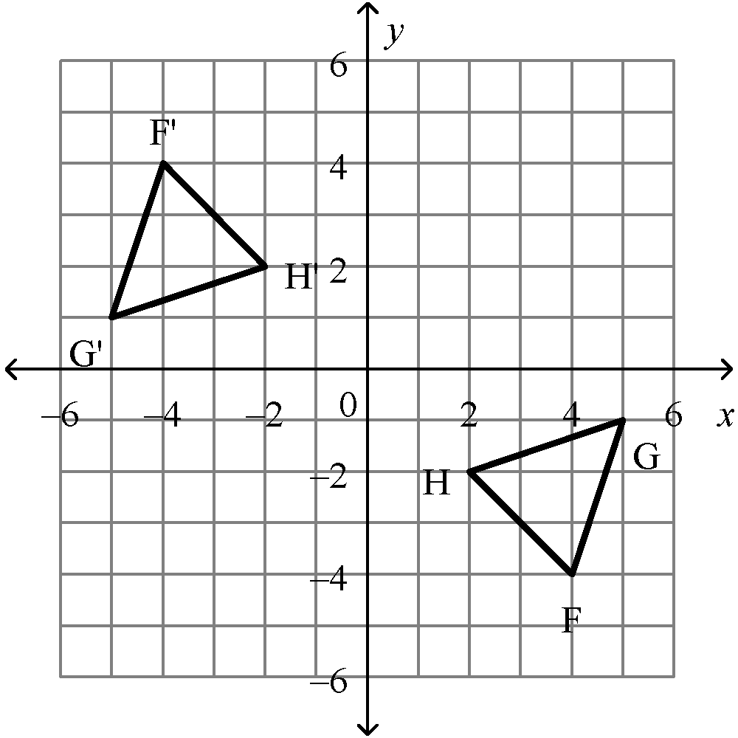 | c. | 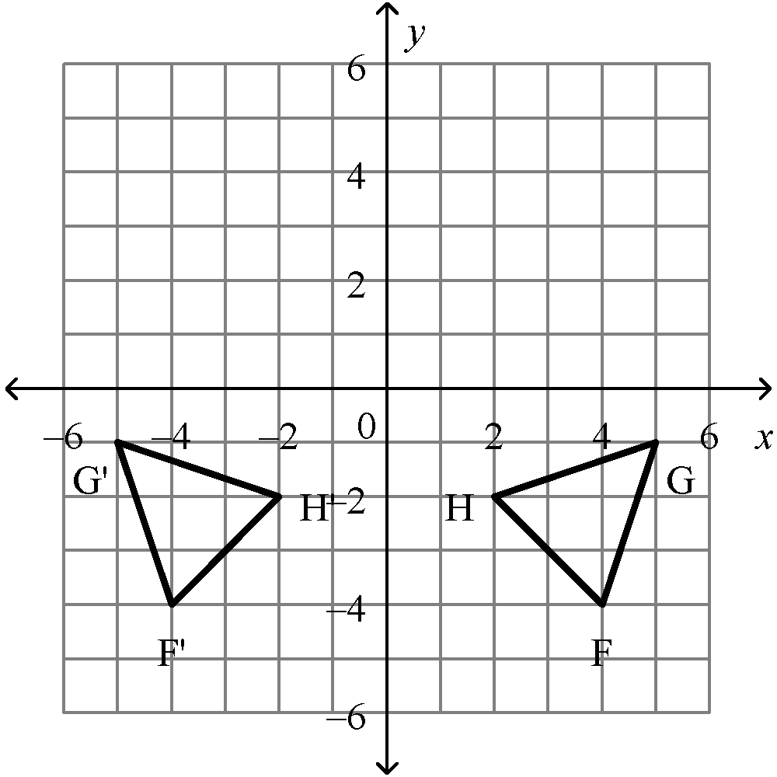
b. | 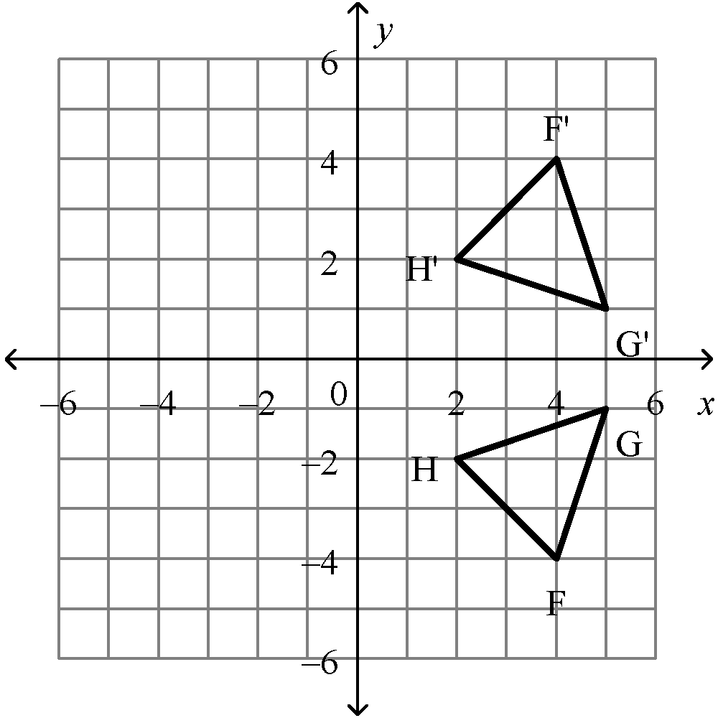 | d. | 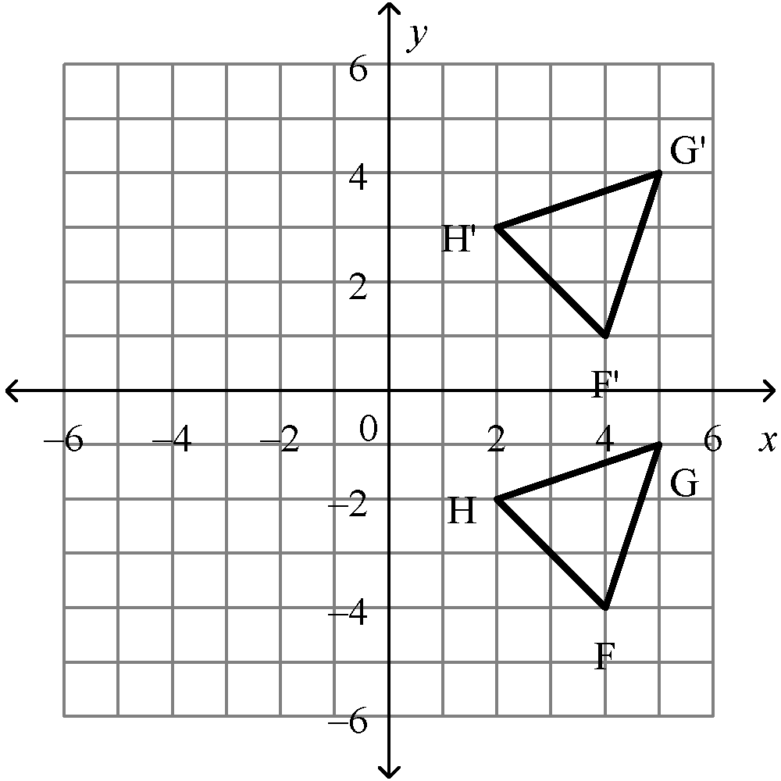

75. (1 point)
Draw the image of this shape after a – 90° rotation about point O.
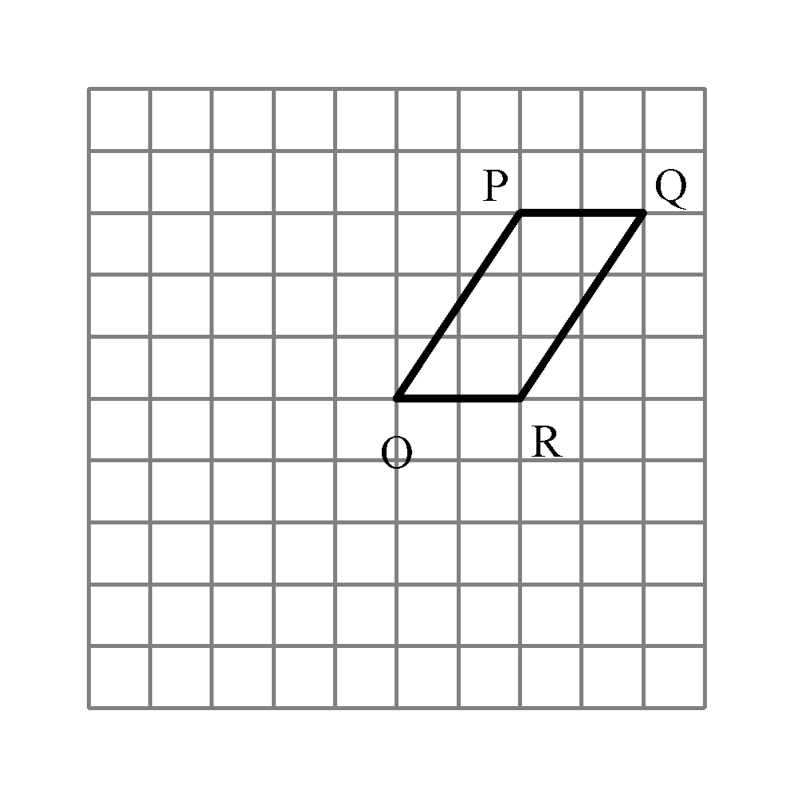
a. | 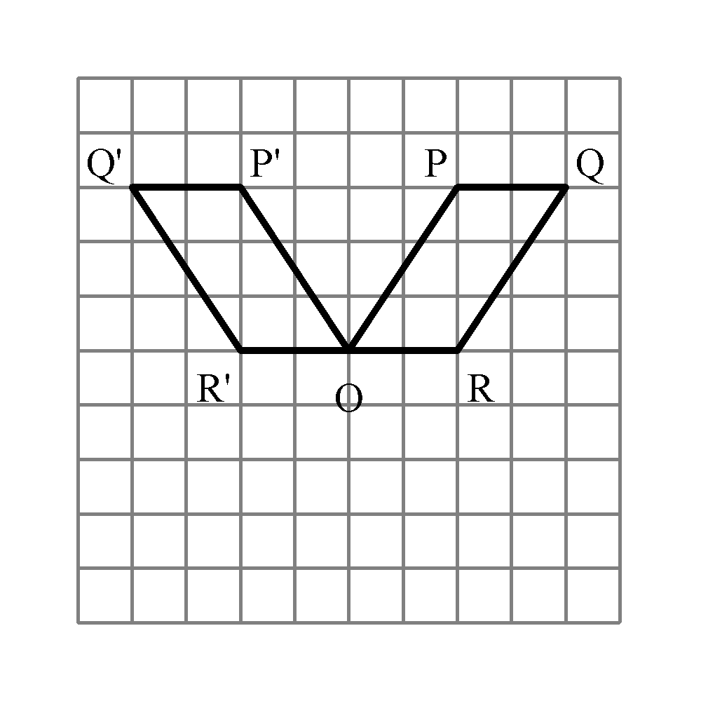 | c. | 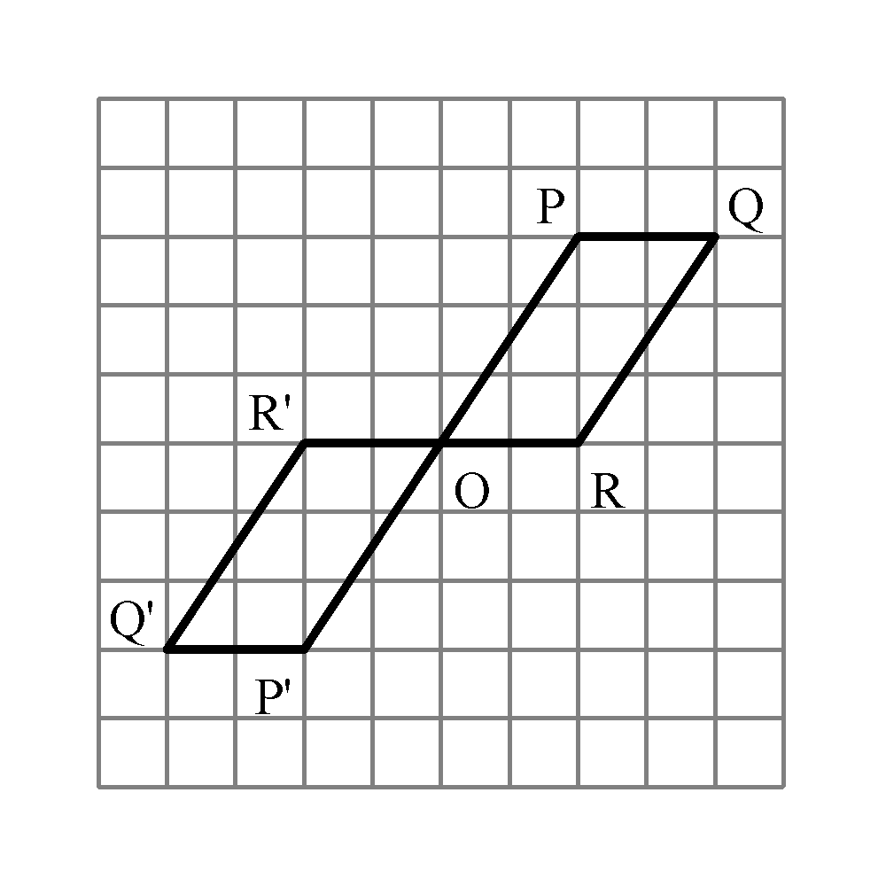
b. | 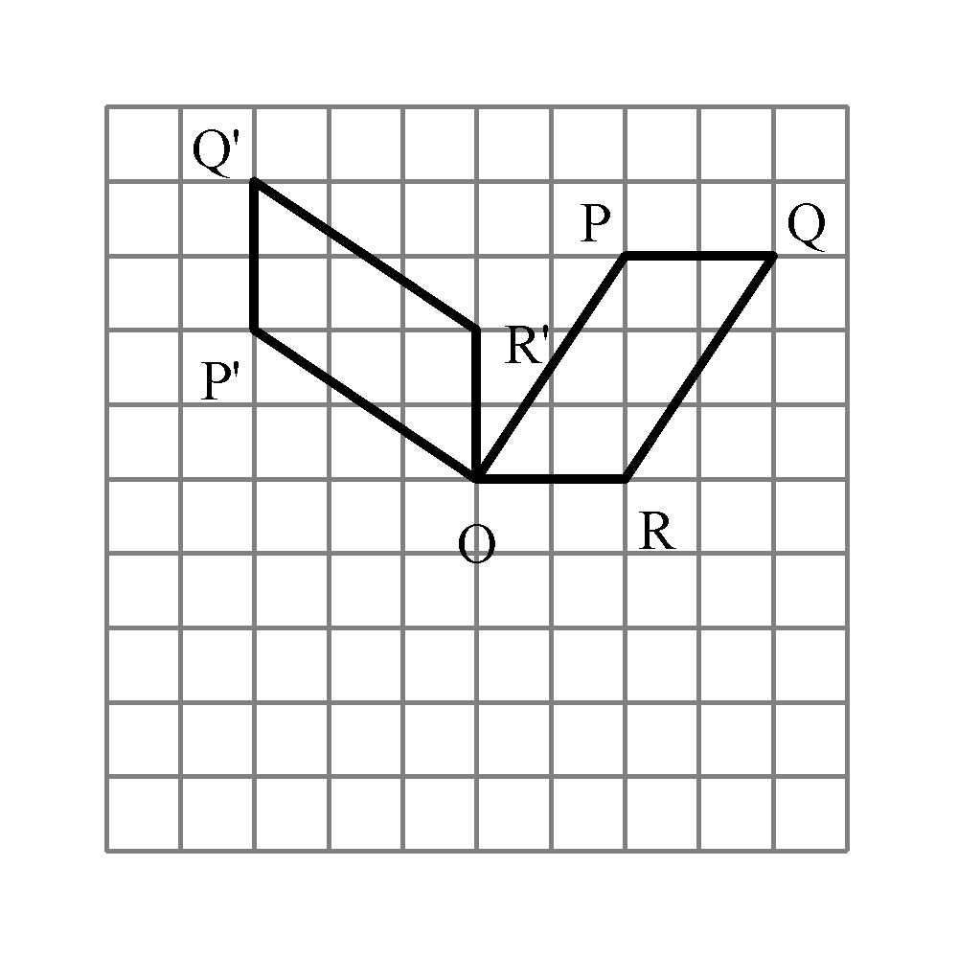 | d. | 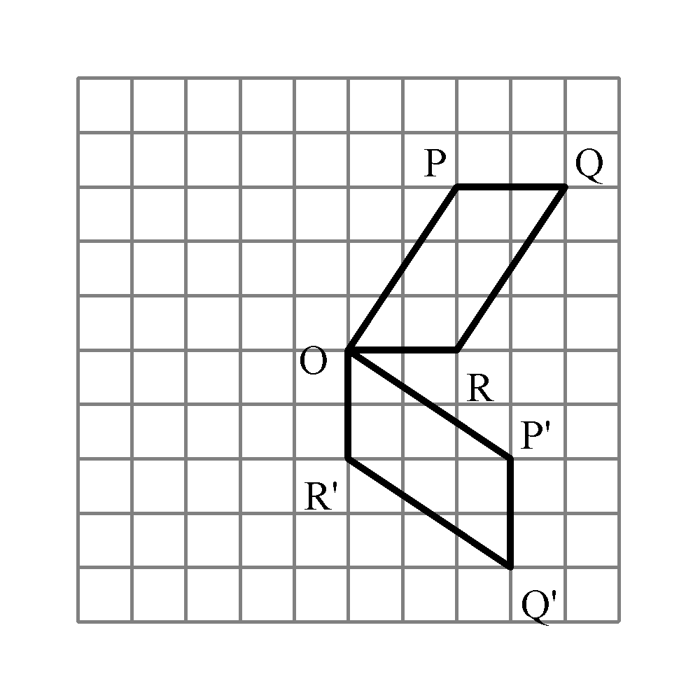

76. (1 point)
Identify the transformation that will move shape K to shape L.
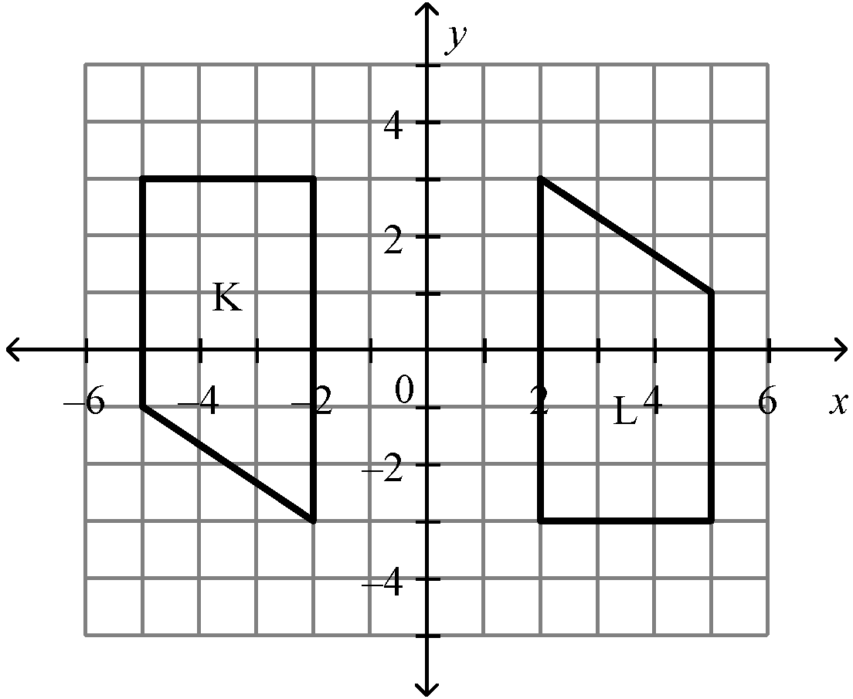

a. | a rotation about the origin | c. | a rotation about the origin
b. | a rotation about the origin | d. | a reflection in the y-axis

