More practice... Keep working at it.....It will pay off!

Multiple Choice
Identify the choice that best completes the statement or answers the question.

____ 1. Write 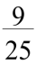 as a decimal.
a. | 1.6 | b. | 0.64 | c. | 0.4 | d. | 0.36

____ 2. Write as a decimal.
a. | 0.01 | b. | 0.056 | c. | 0.07 | d. | 0.875

____ 3. Write 0.28 as a fraction in simplest form.
a. | 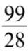 | b. | 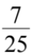 | c. | 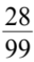 | d.

____ 4. Write 0.54 as a fraction in simplest form.
a. | 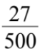 | b. |  | c. | 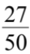 | d. | 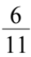

____ 5. What is the greatest number in the set?
, , ,
a. |  | b. |  | c. |  | d.

____ 6. What is the least number in the set?
0.32, 0.26, 0.5, 0.263
a. | 0.26 | b. | 0.32 | c. | 0.5 | d. | 0.263

____ 7. Subtract.
9.123 – 5.77
a. | 3.353 | b. | 8.546 | c. | 4.353 | d. | 4.647

____ 8. Add.
0.769 + 24.3 + 5.8
a. | 30.869 | b. | 1.0889 | c. | 108.89 | d. | 1.07

____ 9. Multiply.
2.2 70
a. | 154 | b. | 1540 | c. | 15.4 | d. | 92

____ 10. Multiply.
7.79 × 0.07
a. | 0.5453 | b. | 7.86 | c. | 0.05453 | d. | 5.453

____ 11. Each sash is 1.65 m long. How much ribbon is needed to make 19 sashes?
a. | 31.35 m | b. | 20.65 m | c. | 3.135 m | d. | 2.065 m

____ 12. Divide.
a. | 0.017 | b. | 0.17 | c. | 0.0017 | d. | 0.00017

____ 13. Divide.
a. | 6.6 | b. | 0.66 | c. | 66 | d. | 0.066

____ 14. How many pieces of ribbon 0.6 m long can be cut from 13.2 m of ribbon?
a. | 22 | b. | 220 | c. | 2.2 | d. | 16

____ 15. Evaluate.
a. | 17.1 | b. | 25.62 | c. | 34.08 | d. | 25.5

____ 16. Evaluate.
a. | 14.1 | b. | 19.5 | c. | 19.23 | d. | 40.02

____ 17. Write 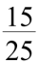 as percent.
a. | 66% | b. | 17% | c. | 35% | d. | 60%

____ 18. Write 0.73 as a percent.
a. | 0.073% | b. | 0.73% | c. | 73% | d. | 7.3%

____ 19. What fraction of the diagram is shaded? Write the fraction as a percent.

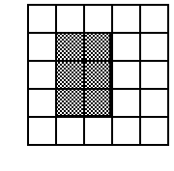
a. | 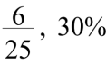 | b. | 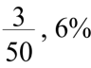 | c. | 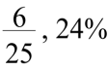 | d. | 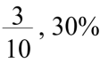

____ 20. Write 0.52 as a fraction in simplest form.
a. | 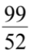 | b. |  | c. | 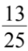 | d. | 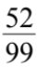

____ 21. Calculate 69% of 12.
a. | 8.1 | b. | 8.28 | c. | 0.81 | d. | 0.828

____ 22. Everyone in Stuart's class has to do a science project.
Out of the 40 students, 60% have completed their projects.
How many students have completed their projects?
a. | 24 students | b. | 16 students | c. | 64 students | d. | 20 students

____ 23. Kevin earned $190 babysitting. He saved 20% of his money. How much did he save?
a. | $43 | b. | $53 | c. | $48 | d. | $38

____ 24. A circle has radius 29.5 cm. What is the diameter?
a. | 9.8 cm | b. | 88.5 cm | c. | 59 cm | d. | 14.75 cm

____ 25. What is the radius of the circle?
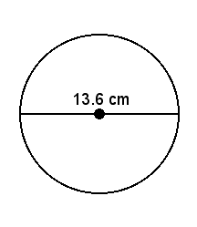
a. | 6.8 cm | b. | 13.6 cm | c. | 27.2 cm | d. | 3.4 cm

____ 26. Calculate the circumference of this circle. Round your answer to two decimal places.
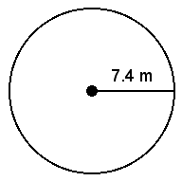
a. | 23.25 m | b. | 172.03 m | c. | 46.50 m | d. | 22.20 m

____ 27. Find the diameter of a circle with a circumference of 14.3 mm.
Round your answer to one decimal place.
a. | 4.6 mm | b. | 2.3 mm | c. | 9.1 mm | d. | 7.2 mm

____ 28. Find the area of this parallelogram.

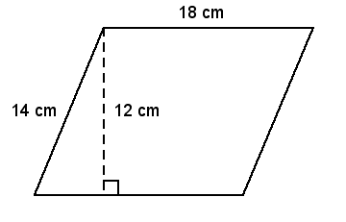
a. | 216 cm² | b. | 252 cm² | c. | 168 cm² | d. | 64 cm²

____ 29. Find the area of this right triangle.
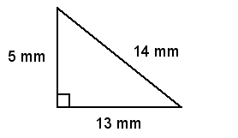
a. | 32.5 mm² | b. | 32 mm² | c. | 227.5 mm² | d. | 65 mm²

____ 30. Find the area of a triangle with base 20 m and height 15.8 m.
a. | 158 m² | b. | 316 m² | c. | 35.8 m² | d. | 17.9 m²

____ 31. Find the area of this circle. Round your answer to two decimal places.
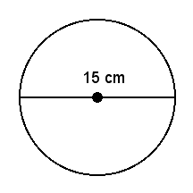
a. | 176.71 cm² | b. | 23.56 cm² | c. | 47.12 cm² | d. | 706.86 cm²

____ 32. Find the area of this circle. Round your answer to two decimal places.
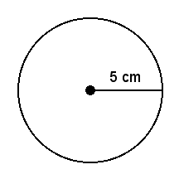
a. | 78.54 cm² | b. | 19.63 cm² | c. | 314.16 cm² | d. | 31.42 cm²

____ 33. Students were asked whether they spend too much or too little time watching television.
The circle graph shows the responses of 120 students.
How many students thought they watched too little television?
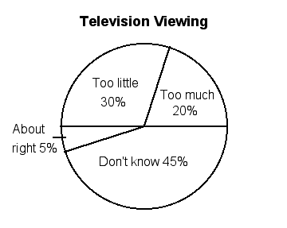

a. | 36 students | b. | 84 students | c. | 24 students | d. | 6 students

____ 34. The table shows the number of students who attended the concert last night.
If the data were displayed in a circle graph, what percent of the graph would represent the 7th graders who attended the concert?

Grade | Number of Students
6 | 375
7 | 275
8 | 350

a. | 27.5% | b. | 65% | c. | 62.5% | d. | 72.5%

____ 35. Find the central angle of a sector that represents 64% of a circle graph.
Round to the nearest degree if necessary.
a. | 230° | b. | 23° | c. | 248° | d. | 212°

The table shows the number of hours per week a college student spends on different subjects.

Subject | Number of Hours
English | 8
French | 10
Art | 5
Math | 8
History | 9

____ 36. What is the sector angle for English?
a. | 72° | b. | 90° | c. | 70° | d. | 81°

____ 37. What is the sector angle for History?
a. | 81° | b. | 45° | c. | 145° | d. | 84°

____ 38. A survey is conducted at a school about a music program. Here are the results:
• | 280 students like the program.
• | 100 students do not like the program.
• | 155 students have no opinion.

A circle graph is made from these data.
What is the central angle of the sector that represents students who like the program?
a. | 188° | b. | 52° | c. | 104° | d. | 67°

____ 39. Find the sum of the fractions modelled by these fraction circles.
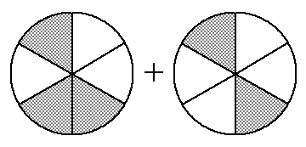
a. |  | b. |  | c. |  | d.

____ 40. Find the sum of the fractions modelled by these fraction circles.
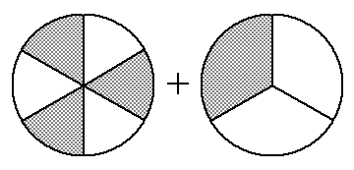
a. |  | b. |  | c. |  | d.

____ 41. Add: +
a. |  | b. | 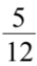 | c. |  | d.

____ 42. Joshua spent of his money on DVDs and on food.
What fraction of his money did Joshua spend?
a. |  | b. |  | c. |  | d.

____ 43. Which fraction is equivalent to ?
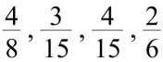
a. | 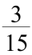 | b. |  | c. | 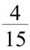 | d.

____ 44. Add: 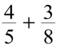
a. | 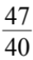 | b. | 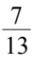 | c. | 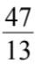 | d. | 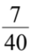

____ 45. You cut vegetables for a stew. You have cup carrots, cup onions, and cup peppers.
About how many cups of vegetables do you have in all?
a. | 1 cup | b. | 2 cups | c. | 3 cups | d. | cup

____ 46. Subtract: 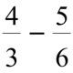
a. |  | b. |  | c. |  | d.

____ 47. Subtract: 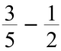
a. | 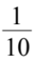 | b. |  | c. |  | d.

____ 48. Subtract: 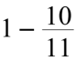
a. | 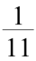 | b. | 1 | c. | 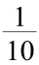 | d. | 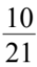

____ 49. Subtract: 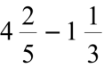
a. | 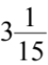 | b. | 3 | c. | 3 | d. | 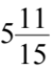

Short Answer

50. Use any method. Order the following numbers from greatest to least.
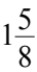, , 1.5, 1.875

51. Copy and complete.
2.791 +  = 4.577

52. Multiply.
2.3 2.3

53. Evaluate.
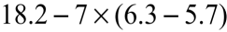

54. Evaluate.
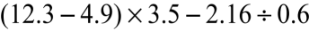

55. Evaluate.
1.7 × (2.4 + 3.5) + 2.1 ÷ 0.5

56. A hall has seating for 300 people. At a concert 92% of the seats were filled.
How many people attended the concert?

57. Workers were surveyed to find their choice of transportation during work days.
Here are the results:
• | 56% chose to drive on their own.
• | 17% chose to be in a car pool.
• | 12% chose transit.
• | 15% chose other modes, such as biking or walking.

Complete this table needed for a circle graph. Round your angle measure to the nearest degree.

Facility | Percent Surveyed | Sector Angle
Driving Alone | 56%
Car Pool | 17%
Transit | 12%
Other | 15%

58. The table shows the number of 6th grade students who prefer each kind of juice at lunch time.
Draw a circle graph to display the information.

6th Grade Juice Choices
Grape Juice | 8
Orange Juice | 6
Fruit Punch | 6
Apple Juice | 20

59. Leo has read of his book. His goal is to finish reading of his book by the end of the week.
How much more does he have to read to meet his goal?

60. A recipe calls for 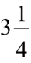 cups of sugar. Marjorie has only 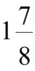 cups of sugar.
How much more sugar will she need?

Problem

61. The Student Council attended a convention. For lunch, 26 out of the 40 members chose milk to drink.
a) | What percent of the students chose milk?
b) | What percent of the students chose another beverage?

62. A group of students are going to winter camp.
They were asked to select their activity for the first day of camp.
Activity | Ski | Snowboard | Skate | Ice Climb
Number of Students | 27 | 36 | 18 | 9

Copy and complete the circle graph with the correct sector names and percents.
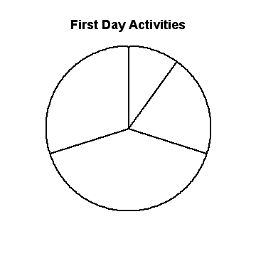
More practice... Keep working at it.....It will pay off!
Answer Section

MULTIPLE CHOICE

1. ANS: D PTS: 1 DIF: Easy REF: 3.1 Fractions to Decimals
LOC: 7.N4 TOP: Number KEY: Procedural Knowledge

2. ANS: D PTS: 1 DIF: Easy REF: 3.1 Fractions to Decimals
LOC: 7.N4 TOP: Number KEY: Procedural Knowledge

3. ANS: B PTS: 1 DIF: Moderate REF: 3.1 Fractions to Decimals
LOC: 7.N4 TOP: Number KEY: Procedural Knowledge

4. ANS: D PTS: 1 DIF: Moderate REF: 3.1 Fractions to Decimals
LOC: 7.N4 TOP: Number KEY: Conceptual Understanding

5. ANS: A PTS: 1 DIF: Easy
REF: 3.2 Comparing and Ordering Fractions and Decimals LOC: 7.N7
TOP: Number KEY: Conceptual Understanding

6. ANS: A PTS: 1 DIF: Easy
REF: 3.2 Comparing and Ordering Fractions and Decimals LOC: 7.N7
TOP: Number KEY: Conceptual Understanding

7. ANS: A PTS: 1 DIF: Easy
REF: 3.3 Adding and Subtracting Decimals LOC: 7.N2
TOP: Number KEY: Procedural Knowledge

8. ANS: A PTS: 1 DIF: Moderate
REF: 3.3 Adding and Subtracting Decimals LOC: 7.N2
TOP: Number KEY: Procedural Knowledge

9. ANS: A PTS: 1 DIF: Easy REF: 3.4 Multiplying Decimals
LOC: 7.N2 TOP: Number KEY: Procedural Knowledge

10. ANS: A PTS: 1 DIF: Moderate REF: 3.4 Multiplying Decimals
LOC: 7.N2 TOP: Number KEY: Procedural Knowledge

11. ANS: A PTS: 1 DIF: Moderate REF: 3.4 Multiplying Decimals
LOC: 7.N2 TOP: Number KEY: Problem-solving Skills

12. ANS: A PTS: 1 DIF: Easy REF: 3.5 Dividing Decimals
LOC: 7.N2 TOP: Number KEY: Conceptual Understanding

13. ANS: A PTS: 1 DIF: Moderate REF: 3.5 Dividing Decimals
LOC: 7.N2 TOP: Number KEY: Procedural Knowledge

14. ANS: A PTS: 1 DIF: Moderate REF: 3.5 Dividing Decimals
LOC: 7.N2 TOP: Number KEY: Problem-solving Skills

15. ANS: A PTS: 1 DIF: Moderate
REF: 3.6 Order of Operations with Decimals LOC: 7.N2
TOP: Number KEY: Procedural Knowledge

16. ANS: A PTS: 1 DIF: Moderate
REF: 3.6 Order of Operations with Decimals LOC: 7.N2
TOP: Number KEY: Procedural Knowledge

17. ANS: D PTS: 1 DIF: Easy
REF: 3.7 Relating Fractions, Decimals, and Percents LOC: 7.N3
TOP: Number KEY: Procedural Knowledge

18. ANS: C PTS: 1 DIF: Easy
REF: 3.7 Relating Fractions, Decimals, and Percents LOC: 7.N3
TOP: Number KEY: Conceptual Understanding

19. ANS: C PTS: 1 DIF: Moderate
REF: 3.7 Relating Fractions, Decimals, and Percents LOC: 7.N3
TOP: Number KEY: Procedural Knowledge

20. ANS: C PTS: 1 DIF: Moderate
REF: 3.7 Relating Fractions, Decimals, and Percents LOC: 7.N3
TOP: Number KEY: Procedural Knowledge

21. ANS: B PTS: 1 DIF: Moderate REF: 3.8 Solving Percent Problems
LOC: 7.N3 TOP: Number KEY: Procedural Knowledge

22. ANS: A PTS: 1 DIF: Moderate REF: 3.8 Solving Percent Problems
LOC: 7.N3 TOP: Number KEY: Problem-solving Skills

23. ANS: D PTS: 1 DIF: Moderate REF: 3.8 Solving Percent Problems
LOC: 7.N3 TOP: Number KEY: Problem-solving Skills

24. ANS: C PTS: 1 DIF: Easy REF: 4.1 Investigating Circles
LOC: 7.SS1 TOP: Shape and Space (Measurement) KEY: Procedural Knowledge

25. ANS: A PTS: 1 DIF: Easy REF: 4.1 Investigating Circles
LOC: 7.SS1 TOP: Shape and Space (Measurement) KEY: Conceptual Understanding

26. ANS: C PTS: 1 DIF: Moderate REF: 4.2 Circumference of a Circle
LOC: 7.SS1 TOP: Shape and Space (Measurement) KEY: Procedural Knowledge

27. ANS: A PTS: 1 DIF: Moderate REF: 4.2 Circumference of a Circle
LOC: 7.SS1 TOP: Shape and Space (Measurement) KEY: Procedural Knowledge

28. ANS: A PTS: 1 DIF: Moderate REF: 4.3 Area of a Parallelogram
LOC: 7.SS2 TOP: Shape and Space (Measurement) KEY: Procedural Knowledge

29. ANS: A PTS: 1 DIF: Easy REF: 4.4 Area of a Triangle
LOC: 7.SS2 TOP: Shape and Space (Measurement) KEY: Procedural Knowledge

30. ANS: A PTS: 1 DIF: Moderate REF: 4.4 Area of a Triangle
LOC: 7.SS2 TOP: Shape and Space (Measurement) KEY: Procedural Knowledge

31. ANS: A PTS: 1 DIF: Moderate REF: 4.5 Area of a Circle
LOC: 7.SS1|7.SS2 TOP: Shape and Space (Measurement) KEY: Procedural Understanding

32. ANS: A PTS: 1 DIF: Moderate REF: 4.5 Area of a Circle
LOC: 7.SS1|7.SS2 TOP: Shape and Space (Measurement) KEY: Procedural Knowledge

33. ANS: A PTS: 1 DIF: Moderate REF: 4.6 Interpreting Circle Graphs
LOC: 7.SP3 TOP: Statistics and Probability (Data Analysis)
KEY: Procedural Knowledge

34. ANS: A PTS: 1 DIF: Easy REF: 4.7 Drawing Circle Graphs
LOC: 7.N3|7.SP3 TOP: Number | Statistics and Probability (Data Analysis)
KEY: Procedural Knowledge

35. ANS: A PTS: 1 DIF: Easy REF: 4.7 Drawing Circle Graphs
LOC: 7.N3|7.SP3 TOP: Number | Statistics and Probability (Data Analysis)
KEY: Procedural Knowledge

36. ANS: A PTS: 1 DIF: Moderate REF: 4.7 Drawing Circle Graphs
LOC: 7.N3|7.SP3 TOP: Number | Statistics and Probability (Data Analysis)
KEY: Procedural Knowledge

37. ANS: A PTS: 1 DIF: Moderate REF: 4.7 Drawing Circle Graphs
LOC: 7.N3|7.SP3 TOP: Number | Statistics and Probability (Data Analysis)
KEY: Procedural Knowledge

38. ANS: A PTS: 1 DIF: Moderate REF: 4.7 Drawing Circle Graphs
LOC: 7.N3|7.SP3 TOP: Number | Statistics and Probability (Data Analysis)
KEY: Procedural Knowledge

39. ANS: D PTS: 1 DIF: Moderate REF: 5.1 Using Models to Add Fractions
LOC: 7.N5 TOP: Number KEY: Conceptual Understanding

40. ANS: C PTS: 1 DIF: Moderate REF: 5.1 Using Models to Add Fractions
LOC: 7.N5 TOP: Number KEY: Conceptual Understanding

41. ANS: A PTS: 1 DIF: Moderate REF: 5.1 Using Models to Add Fractions
LOC: 7.N5 TOP: Number KEY: Conceptual Understanding

42. ANS: D PTS: 1 DIF: Moderate REF: 5.1 Using Models to Add Fractions
LOC: 7.N5 TOP: Number KEY: Conceptual Understanding

43. ANS: A PTS: 1 DIF: Easy
REF: 5.2 Using Other Models to Add Fractions LOC: 7.N5
TOP: Number KEY: Conceptual Understanding

44. ANS: A PTS: 1 DIF: Moderate
REF: 5.2 Using Other Models to Add Fractions LOC: 7.N5
TOP: Number KEY: Conceptual Understanding

45. ANS: B PTS: 1 DIF: Difficult
REF: 5.3 Using Symbols to Add Fractions LOC: 7.N5
TOP: Number KEY: Problem-solving Skills

46. ANS: A PTS: 1 DIF: Moderate
REF: 5.4 Using Models to Subtract Fractions LOC: 7.N5
TOP: Number KEY: Conceptual Understanding

47. ANS: A PTS: 1 DIF: Moderate
REF: 5.4 Using Models to Subtract Fractions LOC: 7.N5
TOP: Number KEY: Conceptual Understanding

48. ANS: A PTS: 1 DIF: Moderate
REF: 5.5 Using Symbols to Subtract Fractions LOC: 7.N5
TOP: Number KEY: Conceptual Understanding

49. ANS: A PTS: 1 DIF: Moderate
REF: 5.7 Subtracting with Mixed Numbers LOC: 7.N5
TOP: Number KEY: Conceptual Understanding

SHORT ANSWER

50. ANS:
1.875, , , 1.5

PTS: 1 DIF: Moderate REF: 3.2 Comparing and Ordering Fractions and Decimals
LOC: 7.N7 TOP: Number KEY: Procedural Knowledge

51. ANS:
1.786

PTS: 1 DIF: Moderate REF: 3.3 Adding and Subtracting Decimals
LOC: 7.N2 TOP: Number KEY: Conceptual Understanding

52. ANS:
5.29

PTS: 1 DIF: Moderate REF: 3.4 Multiplying Decimals
LOC: 7.N2 TOP: Number KEY: Procedural Knowledge

53. ANS:
14

PTS: 1 DIF: Moderate REF: 3.6 Order of Operations with Decimals
LOC: 7.N2 TOP: Number KEY: Procedural Knowledge

54. ANS:
22.3

PTS: 1 DIF: Moderate REF: 3.6 Order of Operations with Decimals
LOC: 7.N2 TOP: Number KEY: Procedural Knowledge

55. ANS:
14.23

PTS: 1 DIF: Difficult REF: 3.6 Order of Operations with Decimals
LOC: 7.N2 TOP: Number KEY: Procedural Knowledge

56. ANS:
276

PTS: 1 DIF: Moderate REF: 3.8 Solving Percent Problems
LOC: 7.N3 TOP: Number KEY: Problem-solving Skills

57. ANS:

Facility | Percent Surveyed | Sector Angle
Driving Alone | 56% | 202°
Car Pool | 17% | 61°
Transit | 12% | 43°
Other | 15% | 54°

PTS: 1 DIF: Easy REF: 4.7 Drawing Circle Graphs
LOC: 7.N3|7.SP3 TOP: Number | Statistics and Probability (Data Analysis)
KEY: Procedural Knowledge

58. ANS:
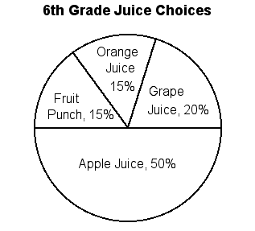

PTS: 1 DIF: Moderate REF: 4.7 Drawing Circle Graphs
LOC: 7.N3|7.SP3 TOP: Number | Statistics and Probability (Data Analysis)
KEY: Communication

59. ANS:
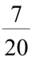 of the book

PTS: 1 DIF: Moderate REF: 5.5 Using Symbols to Subtract Fractions
LOC: 7.N5 TOP: Number KEY: Conceptual Understanding

60. ANS:
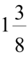 cups

PTS: 1 DIF: Moderate REF: 5.7 Subtracting with Mixed Numbers
LOC: 7.N5 TOP: Number KEY: Conceptual Understanding

PROBLEM

61. ANS:
a) | 65% of the students chose milk.
b) | 35% of the students chose another beverage.

PTS: 1 DIF: Difficult REF: 3.7 Relating Fractions, Decimals, and Percents
LOC: 7.N3 TOP: Number KEY: Problem-solving Skills

62. ANS:
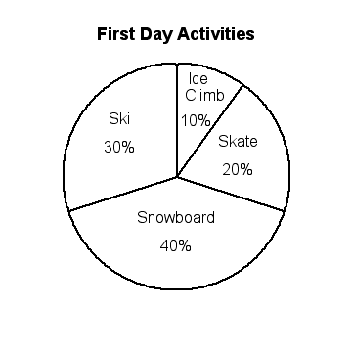

PTS: 1 DIF: Difficult REF: 4.6 Interpreting Circle Graphs
LOC: 7.SP3 TOP: Statistics and Probability (Data Analysis)
KEY: Problem-solving Skills

