Science 8: Practice Final
Mix and Flow of Matter
- Which WHMIS symbol is this?
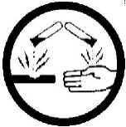
  - Oxidizing
  - Flammable and combustible
  - Corrosive
  - Dangerously reactive
  - Biohazardous

- Which WHMIS symbol is this?
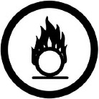
  - Oxidizing
  - Flammable and combustible
  - Corrosive
  - Dangerously reactive
  - Biohazardous

- When temperature increases, particles move faster and further apart. True or False?
  - True
  - False

- What is happening, at a particle level, when a substance is insoluble?
  - Its particles don’t recognize the particles of the solvent
  - Its particles are more attracted to the particles of the solvent than to one another
  - Its particles are becoming evenly dispersed throughout the mixture
  - Its particles are more attracted to one another then to the particles of the solvent

- You are making a drink using drink crystals. Which statement below is correct?
  - The crystals are the solute and the water is the solvent.
  - The water is the solute, and the crystals are the solvent.
  - The crystals are the solution and the water is the solute.
  - The water is the solution and the crystals are the solute.

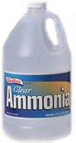
- A bottle of ammonia is broken in one section of a store and its odour is soon noticed throughout the building. This is an example of which of the following processes?
  - Osmosis
  - Permeability
  - Solubility
  - Diffusion

- A substance can exist as a solid, liquid, or a gas depending on its
  - mass
  - colour
  - particle size
  - particle speed

- Oil and water could be best considered a
- Solution
- Pure Substance
- Mechanical Mixture
- None of the above
- Evaporation and melting are both caused when a substance
  - Releases heat energy.
  - Releases coldness.
  - Absorbs coldness.
d) Absorbs heat energy
Use the following to answer the next 2 questions.
Liquid | Flow Rate (cm/s)
Water | 0.66
Molasses | 0.05
Cooking oil | 0.4
Honey | 0.055
Flow Rate of Liquids

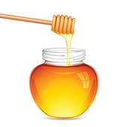

10) Which order ranks the substances by flow rate, from highest to lowest?
  - Water, cooking oil, honey, molasses

Water, cooking oil, molasses, honey
  - Molasses, honey, cooking oil, water
  - Honey, molasses, cooking oil, water

11) Which order ranks the substances by viscosity, from highest to lowest?
  - Water, cooking oil, honey, molasses

Water, cooking oil, molasses, honey
  - Molasses, honey, cooking oil, water
  - Honey, molasses, cooking oil, water

- Why does a piece of metal weighing 10 g sink when it is placed in a large container of ethyl alcohol?
  - The metal has a greater mass than the ethyl alcohol.
  - The ethyl alcohol has a lower density than the metal.
  - The metal has a lower density than the ethyl alcohol.
  - Liquids are always less dense than solids.

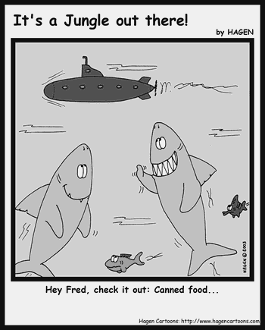
- Your friend is playing a video game in which he is the captain of a submarine. The controls are complicated, simulating all the functions of a real submarine. He is losing game after game because he cannot keep the submarine under the surface. What must he do to make the submarine dive?

Change the type of fuel the submarine is using

Increase the air in the submarine's ballast tank

Increase the average density of the submarine

Decrease the average density of the submarine

- The weight of _______________________ is equal to the buoyant force acting on an object.

The fluid displaced by the object

An object

The total volume of fluid

The container holding an object

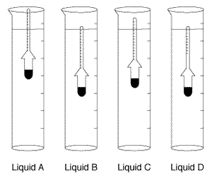
- According to the diagram, which liquid has the highest density?

Liquid A

Liquid B

Liquid C

Liquid D

- In what direction does a fluid at rest exert pressure?

Up and down

Sideways

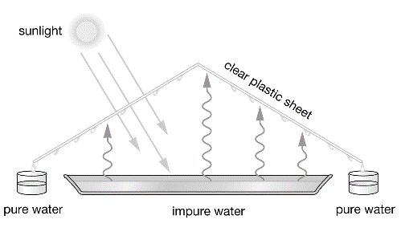
At right angles to a container
  - In all directions

- . What structure does the given figure represent?
  - A homemade filtering apparatus
  - A desert tent
  - A fractionating tower
  - A desalination plant

- The viscosity of a gas __________________ as it is heated, and __________________ as it is cooled.
  - Increases, does not change
  - Decreases, increases
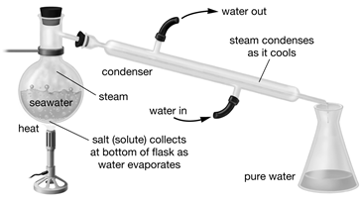
  - Decreases, does not change
  - Increases, decreases

- What does the given figure demonstrate?
  - The dehydration of a saltwater solution
  - Distillation being used to recover water from a saltwater solution
  - The process of crystallization
  - The diffusion of a saltwater solution

Use the solubility curve to answer the next 3 questions.

- At 50C, is KCl more or less soluble than NaCl?
  - More
  - Less
  - They’re the same

- At 40C and 50g, KNO3 is
  - Unsaturated
  - Saturated
  - Supersaturated
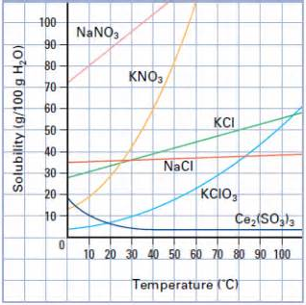
- At what temperature is 80g of NaNO3 saturated?
  - 10C
  - 20C
  - 30C
  - 40C

Light and Optics
- Which of the following sources of light involves living organisms?
  - Fluorescence
  - Chemiluminescence

  - Phosphorescence
  - Bioluminescence

- An example of a surface that is translucent is
  - A mirror
  - Paper
  - Window glass
  - Cardboard

- Which of the following does not refer to mirrors?
  - Angle of incidence
  - Angle of reflection
  - Angle of refraction
  - Normal

- As light enters water from air, it bends
  - Toward the normal
  - Away from the normal
  - Toward the incidence ray
  - Away from the incidence ray

- Which of the following is not found in the human eye?
  - Iris
  - Diaphragm
  - Retina
  - Ciliary muscle
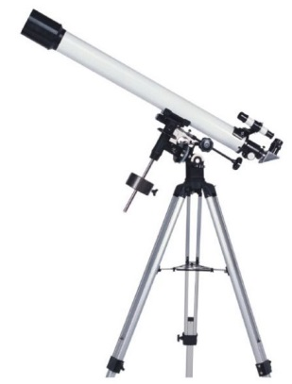
- All human eyes have a blind spot because of the
  - Iris
  - Cornea
  - Optic nerve
  - Pupil

- Which of the following is not found in a reflecting telescope?
  - Objective lens
  - Plane mirror
  - Eyepiece lens
  - Objective mirror

- Lin's theatre group wants to create a dark and gloomy forest scene. They cut out a silhouette of trees from thick, black paper and hold it in front of a stage light to create a shadowy effect. The only problem is the shadow cast on the backdrop is too small. What could Lin suggest they do to increase the size of the shadow?
  - move the light away from the paper cutout
  - move the paper cutout closer to the curtain
  - trim the paper cutout to a smaller size
  - move the paper cutout closer to the light

- On a smooth plane mirror, if the angle of incidence is 60° then the angle of reflection is ...
  - 30°
  - 60°
  - 90°
  - none of the above
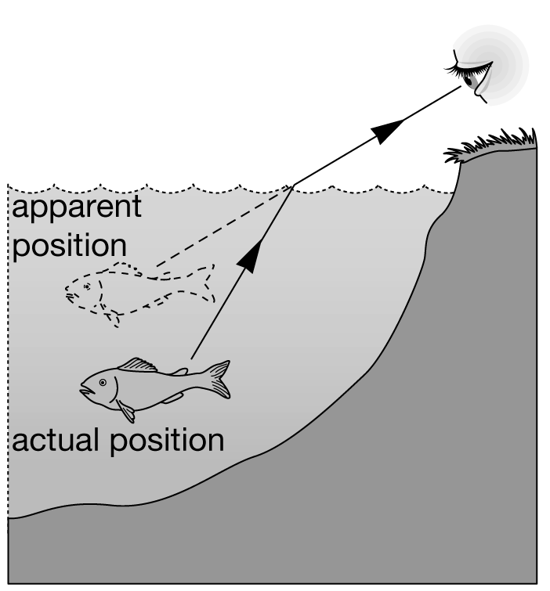
- What is causing the refraction?
  - The air and the water are at different temperatures.
  - The water is reflecting the light.
  - The air and the water have different densities.
  - The air is reflecting the light.

- What do we call the natural adjustment in the size of the pupils?
  - accommodation
  - optic nerve
  - blind spot
  - iris reflex

- Which of the following is not a characteristic of a convex lens?
  - thinner in the middle, thicker edges
  - causes light to converge
  - thicker in the middle, thinner edges
  - forms images upside down

- The film in a camera and the _______________________ in an eye perform a similar function.
  - retina
  - optic nerve
  - lens
  - iris

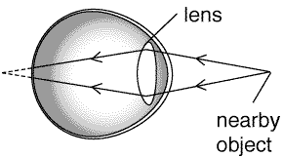
- Armand is in his late 40s. His eye condition is described in this diagram. What name does the doctor give for this condition?
  - near-sightedness
  - far-sightedness
  - focusing
  - accommodation

- Which of the following parts of the human eye and a film camera share the same (or similar) function?
  - Aperture and pupil
  - Film and retina
  - Lens and lens
  - All of the above

- The image seen in a convex mirror, from outside the focal point, in comparison with the object, is always
  - smaller and upright
  - larger and upright
  - smaller and inverted
  - larger and inverted
Mechanical Systems
- Which of the following is false?
  - A pair of scissors is a first class lever
  - Work is done on an object if a force is exerted on the object
  - In a second class lever, the effort force is always less than the load
  - The steeper the inclined plane, the more the effort force required to move the object

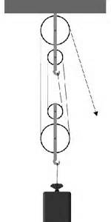
- If the driving gear has more teeth than the driven gear, it is called a:
  - Multiplying gear.
  - Reducing gear.
  - Parallel train.
  - Pinion.

- What is the Mechanical Advantage of the pulley system?
  - 1
  - 2
  - 3
  - 4
  - 5

- A diesel engine produces 80 kJ of energy for every 200 kJ of input energy. The efficiency of the engine is
  - 40%.
  - 80%.
  - 100%.
  - 250%.

- How would you calculate the amount of work done by a simple machine?
  - Divide the load force by the effort force.
  - Multiply force by distance moved.
  - Measure the mass of the object.
  - Divide the force by the distance moved.

- A machine that changes only the direction of a force has a mechanical advantage of ________
- 100
- 10
- 5
- 1

- What property of the brake fluid makes the whole system work?
  - It is a lubricant
  - Its volume decreases as pressure is applied to it
  - It does not heat up with increased pressure
  - It is incompressible

- How much pressure would be needed to lift a weight of 10 000 N resting on a piston that has an area of 5 m²?
  - 1000 Pa or 1 kPa
  - 2000 Pa or 2 kPa
  - 5000 Pa or 5 kPa
  - 500 Pa or 0.5 kPa
- What is the mechanical advantage of a hydraulic lift where the load is 1000 N and the effort force is 50 N?
  - 50
  - 100
  - 20
  - 10

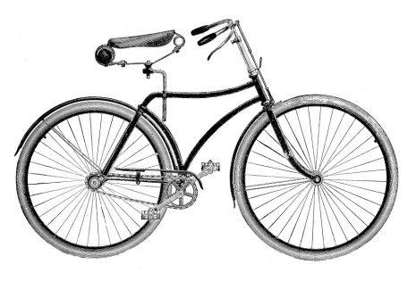
- How do air bags in cars help prevent injury?
  - They redirect the person's energy.
  - They spread the force of impact over a large area.
  - They decrease the surface area that will hit the driver.
  - They slow the person before the person hits the dashboard.

- Which of the following is an example of an open system?
  - the human circulatory system
  - a car jack used by a mechanic in a garage
  - the air pressure system used to inflate car tires at a service station
  - the system that operates a the flaps on an airplane wing

- Within the bicycle, there are many different parts that have very different functions. Each of
these parts performs a specific function so that the bicycle can perform its overall function – to move you around. The many different parts of the bicycle are called
  - subsystems
  - system components
  - technological devices
  - complicated device
- To what class of level does a nutcracker belong to?
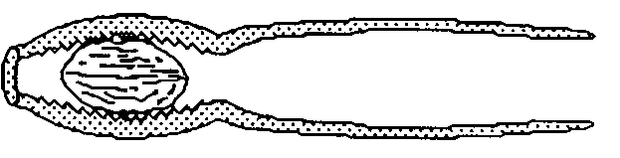
  - Class 1
  - Class 2
  - Class 3
  - It is not a lever
- Which of the following statements is true?
  - A hockey stick is a second class lever.
  - A good machine is always 100% efficient.
  - Pulley systems can only produce a power advantage.
  - A wheel and axle can be used to gain a speed advantage.

- The force of gravity acting on a 500 g mass is
  - 0.5 kg.
  - 5 N.
  - 0.5 N.
  - 5 kg.

- How much force is required to lift a 2 kg dictionary to a height of 1 m?
  - 20 N
  - 4 N
  - 200 N
  - 400 N

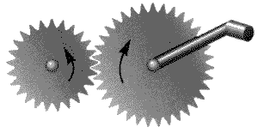
Use the following diagram to answer the next 2 questions

- The two gears (labelled X and Y) together form a gear
  - Sequence
  - System
  - Train
  - Drive

- These gears are
  - Revolving gears
  - Reducing gears
  - Parallel gears
  - Multiplying gears

Use the following diagram to answer the next two questions:
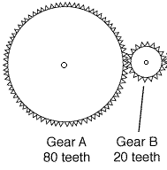

- If gear A is the driver, what is the mechanical advantage of the gear train?
- 0.25
- 0.4
- 2.5
- 4

- If gear A is the follower, what is the speed ratio of the gear train?
  - 0.25
  - 0.4
  - 2.5
  - 4

Fresh and Saltwater Systems

- The distribution of water on Earth, by volume, from least to greatest would be
  - oceans, groundwater, glaciers and ice sheets, surface waters
  - ground water, surface waters, glaciers and ice sheets, oceans
  - surface waters, glaciers and ice sheets, groundwater, oceans
  - surface waters, groundwater, glaciers and ice sheets, oceans

- Two common processes are used to change saltwater into freshwater. When saltwater is forced through a filter, or membrane with holes too small for the salt to fit, the process is called
  - dissolving
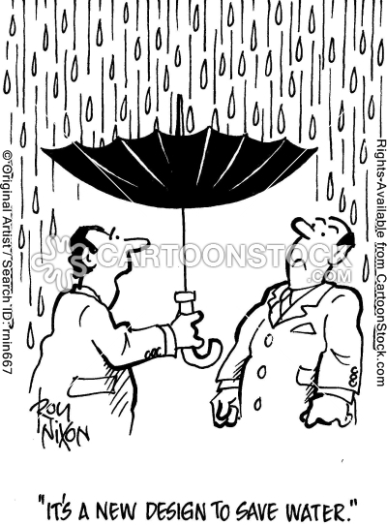
  - distillation
  - able osmosis
  - reverse osmosis

- How does a stream’s speed affect its ability to erode?
  - increase in speed, increase in erosion
  - increase in speed, decrease in erosion
  - decrease in speed, increase in erosion
  - decrease in speed, no erosion

- Hard water contains a lot of dissolved
  - calcium
  - magnesium
  - Both A and B
  - Neither A or B

- What drives the water cycle?
  - the Sun
  - the Moon
  - tides
  - climate

- Icebergs are formed when large chunks of ice break loose from continental glaciers. What do glaciologists call this process?
  - Flowing
  - Birthing
  - Icefall
  - Calving

- You are part of a team of local municipal planners conducting a study of run-off in your community. You need to know what kinds of factors affect run-off. Which of the following is not a factor?
  - whether the roads are gravel or paved
  - the steepness of the slopes in the community
  - the rate of evaporation
  - the rate of precipitation

- What are Canada's five major drainage basins?
  - Pacific, Hudson Bay, Arctic, Atlantic, and Gulf of Mexico
  - Pacific, Hudson Bay, Arctic, St. Lawrence, and Gulf of Mexico
  - Colombian, Hudson Bay, Arctic, Atlantic, and Gulf of Mexico
  - Pacific, Hudson Bay, Arctic, Atlantic, and Great Lakes
- What are the three factors influencing surface currents?
  - uneven heating of the atmosphere, the Sun, continents
  - uneven heating of the atmosphere, Earth's rotation, continents
  - Earth's rotation, the Sun, continents
  - uneven heating of the atmosphere, Earth's rotation, the Sun

- If you camp out one night at an ocean shoreline and you notice that the tidal range is higher than usual, you can guess that
  - the Sun and the Moon are at right angles to each other
  - the Sun and the Moon are in line with Earth
  - there has been a volcanic eruption deep in the water
  - there has been a large upwelling

- What is the name of the region of the ocean where the temperature of the water changes rapidly?
  - mixed layer
  - thermocline
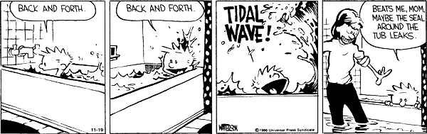
  - deep water
  - headwaters

- When the Sun, the Moon, and Earth form a 90° angle, we have __________________ tides.
  - Spring
  - Neap
  - Normal
  - Fall

- Wavelength is the horizontal distance between successive wave _______________________ .
  - Particles
  - Breakers
  - Crests
  - Tides

- The continental slope is located at the end of the _______________________ .
  - Shoreline
  - continental shelf
  - rift zone
  - ocean trench

- You notice that an algal bloom has covered a local pond. What is likely causing this?
  - There has been an increase in acid rain in the area.
  - A local farmer has decided to grow algae there.
  - Run-off carrying extra nutrients has flowed into the pond.
  - An underground spring is feeding algae to the pond.

- As part of an investigation, you are asked to compare the temperature of two cities. One city is on the shore of a Great lake and the other is far from any open water. What do you predict you will find out?
  - There will be no real difference in temperature between the two cities at any given moment.
  - The city far from any open water will have a smaller average monthly temperature range.
  - The city on the shore of the lake will have a smaller average monthly temperature range.
  - Both cities will have the same average monthly temperature range.
Cells & Systems
- The primary function of all nerve cells is to
- Interpret stimuli
- Control responses
- Transmit impulses
- Reinforce responses

2) The correct order from least complex to most complex is
  - Cell, tissue, organ, organ system
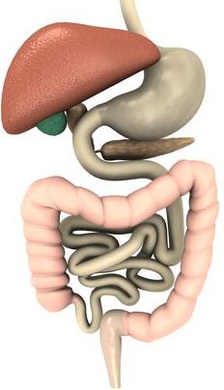
  - Tissue, cell, organ, organ system
  - Organ, tissue, cell, organ system
  - Cell, organ, organ system, tissue

3) Where are the digestive system and the circulatory systems connected?
- at the alveoli
- at the villi
- at the arteries
- at the pancreas

4) Where are the respiratory and circulatory systems connected?
- at the alveoli
- at the villi
- at the arteries
- at the pancreas

5) When you increase the power of an objective lens on a microscope
- you see more of the specimen
- you see less of the specimen
- the magnification decreases
- the field of view increases

- Many of the organelles found in animal cells are also found in plant cells. However, there are a few differences. Identify the organelle that is present only in plant cells, and never in animal cells.
  - Vacuoles
  - Cytoplasm
  - Chloroplasts
  - Nucleus

- The human body is made up of a variety of organs. Which of the following statements does not accurately describe organs?
  - Organs are structures in the body that perform particular functions
  - An organ is a group of several tissues working together
  - The eye, ear, and mouth are all examples of organs
  - An organ is a group of similar cells working together

- Which of the following human blood vessels are made up of thin walls containing valves for carrying blood to the heart?
  - Veins
  - Arteries
  - Epithelial
  - Capillaries
- Identify the relationship between alveoli and capillaries.
  - Blood is exchanged at this location
  - Gases are exchanged between the two
  - Alveoli open to the capillaries
  - Alveoli separate the capillaries from the arteries

- Which term best describes the movement of water from an area of high concentration to an area of low concentration?
  - Flow
  - Diffusion
  - Osmosis
  - Impermeable

A euglena (a single-celled organism) is adapted to live in a pond environment. It is able to move, obtain food, and carry out other functions essential for life. Which of the following structures does it use for movement?
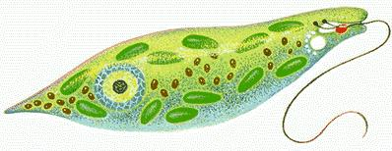
  - Cilia
  - Flagella
  - Pseudopods
  - None of these

- The main function of the cell wall is to
  - Give structural support
  - Digest food
  - Help in the process of osmosis and diffusion
  - Act as a control center of the cell

The stomata of plants do not act independently. Which cells directly cause the stomata to open and close?
  - Guard cells
  - Root cells
  - Chloroplasts
  - Palisade cells

- An amoeba, a unicellular organism, can be compared to a pine tree, a multicellular organism. What is the main difference between the two types of organisms?

Their ability to reproduce.

Their ability to respond to their environment.

The size to which the organisms can grow.

The functions carried out by the cell(s).

Which tissue in plants is responsible for transporting glucose from the leaves to other parts of the plant?

Epidermal tissue

Xylem tissue.

Phloem tissue.

Epithelial tissue.

Which of these is NOT part of the respiratory system?

Trachea

Bronchi

Alveoli

Villi

