Heat & Temperature: Practice Unit Test
A) True or False. Write T or F in front of every statement.
_____ 1. Telephone wires tend to sag in the winter because the cables contract
_____ 2. A gas can be compressed without changing its temperature
_____ 3. The energy of motion is called kinesthetic energy

B) Matching. Write the letter of the term that best matches the description on the left.
# | Letter | Definition | Term
1 |  | Type of heat transfer that requires no particles | a) Cogeneration
2 |  | Type of heat transfer that can only occur in liquids and gases | b) Thermal pollution
3 |  | Fast moving particles bump into neighbouring particles, increasing their energy and motion | c) Radiation
4 |  | The accidental warming of the environment | d) Conduction
5 |  | The use of waste heat to generate electricity of heat building | e) Evaporation
6 |  | The change of state when a puddle disappears from a sidewalk | f) Convection
7 |  | Used to prevent the transfer of heat | g) Melting
8 |  | Cheese dripping onto the bottom of the oven when heated is an example of this change of state | h) Insulation
9 |  | A material used to transfer heat | i) Conductor

C) Multiple Choice
- Which of the following is not an example of a thermal energy remover?
- refrigerator
- freezer
- air conditioner
- fan

- Which of the following would be the best conductor of heat?
- plastic juice pitcher
- aluminum hockey stick
- wooden baseball bat
- a glass window

- As particle motion increases, the temperature
- decreases
- remains the same
- may either decrease or increase depending on the type of material
- increases
- Thermal energy is a measure of the
- total energy content of the particles in a substance
- average energy of the particles in a substance
- amount of heat that is transferred from one substance to another
- ability of a material to heat up and retain its heat
- none of the above

- Temperature is a measure of the
- total energy content of the particles in a substance
- average energy of the particles in a substance
- amount of heat that is transferred from one substance to another
- ability of a material to heat up and retain it’s heat
- all of the above

- The element bromine has a melting point of -7C and a boiling point of 59C. This would mean that :
- Bromine is a gas at room temperature
- Bromine is a liquid at room temperature
- Bromine is a solid at room temperature
- None of the above

- Using the heat generated by molten rock underneath the earth’s surface is an example of
- geothermal energy
- chemical energy
- nuclear energy
- thermal energy
- electrical energy

- A disadvantage of using fossil fuels as our primary source of energy is that
- it pollutes the environment
- it is a non-renewable resource
- it produces excess carbon dioxide, a greenhouse gas
- all of the above
- none of the above

9. Why does a bimetallic strip bend when it is heated?
A) The two metals are joined loosely together.
B) One of the metals expands more than the other.
C) One of the metals contracts more than the other.
D) Both metals expand at the same rate

10. Suppose you have two cups of water, one small and one large. Both are at the same temperature. Which of the following statements is true?
A) The large cup of water has more thermal energy than the small cup of water.
B) There are more particles of water in the small cup.
C) The particles of water in the small cup are moving slower than the particles of water in the large cup.
D) The particles of water in the small cup are moving faster than the particles of water in the large cup.

11. Scientists use the idea of particles to explain properties common to all solids, liquids, and gases. Using the given picture, determine which of the following statements is true. 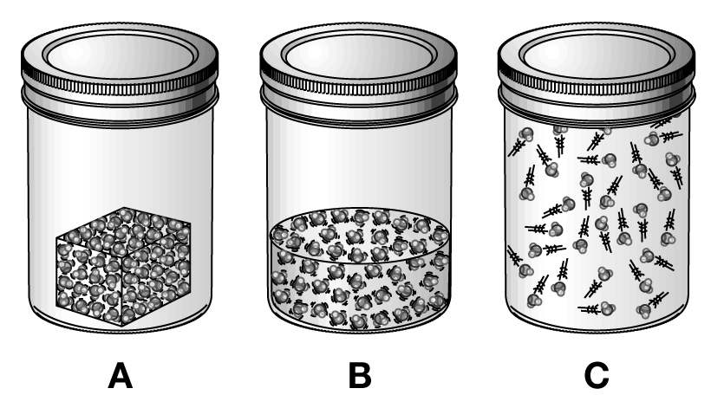
A) A is a solid because particles flow together.
B) C is a solid because particles fill the jar.
C) B is a liquid because particles are relatively close together.
D) A is a gas because particles are in a fixed position.

12. As Neil’s cup of hot chocolate begins to cool, what can he conclude is happening to its particles?
A) They have stopped moving.
B) They are moving more slowly.
C) They are moving more quickly.
D) They are moving further apart.

13. In which of the following are the particles moving fastest?
A) a cold gas
B) a hot liquid
C) a hot solid
D) a cold liquid

14. On a hot day, moisture will form on the side of a glass of cold lemonade. Which is the best explanation for this phenomenon?
A) evaporation of some of the lemonade
B) evaporative cooling of the glass
C) melting of the ice in the lemonade
D) condensation of water vapour in the air

15. Which of the following would be an example of a heat insulator?
A) a gold bracelet
B) a copper pot
C) an iron nail
D) a wooden spoon

16. What combination of colour and texture would absorb energy well?
A) light-coloured and shiny texture
B) light-coloured and dull texture
C) dark-coloured and shiny texture
D) dark-coloured and dull texture

17. In which of the following does convection occur?
A) all fluids
B) solids only
C) liquids only
D) gases only

18. What is the main difference between active solar heating and passive solar heating?
A) Passive solar heating makes use of small windows whereas active solar heating uses large windows.
B) Active solar heating makes use of mechanical devices to help transfer heat whereas passive solar heating makes use of windows and convection currents to distribute heat
C) Passive solar heating makes use of numerous windows on the south side of the building to collect heat energy whereas active solar heating uses solar collectors on the roof or south side of the building to collect heat energy.
D) Active solar heating uses simple devices to redistribute heat energy whereas passive solar heating uses a complicated system of pipes and glass plates to obtain heat energy

19. Food is a source of energy. What kind of energy is it?
A) nuclear energy
B) chemical energy
C) mechanical energy
D) electrical energy
20. The Particle Model of Matter helps to explain ideas about Thermal energy. This model includes each of the following points EXCEPT:
- All substances are made up of tiny particles that are too small to see
- The particles are always in motion
- The particles increase their energy output when they collide
- The particles have spaces between

21. Which of the following energy transfers would be correct?
- Thermal energy in a hot drink is transferred to cold hands
- An ice cube loses thermal energy when it melts in lemonade
- Thermal energy is transferred from a room to a heat, so it can be heated
- Thermal energy is lost in a snowball when it melts

22. When air is heated inside a balloon, the air makes the balloon rise. This happens because – compared to the air outside the balloon, the heated air is
- Less dense
- More dense
- Warmer
- Cooler

23. When thermal energy is added to a solid the volume of the solid will change. Steel beams bending or even breaking in a bridge because of an extreme change in temperature are a result of thermal
- Conduction
- Contraction
- Expansion
- Design

24. Solar cells are arranged in panels, which are connected in series, and then placed to capture and store the Sun’s energy in low voltage batteries. The panels are connected in a series to form what is called a solar
- System
- Field
- Site
- Array

25. Air that is heated by burning fuel in a furnace and then sent throughout the house through ducts to a register in every room is an example of this type of heating system
- Forced-air
- Hot-water
- Convection
- Conventional
26. Basic parts of a cooling system are: a storage tank, a compressor, a freezer unit, condenser coils, and a
- Fan
- Cooler
- Evaporator
- Refrigerant
27. Insulators are rated by their insulating ability. R-value is given to each material that is used in the construction of a building. The best insulating product would have a
- Low R-value
- High R-Value
- Fractional R-Value
- Restricted R-Value
28. An experiment testing the effect of heat on different liquids was performed by some students. Which of the following variables would have been the manipulated variable?
- The amount of heat used
- The different types of liquids
- The size and type of glass tubing each liquid would rise
- The different levels each of the liquids reached in the glass tubing
29. There are two types of solar energy heating systems. The system using direct Sun rays is called
- Active
- Activating
- Positive
- Passive

30. Two types of heating systems in a house help to maintain heat flow where it is needed. The type of heating system that provides heat from a single, central source such as a furnace is called
- Local heating
- Central heating
- Boundary heating
- Thermal heat control

