Unit 3: Environmental Chemistry
Topic 1
NUTRIENTS AND FERTILIZERS

All matter — including plants — is composed of one or more chemicals. Your body is composed of chemicals and also needs them to grow and function. Such chemicals are called _______________. Many nutrients that you need are found in plants. These are known as ________________ nutrients. Other nutrients, ______________ nutrients, come from non-living things and include minerals.

Ninety-nine percent of your body is formed from only six elements — oxygen, carbon, hydrogen, nitrogen, phosphorus, and sulfur. However, ___________________________ like copper play important roles in body functions and maintenance. Even with a balanced diet, a person may develop a chemical imbalance and become unwell.

QUESTION 1:
What element or vitamin might your body require in each of the following situations?
- You’re having a problem regulating your metabolism. You’re too hot one minute and too cold and weak the next.
- You seem to be retaining a lot of water.
- You feel weak and tired all the time. Any form of exercise quickly forces you to breathe hard. Hint: For exercise, oxygen transport to muscles and energy production from sugar must be efficient.
- You have been developing cavities lately, and your doctor says your bone density has decreased.
- You have developed a goitre.
- Your gums are bleeding, your teeth are falling out, and you find that you bruise very easily.
- You have been eating space food—food for space travellers—and have developed an irregular heart rhythm when exerting yourself.. An irregular heartbeat may involve faulty nerve activity.

MACRONUTRIENTS and MICRONUTRIENTS
- All living things need nutrients to survive. Nutrients are elements and compounds that organisms need for living, growing, and reproducing. Plants obtain the nutrients _________, _________, and ___________ from air and water. They obtain nitrogen, phosphorus, potassium, magnesium, calcium, and sulfur from the soil. These nine elements are all essential for the normal growth of plants.
- Because they are needed in relatively ________ amounts, they are called _________________ (“macro” - means large or large scale). In earlier science classes, you learned about the importance of carbon, hydrogen, and oxygen for living things. You will learn more about them throughout this unit. The table below summarizes the role of the six other macronutrients in the growth and development of plants and humans.
- Elements such as selenium are also essential for plant and animal growth and development. However, they are needed in only _______ or _________ amounts, so they are called ________________ (“micro” - means very small or small scale).
TYPES OF ORGANIC MOLECULES
- ________________________
When we eat food such as pasta, rice, potatoes, fruits, and bread, we are eating carbohydrates. Carbohydrates are organic molecules made up of atoms of carbon, hydrogen, and oxygen. These atoms can form simple molecules, such as sugar, or large, complex molecules, such as starch, cellulose, and glycogen.

- __________________
Fats, oils, and waxes are lipids—compounds composed of many carbon, hydrogen, and oxygen atoms. Both animals and plants produce lipids. For example, our skin produces oils, and our bodies store food in the form of fat. Plant products such as canola seeds, corn, peanuts, soybeans, walnuts, and cashews contain large amounts of oils.

- ________________
Foods such as meat, fish, eggs, and dairy products add proteins to our diet. Proteins have many functions. They are used by organisms for growth and repair, and as a source of energy. They are the main component of enzymes. Recall that enzymes are catalysts that control chemical reactions in organisms.
- ___________________
A nutrient that is an organic compound required in tiny amounts for essential metabolic reactions in a living organism. Most vitamins ______________ be obtained in sufficient quantities by synthesis in the body, and therefore must be obtained from the _______________.

FERTILIZERS

- Farmers must have an understanding of chemistry to produce good crops. They have to know what chemicals to add to soil to improve plant growth and what chemicals to treat plants with to protect them from pests.
- A fertilizer is a substance that ________ soil so that plants will grow _________. For example, potassium is essential to plant growth. If a soil is low in potassium, plants cannot grow well in it. The soil must be enriched by adding a potassium fertilizer.
- Fertilizers are described by the major nutrient elements they contain. These elements are ___________, ___________, and _____________. Figure 1.4 shows a typical fertilizer label. The three numbers 15–30–15 on the label indicate that this fertilizer contains 15% nitrogen compounds, 30% phosphorus compounds, and 15% potassium compounds. Some fertilizers have a fourth number and the letter “S” on the label to indicate that they contain sulfur as a major ingredient.
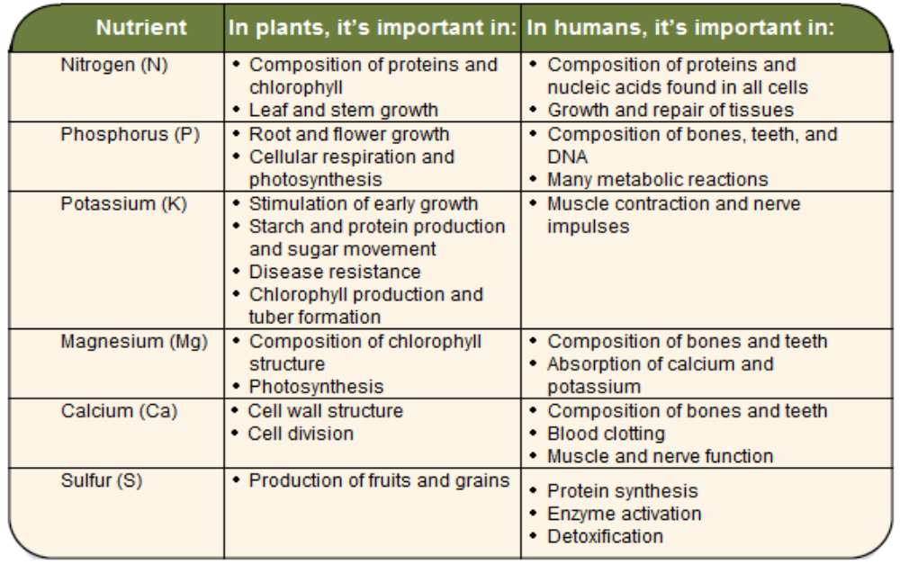

- Fertilizers may come from natural sources or synthetic chemicals. They are added to the soil to help plant growth, but they must be applied carefully. Too much can damage organisms. Too much fertilizer may even damage the crop it’s supposed to help. If fertilizer enters ponds, streams, lakes, or rivers, it may damage those ecosystems by changing the concentration of chemicals.

PLANT AND ANIMAL INTAKE
- Nutrients enter the roots of plants either __________________ or __________________. Passive uptake does not require the plant to use any energy. It occurs through a process called ___________. Diffusion is the movement of molecules from an area of ___________ concentration to one of ___________ concentration. Figure 1.26 shows diffusion occurring in a solution of food colouring and water. The food colouring gradually moves from the more concentrated area where it enters the water until it is spread evenly throughout the water.

- Similarly, some nutrients move into the roots of plants by ________________________. They move from the area of higher concentration outside the roots to the area of lower concentration within the roots.
- Water moves into plant roots by a special type of diffusion called ______________. Water moves through the walls of the plant’s roots from an area where there are more water molecules to an area where there are fewer water molecules.

- Plants need high concentrations of some nutrients in their roots. The concentrations of these nutrients may be higher in the roots than in the water in the surrounding soil. To maintain these high concentrations, plants must move some nutrients from the soil, an area of lower concentration, into their roots. To move nutrients in this direction, plants use a process called ___________________________. In active transport, plants must use ___________ to move the molecules of nutrients in the direction opposite to diffusion. This energy is used by specific molecules in the root cells that transport the nutrient molecules into the plant roots.

- Humans and other animals obtain the 25 elements our bodies need for normal growth and function from the air we breathe and the food we eat.

- The process of taking food into our bodies is called _______________. Most of the ingested food must be broken down into smaller particles so our bodies can absorb the nutrients from it.
- Nutrients such as glucose and amino acids are _____________ through cell membranes and into the bloodstream. The blood carries them to cells throughout the body where they are either used or stored.

Topic 2
PESTICIDES AND DDT

- Perhaps you put fertilizer on your lawn. You might even use ____________________. Treating your lawn this way makes it healthy and green. In addition to fertilizers, pesticides are often used to help grow high-yield crops.
QUESTION 1:
Name three kinds of pesticides and indicate which pest each controls.

DDT
The insecticide ___________ is a white, crystalline solid with no odour or taste. It was widely used to control insects in agriculture and insects that carry diseases. Because of damage to wildlife, the use of DDT in Canada has been banned. But it is still widely used in some countries.

The use of pesticides is potentially hazardous. Minimizing the use of insecticides reduces the risk of harm to the environment. Are some countries better than others in avoiding the use of insecticides?

QUESTION 2:
Using the graph on page 192 of your textbook identify
- how many species of insects and mites were resistant to insecticides in 1940?

- how many species of insects and mites were resistant to insecticides in 1990?

DDT was hailed as a “powerful insecticide” that was “harmless to humans” when it was first invented. Its “dark side” only became apparent a decade later.

QUESTION 3:
Name three non-target organisms affected by DDT.

Bioaccumulation

Some scientists make a distinction between the terms ___________________________ and ____________________________. They use the term biomagnification for the increase of a chemical’s concentration along the food chain. Bioaccumulation is used for a related process – the increase in concentration of a chemical in a particular group of biological organisms over time.
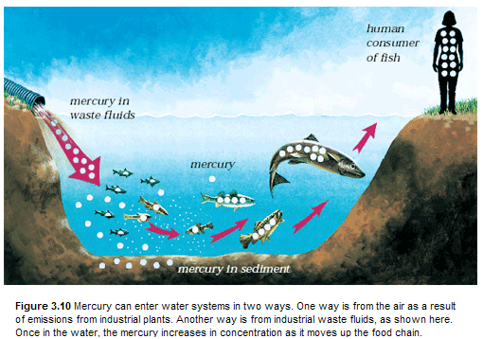

Draw your own version of Biomagnification:

MULTIPLE CHOICE

- The process of digestion produces the chemicals known as
- nutrients.
- organics.
- inorganics.

- Nutrients are classified into two major groups,
- organic and inorganic.
- lipids and enzymes.
- vitamins and minerals.

- Which of the following lists, in the correct order, the major classes of organic molecules found in grains, dairy products, and legumes?
- Lipids, proteins, and carbohydrates
- Carbohydrates, lipids, and proteins

- The nutrients that act mainly as an energy source for metabolism in your body are the
- lipids.
- carbohydrates.

- A bag of commercial fertilizer is labeled 10-15-20. These numbers tell you that the fertilizer mix provides nutrients in the following proportion:
- 10% nitrogen, 15% potassium, 20% phosphorous.
- 10% nitrogen, 15% phosphorous, 20% potassium.
- 10% potassium, 15% nitrogen, 20% phosphorous.

- The nitrogen cycle includes the following three compounds:
- nitrates, nitrogen oxide, and ammonia.
- nitrates, urea, and nitrogen oxide.
- nitrates, ammonia, and nitric acid.

- Fertilizers have helped to double food production since 1950. One problem associated with fertilizer use is
- the ability to use marginal lands for farming.
- the expense of using fertilizers.
- natural nitrates are becoming scarce due to fertilizer production.

- Elements and minerals absorbed by a plant are used to build
- vitamins, carbohydrates, and inorganic compounds.
- vitamins and minerals.
- vitamins, proteins, lipids, and carbohydrates.

- By mass, the four most common elements in your body are oxygen (65%), carbon (18%), hydrogen(10%), and nitrogen (3%). What percentage of your body is occupied by the other elements?
- About 4%
- About 40%
- About 0.4%

- The nutrients that are most essential to bone structure are
- phosphorous and calcium.
- potassium and calcium.
- iron and calcium.
- calcium only.

- The mineral most crucial to red blood cells is
- iron.
- copper
- iodine.
.

- The four most common elements in the human body are
- oxygen, carbon, hydrogen, and nitrogen.
- oxygen, carbon, sulfur, and nitrogen.
- oxygen, carbon, hydrogen, and iron.

- Thyroid hormones play an important role in regulating metabolism. A major nutrient found in these hormones is
- iodine.
- iron.
- sulfur.

- Weed, insect, and fungus pests can be controlled by applying specific pesticides called (in the correct order)
- DDT, dieldrin, and fungicides..
- fungicides, herbicides, and insecticides.
- herbicides, insecticides, and fungicides.

- The difference between an insecticide and the citronella candle you may burn on your deck is that
- citronella is a herbicide.
- the insecticide is a chemical.
- insecticide will kill the mosquitoes, while citronella just sends them away.

The following diagram illustrates an ocean food web.
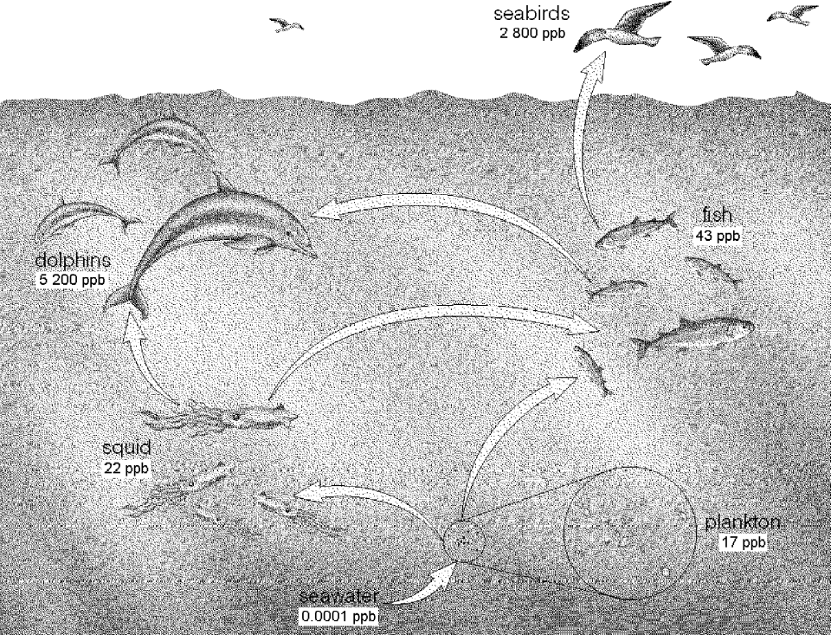

- How did the DDT likely enter the food web illustrated above?
- It occurs naturally.
- It was accidentally releases from factories.
- It was applied to control insects on land.

- In the food web illustrated above, the numbers represent
- the number of organisms at each stage in the food web.
- the amount of DDT in each organism’s tissues.
- The length of time DDT has been in the environment at each stage in the food web.

- The term that best describes the change in DDT concentrations illustrated above is
- biomagnification.
- bioamplification.
- tissue amplification.

- Assume that no further DDT is introduced into the food web illustrated above. The concentrations of DDT will
- decrease quickly in the environment over time.
- increase slowly in the environment over time.
- decrease more slowly in the tissues of predator species than in their prey species.

- Imagine that the data in the food web illustrated above were collected ten years after a ban on the use of DDT. What could you conclude from this?
- DDT is probably still in use despite the ban.
- DDT is leaching into this environment from other areas.
- DDT can persist in the environment for many years.

- The researcher who was chiefly responsible for identifying the serious consequences of pesticide use in the 1960s was
- Rachel Carson.
- Paul Müller.
- The World Health Organization.

- A major concern about the use of pesticides is
- their use for criminal activity.
- their persistence in the environment.
- organic farmers are at a disadvantage because they cannot use any pesticides.

- The scientist who received the 1948 Nobel Prize in Physiology or Medicine for inventing DDT was
- Rachel Carson.
- Albert Einstein.
- Paul Müller.
MATCHING

Match the description to one of the following terms.
- Herbicide
- Fungicide
- Insecticide
- Pesticide

- ______ Controls weeds by killing them.
- ______ Includes three other terms from the above list.
- ______ Controls fungus pests by killing them.
- ______ Controls insects by killing them.

Match the description to one of the following terms.
- Biomagnification
- DDT
- Persistence
- Pesticide resistance
- Pesticides

- ______ The accumulation of a chemical in organisms at different levels of the food web.
- ______ A process that allows a species to adapt to the presence of a pesticide.
- ______ A key characteristic of DDT that makes it harmful to the environment.
- ______ Can severely affect the reproduction of birds of prey.
- ______ A discovery for which Paul Müller was awarded the Nobel Prize.

Match the description to one of the following terms.
- Enzyme
- Lipid
- Carbohydrate
- Mineral

- ______ Found in rice and grains
- ______ An inorganic substance
- ______ May be classified as a trace element
- ______ Used to store unused energy
- ______ Not classified as a nutrient
Topic 3
ACIDS, BASES AND pH
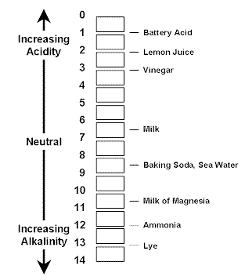
What is an acid and what is a base?
QUESTION 1:
Identify the following as either an ACID or a BASE.
- tastes sour
- feels slippery
- tastes bitter
- causes burning sensation in muscles

QUESTION 2:
Match the following.
- antacid tablets A. aluminum
- household and industrial strength cleaners B. phosphoric acid
- a strong acidic electrolyte in car batteries C. sodium hydroxide
- a tangy flavour in food D. sulfuric acid

The colour change of a ________________________ can show you how acidic or basic a liquid is. The reading on a pH meter scale (the pH ____________) can also show you this information in a quantitative way.

QUESTION 3:
Suppose red litmus paper turns blue in solution 1 and blue litmus paper turns red in solution 2. Neither one changes colour in solution 3. What could you infer about solutions 1, 2, and 3?

QUESTION 4:
List the following substances according to their pH, going from lowest to highest pH:
- baking soda • household ammonia
- car battery acid • human blood
- drain cleaner • normal rain

________________________________ solution is a _________ pH indicator. It is purple when neutral, and it ranges through beautiful golds and greens (basic), and blues and reds (acidic) as the pH of the solution changes.

If you have an upset stomach, you might take an antacid to help you feel better. An antacid is a mild _____ that reacts with the acid in your stomach to ____________ it. The base in the antacid and the acid in your stomach react to form compounds that are less upsetting to your stomach. This acid-base reaction is called neutralization. The neutralization reaction produces water and a compound called a salt. For example, what we call table salt can be produced by combining hydrochloric acid with sodium hydroxide solution, a base. Here is the equation for that neutralization reaction:

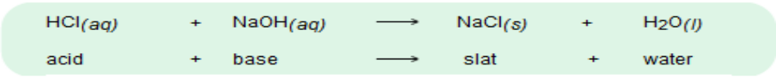

Acidic lakes are sometimes treated with _______ (calcium hydroxide) to neutralize them. The lime is mixed with water so that it dissolves. A chemical reaction takes place between this limewater, which is a base, and the dilute sulfuric acid of the lake’s water. The reaction produces calcium sulfate (a ________) and water. If all the acid and all the base are used up, the solution becomes neutral. The equation for that reaction is:

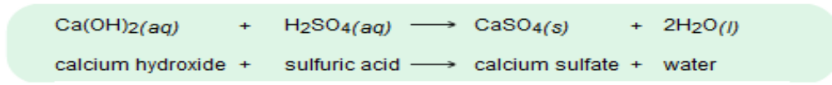

ACID PRECIPITATION, NEUTRALIZING, AND EMISSIONS
Have you ever wondered where all the emissions go after they leave factory towers?

It turns out that what goes up must come down. But while up there, “it” just might be up to some chemical “mischief”. This is the case with the formation of ______________________. Sulfur and nitrogen oxides are released by certain industries. Carbon dioxide escapes when fossil fuels are burned. These emissions react chemically with water in the atmosphere to produce acids. The result is acid precipitation.

______________ can be particularly bad because snow accumulates over the winter. The spring thaw releases the build-up. This causes a large ________ of acid into ground water and surface water systems. This “acid ________” occurs just as organisms are laying eggs. Fresh eggs are vulnerable to acidity. In ground water the acid shock destroys the tiny root hairs of plants, which are vital for water and nutrient absorption. The high acid concentration also kills important bacteria.

QUESTION 5:
Where does at least 50% of the acid precipitation in eastern Canada come from?

The ___________________________ – based soils of central and southern Alberta act as a natural buffer to quickly neutralize acids.

QUESTION 6:
Acid rain affects soil and even rock.
- What is marble formed from (you may need to look this one up)? Why would marble statues be affected by acid rain?

- How does acid precipitation affect the soil?

One group of students used a drop of liquid from each test tube as samples. They made wet mount slides to do a count of yeast cells under a microscope. The students used the cell counts in the samples as relative population densities of yeast at the different pH levels. Their results were as follows:
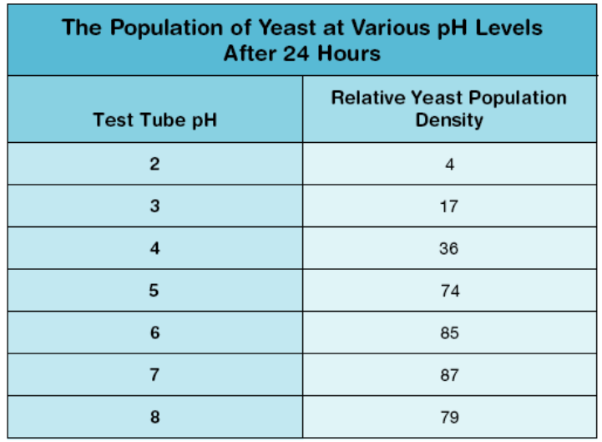
QUESTION 7:
Answer question 1 from “Analyze” and questions 2 and 3 from “Conclude and Apply”. Base your answers on the results given in the data table above.

Bromothymol blue is a ____________________________ that turns ________________ in an ______________solution and remains ____________ in a neutral or basic solution. For this investigation, the indicator is first placed in an alkaline solution and turns the solution blue.

Hydrochloric acid is added drop – by – drop until the indicator turns yellow. At this point, the solution has just changed from being neutral to being acidic. This point can be viewed as the neutralization point. All the drops released from the dropper will be the same size. The technique of adding a chemical drop by drop until a change occurs is referred to as ________________.

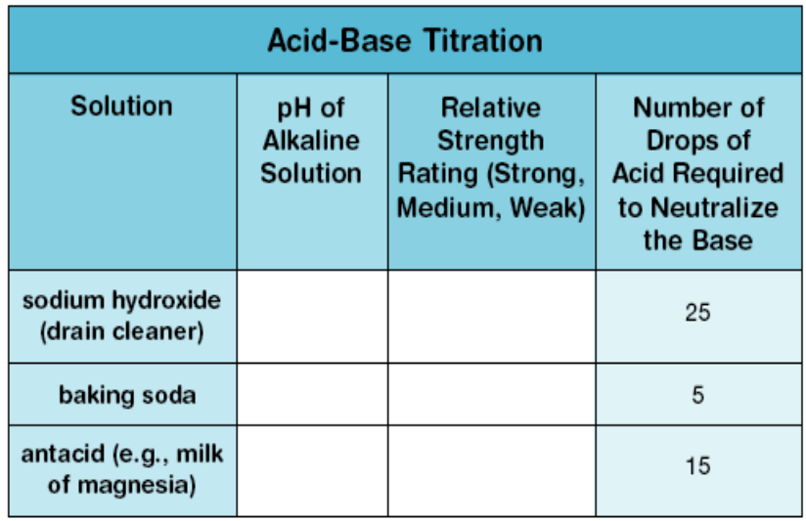

QUESTION 8:
Complete the table. Hint: Refer to “Figure 3.9” on page 198 and 199 of your textbook for levels of pH and relative strength.
QUESTION 9:
Answer “Analyze” question 2 on page 208 of your textbook. Hint: You are looking for a ratio.

QUESTION 10:
There are solutions to the threat of acid precipitation. Fortunately, many of Alberta’s soils and water systems are naturally buffered against acid precipitation.
- Why is liming only a temporary solution to acid precipitation?
- List two ways to remove oxides from car and factory emissions.

MULTIPLE CHOICE

- Substances that have a tart taste, like lemons or soft drinks, are usually
- acids.
- bases.
- catalysts.
- enzymes.

- Chemicals that have a bitter taste or slippery feel are usually
- acids.
- bases.
- catalysts.
- enzymes.

- The best way to determine if a substance is an acid or a base is to use a(n)
- taste test.
- acid-base indicator.
- pH scale.
- acid-base neutralizer.

- Sammi needs to organize a number of chemical samples into groups of acids and bases. Which of the following will she use?
- A pH scale
- A catalyst
- A sorbent
- None of the above

- Which of the following chemical reactions contribute to acid precipitation?
- SO₂ + H₂O H₂SO₃
- 2 NO₂ + H₂O HNO₂ + HNO₃
- CaCO₃ + H₂SO₄ CaSO₄ + H₂O + CO₂
- CO₂ + H₂O H₂CO₃
- i and iv
- i, ii, and iii
- ii, iii, and iv
- i, ii, and iv

- The major source of chemicals that contribute to acid precipitation is
- natural oxides.
- oxides from the burning of fossil fuels.
- sulfates from the burning of fossil fuels.
- carbonates in rock debris.

- Which alternative offers the most practical way to deal with acid rain?
- Reduce the amount of harmful substances released into the environment.
- Treat lakes with neutralizing chemicals.
- Stop all industrial processes that create harmful substances.
- All of the above.

- Devices that use calcium oxide as a sorbent to remove sulfur dioxide from exhaust gases are called
- oxidators.
- scrubbers.
- liming agents.
- catalytic converters.

- Catalytic converters remove harmful oxides from car exhaust. They can function for many years because
- catalysts are not used up in the oxidation reaction.
- sorbents can capture most of the oxides.
- liming agents are not used up in the oxidation reaction.
- they use metal oxide sorbents, which can be reused.

- Which statement below best describes a catalyst?
- It restores chemicals to their original state following a reaction.
- It absorbs other substances in a chemical reaction.
- It promotes complete oxidation in a chemical reaction.
- It speeds up a chemical reaction, but is not used up in the reaction.
Examine the following diagram.
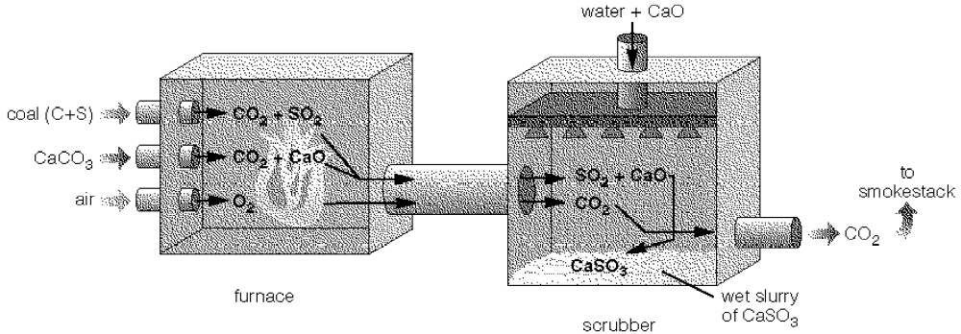
- What process is illustrated in the diagram shown above?
- Scrubbing of exhaust gases.
- Catalytic conversion of exhaust gases.
- pH adjustment of exhaust gases.
- None of the above.

- In the process illustrated above, CaO is the
- catalyst.
- scrubber.
- sorbent.
- oxide.

- In the process illustrated above, the waste product is
- calcium oxide.
- calcium sulfite.
- calcium carbonate.
- sulfur dioxide.

- Red cabbage juice and litmus are similar in that
- both are acid-base indicators.
- both are acid-base neutralizers.
- both are sorbents.
- both catalyze oxidation reactions.

MATCHING

Match the description to one of the following terms.
- Catalyst
- Catalytic converter
- Oxidation
- Scrubber

- ______ A device that removes oxides from car exhausts before they get into the air
- ______ A device that uses a sorbent
- ______ The process that takes place in a catalytic converter
- ______ A substance that speeds up a chemical reaction

Match the description to one of the following terms.
- pH paper
- pH scale
- Litmus
- Colour change
- Catalyst

- ______ An indicator used to identify acids and bases
- ______ Compares how acidic or basic a substances is
- ______ Uses as an indicator substance
- ______ Evidence of a chemical reaction

Match the description to one of the following terms.
- Acid
- Base
- pH scale
- Acid precipitation
- pH
- Scrubber

- ______ Means “the power of hydrogen.”
- ______ Washes acid compounds out of the air.
- ______ Compares relative acidity or alkalinity of a substance.
- ______ A chemical that has a pH greater than 7.0.

CSI: St. Albert

On March 14st, 2013 Dr. Jennifer Sine, a well-known scientist of St. Albert and Edmonton was working on a very important, top secret project for the University of Alberta. During her time at the lab she was murdered. At the scene of the crime they found her gloved hand cut off and sitting beside a poisoned feather duster. Someone succeeded in stealing her lab notes, which she had been working on for the past 6 months. It was determined by the coroner that it wasn’t her hand being cut off that killed her, it was the poisonous substance found on the feather and glove. Your job as a crime scene investigator is to determine the substance that killed Dr. Sine. There are 5 substances that have an unknown pH linked to 5 suspects. The one that killed Dr. Sine had a pH of about 2.0. Listed below are the suspects and information of the poison that links them to the crime scene and to Dr. Sine.

Suspects:
#1: Dr. Tumbach: She worked hard along side Dr. Sine. Some say she was the brains behind the operation. “Sine got all the credit for the work I did.”
Liquid #3 was linked to Dr. Tumbach
#2: Keri-Lynn Buckland: She was jealous of Dr. Sine’s good looks and she wanted to know all of the doctor secrets. She was quoted to say “One day people will see how much more wonderful I am compared to that Sine chick. She had an easy climb up the science ladder where the rest of us had to claw our way up!”
Liquid #4 was her own concoction.
#3: Mr. Hayes: Why you ask? Isn’t it always the assistant principal that does the dirty work?
Liquid #5 was found in Mr. Hayes’ desk
#4: Cache McDougall: Mr. McDougall was known around the town as the one arm bandit. Everyone knew that he wanted to marry Dr. Sine. But it wasn’t for her brains that he wanted to marry her….it was her ARM!!!
Liquid # 1 was found on the one arm of Mr. McDougall.

#5: Icabod Glen Cocoa: He was in love with Dr. Sine and everyone knew it. She was too focused on work and had no time for love. This made him angry. “She is the only one for me and I am the only one for her. If I can’t have her, no one can.”
Liquid #2 was his own love potion.

You must determine the pH of all 5 liquids and fill in the chart below. You then must make an accusation based on your results.

Suspect | Liquid # | pH

Accusation:
________________________________________________________________________________________________________________________________________________________________________________________________________________________________________________________________________________________________

POLLUTION AND DOSES

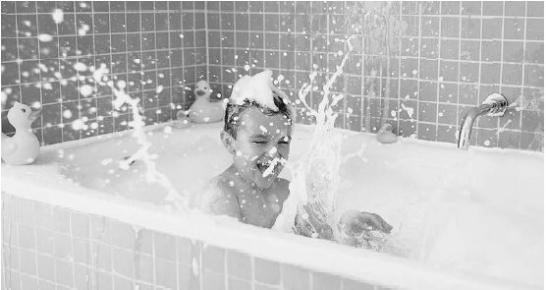

The sharing of bath water leads to this question. How much mud, dust, or grime in the water is too much? You’d certainly think about this if the family dog somehow got in the tub ahead of you.

A similar question could be asked about a ___________________ in an environment. A very small amount may not be detectable. But when a pollutant builds up due to ongoing _____________________, there comes a point when there is too much. When is that level reached? It may be too much before it even becomes visible.

Where Does Pollution Begin? (pg. 124)
In “Part 1” you will prepare a series of salt solutions that are diluted by a factor of 10 each time. The steps of “Procedure” work best with drinking glasses that have sides that go straight up and down. In “Part 2” you will use a taste test to see what the minimum dilution is that a person can taste. In “Part 3” you will do everything again, but with water. Follow the steps of “Procedure” for all three parts of the investigation.

QUESTION 1:
Answer questions 1 from “Analyze” and question 4 of “Conclude and Apply”.

Here is an example to help you better understand parts per million as a unit of measurement. Suppose you put 999 mL of water in a large beaker or bucket, add 1 mL of food colouring, and stir to make a solution. The concentration of food colouring in the container is 1 mL of food colouring per 1000 mL of solution, or you can say, 1 part food colouring per 1000 parts solution.

Now you will make a very dilute solution using the solution you just made. Pour 999 mL of water into another large container. Add 1 mL of the mixture from the first container. This contains 0.001 mL of food colouring. Stir. The concentration in the second container is therefore 0.001 mL of food colouring per 1000 mL of solution, or 0.001 parts food colouring per 1000 parts solution. To express this as parts per million, write:

0.001 parts per 1000 parts = X parts per 1 000 000 parts

where X is the number of parts per million parts of solution

Next write this statement as a ratio:

0.001 : 1000 = X : 1 000 000

Now write each ratio as a fraction:

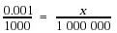

Multiply each side of this equation by 1 000 000 to clear the fractions:
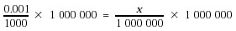
Therefore, X = 1.

The concentration of food colouring in the diluted solution in the second container is now 1 part per million parts solution, or 1 ppm.

Sometimes you may encounter even lower concentrations of chemicals in parts per billion (ppb) and parts per trillion (ppt). Here’s an example to show the difference between these measurements:
- 1 drop of food colouring in a half-full bathtub is about 1 ppm
- 1 drop of food colouring in a full swimming pool is about 1 ppb
- 1 drop of food colouring in the amount of water needed to fill 1000 swimming pools is about 1 ppt

QUESTION 2:
Calculate the salt concentration (in ppm) when you have dissolved 10 mg of salt into 250 g of water (250 mL of water has a mass of 250 g). Note: When 1 mg of a solid is dissolved in 1 L of water, its concentration is 1 ppm. In other words, 1 ppm of a solid in water can be written as 1 mg/L.

QUESTION 3:
You are the water manager for a large North American city. You will be processing one billion kg of drinking water over a certain time period. You have tested the water and found that it contains 0.05 ppb of mercury, 1.3 ppb of arsenic, and 9.4 ppb of lead. Is this water safe to drink as far as the mineral content is concerned? Explain.

LD50 AND RISK ASSESSMENT

DID YOU KNOW?
Coumadin is the medical name for warfarin, a chemical commonly used to poison rodents. This chemical is a blood thinner that causes severe internal bleeding when used as a pesticide. As a medicine, coumadin is used in low concentrations to provide protection against strokes and heart attacks. Coumadin levels in the blood are closely monitored. Doctors know where the benefit ends and the toxicity begins. The oral dosage is adjusted accordingly.

QUESTION 4:
Do the following chemical concentrations, measured within the human body, exceed the LD50 dose?
- nicotine: 0.75 ppm
- tetanus toxin A: 0.0000055 ppm

QUESTION 5:
Why is a waiting period important before a new chemical is approved for use?

QUESTION 6:
People take potentially harmful substances voluntarily.
- For many people, drinking coffee is a(n) _______________ risk.
- _______________ chemical has the potential to be harmful, depending on _______________.

Individuals and organizations must consider many factors before using a potentially toxic chemical.
*What chemical is most appropriate for the purpose? * When should it be used?
*What financial costs are involved? * In what quantities? * Where?
*How should it be used? *How might it affect people, other organisms, and the environment in the short-term?
*What about the long-term? * At what levels is the chemical safe to use?
*Could it react with another chemical in the environment to create a toxic substance?
*What are its breakdown products?
Evaluating the risks associated with chemicals requires a great deal of knowledge and experience.
Think carefully about the following “balance – the – risks” example:

It’s hard to get everyone to agree about this question, but how much is too much? Even with objective data about LD50 levels and acceptable ppb concentrations, there is still a subjective component to answering the question. People not only interpret the data differently, but they differ on how much risk they are comfortable with. And people put different values on the costs and benefits.

KEY TERMS:
- ________________________ a material or form of energy that will cause harm to living organisms

- _________________________: any alteration of the environment that produces a condition harmful to living things. The act of contaminating the environment with pollutants is pollution
- _________________________: the dose of a chemical that will kill 50 percent of the population to which it is applied

QUESTION 7:
Turn to page 221 of your textbook and answer questions 4 and 5 of “Topic 4 Review”.

MULTIPLE CHOICE

- A student needs an example that shows what is meant by a concentration of 1 ppm. What is the best choice?
- 1 drop of food colouring in a bathtub half-filled with water
- 1 drop of food colouring in a swimming pool filled with water
- 1 drop of food colouring in 100 swimming pools filled with water
- 1 drop of food colouring in 10 000 swimming pools filled with water

- Five parts vinegar are mixed with 995 parts water. What is the concentration of the vinegar in the vinegar-water solution?
- 5 ppm
- 50 ppm
- 500 ppm
- 5000 ppm

- Calculate the concentration of the solution:

1.2 mL of chemical in a 500 mL solution.
- 2.4 ppm
- 24 ppm
- 240 ppm
- 2400 ppm

- Calculate the concentration of the solution:

0.0045 mL of chemical in a 200 mL solution.
- 2.5 ppm
- 22.5 ppm
- 225 ppm
- 2250 ppm

- Calculate the concentration of the solution:

0.024 mL of chemical in a 7000 mL solution
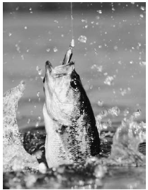
- 3.43 ppm
- 34 ppm
- 340 ppm
- 3400 ppm

Topic 5
PHOSPHATES AND NITRATES

Is this fish safe to eat? It lives, breathes, and eats in the water. The same can be said for most of the organisms it eats. But water in the environment may become polluted. Pollutants in the water could affect the food web of this fish – and the person at the other end of the fishing line.
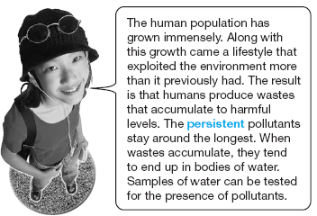

__________________________ and ____________________ are naturally occurring chemicals that are essential to plant growth. Phosphates and nitrates are pollutants if they come from sewage run – off or agricultural run – off.

At harmful levels, phosphates and nitrates in water lead to _________________________. As the result of such a population explosion, a large number of algae die. Decomposers flourish on the dead algae and use up _______________. Therefore, decomposition leads to low oxygen levels in the water. _____________ is critical to aquatic organisms, notably fish.

The levels of dissolved phosphates, nitrates, and oxygen are ___________________. The levels of these chemicals, along with the level of carbon dioxide, are good indicators of water quality.

Although dissolved phosphates and nitrates cannot be observed directly, there are chemical tests to determine their presence.

DISSOLVED OXYGEN
You may have seen air bubbling through water in an aquarium. This was due to air being pumped into the water. The air going through the water keeps up the dissolved oxygen level in the water. The dissolved oxygen is needed by the fish. Both levels of dissolved oxygen and carbon dioxide are important aspects of water quality.

Imagine white – water rafting down a roaring river. As the water churns over and around rocks, oxygen from the air is dissolving into it. Dissolved oxygen is essential for the health of aquatic life such as fish, insects, and micro – organisms. The level of dissolved oxygen in water depends on:

- __________________________(the colder it is the more oxygen)
- ____________________ due to wind or the speed of moving water
- the amount of ___________________________ by plants and algae in the water
- the _________________ of organisms using up the ____________________.

- Five milligrams per litre (equal to 5 ppm) of dissolved oxygen will support most organisms that live in lakes and streams. The following table gives examples of levels of dissolved oxygen needed by aquatic invertebrates.

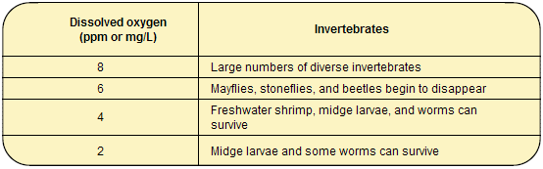
- Fortunately, there are also chemical tests available to determine the presence of oxygen and carbon dioxide.

The tests for dissolved oxygen and dissolved carbon dioxide in the textbook use a titration technique to produce quantitative data. First, one or more chemicals are added to the sample to detect the presence of the gas and create a coloured solution. If the dissolved gas is present, another chemical is dripped in, or titrated, until the colour of the sample changes. The number of drops required to create this change is used to calculate the amount of dissolved gas in the sample.

QUESTION 1:
How do you know if the water sample contains the following items?
- dissolved oxygen
- dissolved carbon dioxide

DID YOU KNOW?
Here’s a memory clue for interpreting dissolved oxygen levels in a natural water system.

**8 (ppm or mg/L) is great, 4 is poor, and 2 is terrible(poo)**

At 8 ppm, most aquatic organisms can survive and reproduce. At 4 ppm, many species have difficulty living and reproducing. At 2 ppm, few species can survive.
BIOINDICATORS

The water quality in natural bodies of water can be affected by pollution as well. You have seen that chemical tests can be used to assess water quality in a direct way. You can also assess water indirectly. Just look at what lives in the water and how well it lives. Such organisms serve as _______________________________________.

Scientists use organisms that live in water to help determine water quality. These indicator organisms include fish, plants, worms, insects, plankton (microscopic algae and tiny animals), protozoa, bacteria, and viruses.

___________________________ Indicators
_____________________ organisms such as bacteria can cause serious health problems if they are present in large enough numbers. Small samples of water are taken frequently from water sources that people use. These samples are processed to determine the numbers and types of microscopic organisms, such as harmful bacteria (e.g., some strains of Escherichia coli). If the count is too high, additional water treatment may be necessary.

_______________________________________________
Water with a large number of harmful bacteria can cause illness. Other biological indicators of water quality do not cause illness themselves but can show the effects of pollution, which may indicate unsafe water. Aquatic invertebrates are one group of indicator organisms. Invertebrates are animals without backbones. Those that live in water include insects, crustaceans (such as shrimp), worms, and mollusks (such as clams, snails, slugs or octopus). They are used for monitoring because different invertebrates prefer different living conditions. For example, the organisms living in a stagnant pond are different from those living in a pond with a higher concentration of dissolved oxygen. Water temperature and pH can also affect the types of organisms found in an area.

QUESTION 2:
- What chemical factor does water pollution often affect?
- What biotic factor does water pollution usually affect?
- Name a biotic acid – base indicator used to warn about air pollution.
Hint: Refer to “Pause and Reflect” on page 231.

QUESTION 3:
Study “Table 3.5” on page 231. In this table, water quality is rated by oxygen concentration. The invertebrates listed in the “Poor Quality” or “Moderate Quality” columns can be found in better quality water. However, the populations of invertebrates found in the “Good Quality” column quickly decline or die out at about 6 ppm. Organisms in the “Moderate Quality” column will have mostly disappeared by 4 ppm. Very few organisms can survive in water with less than 2 ppm of oxygen.

- Water sample M has an oxygen concentration of 9.4ppm. Does this prove that it is good quality water? Explain.

- Use your interactions of species knowledge to predict what will happen if the oxygen concentration in a pond falls from 9 to 6.

- Estimate the oxygen levels in each sample by looking at the number of freshwater invertebrates in the following samples:
- Site A sample: 3 midges, 3 caddis flies, 1 damsel fly, 1 leech.
- Site B sample: 4 crane flies, 5 dragonflies, 1 stonefly, 3 blackflies.
- Site C sample: 1 gilled snail, 5 mayflies, 2 crane flies, 1 crayfish.
- Site D sample: 3 midges, 4 leeches, 1 worm, 1 dragonfly.

Definitions:
Point Source:

Non-Point Sources:

QUESTION 10:
Classify the following pollution sources as point sources or non-point sources.
- The feedlot located on Merry Brook, 10 km upstream from the town of Smithville.
- Feedlots and pastures located throughout the Slave Lake River Basin.

QUESTION 11:
Turn to page 235 of your textbook and answer question 3 of “Topic 5 Review”.

MULTIPLE CHOICE

- An alteration of the environment is considered pollution if
- it causes immediate harm to living things in that environment.
- the concentration of harmful chemicals is easy to detect.
- it produces a condition that is harmful to living things.
- the concentration of a pollutant exceeds its LD50.

- The distinction between a pollutant and pollution is that
- a pollutant alters the environment to produce harmful conditions, while pollution is a harmful material.
- pollution is the alteration of the environment to produce harmful conditions, while a pollutant is a harmful material.
- a pollutant causes physical or chemical changes, while pollution affects biological mechanisms.
- pollution causes immediate harm to living organisms, while a pollutant takes longer to act.

- Which of the following can be sources of pollution?
- Physical effects such as heat or noise.
- Chemical substances such as DDT.
- Naturally occurring elements such as lead and mercury.
- Naturally occurring substances such as Giardia and botulism toxins.
- ii, iii, and iv
- ii and iv
- i, ii, and iii
- all can be sources of pollution
A factory releases arsenic into a river. The mayor of Endsville, a village downstream from the factory, hires you to test the water. Your findings are as follows:

Sample Point | Arsenic (ppb)
source | 50
1 km downstream | 5.0
2 km downstream | 0.5
3 km downstream | 0.05

- Based on the information in the table above, what happens to the arsenic in the river?
- The arsenic dissolves in the water.
- The arsenic is diluted by the water.
- The amount of arsenic decreases with the distance from the factory.
- The arsenic is absorbed by organisms in the river.
- Based on the information in the table above, how much more concentrated is the arsenic in the river at the factory than at Endsville?
- 1000 times more concentrated
- 1000% more concentrated
- 10 000 times more concentrated
- 10 000% more concentrated

- Toxicity can be best described as
- the ability of a chemical to cause harm to an organism.
- the occurrence of serious symptoms after one exposure to a substance.
- the maximum permitted level of a chemical.
- the lowest detectable amount of a chemical.

- A chemical causing symptoms after only one exposure is said to have
- acute toxicity.
- chronic toxicity.
- symptomatic toxicity.
- an LD50 of 1.

- If lead accumulates in body tissues, it can cause serious nerve damage in many organisms. Lead is described as having
- biological toxicity.
- acute toxicity.
- chronic toxicity.
- having an LD50 over 10.

- The LD50 measurement is designed to account for
- the fact that some pollutants take longer to act than others.
- the fact that some individuals are more sensitive to pollutants than others.
- the fact that pollutants accumulate at different rates in different populations.
- the fact that the presence of pollutants may be difficult to detect.

- A common measurement of toxicity is
- Lethal Dose 50.
- Living Duration 50.
- Lethal Danger 50.
- Lethal Duration 50.

- The term “LD50” is defined as
- the dose of chemical required to kill 50 individuals.
- the dose of chemical required to kill 50% of a population.
- a lethal dose of 50 ppm.

- The most lethal naturally occurring toxin is
- botulinum toxin A.
- dioxin.
- nicotine.
- solanine.
- Macroinvertebrates include
- crustaceans, molluscs, and fish.
- crustaceans, molluscs, and birds.
- crustaceans, molluscs, and insects.
- crustaceans, molluscs, and amphibians.

- Which of the following is an example of a non-point source of pollution?
- A drainpipe
- A fertilized field
- A smokestack
- The exhaust pipe on a truck driving across the province
- Certain pollutants such as fertilizers and sewage react with naturally-occurring substances to produce non-polluting compounds. These pollutants are called
- non-persistent pollutants.
- neutralizers.
- non-accumulating pollutants.
- chemical indicators.

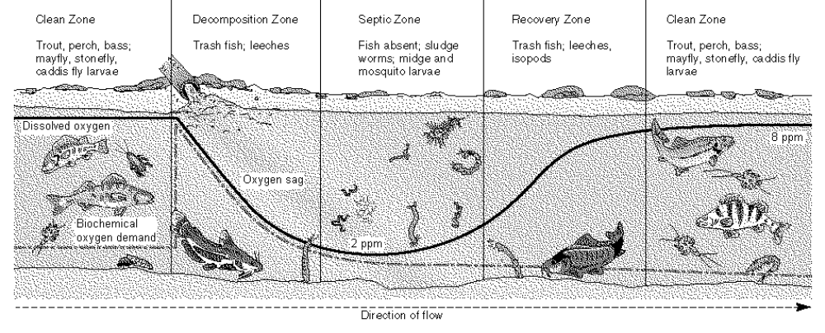
- From the illustration above, you can infer that
- biodiversity increases as the concentration of dissolved O₂ increases.
- biodiversity is not related to the concentration of dissolved O₂.
- biodiversity decreases as the concentration of dissolved O₂ increases.
- biodiversity is not an indicator of the concentration of dissolved O₂.

- From the illustration above, what can you conclude about the relationship between dissolved oxygen and organic waste?
- The decomposition of organic waste releases only a small amount of oxygen.
- The decomposition of organic waste consumes a great deal of oxygen.
- The decomposition of organic waste releases a great deal of oxygen.
- The decomposition of organic waste consumes only a small amount of oxygen.

- In the stream ecosystem illustrated above, which species would be considered a biological indicator?
- Trout and perch
- Catfish and leeches
- Caddis fly larvae and isopods
- All insect larvae

- In the stream ecosystem illustrated above, where is the biochemical oxygen demand the highest?
- In the septic zone
- In the clean zone
- In the recovery zone
- In the decomposition zone

- In general, the organisms that are most useful as indicators of water quality are
- algae.
- birds and fish.
- microinvertebrates.
- macroinvertebrates.

- All wastes entering the environment are
- harmless if released only once.
- harmless if released only in one area.
- potentially harmful in any area.
- harmful only when spread over a large area.

- Some pollutants are difficult to break down and therefore accumulate in the environment. These are termed
- non-persistent pollutants.
- persistent pollutants.
- chronic pollutants.
- chemical indicators.
The following diagram illustrates the neighbourhood of a river.
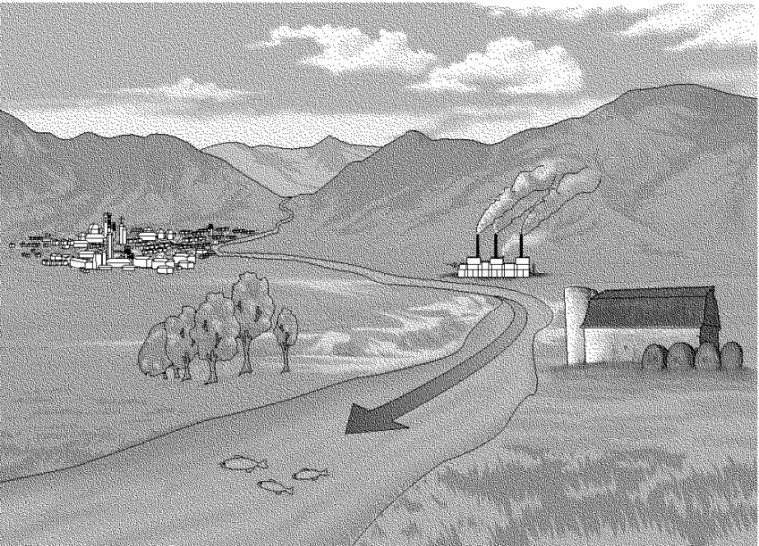
- In the illustration above, what does the factory represent?
- A point source of pollution.
- A non-point source of pollution.
- A persistent source of pollution.
- A non-persistent source of pollution.
- In the illustration above, the farm is representative of a
- point source of pollution.
- non-point source of pollution.
- persistent source of pollution.
- non-persistent source of pollution.
- In which part of the river illustrated above would you expect to find the greatest biodiversity?
- Upstream of the town
- Downstream of the farm
- Between the factory and the farm
- Between the town and the factory

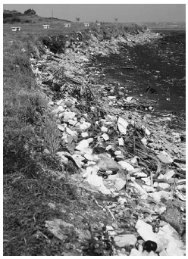

PCB's and CFC's
Litter is one of the most obvious wastes that people leave in the environment. Everyone produces waste. Unfortunately, “just throwing it away” doesn’t mean it stays away

A ________________ would oppose the establishment of a landfill or a sewage treatment plant in his or her neighbourhood. This person objects, knowing full well that the facility is necessary for his or her wastes and everyone else’s garbage. The _________________ may be unwilling to face up to the responsibilities that go along with his or her production of waste materials.

_____________________ can travel from one continent to another. Rivers, currents in the atmosphere, and ocean currents transfer materials great distances.

QUESTION 1:
Pollutants move huge distances away from where they were produced.
- How long does it take for Russian pollutants to cross the Arctic to Canada?

- How do Inuit people living in the high Arctic, and away from industrialized regions, end up with high levels of PCBs in their blood?

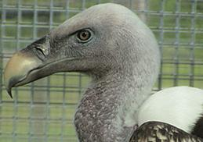
Many pollutants do their harm only when they accumulate near Earth’s surface. Chlorofluorocarbons (CFC’S) cause damage from way up in the atmosphere beyond the reach of even the highest – flying birds.

DID YOU KNOW?
- The Ruppell’s griffon vulture holds the record for the highest – flying bird. One of these vultures was sucked into a jet engine at an elevation of over 11 km.
QUESTION 2:
CFCs have been both useful and harmful.
- Why were CFCs considered to be ideal for use in refrigerators, aerosol cans, and as forming agents?

- If they are non-toxic, how did CFCs manage to damage the environment and threaten organisms?

- What has the global community done to address the CFC problem?

WATER POLLUTION AND BIODEGREDATION
Have you seen a water filter attached to a faucet? These filters are supposed to filter out impurities such as bacteria, chlorine, lead, copper, and mercury. Some of these impurities are due to the improper disposal of waste into surface water. This leads to an issue: what can and should be done to prevent water pollution? It would make sense to avoid releasing these impurities in the first place.

QUESTION 3:
Sewage must be treated properly.
- What percentage of Canadians do not treat their waste water?
- In the final stage, a water-treatment system can use plants to remove remaining pollutants. Name a plant that could be used for this purpose.

- Create a flowchart to summarize tertiary waste water treatment in as few words as possible. Include the terms SEWAGE (untreated waste water), EFFLUENT (treated waste water), PRIMARY, SECONDARY, and TERTIARY in your chart.

QUESTION 4:
Decisions must be made when dealing with issues. Many environmental issues have already been dealt with through legislation. What is your legal responsibility if you accidentally spill a significant quantity of a substance that may harm the environment?

QUESTION 5:
Some wastes contaminate while others can break down into safe substances.
- How many litres of water can one drop of oil contaminate?
- Natural and synthetic substances that can be broken down by decomposers are classified as ______________.
- Can a biodegradable substance be a pollutant? Explain.

QUESTION 6:
Biodegradability is not the only factor that determines how environmentally friendly a substance is.
- From a biodegradability standpoint, is it better to use plastic or paper shopping bags? Explain.
- Are plastic bags or kitchen wastes a more serious environmental pollutant? Why?

HAZARDOUS WASTES AND BIOREMEDIATION
QUESTION 7:
Which of the following substances does not belong in this list? Why?

- ant poison
- prescription medicine
- dishwashing detergent
- glue
- nail polish remover

When you toss a worn-out pair of gloves into the garbage, the gloves start on a journey. This trip likely ends in a landfill site. Fortunately, other things you throw away may not get there at all, thanks to modern waste management. Recycling and recovering are components of waste management that you are sure to be familiar with.

DID YOU KNOW?
The City of Edmonton is recognized worldwide as a leader in waste management. Find out more on page 248 of your textbook.

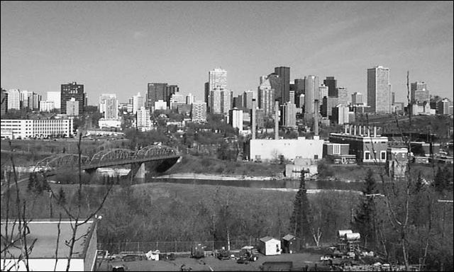

QUESTION 8:
The 4 Rs reduce the need for landfill.
- Which of them is the preferred option? Why?
- On average, what mass (how many kilograms) of unwanted material is generated by Canadians each day?
- Why is the production of recycled paper more environmentally friendly than paper made directly from the wood of trees?

A group of students researched the use of living things to process wastes. Here is what they found:

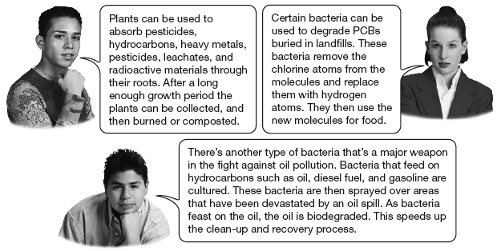

The students described different aspects of ____________________________

In Canada, little bacterial growth occurs in the cold winter months, so biodegradation is very _________, if it occurs at all.

Temperature is just one factor that affects the rate of biodegradation.

Other factors are ____________________, ______, ________________________, and ____________________________.

Bioreactor technology is a developing technology based on the knowledge of the effects of these factors. Bioreactors are designed to ________________ the __________________________ of organic wastes such as food and paper in municipal landfills. Liquids are added to the landfill to create ideal conditions for micro-organisms that decompose organic waste. Under these conditions, biodegradation occurs much more quickly.

Another method of encouraging ________________________ in soil involves planting vegetation. Bacteria and fungi occur in larger numbers in soil that contains plants than in soil without plants. The bacteria and fungi live around the roots of the plants. This greater microbial activity may increase the biodegradation of hazardous materials.

Green plants can also be used in another way to remove or degrade hazardous materials. ______________________________________ is a technique that can be used to reduce the concentration of harmful chemicals in soil or groundwater. “Phyto” means plant and “remediation” means correction or cure. Plants have been used to clean up metals, hydrocarbons, solvents, pesticides, radioactive materials, explosives, and landfill ____________________. Some plants can absorb and accumulate (build up) unusually large amounts of metals from the soil. The plants are allowed to grow for some time and then _______________ and __________________ or __________________. In some cases, the metal can be recycled. Once the plants used for phytoremediation have “cleaned” the soil, other plants can be planted there.

QUESTION 9:
List three factors that affect the rate at which organisms break down substances during bioremediation.

MULTIPLE CHOICE

- The largest contributor to modern air pollution in Canada is
- human activities.
- volcanoes.
- forest fires.
- grass fires.

The following is a map showing wind currents and air pollution.

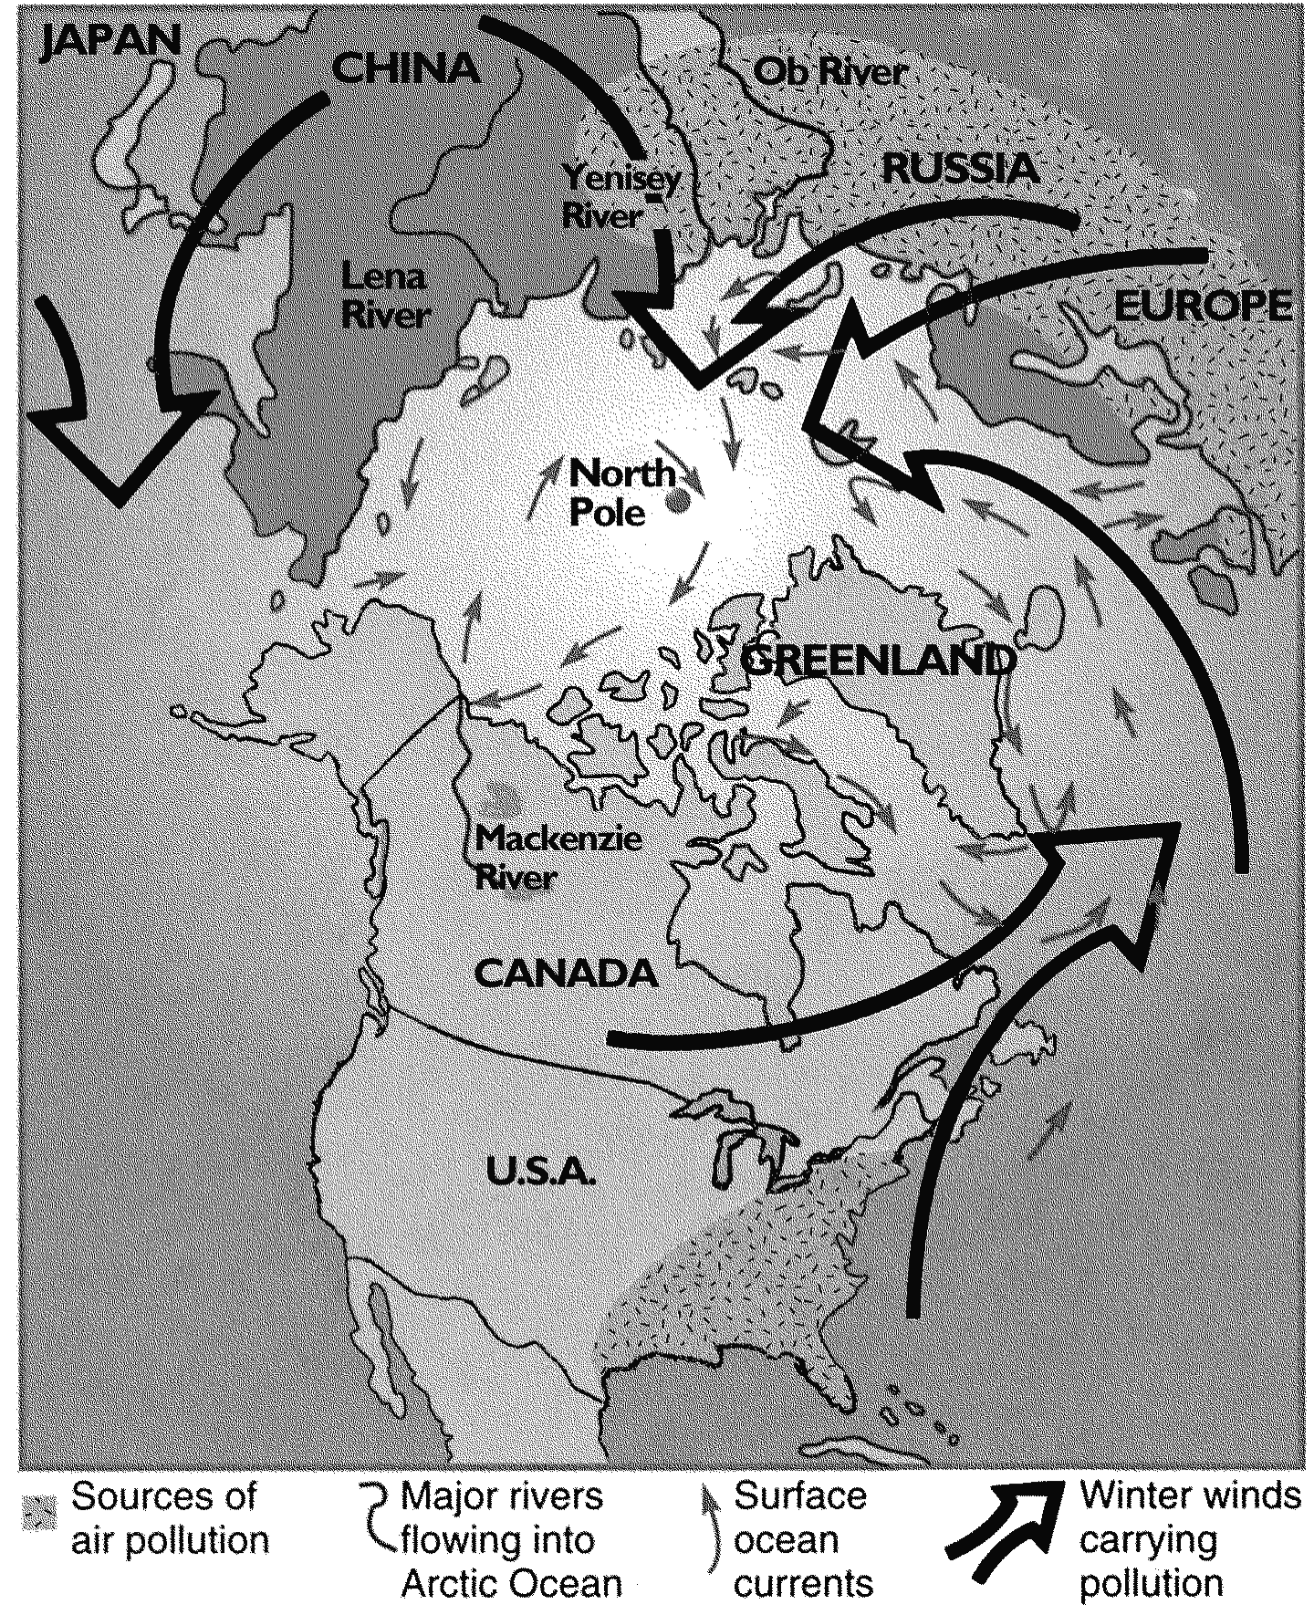

- This map above indicates that the problem of air pollution is
- local  near industrial sites.
- regional  in areas of industry.
- national  in industrialized countries.
- global.

- The map above indicates that
- Canada and the United States are the main sources of air pollution.
- wind and ocean patterns help to concentrate airborne pollutants near the Arctic.
- the north pole is one of the few unpolluted places left in the northern hemisphere.
- wind and ocean patterns tend to carry pollutants away from northern latitudes.
- Until recently, chlorofluorocarbons (CFCs) were used in many industrial processes. What property of these compounds makes them very harmful to the environment?
- They are inexpensive to produce.
- They tend to react with hydrogen.
- They are very toxic to humans.
- They are very stable.

- Chlorofluorocarbons (CFCs) have not been in use for many years, yet we will see evidence of their presence in the atmosphere as
- ozone is produced in the stratosphere.
- ozone is depleted in the stratosphere.
- ozone is produced at ground level.
- ozone is depleted at ground level.

- Waste water from washing clothes or fertilizing lawns must be treated to
- remove nitrogen and phosphorous.
- remove organic material.
- destroy disease-causing organisms.
- all of the above.

The following diagram illustrates the sewage treatment process.
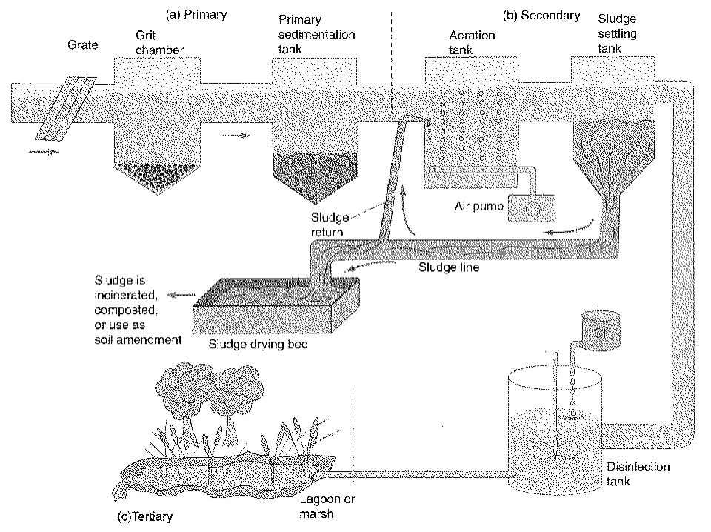
- What is the function of the aeration tank shown in the diagram above?
- The air bubbles stir up sediments.
- The air supplies oxygen for bacterial decomposition.
- The oxygen reacts with other dissolved gases to form harmless compounds.
- The air supplies oxygen, which helps to disinfect the sewage.

- What is the purpose of the disinfection tank in the process illustrated above?
- To remove nitrogen and phosphorous.
- To remove heavy metals.
- To destroy disease-carrying organisms.
- To destroy leftover sediments.

- Water that filters down through soil and rock is called
- ground water.
- an aquifer.
- surface run-off.
- terrestrial water.

- An area of porous rock below ground level which can hold useful amounts of water is called
- a ground water well.
- an aquifer.
- an injection well.
- a recharge zone.

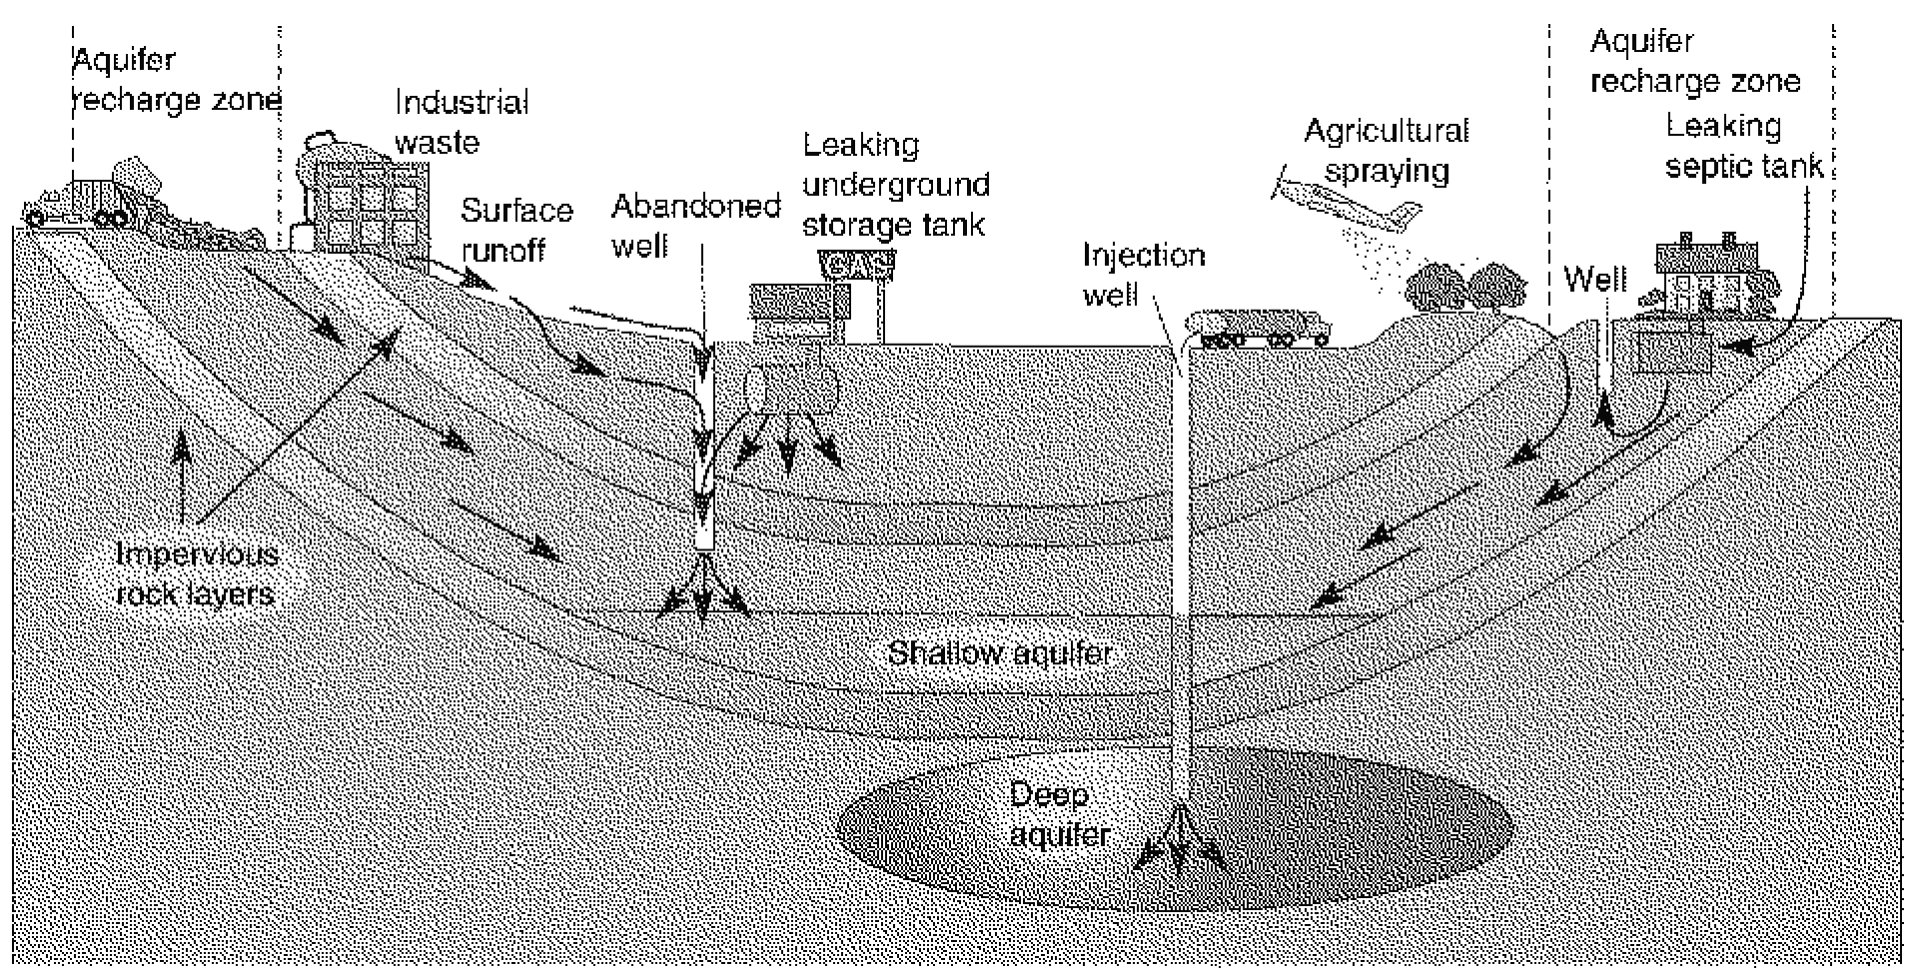
The following diagram illustrates sources of ground water pollution.

- In the water system illustrated above, how do pollutants get into the aquifers?
- They permeate the rock.
- They are carried away by run-off.
- They are carried down by ground water.
- They escape from the injection well.

- From the diagram above, what can you infer about pollutants in aquifers?
- Pollutants will be diluted by the aquifer.
- Pollutants will be concentrated in the aquifer.
- Pollutants are filtered by the rock layers.
- Pollutants will accumulate only in shallow aquifers.

- Patty believes that any biodegradable product is better than a non-biodegradable product. What is she not considering?
- The time the product may take to degrade.
- The conditions needed to degrade the product.
- The by-products that result when the product degrades.
- All of the above.

- When a compound is described as “biodegradable,” this means that
- the compound will break down into harmless substances.
- the compound can be broken down by microorganisms in the soil.
- the compound is environmentally friendly.
- the compound will break down quickly in an ordinary landfill.

- Any substance that can be used to dissolve another substance is called a
- solution.
- solute.
- solvent.
- sorbent.

The following diagram illustrates a waste management system.

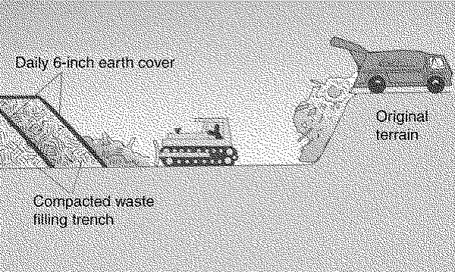

- The waste management system shown in the diagram above is called a
- secure landfill.
- sanitary landfill.
- composting landfill.
- compacted landfill.

- In the waste management system illustrated above, the daily earth cover serves to
- reduce the volume of leachate produced.
- prevent the accumulation of methane gas.
- increase the rate of biodegradation.
- reduce litter and discourage rats.

MATCHING
Match the description to one of the following terms.
- Bioremediation
- Bioreactor
- Biodegradable

- ______ The use of living organisms to remove pollutants from the environment.
- ______ A tank that provides good conditions for bacteria to break down pollutants.
- ______ Capable of being broken down through natural processes.

Match the description to one of the following terms.
- Secure landfill
- Leachate
- Sanitary landfill
- Aquifer
- Ground water

- ______ Water that filters down through soil and rock.
- ______ An underground area of permeable rock holding water.
- ______ A liquid containing a mixture of water and decomposing waste.
- ______ A landfill that regularly covers waste with earth.
- ______ A landfill that safely disposes of hazardous waste.

