Review – Cells and Systems Name:__________________________________
1. All living things are made up of cells.
A) True
B) False

2. The coarse-adjustment knob should be used only with the low-power objective lens.
A) True
B) False

3. One component of the cell theory is that cells are the basic structural and functional unit in all organisms.
A) True
B) False

4. The nucleus is the control centre of the cell.
A) True
B) False

5. Chloroplasts are found only in animal cells.
A) True
B) False

6. Cell walls are found in both plant and animal cells.
A) True
B) False

7. The movement of particles from an area of low concentration to an area of high concentration is called diffusion.
A) True
B) False
8. "Osmosis" is the term used to describe the diffusion of water through a permeable membrane.
A) True
B) False

9. Unicellular organisms obtain all necessary materials through their cell membranes.
A) True
B) False

10. Organs are made up of groups of similar tissues.
A) True
B) False

11. Organ systems work together to form layers of tissue.
A) True
B) False

12. Groups of different tissues form organ systems.
A) True
B) False

13. Tissues are made up of cells with the same structure and function.
A) True
B) False

14. Capillaries are the largest blood vessels.
A) True
B) False

15. The trachea is found in the respiratory system.
A) True
B) False
16. The excretory system filters waste materials from the blood.
A) True
B) False

17) This part in the digestive system has a similar function to part in the respiratory s
System.
- salivary glands – cilia
- villi – alveoli

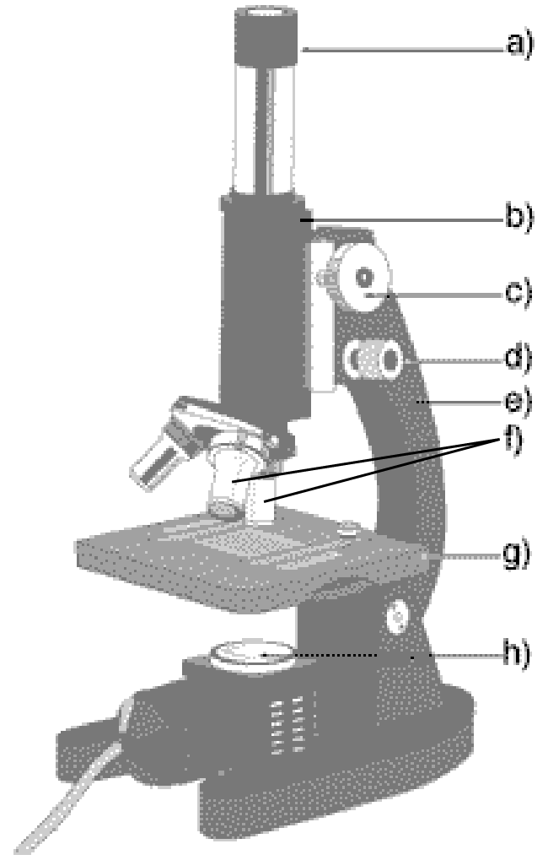
18. Matching
1. fluid-filled storage area
2. contains the green pigment called chlorophyll
3. controls all the cell's activities
4. surrounds the cell and controls flow of substances
5. transforms energy for the cell
________chloroplast
________nucleus
________vacuole
________mitochondrion
________cell membrane

19. Label the microscope
a) _______________________
b) _______________________
c) _______________________
d) _______________________
e) _______________________
f) _______________________
g) _______________________
h) _______________________
i) ________________________

20. Examine this diagram of the human digestive system. Label the organs in the spaces provided below.
a) _______________________
b) _______________________
c) _______________________
d) _______________________
e) _______________________
f) _______________________
g) _______________________
h) _______________________
21. Name the flap that covers the tube leading to the lungs ____________________
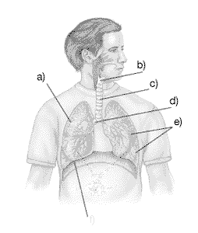
f)
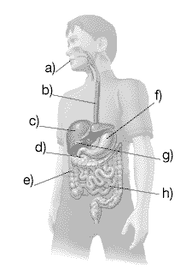
22. Examine this diagram of the human respiratory system. Label the organs in this diagram by writing the appropriate terms in the spaces provided below.
a) _______________________
b) _______________________
c) _______________________
d) _______________________
e) _______________________
f) _______________________

23. Use the lines below to label this diagram of the human heart.
a) _______________________
b) _______________________
c) _______________________
d) _______________________
e) _______________________
f) _______________________
g) _______________________
h) _______________________

a)
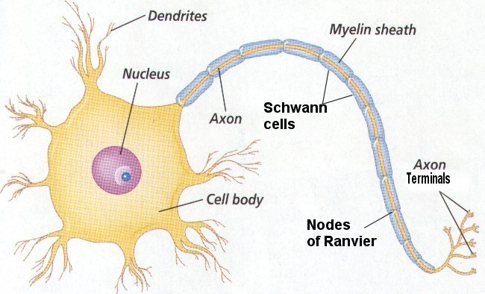
e)
d)
c)
b)
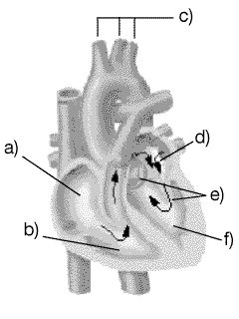
g)
h)

24. Use the lines below to label this diagram of the nervous system.
a) __________________________
b) __________________________
c) __________________________
d) __________________________
e) __________________________

