SCIENCE FOCUS 8 UNIT 2  Cells and Systems | Name: ________________________  Note to parents: Beside each topic is the date that the topic needs to be completed and reviewed. Please initial beside the date when it has been completed. Timely completion of this task will make the learning process easier, more comprehensive and will earn report card marks.

TOPIC 1: Living Organisms – complete and review by ______________________
parent’s initials
Vocabulary

CONCEPT | DEFINITION | ILLUSTRATION
cell

Questions (the number in brackets at the end of the answer line is the page where the answer can be found)

- What are 5 characteristics of living things? List and explain. (98)

- List and explain the functions and structures from page 99
1. Energy
2. Environment
3. Reproduction

4. Growth
5. Wastes

- What are systems made up of? _______________________________________________

_________________________________________________________________________ (100)

- What is the main organ of the circulatory system? ______________________________(100)

- What are tissues? ____________________________________________________________

_________________________________________________________________________(100)

- What is the smallest thing that scientist consider to be living? _____________________(100)

- What does the circulatory system do? ____________________________________________

_________________________________________________________________________ (100)

- Summarize the information about the pika in the space below. (102)

INSERT FIGURES 2.1 A,B AND C FROM PAGES 100 AND 101 IN THE SPACE BELOW

TOPIC 2: Microscopes and Cells – complete and review by ____________________
parent’s initials
Vocabulary

CONCEPT | DEFINITION | ILLUSTRATION
Magnifying

Microscopes

- Who was Anton Van Leeuwenhoek (1632-1723)?_________________________________

_________________________________________________________________________(104)

- What did Van Leeuwenhoek study?______________________________________________

_________________________________________________________________________(104)

- What is Van Leeuwenhoek famous for? __________________________________________

_________________________________________________________________________(104)

- What did Robert Hooke discover through his microscope?_ __________________________

_________________________________________________________________________(104)

- Hooke called the little boxes _______________________________________________(104)

- Who made the hypothesis that all organisms are composed of cells ________________(104)

- What is a cell?__________________________________________________________(104)

- List the 2 important ideas of the cell theory _______________________________________

_____________________________________________________________________________
______________________________________________________________________________

_________________________________________________________________________(104)

- What type of microscope is used in today’s classrooms? ________________________ (105)

- How many lenses does the classroom microscope have? _________________________(105)

- How does an electron microscope work? _________________________________________

_____________________________________________________________________________

_________________________________________________________________________(105)

- When and where was the first electron microscope built? ________________________(105)

- When was the first practical electron microscope developed and by who? _______________

_________________________________________________________________________(105)

- What is a wet mount and how do you prepare one? _________________________________

_________________________________________________________________________(105)

15. Label the compound microscope below.

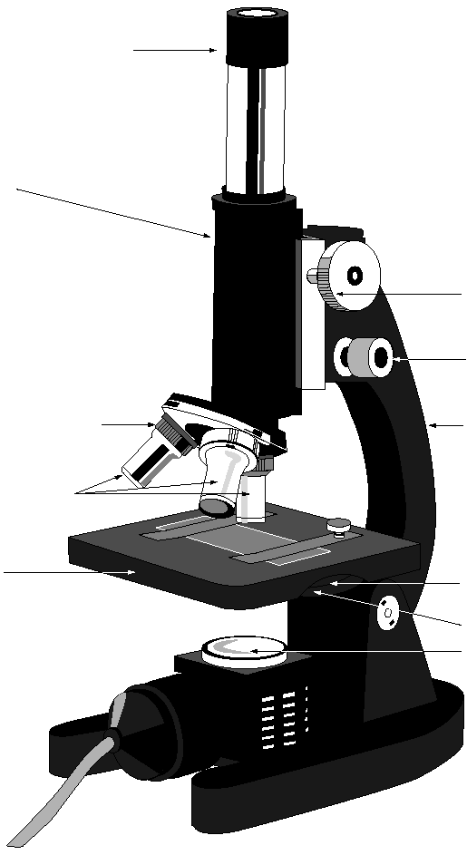

TOPIC 3: The Cell and its Structures – complete and review by ____________
parent’s initials
Vocabulary

CONCEPT | DEFINITION | ILLUSTRATION
Multicellular

Unicellular

Cytoplasm

cell membrane

cell wall

Nucleus

Vacuole

Chloroplast

Organelles

- List 6 single celled organisms__________________________________________________

_________________________________________________________________________(115)

- What are flagella, and what function do they perform? ______________________________

_________________________________________________________________________(115)

- What are cilia used for ________________________________________________________

_________________________________________________________________________(115)

- What activities must a cell perform to stay alive? (122)

- What are organelles? _________________________________________________________

_________________________________________________________________________(122)

- Label the animal cell. (122)

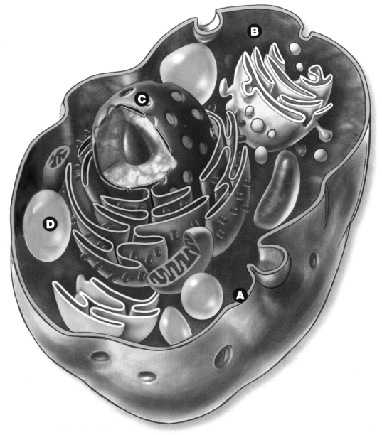

- _____________________________

- _____________________________

- _____________________________

- _____________________________
Label the plant cell (123)

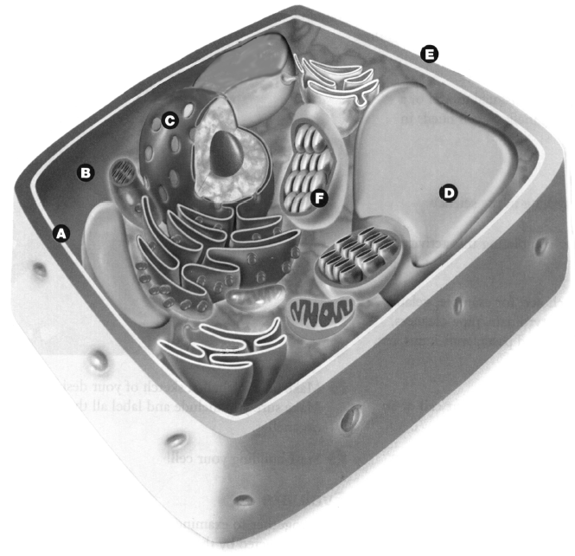

- _____________________________

- _____________________________

- _____________________________

- _____________________________

- _____________________________

- _____________________________

- What is the main difference between animal and plant cells?__________________________

_________________________________________________________________________(123)

- Why are cells so small? _______________________________________________________

_________________________________________________________________________(125)

- How do organisms get bigger?__________________________________________________

_________________________________________________________________________(126)

TOPIC 4: Fluid Movement in Cells – complete and review by _________________
parent’s initials
Vocabulary

CONCEPT | DEFINITION | ILLUSTRATION
selectively
permeable

Diffusion

Osmosis

vascular tissues

phloem tissues

xylem tissues

root hairs

Transpiration

- What is the purpose of the cell membrane? _______________________________________

_________________________________________________________________________(128)

- What does the selectively permeable membrane do?________________________________

_________________________________________________________________________(128)

- How does the selectively permeable membrane work? _______________________________

_________________________________________________________________________(128)

- Using the particle model describe how ink diffuses in a beaker of water _________________

_________________________________________________________________________(129)

- How does carbon dioxide move in and out of the amoeba?___________________________

_________________________________________________________________________(130)

- What percent of a cell is water? ____________________________________________(130)

- What is osmosis?____________________________________________________________

_________________________________________________________________________(130)

- How does putting a limp carrot in water help to make it crisp again? ____________________

_________________________________________________________________________(130)

- What must you do to help your cells perform their jobs ______________________________

_________________________________________________________________________(131)

- What happens in your body when you sweat?______________________________________

_________________________________________________________________________(131)

- What do cells use for energy? ______________________________________________(131)

- What do plants use water for? ______________________________________________(134)

- What is the role of a plant’s tissues?_____________________________________________

_________________________________________________________________________(134)

- List the 2 types of vascular tissues and their functions _______________________________

______________________________________________________________________________

______________________________________________________________________________

_________________________________________________________________________(134)

- Where are xylem and phloem tissue usually found __________________________________

_________________________________________________________________________(134)

- What are roots covered with and what are they made of? _____________________________

_________________________________________________________________________(134)
- What happens when water enters the root hairs?____________________________________

_________________________________________________________________________(134)

- How is water transported to the stems and leafs of plants? ____________________________

_________________________________________________________________________(135)

- Where does photosynthesis take place? ______________________________________(135)

- Why are leaves flat and thin?___________________________________________________

_________________________________________________________________________(135)

- What is the purpose of stomata? ________________________________________________

_________________________________________________________________________(135)

- What do guard cells do? __________________________________________________(135)

- Explain how pushing and pulling raises water to the top of trees _______________________

______________________________________________________________________________

_________________________________________________________________________(135)

TOPIC 5: Cell Specialization – complete and review by _______________________
parent’s initials
Vocabulary

CONCEPT | DEFINITION | ILLUSTRATION
Specialized

Tissues

Organs

Systems

muscle tissue

nerve tissue

epithelial tissue

Connective
Tissue

- What do red blood cells do? ____________________________________________________

_________________________________________________________________________(138)

- What are 2 major disadvantages for unicellular organisms? ___________________________

______________________________________________________________________________

_________________________________________________________________________(139)

- What are the advantages of being multicellular? ____________________________________

______________________________________________________________________________

_________________________________________________________________________(140)

- How do specialized cells work in multicellular organisms? __________________________

_________________________________________________________________________(140)

- What are tissues? ____________________________________________________________

_________________________________________________________________________(140)

- What are organs? ____________________________________________________________

_________________________________________________________________________(140)

- What are systems? ___________________________________________________________

_________________________________________________________________________(140)

- What are the main types of tissues found in animals and what do they do? (141)

- What are the main types of tissues found in plants and what do they do? (141)

- How are these tissues classified? ________________________________________________

________________________________________________________________________ (141)

- List the human organs mentioned on page 142 ____________________________________

_________________________________________________________________________(142)

- What are the 3 main systems in plants? ___________________________________________

_________________________________________________________________________(144)

INSERT FIGURES 2.22 AND 2.23 FROM PAGE 141 IN THE SPACE BELOW

TOPIC 6: Body Systems in Humans – complete and review by ____________________
parent’s initials
Vocabulary

CONCEPT | DEFINITION | ILLUSTRATION

Digestive
System

Respiratory
System

Circulatory
System

Excretory
System

Nervous
System

Alveoli

Capillaries

- Explain how food moves through the digestive system (146)

- What does inhalation and exhalation do___________________________________________

_________________________________________________________________________(146)

- What makes up the circulatory system and what does it do? __________________________

______________________________________________________________________________

_________________________________________________________________________(146)
Insert figures 2.26, 2.27, 2.28 &2.29 from pages 146, 147, & 148 in the space below

- What are the 4 main compartments of the heart? ___________________________________

_________________________________________________________________________(147)

- How are the respiratory and circulatory systems connected?.________________________

_________________________________________________________________________(148)

- What is the path air travels starting from the nose to the alveoli? _______________________

_________________________________________________________________________(148)

- List and describe what the 3 types of blood vessels do._______________________________

_________________________________________________________________________(148)

- How does oxygen move from the alveoli to the blood? ______________________________

_________________________________________________________________________(149)

- Where does the transfer of food from the digestive to the circulatory system take place? ____

_________________________________________________________________________(149)

- What are villi? ______________________________________________________________

_________________________________________________________________________(149)

- How does food pass from the intestine into the capillaries? __________________________

_________________________________________________________________________(149)

- What is the purpose of the excretory system? ______________________________________

_________________________________________________________________________(151)

- What is the key organ in the excretory system? ________________________________(151)

- Why do our bodies make constant adjustments? ____________________________________

_________________________________________________________________________(151)

- How much heat is lost through your skin? ____________________________________(151)

- Why do we shiver when we are cold _________________________________________(151)

- How does your body cool itself? ________________________________________________

_________________________________________________________________________(151)

- What does the nervous system do? ______________________________________________

_________________________________________________________________________(151)

- Where does the temperature information go? ______________________________________

_________________________________________________________________________(152)

- What is the endocrine system? __________________________________________________

_________________________________________________________________________(152)

- What can affect the body systems and disrupt how they function? _____________________

_________________________________________________________________________(153)

Insert table 2.1 from page 153 in the space below

1.
2.
3.
4.
5.

TOPIC 7: Body Systems and Your Health – complete and review by _______________
parent’s initials

- When people are excited why do they experience rapid breathing and increased heart rates?

_____________________________________________________________________________

_________________________________________________________________________(154)

- What evidence does your rhythmic pulse provide? __________________________________

_________________________________________________________________________(154)

- What do the blood vessels of the circulatory system form? __________________________

_________________________________________________________________________(154)

- What % of an adult’s body weight is blood? __________________________________(154)

Insert Table 2.2 in the space below

- What systems work together to bring oxygen and nutrients form the outside environment to

the body? ________________________________________________________________(155)

- What is the leading cause of hospitalization in Canada? _____________________________

_________________________________________________________________________(155)

- What does the pumping action of the heart do? _____________________________________

_________________________________________________________________________(155)

- Why is high blood pressure called the silent killer? _________________________________

_________________________________________________________________________(155)

- What device is used to measure blood pressure, and how does it work (156)

- List the 5 things that blood pressure can indicate about a person’s circulatory system (156)

- How does cigarette smoke affect the circulatory system? _____________________________

______________________________________________________________________________

_________________________________________________________________________(157)

- How can a poor diet affect the circulatory system? __________________________________

_________________________________________________________________________(157)

- What can people do to reduce the risk of circulatory disorders? ________________________

_________________________________________________________________________(157)

- What provides the body with its main source of energy? _____________________________

_________________________________________________________________________(158)

- Why should starch be the main carbohydrate in your diet? ____________________________

_________________________________________________________________________(158)

- Why are fats essential? ________________________________________________________

_________________________________________________________________________(159)

- What do proteins do? _________________________________________________________

_________________________________________________________________________(159)

- How do peptic ulcers form? ____________________________________________________

_________________________________________________________________________(159)

- Many disorders of the respiratory system have been linked to _________________________

_________________________________________________________________________(160)

- How does lung cancer develop? ________________________________________________

______________________________________________________________________________

_________________________________________________________________________(160)

- What are the essential needs to maintain healthy organs and systems? __________________

______________________________________________________________________________

_________________________________________________________________________(162)

- What does your immune system do? _____________________________________________

_________________________________________________________________________(162)

