Sc 8 - Final Exam Review

Unit 1 - Mix and Flow of Matter

- List the five points of the particle model of matter

- Place the following substances in the correct columns. Do you remember the difference?
Scrambled eggs, cookie dough, oil, water, salt, black coffee, lemonade

Homogeneous | Heterogeneous

- A _______________________________ solution is one in which no more solute will dissolve in a specific amount of solvent at a specific temperature. Please give an example:

- What are 3 factors affect the rate of dissolving?

- Using particle model, explain why sugar dissolves in water and rocks do not.

- What is Buoyant Force? Discuss why it is easier to Float in the Dead Sea than in the Sturgeon River.

- Please define Flow Rate. What are some common examples of substances with a high flow rate and a low flow rate? Would a solid have a flow rate? Why?

- Please calculate the Density of a substance that has a mass of 2500 g and volume of 150 mL. D = M
V

- List and explain the 5 changes of state .

- Why are gases more compressible than a liquid?

- Calculate the Pressure of a girl that uses 3000 N of Force to push her hand through an area of 12 cm²
P = Force
Area

Unit 2 - Cells and Systems

- All living organisms share 5 characteristics. Please list them and give an example for each

- What is the basic unit of structure and function in all life? What is the difference between single celled organisms and multi-cellular organisms? Give an example of each.

- What is osmosis? How is it different from diffusion? Give examples where and when they occur.

- What 2 structures are found in plant cells but not in animal cells? Why?

5. Can you label all the organelles in the animal cell below?

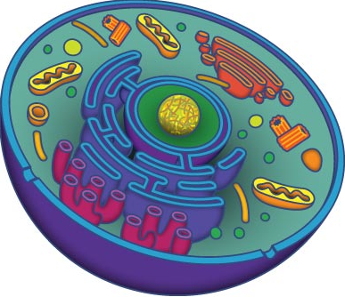

- There are 3 types of cell membranes. Please discuss each one. (perm, im-perm & semi-perm) Using a plant as an example, explain how the fertilizer we add to the soil gets into the plant. (tissues?)

- What is transpiration? How does it fit into the Water Cycle?

- What hair-like projections located in the respiratory system can help trap and remove dust and bacteria from the air? Is there hair like projections in our digestive system? What is their function?

- Where do the Circulatory and Digestive Systems connect? How does this happen? Why?

- Give an explanation of how your nervous system would react to a change of temperature. For example – going from 30 degrees Celsius to 15 degrees Celsius

- Do you know all the parts of the microscope and their functions? Can you label the following diagram?

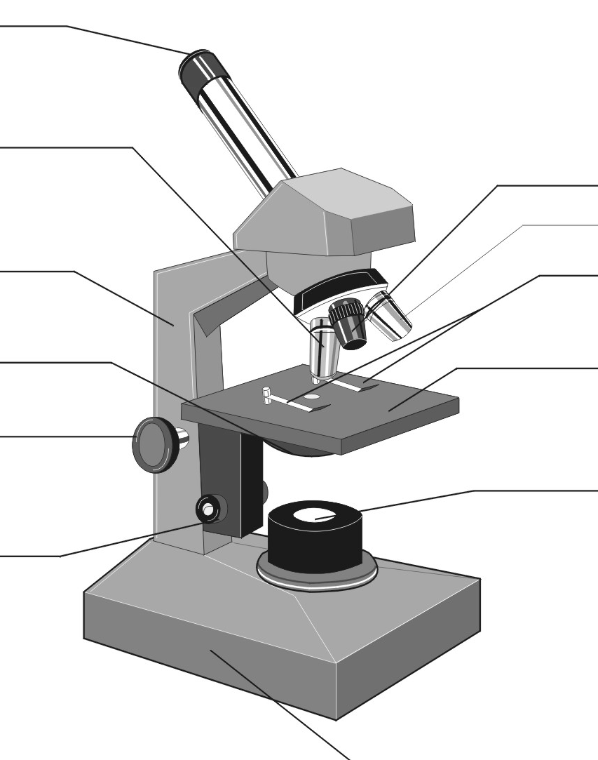

Unit 3 Light and Optical Systems

- Please list the 5 sources of Light and give an example for each. Make sure you can describe .

- Please sketch and label the Law of Reflection Diagram p.189 State the Law of Reflection:

- Please list the 3 different types of materials and describe how Light behaves with each. p. 185 Please give an example for each.

- Please discuss the 3 Types of Mirrors we studied and describe how Light behaves with each. Give an example for each. p.195

- What is refraction? Give an example

- List the three types of behaviour of light. P. 205
Type of behaviour | What happens to light striking a surface?

- Please complete the table that compares the parts of our EYE with parts of a CAMERA. P.211
EYE | CAMERA

- Use the Diagrams on p. 210 to complete the following table referring to Far-sighted and Near-sighted.
 | Far Sighted | Near Sighted
Problem with vision
Shape of Eye
Where Image Falls
Lens needed to Correct Vision

- Why do binoculars use prisms? p. 223

- Please sketch and explain how Light Travel through the different Lens. P. 208
Double Convex Lens Double Concave Lens

Unit #4 – Mechanical Systems

1. What is work? How do you know when it is done?

2. List the 5 Simple Machines from topics 1 & 2 and give an example of each

Simple Machine | Example

3. Sketch Class I, II, and III Levers and label Effort, Fulcrum and Load
Class I | Class II | Class III

4. Compare Hydraulics vs Pneumatics – Define, Key info, examples, etc. . .
 | Hydraulics | Pneumatics
Key Ideas (close, open, gas, liquid, etc. . .)

2 Examples

5. Compare Steam engines vs combustion engines vs turbines – Key Points
Steam Engine | Combustion engine | Turbine

6. Compare the following variables
 | Control | Manipulated | Responding
Define

- Define Industrial revolution -

Ergonomics-

mass production –

8. Write down the *Formulas and *Units for each. All formulas for calculation questions on the Final Exam will be provided. Go over practice Q on old quizzes/tests and in the textbook to ensure you can do them.

Work = Pressure =

MA = Efficiency =

9. How would you calculate the speed ratio of a gear train where the driving gear had 120 teeth and the follower gear had 60 teeth?

10. Looking at the illustration in the textbook on p.305 explain how the man can lie on a bed of nails and not injure himself.

- Explain how you apply Pascal’s Law whenever you squeeze a toothpaste tube.

Unit # 5 – Water Systems – Final Review

1. Please sketch and label the Water Cycle

2. Please indicate the distribution of water on earth as a percent
Ground water
Rivers, lakes, ponds, etc
Glaciers, ice burgs, ice sheets
Oceans and seas

3. What is the difference between water quality and water quantity. Give 2 examples

4. Please describe some structural adaptations that Aquatic organisms have that help them survive.

5. Please sketch and label the process of HOW glacial ice forms (p.376)

6. Please explain the difference between an advancing and retreating glacier

7. When ocean or seawater freezes it forms __________________________________. When a chunk of ice breaks off a continental glacier it forms an __________________________________. This process is called _________________________________________________.

8. How are global warming and greenhouse effect related? (p.387)

12. Name Canada’s five major drainage basins. Generally, where does St. Albert’s water flow?

13.How are aquifers and the water table related? Why are they important to us?

14. What is an algae bloom? What are some possible causes?

15. Why is water management important? How can nutrients in our water be problematic? How would this relate to biomagnification?

16.Please sketch an example of simple aquatic food chain.

17. Please list 5 specific human activities that affect our water systems in a negative way. Explain each.
Human Activity | Explain Negative Affect

18. What is a bioindicator species? Why are they important to water management?

