GRADE 8 SCIENCE
REVIEW and STUDY
booklet

This resource is intended to be used as a
YEAREND Tool for STUDENTS AND TEACHERS
in association with the

POWERPOINT SCIENCE UNITS

The review questions have been designed to direct the students to review concepts and find the answers within the PowerPoint Units

The sample practice questions are provided, not as specifics that will be tested on the FINAL EXAM, but, as examples of further exploring the Science Concepts in each of the units covered.

There is an Answer Key available for the practice questions, but there is no KEY provided for the REVIEW questions, as it is the intent of this review process for the students and teacher (parent) to work together to gather information and share this information in class (at home).

All questions were developed so that recollection and mastery of concepts will occur as the Science PowerPoint are reviewed

SAMPLE PRACTICE QUESTIONS
SELECTED FROM
SECTION & UNIT TESTS

developed by
EDQUEST RESOURCES online @

Edquest.ca

MIX and FLOW of MATTER

Scientists identify infectious and toxic materials using what WHMIS symbol?

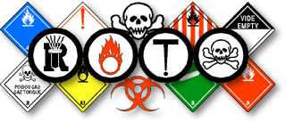

Describe how slurries are made.

_______________________________________________________________________________

_______________________________________________________________________________

How are substances tested to determine if they are pure substances or mixtures?

_______________________________________________________________________________

_______________________________________________________________________________

How is the concentration of a substance determined?

_______________________________________________________________________________

_______________________________________________________________________________

In what solutions are the solute and solvent both gases?

_______________________________________________________________________________

_______________________________________________________________________________

What is a solution called if it contains water as the solvent?

_______________________________________________________________________________

For each of the following hazardous products match the correct WHMIS symbol
_____ | Materials that are infectious and cause other toxic effects | A. | 
_____ | Material that is poisonous and infectious with immediate toxic effects | B. | 
_____ | Material that is infectious | C. | 
_____ | Material that will react when exposed to oxygen | D. | 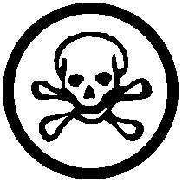

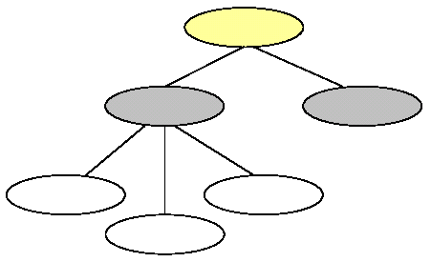
In this organizational chart for Matter, Number 3 indicates …
1
2
3
4
5
6
______________________________

When comparing concentrations of different solutions, it is necessary to compare the concentrations in the same volume. Which of the following solutions would have the lowest concentration?
A. | 16% ( 16g/100ml )
B. | 1.2g per 25ml ( 4.8 g/100ml )
C. | 2.3g per 50ml ( 4.6 g/100ml )
D. | 3.6g per 20ml ( 10.6 g/100ml )

What is happening when the particles of a solute are filling the spaces between the particles of a solvent?

_______________________________________________________________________________

_______________________________________________________________________________

How does temperature affect viscosity?

_______________________________________________________________________________

_______________________________________________________________________________

How do you compare substances to water using a mass to volume relationship?

_______________________________________________________________________________

_______________________________________________________________________________

What is the purpose of the Plimsoll Line that is put on ship?

_______________________________________________________________________________

_______________________________________________________________________________

Why is it necessary to have a closed system when working with hydraulic fluids?

_______________________________________________________________________________

_______________________________________________________________________________

What is Pascal’s Law?

_______________________________________________________________________________

_______________________________________________________________________________

When the particles of a solute fill the spaces between the particles of the solvent this is happening ...
A. | fusion
B. | diffusion
C. | occlusion
D. | dissipation

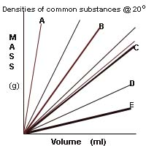
If C in the graph above is water, then D and E are likely to be …
__________________________________
Substance | Density (10³kg/m³)
Gold | 19.3
Copper | 8.92
Aluminum | 2.70
Seawater | 1.025
Water | 1.00
Ethyl alcohol | 0.79
Air | 0.0012
There are three factors that can affect the rate of dissolving. From the list of answers for this question, one does not belong. Identify which one it is.
A. | stirring
B. | temperature
C. | size of pieces
D. | reaction time

When a force is applied to a substance and the particles cannot be forced closer together, they transfer this force equally in all directions throughout the substance. The substance can do this in a closed system because it is…
___________________________________

How does a hyperbaric chamber work?

_______________________________________________________________________________

_______________________________________________________________________________

What simple machine device is used to move water vertically using rotational motion?

________________________________________________

________________________________________________

Illustrate it!

What purpose would be served to add air to the ballast tanks in a submerged submarine?

_______________________________________________________________________________

_______________________________________________________________________________

Describe and illustrate the ‘Ramp Method’ experimental design to compare viscosities of different substances

________________________________________________

________________________________________________

________________________________________________

________________________________________________

________________________________________________

A diver can get a condition, known as ‘the bends’, which is treated in a special pressure chamber, called a hyperbaric chamber. The chamber enables nitrogen ‘bubbles’ to …
________________________________________

What type of instrument is used to measure the pressure of a fluid?
_________________________________________

All cargo ships have a special line called the Plimsoll Line that shows how much the ship should be loaded so it won’t sink as it …
_________________________________________

A device that uses rotational motion to move a liquid vertically called a ...
________________________________

When air is added to a submerged submarine it is able to resurface because its overall ...
A. | buoyancy decreases
B. | pressure increase
C. | density decreases
D. | viscosity increases

Using the ramp method to determine viscosity, a student found out that Fluid A has a flow rate of 10. 5 ml, per second. Fluid B has a flow rate of 11. 3 ml, per second. Compared to fluid B, fluid A is ...
___________________________________

Cells and Systems

Explain what metabolism represents in an organism.

________________________________________________________________________________

________________________________________________________________________________

Describe different structures that organisms have that perform similar functions.

________________________________________________________________________________

________________________________________________________________________________

Identify and label the locations of different adjustment knobs on a microscope.

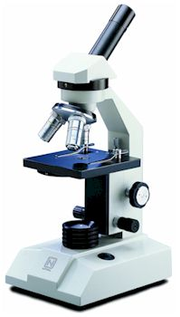

Explain the function of the mitochondria in an animal cell.

________________________________________________________________________________

________________________________________________________________________________

How does an amoeba move around?

________________________________________________________________________________

________________________________________________________________________________

Identify the parts of the microscope:
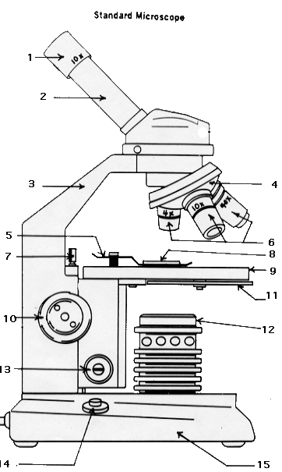
2. | ____________________________________
6. | ____________________________________
9. | ____________________________________
10. | ____________________________________
12. | ____________________________________

Energy is the ability to do make things move or change and is needed by all organisms. The sum of all the different processes that happen in an organism is referred to as the organism’s …
___________________________________

Illustrate the process of osmosis, showing and explaining where the water moves from and where it moves to.

_________________________________________

_________________________________________

_________________________________________

_________________________________________

_________________________________________

__________________________________________

Label the parts of a nerve cell.

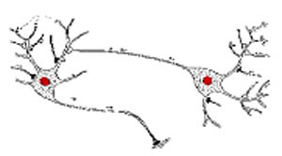

Identify the different types of cells.

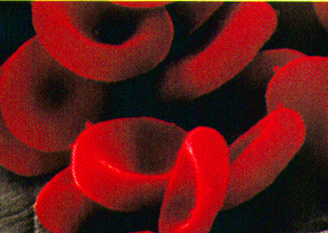 | 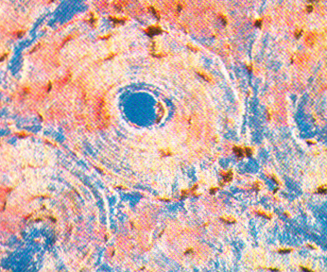 | 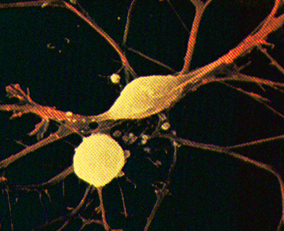 | 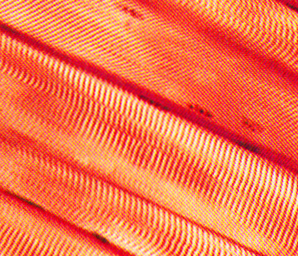
_________________ | _________________ | _________________ | _________________

Certain materials are allowed to pass through this and others are prevented from passing through. The type of cell membrane that is present in a plant and animal cell is called a ...
_________________________________________

Osmosis is the diffusion of water through a selectively permeable membrane. This process occurs because water will move from an area of ...
A. | low concentration to high concentration
B. | high concentration to low concentration
C. | low concentration to low concentration
D. | high concentration to high concentration

The liver converts this highly toxic substance into a less harmful substance – urea ...
A. | ammonia
B. | gastric juice
C. | sodium chloride
D. | hydrochloric acid

Peristalsis is caused by contractions of muscles in this structure of the digestive system …
___________________________________

Gastric Juice is composed of mucus, hydrochloric acid, water and digestive enzymes. The purpose of the mucus is …
____________________________________

Explain the muscular action called peristalsis.

________________________________________________________________________________

________________________________________________________________________________

Why is the epithelial tissue in capillaries only one cell thick?

________________________________________________________________________________

________________________________________________________________________________

What is the function of the bladder in the excretory system?

________________________________________________________________________________

________________________________________________________________________________

What body systems work together to exchange gases?

________________________________________________________________________________

________________________________________________________________________________

What is bronchitis?

________________________________________________________________________________

________________________________________________________________________________

Why is cholesterol bad for you?

________________________________________________________________________________

________________________________________________________________________________

The transportation of nutrients in plants is the role of the plant's tissue. Specialized tissue connects the roots to the leaves. The Phloem tissue transports sugars that is manufactured in the ...
__________________________________________

Each body system works with other body systems to perform its function effectively. When the body feels hot and cold on the skin, the systems working together are the ...
A. | Circulatory and Respiratory
B. | Sensory and Integumentary
C. | Sensory and Muscular
D. | Integumentary and Circulatory

Oxygen-rich air is drawn into the lungs through tube-like passageways called bronchi. The bronchi are lined with tough connective tissue in order to …
_________________________________________

Capillaries have two adaptations for exchanging gases and nutrients: they are made of specialized epithelial tissue that is only one cell thick and they …
A. | reverse the flow of gases
B. | are reinforced with a double membrane
C. | are very narrow, so the blood cells have to pass through in single file
D. | collapse on bacteria, preventing it from getting to the heart

BODY SYSTEMS

Identify (illustrate and label) the main organ associated with each body systems,
by completing the relationship diagram.
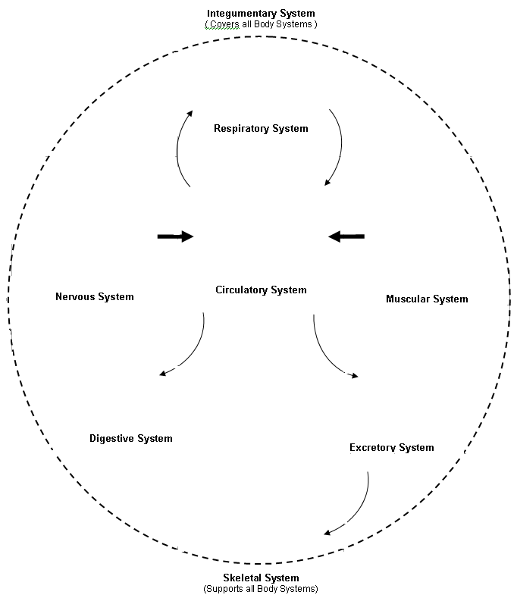

This organ is the key organ in the body that coordinates all other organs ...
A. | Skin
B. | Brain
C. | Heart
D. | Small Intestine

These organ systems remove wastes from the body. They are the...
______________________________________________

The small holes on the sides of an insect’s abdomen, which enable the insect to breath are called …
A. | ‘Sportacles’
B. | ‘Spiracles’
C. | ‘Spectracles’
D. | ‘Spirals’

Organs work together to make a system or network that performs a specialized function. Plants have only two main systems. They are the ...
A. | shoot and the roots
B. | roots and the leaves
C. | stems and the leaves
D. | leaves and the shoot

This organ system carries nutrients throughout the body, so that specialized cells can perform specialized functions. This body system is the ...
A. | digestive system
B. | muscular system
C. | respiratory system
D. | circulatory system

Light and Optical Systems

Describe Sir Isaac Newton’s experiment to show that light is made up of different colors.

________________________________________________________________________________

________________________________________________________________________________

How does a refracting telescope work?

________________________________________________________________________________

________________________________________________________________________________

Describe and illustrate diffuse reflection.

________________________________________________

________________________________________________

________________________________________________

________________________________________________

________________________________________________

What is the Law of Reflection and why is it a LAW?

________________________________________________________________________________

________________________________________________________________________________

What are some practical applications of concave mirrors?

________________________________________________________________________________

________________________________________________________________________________

Thoughts about light have changed over time as we learn more about it. Our eyes causing vision to occur were proven wrong because it was impossible to see in the dark. This theory of light was presented to the people of his time by …
__________________________________________

Because Archimedes’ understood that light travels in straight lines and can be reflected, his military plan, using these principles of light looked like this and was used to …
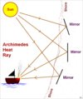
_______________________________________

The invention of the microscope enabled scientists to study micro-organisms. This area of science is called ...
A. | Genetics
B. | Microbiology
C. | Cell Structure
D. | Animal Science

Cosmetic mirrors, flashlights, reflecting telescopes, and the headlights in a car are all examples of practical applications for these type mirrors …
A. | plane mirror
B. | bubble mirror
C. | convex mirror
D. | concave mirror

When light moves from one medium to another in what direction is it bent in relation to the normal?

_______________________________________________________________________________

_______________________________________________________________________________

Diverging rays of light occur when light passes through what kind of lens? ( Illustrate )

_______________________________________

_______________________________________

_______________________________________

_______________________________________

Referring to the wave model of light, how is frequency determined?

________________________________________________________________________________

________________________________________________________________________________

What type of electromagnetic rays do modern radar devices use?

________________________________________________________________________________

________________________________________________________________________________

How do glow in the dark objects get their light?

________________________________________________________________________________

________________________________________________________________________________

Refraction is the bending of light when it travels from one medium to another. What direction does the light bend when it travels from a medium of greater density to one of lesser density?
________________________ __________
When the sky is refracted by warm air an illusion of a watery surface is created. This illusion is called a …
__________________________________
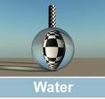
cable behind a drop of water
During refraction, an object in a denser material (like the water drop, will appear to be ...
A. | smaller
B. | invisible
C. | larger
D. | inverted

Radar is an acronym for radio detection and ranging. These devices send out waves, which bounce off objects and return (obeying the law of reflection). Older radar devices used radio waves, whereas modern radar devices use …
A. | microwaves
B. | gamma rays
C. | infrared waves
D. | ultraviolet waves

You will see - if you look very closely on the screen - what makes the picture on a television possible. (Describe and illustrate what you see)

__________________________________________

__________________________________________

__________________________________________

__________________________________________

Describe the function of rods (the photoreceptor cells that make up one part of your retina).

_______________________________________________________________________________

_______________________________________________________________________________

Why is the image green in night vision goggles?

_______________________________________________________________________________

_______________________________________________________________________________

Describe the surface of the ommatidia in an insect eye.

_______________________________________________________________________________

_______________________________________________________________________________

How is digital information in a computer stored?

_______________________________________________________________________________

_______________________________________________________________________________

Know where the different kinds of light can be located on the electromagnetic spectrum

Doctors use MRI (magnetic resonance imaging) machines to create pictures of the tissues inside the human body.  The MRI machine uses these types of electromagnetic waves to produce images … |  | 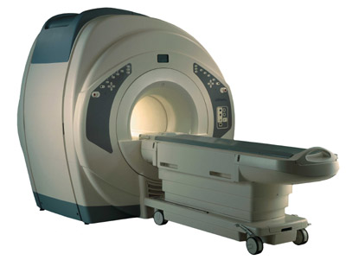
A. | X-rays
B. | microwaves
C. | radio waves
D. | infrared waves

Nocturnal animals, such as cats and owls have very large pupils to allow them to collect as much light as possible. The purpose of the thin layer inside their eyes, called the tapetum lucidum, is to act as this inside their eye –a …
A. | magnifier
B. | mirror
C. | lens
D. | filter

The greatest advantage to digital imaging is that the pictures don’t have to be …
A. | translated
B. | recovered
C. | processed
D. | transmitted

The process of creating a big picture, or a message, out of smaller pictures, or colored tiles, is similar to the process of digital imaging. The small elements that make up a picture, or a stadium image, are called pixels. The more pixels that make up a picture the higher the … | 
________________________________________

Mechanical Systems

Illustrate a diving board and identify the location of the load, the effort force and the fulcrum.

In most simple machines what is the advantage and what is the disadvantage?

ADVANTAGE _________________________________________________________________

DISADVANTAGE ______________________________________________________________

Illustrate a gear train that has multiplying, parallel and reducing gears in the correct order

Illustrate a pulley system that would have a mechanical advantage of 4.

A block and tackle pulley system is used to lift heavy machinery in the CTS room. 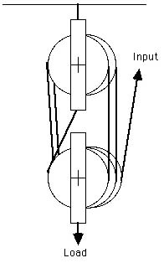 One machine is 79kg. To lift it into place where it is going to be used, it has to be raised 90cm off the floor.  How much work is being done to raise the machine onto its platform?  (Show your work)
   | . | .
  0 | 0 | 0 | 0
  1 | 1 | 1 | 1
  2 | 2 | 2 | 2
  3 | 3 | 3 | 3
  4 | 4 | 4 | 4
  5 | 5 | 5 | 5
  6 | 6 | 6 | 6
  7 | 7 | 7 | 7
  8 | 8 | 8 | 8
  9 | 9 | 9 | 9

Transmissions are special types of linkages. It is used to transfer energy fro the engine to the wheels in a car. A transmission contains a number of these that allow the driver to apply a large force to move objects slowly or a small force to move objects quickly. They are …
A | chains
B | fan belts
C | gears
D | linkages

On a bicycle, gears are made up of flat, toothed disks called …
__________________________________

If it takes 30 N of force to lift a 90 N carton using a pulley system, what would the pulley system look like …
A |  | B |  | C | 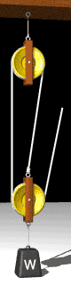 | D | 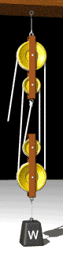

How do you calculate work? How do you calculate efficiency?

40cm is the distance moved and 50 N 1600 J are used to get 1200 J from a
of force is used. machine.

What gives a hydraulic system its mechanical advantage?

_______________________________________________________________________________

_______________________________________________________________________________

How is mechanical advantage calculated and illustrated in a hydraulic lift?

50N in

1500N out

________________________

Calculate the area of the output piston in a hydraulic lift.

Mechanical Advantage is 30
Area of input piston is 5 m²

________________________

Work is calculated using the formula – W = F x d. If you lift a box onto your desk that is .4 meters off the floor, using 50 Newtons of force, how much work are you doing?
_________________________________

Using a machine does not mean that less work is done. This is because …
_________________________________

Efficiency is a measure of how well a machine does work. Dividing the mechanical advantage by the speed ratio and multiplying the result by 100 will determine the efficiency of the machine. A pulley system that has a speed ratio of 3 and a mechanical advantage of 2 has an efficiency of ....
A. | 33%
B. | 67%
C. | 60%
D. | 30%

Using the scientific definition of work, which statement below describes work being done.
A. | Tommy worked very hard to get all his homework done.
B. | Doing science is hard work when you learn formulas.
C. | It was hard work for Jessie to move the desk two meters.
D. | It was hard work but Rick couldn’t move the car at all.

The mechanical advantage in a hydraulic system is provided by the …
_________________________________

What are the criteria for evaluating mechanical devices and how would convenience fit into these criteria?

___________________________________ _____________________________________

___________________________________ _____________________________________

______________________________________________________________________________

______________________________________________________________________________

What influences the design and creation of a complex machine?

______________________________________________________________________________

______________________________________________________________________________

What applications can a simple machine, like the lever be used for?

______________________________________________________________________________

______________________________________________________________________________

How is the mechanical advantage of a pulley system calculated?

______________________________________________________________________________

______________________________________________________________________________

What is the science of ergonomics?

______________________________________________________________________________

______________________________________________________________________________

How can the efficiency of a pulley system be calculated if you know the force and distance?

______________________________________________________________________________

______________________________________________________________________________

During the research phase, when a device is improved upon, certain criteria are taken into account. Of the criteria listed below, which would be least important ...
A | function
B | efficiency
C | effectiveness
D | convenience

Mechanical devices are evaluated so that the consumer who is ultimately going to use it can make a better choice. Another important reason to carefully evaluate a mechanical device is to ...
_________________________________

Use the pulley illustrated to complete this question
(Show your work in the space provided)
What is the Mechanical Advantage of this pulley system
_________________________________

How much of a load could you lift if you pulled on the rope with 100 N of force?

How much work are you doing if the rope is pulled 4 M?

CSA is a non-government association that tests and approves a wide range of products to ensure they are safe for use by the consumer. CSA stands for ...
_________________________________

Find the efficiency

Input force = 20N
Output force = 100N.
Input distance = 3m
Output distance = 0.5 m.

Identify the simple machines present in a bicycle.

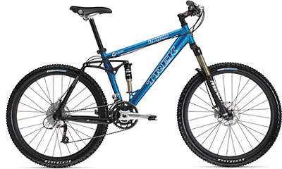

Why is it useful to have a mechanical device (like a bicycle) with a mechanical advantage of less than 1?

______________________________________________________________________________

______________________________________________________________________________

The design of mountain bikes to handle the rough terrain they would be used in, is considered to be evaluating a function because of this influence ...
A | mass appeal
B | mass demand
C | environment
D | ergonomics

Your grandfather loaned you his bicycle to experiment with. As you push down on the pedals you find that you are exerting 797N of force. The resulting load force causing the bicycle to move forward is 104N.

What is the mechanical advantage of your grandfather’s bicycle?
Show your work ….

Fresh and Saltwater Systems

Why does the eastern side of the Rockies receive a Chinook?

_______________________________________________________________________________

_______________________________________________________________________________

What is in water that makes it hard?

_______________________________________________________________________________

_______________________________________________________________________________

How does the process of reverse osmosis change saltwater into freshwater?

_______________________________________________________________________________

_______________________________________________________________________________

How far does the water itself travel in a wave?

_______________________________________________________________________________

_______________________________________________________________________________

What is the main reason that tides occur on the Earth?

_______________________________________________________________________________

_______________________________________________________________________________

What is included in a river’s sediment load?

_______________________________________________________________________________

_______________________________________________________________________________

Models are often used to help explain a concept that is important to visualize, so you can understand and relate to it more easily.
This glass of lemonade models the distribution of all kinds of water on the Earth (like the chart illustrated above).  All of the freshwater on the Earth (like in the graph above) is represented in the lemonade model by the …  _______________________________ | 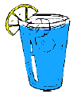

Hard water can cause pipes that carry it to become clogged with scales of minerals. Hard water is water that contains high concentrations of dissolved … |  |  |  | 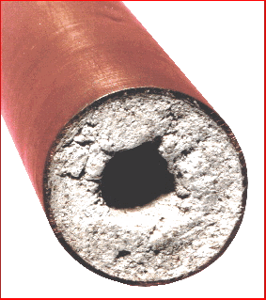
A. | Gold  and Silver | C. | Hydrogen  and Oxygen
B. | Calcium  and Chlorine | D. | Calcium  and Magnesium

Waves are movements on the surface of the water. | 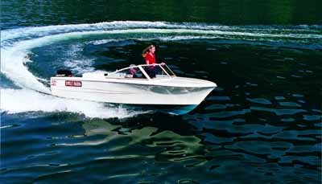
Waves made by boats as they travel across the surface of the water are called wash.  Why would you see a sign, such as this one, on an open waterway that is used for recreational purposes? | 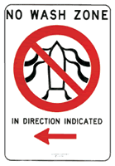
_________________________________

What glacial effect indicates that a glacier has advanced and retreated because of the gouges and scrapes it has made in the bedrock?

_________________________________________

What is the main climate effect that large bodies of water have on a particular area?

_______________________________________________________________________________

_______________________________________________________________________________

Describe what you would likely find in the continental shelf zone of the ocean.

_______________________________________________________________________________

_______________________________________________________________________________

What important zone in the ocean ecosystem enables many of the species that live there to live part of their lives out of the water?

___________________________________________

Describe the type of aquatic environment that brine shrimp live in.

_______________________________________________________________________________

_______________________________________________________________________________

Illustrate the water cycle and identify that part of the water cycle where water vapor forms clouds?

___________________________________________

___________________________________________

___________________________________________

___________________________________________

___________________________________________

The continental shelf is a shelf of land that extends out from the edge of a continent below the ocean’s surface.  The water in this zone of the ocean is … | 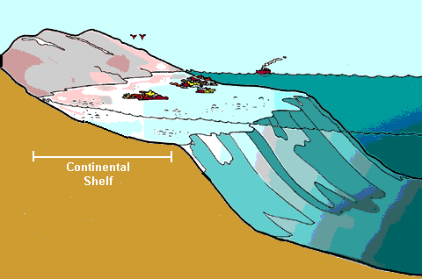
A | Cold and rich in a variety of species
B | Cold and dark with few species
C | Warm and light making it rich in nutrients
D | Warm and dark with few nutrients

A change in the water level in the ocean is referred to as a tide. Tides occur 4 times each day, every 6 hours, every day. There are two types of tides, high tide and low tide. The main reason that tides occur on the Earth is because of the ...
A | rotation of the earth and tilt of its axis
B | gravitational force of the Earth on the moon
C | gravitational force of the moon on the water
D | moon phases and changing of the seasons

A stream, or river profile is a description of its characteristics. Each stream has a pattern of flow that is shaped by its characteristics. Stream characteristics include …
_________________________________

Geological features on the ocean floor are a result of the continental plates moving. Where the continental plates are moving toward each other and moving away from each other you will find …
_________________________________

Prairie lakes with high concentrations of carbonates and bicarbonates have white coatings on the rocks near the shoreline. These minerals have been dissolved out of the soil and have made the lakes …
_________________________________

What agricultural use of water is hampered with a serious side effect because of dissolved salts, in the soil, deposited on the surface?

_______________________________________________________________________________

_______________________________________________________________________________

What is the primary source of phosphate and nitrate pollution throughout Alberta’s river systems?

_______________________________________________________________________________

_______________________________________________________________________________

What is another more important way to solve environmental problems that society faces besides science and technology?

_______________________________________________________________________________

_______________________________________________________________________________

Identify the many different types of glacial landforms in the illustration.

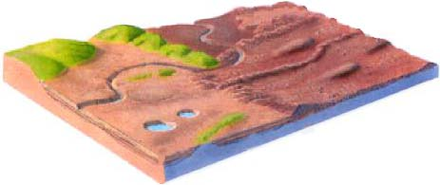

This ocean zone contains water that is a mixture of saltwater and freshwater, called ...
A | pure water
B | saline water
C | algae bloom
D | brackish water

Continental glaciers, or icecaps cover large areas of land, forming the coldest regions on the Earth. Glaciers can also form high up in mountain ranges, where snow and ice build up over long periods of time. These glaciers are known as …
_________________________________

Adaptations are physical characteristics, or behaviors of a species, that increase its chances of survival. All living things have adaptations that are specific for the environment they live in.
Fish, like this Arctic Cod,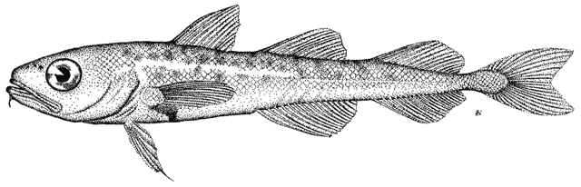 in arctic water have a special adaptation that prevents their blood and body tissue from freezing. It is a natural ...
_________________________________

To revitalize a dead river, so it will once again thrive, needs cooperation from scientists, Industrialists, government and people. | 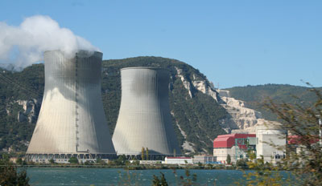
What is the danger to the river in this picture?

_________________________________

