SCIENCE 9
PROVINCIAL ACHIEVEMENT TEST
STUDY GUIDE

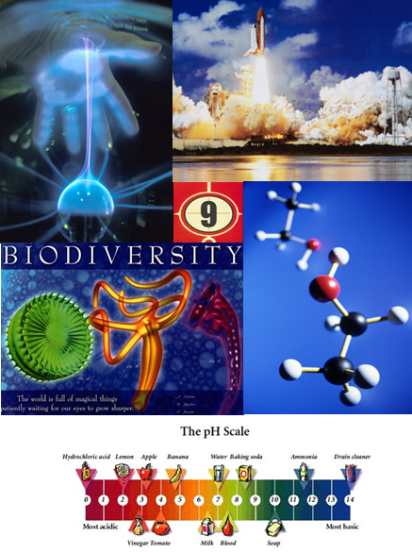

Unit A: Biological Diversity

Variation and Diversity
Science in Action Pages 9, 10, 20, and 21
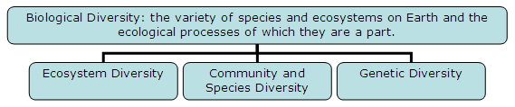
  - Ecosystem diversity = number of different ecosystems on Earth (e.g. boreal forest, prairies); ecosystems include the living (biotic) and the non-living (abiotic) things in an environment
  - Community diversity = number of different species living in the same area and sharing the resources (e.g. wildebeests, antelopes and zebras on the Serengeti Plain); communities are made up of several populations (i.e. members of one species living in a specific area and sharing resources)
  - Genetic diversity = variations between members of a population at a cellular level (e.g. number of and color of bands on the banded snail, blood types of humans)

More species of insect than all of the other kinds of life forms combined exist on earth. Only 1% of all species that have ever lived are alive today. Areas around the equator have the greatest numbers of species. No single kind of organism can survive in all of Earth’s regions

Species = group of organisms having the same structure and reproducing with one another
Ecosystem = any place in which living (biotic) things live and interact with other biotic and abiotic (non-living) things
Population = members of a same species living in a specific area and sharing resources
Community = populations of different species living in the same area

Science in Action Pages 28 and 29
Variability = variation (i.e. differences among individuals) within a species
- Important if environment changes (i.e. climatic change, new predator, new disease, elimination of food source). Differences among individuals in a species can allow each to ‘deal’ with environmental conditions differently; this means that if a change occurs, not all will die; there will be some that can still survive and adapt to the new environment (e.g. different colors of banded snails mean that only a few will be seen by predators even when its environment changes with the seasons/peppered moths in England/bacteria resistant to antibiotics)
- Variation allows similar organisms to survive external threats. This allows many species that may have the same niche or job to thrive even if one of the species is eliminated from the same habitat. (e.g. Different trees are producers in a boreal forest. If a disease which affects only pine trees, wipes out the entire pine tree population, the other trees can still continue their niche.)
- Types of variation:
- Discrete variation = differences in characteristics that have a defined form (‘either-or’ form), such as being an albino or having blue eyes
- Continuous variation = differences in characteristics that have a range of forms, such as height in humans or the mass of squirrels)

Science in Action Page 18
Niche = role an organism plays within the ecosystem (includes its food, its habitat, its range, its effect on other species and the environment, and its predators); by having different niches, closely related species can survive (e.g. owls hunt at night, hawks hunt in the daytime)

Interdependence of Species
Science in Action Pages 17, and 27 to 29
No species can survive by itself – each must depend on another
General relationships are where trees take in carbon dioxide and release oxygen and most other organisms need oxygen and produce carbon dioxide. Specific relationships involve the interaction of two groups and symbiosis and predation are two examples.
- Food chains and food webs show plants being eaten by herbivores, herbivores being eaten by carnivores, and decomposers break them all down
- Predator-prey relationship = one species hunts another for food (keeps both populations under control) e.g. lynx and snowshoe hare
- Interspecies competition = when 2 or more species need the same resource (both are harmed)
- Resource partitioning = when members of the same species use a resource in different ways (e.g. tadpoles eat plants while frogs eat animals, birds feeding on worms located on different places on a tree)
- Symbiosis = association between members of different species in which one species survival depends directly on the health and survival of another species
- Commensalism = one species benefits while the other does not (e.g. bird nesting in a tree, barnacles on whales)
- Mutualism = both species benefit (e.g. fungus and alga form lichens, ants protecting acacia trees, remora fish eating off of sharks)
- Parasitism = one species benefits and the other is harmed (e.g. tapeworms in an animal)

Reproduction
Science in Action Pages 30 to 33
Asexual reproduction does not involve the union of male and female sex cells, but is actually the transmission of the same genetic information from a parent to its offspring. Basically the offspring is an exact copy of the parent.
- Binary fission = cell splits exactly in two after duplicating itself (e.g. bacteria, amoeba)
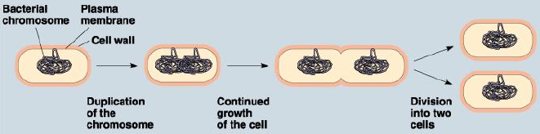
- Budding = parent produces small bud, which eventually detaches and becomes a new individual (e.g. hydra, yeast, coral)
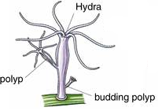
- Spore Production = parent produces spores and each spore develops into a new individual (e.g. fungi, green algae, some moulds, ferns)
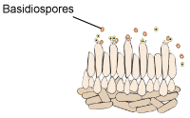
- Vegetative Reproduction = reproduction of a plant that does not involve the formation of a seed (e.g. strawberries, potatoes, tulips, aspen trees)
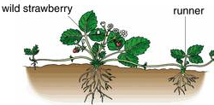
- Parthenogenesis = process that transforms unfertilized eggs into mature organisms (e.g. bees, ants, rotifers)

Science in Action Pages 32 to 35
Sexual Reproduction involves the union of male and female sex cells (i.e. gametes) to form a zygote and requires two parents. It creates variation in offspring.

- Events in animal reproduction
      - Male gametes (sperm) and female gametes (egg or ova) are produced
      - Sperm unites with the egg to form a zygote during mating (fertilization) – they must arrive at the same time and in a moist environment so the gametes do not dry out
      - Zygote divides repeatedly (cleavage) until it becomes a multicellular embryo
      - Embryo develops inside or outside the female parent; it is different from both parents, but similar to them in other respects
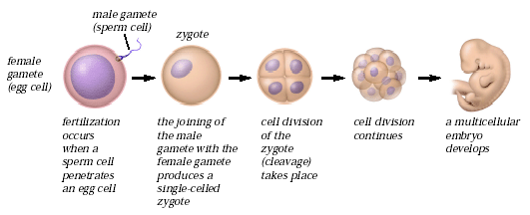
        - Events in plant reproduction
- Pollen (contains male gametes) is found on the stamen; ovules (contain female gametes) are found in the pistil
- Pollen is transferred from the anther of the stamen to the stigma of the pistil
- Male and female gametes unite to form a zygote (fertilization)
- Zygote divides repeatedly (cleavage) until it becomes a multicellular embryo (this is found inside a seed); it is different from both parents, but similar to them in other respects
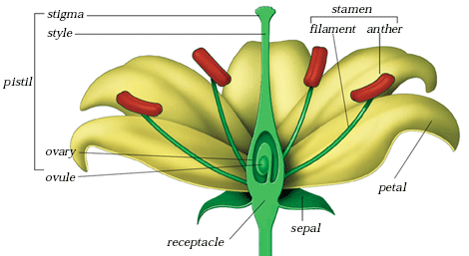
  - Most plants can produce seeds (sexual) or reproduce through cuttings, bulbs, or runners (asexual). Jellyfish and moss alternate between sexual and asexual reproduction from generation to generation. Aphids can produce female young with and without fertilization (males only with fertilization)
  - Bacterial Conjugation = primitive type of sexual reproduction in which one bacterium grows a tube-like structure and passes on a copy of its DNA to another bacterium

Type of Reproduction | Advantages | Disadvantages
Asexual | - does not require specialized cells  - does not require mating  - rapid increase in numbers  - little energy needed | - unfavorable conditions occur, entire population dies  - no variation
Sexual | - lots of variation, to survive environmental change | - does require specialized cells  - does require mating  - slow increase in numbers  - lots of energy

Science in Action Pages 46 to 47
Mitosis occurs in the body cells (somatic cells), has one division, and is made up of 5 stages:
- Interphase – duplication of DNA and cell increases in size
- Prophase – nuclear membrane disappears, chromatin condenses into chromosomes
- Metaphase – chromosomes align themselves in the middle of the cell and are attached to spindle fibers
- Anaphase – spindle fibers pull chromosomes to opposite poles in the cell
- Telophase – nuclear membrane reappears, chromosomes become chromatin, and cell membrane begins to pinch in order to form 2 identical cells
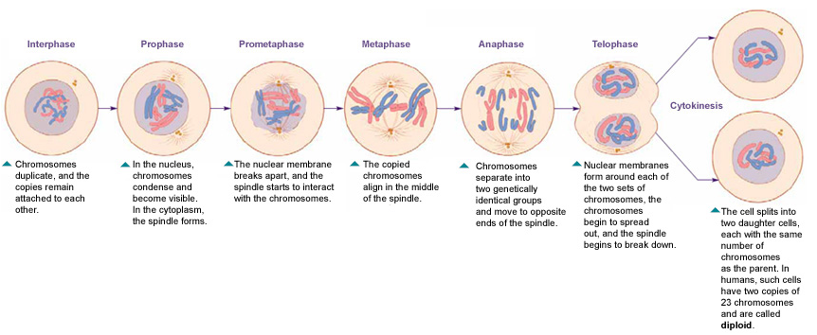
Meiosis occurs in the sex cells (gametes), has 2 divisions, and produces 4 daughter cells
- Each daughter cell has only half of the DNA of the parent
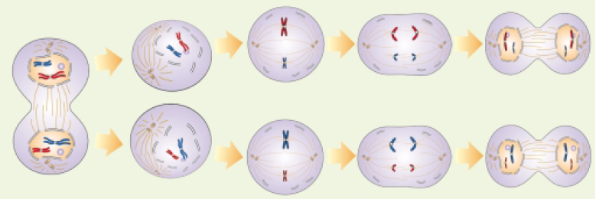

Mitosis | Meiosis
Only one cell division | Two cell divisions
Produces two cells | Produces four cells
Cells produced contain a full set of the parent DNA | Cells produced contain only half of the parent DNA
Occurs in the body, or somatic cells | Occurs in the sex cells or gametes

Genetics
Science in Action Pages 40 to 43
DNA (deoxyribonucleic acid) is the inherited material responsible for variation. It is contained in the cells of all living organisms (normally in the nucleus); it also stores genetic information for heritable traits in all living organisms and directs the structures and functions of the cell.
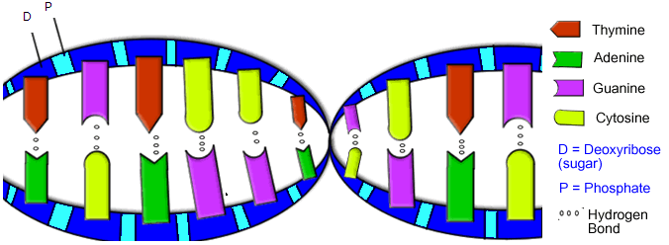
- Made up of nitrogen bases; their order serve as the genetic code (adenine bonds with thymine, guanine with cytosine) as well as sugars and phosphates
- DNA is arranged into packages called chromosomes, which are tightly packed strands of DNA in a cell visible under a light microscope during cell division (humans have 46 chromosomes, each species has its own chromosome number)
- Genes are located on chromosomes and contain coded instructions for a feature (genes also come in pairs)
- Alleles are the possible forms of the genes – two alleles together form a genotype and the genotype determines the physical result, which we call the phenotype

Science in Action Pages 32, 33, 39, and 50 to 53
Purebred = Homozygous = Alleles are the same for that trait (e.g. BB or bb)
Hybrid = Heterozygous = Alleles are different for that trait (e.g. Bb)
Dominant allele = allele which masks or hides all other alleles
Recessive allele = allele which only appears if two are inherited

Examples of crosses (B = black which is dominant to b = white)
- BB x bb
100% of offspring are Bb (black)
B B
b
Bb | Bb
Bb | Bb
b

- BB x Bb
50% of offspring will be BB. 50% of offspring will be Bb. All of these would be black.
B B
B
BB | BB
Bb | Bb
b

- Bb x Bb
50% are Bb. 25% are BB. 25% are bb. 75% are black and 25% are white.
B b
B
BB | Bb
Bb | bb
b

- Bb x bb
50% are Bb. 50% are bb. 50% are black and 50% are white.

B b
b
Bb | bb
Bb | bb
b

- bb x bb
100% are bb (white).

b b
b
bb | bb
bb | bb
b

To complete a cross, create a Punnett Square (Male alleles go on the top and female alleles go on the side. Potential offspring are in the four boxes.)

Incomplete dominance = a pattern of inheritance in which the alleles are not truly recessive or dominant – this results in a blending of the parental traits (red flower crossed with white flower makes red, pink, and white offspring)

Offspring can also be completely different from both parents because many gene location and several alleles are involved; as well, environmental factors can alter the action of genes (e.g. alcohol in blood of pregnant woman causes fetal alcohol syndrome in the baby)

Science in Action Pages 32 to 33.
Heritable or Inheritable Characteristics
- Heritable characteristics = characteristics passed on from generation to generation (e.g. eye color, skin color, hair type)
- Non-heritable characteristics = characteristics which are acquired or learned (e.g. learning to play the piano, changing hair color using dyes)
- Some variation can result from interaction of heredity and environment (Nature vs. Nurture debate) – e.g. Height and weight are largely determined by genetics but a person’s diet can affect how heavy they become.
- These variations are not heritable (e.g. one plant grows larger in the sun than one grown in low light)
Human Impact on Biological Diversity
Science in Action Pages 67 to 71
Extinction = disappearance of every individual of a species from the entire planet
- Natural part of Earth’s history
- 99% of all species that have ever existed are now extinct
- Mass extinctions, like the one that killed the dinosaurs, are caused by catastrophic events
- Unlike mass extinctions, most extinctions take place over long periods of time
- Due to human activity, the rate at which species are becoming extinct is increasing

Extirpation = local extinction = disappearance of a species from a particular area
- Examples include the swift fox from all of Canada, the woodland caribou from northern Alberta, and the grizzly bear from the prairies
- Threatened species become endangered species, which can then become extirpated

Natural causes of Extinction and Extirpation
- Catastrophic events such as volcanic eruptions, floods, or fires (e.g. volcanic eruption changed the sides of Mount Etna in Sicily)
- Lack of food due to overpopulation
- Disease (e.g. American chestnut trees destroyed by chestnut blight)
- Overspecialization = organisms have adaptations that suit them to only a very narrow set of environmental conditions (e.g. giant panda who eats only bamboo shoots)

Human causes of Extinction and Extirpation
- Habitat destruction to meet human needs, such as building construction, agricultural development, logging, and damming of rivers
- Pollution created from habitat destruction – pesticides, herbicides, and fertilizers in water
- Introduction of Non-native species – when introduced species use the same resources as native ones, they compete with the native ones, causing a population decline (e.g. cattle exist where buffalo used to roam)
- Over-hunting – killing organisms on mass scales for sport or for their resources (e.g. passenger pigeon, plains bison, black-tailed prairie dogs)

Effects of Extinctions and Extirpations
- Extinctions = reduce the number of species on the planet
- Extirpations = reduce biodiversity in particular areas
Due to this reduction in species, other organisms are affected in the ecosystem, which can lead to a reduction in ecosystems

Science in Action Pages 72 to 76
To eliminate adverse effects on biological populations:
- In-situ conservation = maintenance of populations of wild organisms in their functioning ecosystems (e.g. provincial and national parks, organizations that protect networks of areas and corridors between areas)
- Restoration and creation of ecosystems and species by picking up garbage, creating laws, planting trees, buying land for natural habitat, bringing back native wildlife, raising money, recycling, protection, and research
- Laws and Policies making it illegal to hunt endangered (very few individuals) or threatened (rapidly decreasing numbers) organisms and to pick or transplant plants
- Controlling the spread of exotic species by pulling them out of the soil (plants) or by hunting/killing them (animals)
- Ex-situ conservation = conservation of components of biological diversity outside of a natural habitat (e.g. conserving genetic resources so as many gene variations as possible for a species can be stored)
- Seed banks allow plant gametes to be stored for long time periods
- Animal gametes cannot be stored for very long; consequently, it is important to maintain populations in their habitat
- Zoos preserve diversity through breeding programs and giving animals a habitat they are adapted to because no habitat exists in the wild

Types of Selection and Biotechnology
Science in Action Pages 24 and 66
Natural selection = when the environment selects which individuals will survive long enough to reproduce (i.e. favoring certain traits over others) e.g. over time, giraffe-type creatures developed longer necks so we have giraffes today

Artificial Selection = process of selecting and breeding individuals with desirable traits to produce offspring that have these desired traits
- Examples include cattle that produce more beef or more milk, corn that produce large cobs and lots of seeds, and champion horses or dogs to win shows
- Reduces variation within species because the individuals breeding are often closely related to each other

Natural selection tends to increase variation within a species, is done by the environment, and selected traits are useful for the survival of the species whereas artificial selection tends to decrease variation within a species, is done by humans, and selected traits are useful for humans

Science in Action Pages 66 to 69
Biotechnology = technology that changes natural reproduction
- Cloning = take a cut from a plant and grow an identical plant from the cutting (can only produce a few clones) OR cells are removed from an individual plant and nutrients & hormones are added to them (can produce more clones)
- Genetic Engineering = any technology that directly alters the DNA of an organism
- Inserting a gene from one species into another species (e.g. genetically engineered bacteria produce insulin for diabetic humans)
- Removing a gene from a species
Artificial reproductive technology = any artificial method of joining a female and male gamete
- Artificial insemination = harvesting male gametes and inserting them into many females
- In vitro fertilization = harvesting male and female gametes, combining them to form zygotes, and then inserting the zygotes into surrogate mothers (can determine sex of zygote beforehand)

Problems with Manipulating Nature | Bonuses from Manipulating Nature
Reduces the genetic variation in breeding lines | Creates organisms with desirable traits quickly
Increases the susceptibility to disease | Can add or remove genes for traits that we want
Clones have birth defects and early death | Could be used to increase the numbers of an endangered species
Could unintentionally transfer traits into another species | Can introduce traits from wild species that are helpful to humans
Miscellaneous
Linnaeus developed a classification system to name organisms
- Kingdom, Phylum, Subphylum (possibly), Class, Order, Family, Genus, Species
- Name of organism is written Genus species (Genus name capitalized, species in lowercase, italicized or underlined) e.g. Canis lupus for timber wolf
- Written in Latin (dead language so it will never change/consistent globally)
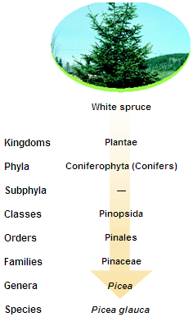
Living things are classified into the following kingdoms:
Kingdom | Structural Organization | Method of Nutrition | Examples of Organisms
Monera | small, simple single prokaryotic cell (nucleus is not enclosed by a membrane); some form chains or mats | absorb food | bacteria, blue-green algae, and spirochetes
Protista | large, single eukaryotic cell (nucleus is enclosed by a membrane); some form chains or colonies | absorb, ingest, and/or photosynthesize food | protozoans and algae of various types
Fungi | multicellular filamentous form with specialized eukaryotic cells | absorb food | funguses, molds, mushrooms, yeasts, mildews, and smuts
Plantae | multicellular form with specialized eukaryotic cells; do not have their own means of locomotion | photosynthesize food | mosses, ferns, woody and non-woody flowering plants
Animalia | multicellular form with specialized eukaryotic cells; have their own means of locomotion | ingest food | sponges, worms, insects, fish, amphibians, reptiles, birds, and mammals
A growing number of researchers now divide the Monera into two distinct kingdoms: Eubacteria (the true bacteria) and Archaebacteria (bacteria-like organisms that live in extremely harsh anaerobic environments such as hot springs, deep ocean volcanic vents, sewage treatment plants, and swamp sediments). Viruses, prions, and other non-cellular entities are not included in the five kingdoms.
Unit B: Matter and Chemical Change

Physical and Chemical Properties/Changes
Science in Action Pages 97 to 109
Chemical Property = any property that describes how a substance reacts with another substance when forming a new substance is a chemical property.
Physical Property = any observable or measurable property without forming a new substance is a physical property.

Chemical Properties | Physical Properties
Chemical Properties | Qualitative  Characteristic that may be described but not measured. | Quantitative  Characteristic that can be measured numerically.
Reacts with water | Colour | Melting point
Reacts with air | Texture | Boiling point
Reacts with oxygen | Taste | Density
Reacts with acids | Smell | Viscosity
Reacts with other pure substances | State | Solubility
Toxicity | Crystal shape | Electrical conductivity
Stability | Malleability | Heat conductivity
Combustibility | Ductility

Physical Change = the form of a substance is changed, but not its chemical composition. The change is temporary/reversible. e.g. ice melts to form a puddle of water; dissolve sugar in water

Chemical Change = causes one or more new substances, with new properties, to be formed and may be difficult or impossible to reverse. e.g. burning paper.

Evidence of Chemical Change:
- Heat or light energy is produced or absorbed. When gasoline burns in a car engine and heat is released.
- Change in color or odor. Bleach on a denim jacket; Striking a match
- Formation of a solid (precipitate). Aqueous silver nitrate (AgNO₃) is added to an aqueous solution containing potassium chloride (KCl) and the precipitation of a white solid, silver chloride is observed.
- Formation of a gas (bubbles). Vinegar and baking soda produces bubbles.
Classification of Matter
Science in Action Pages 102 to 103
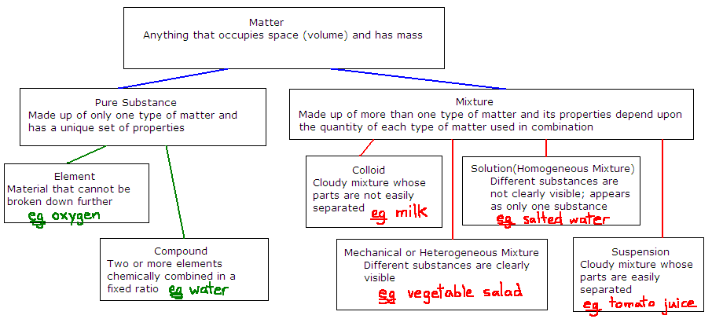

Properties of Metals, Non-metals, and Metalloids:
 | State at Room Temperature | Appearance | Conductivity (ability to transfer thermal and electrical energy directly) | Malleability (able to be pounded or rolled) and Ductility (able to be stretched into long wire)
Metals | Solids, except mercury (a liquid) | Shiny luster | Good conductors of heat and electricity | Malleable and ductile
Non-metals | Some gases, some solids, only bromine is a liquid | Not very shiny | Poor conductors of heat and electricity | Brittle and non ductile
Metalloids | Solids | Can be shiny or dull | May conduct electricity but poor conductors of heat | Brittle and non ductile

States of Matter
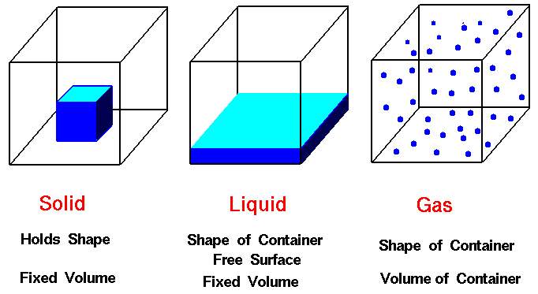
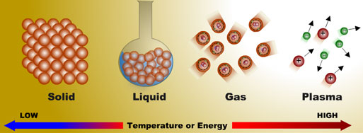
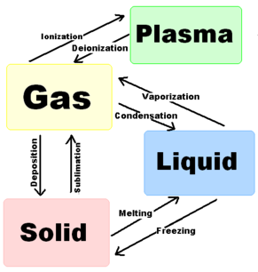

Periodic Table
Science in Action Pages 122 to 133
The Origin of the Periodic Table:
The Periodic Table was developed by Dmitri Mendeleev to explain relationships and patterns that exist amongst elements and their properties. He noted that there would be newly discovered elements and left space in his table. Within sixteen years those gaps were filled with elements that fit Mendeleev’s predicted pattern.

The Periodic Table Outline
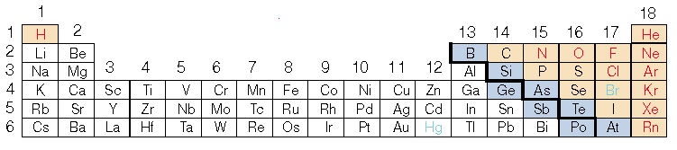
Periods or Rows = the horizontal rows indicate how many electron levels, shells, or orbitals, that exist in that specific element. Although only 6 periods are shown in the table above, there are actually 7 periods.

Groups or Families = the vertical columns indicate how many electrons exist in the last electron level, shell, or orbital of that specific element. Elements in the same groups or families share similar chemical properties. e.g., halogen gases are all in group 18.
- The first two elements (hydrogen and helium) hold a maximum of two electrons in the first orbital.
- For elements three to eighteen (lithium to argon), electrons fill the first orbital with two electrons and then distribute the remaining electrons in progressive orbitals, each holding a maximum of eight electrons.
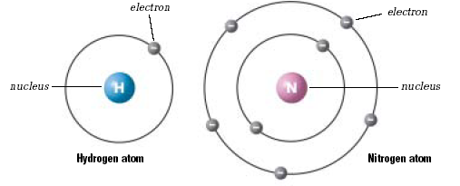
Note: The hydrogen atom has the atomic number of 1 therefore contains 1 electron. This electron is found in the first orbital and has room to gain 1 more electron if it comes in contact with another atom. This would then completely fill the first orbital. Nitrogen’s atom has the atomic number of 7 and thus contains 7 electrons. Two of the seven electrons fill the first orbital and the remaining five occupy the second orbital. Three more electrons can be accepted into this second orbital and is only considered full once it gains these three electrons.

Electrons, Orbitals, and the Periodic Table:
- The period (row) that an element is found in tells us how many orbitals exist in that element. e.g., Hydrogen is in the first period and contains one orbital and nitrogen is in the second period and contains two orbitals.
- The family (group) which an element is found indicates the number of electrons found in the last, final, or valence orbital. e.g., Hydrogen is in the first family and contains one valence electron, whereas nitrogen is found in the fifth family and contains five valence electrons.

Important Families or Groups
Alkali metals = in group 1; are highly reactive (with water) metals that do not occur freely in nature; are softer than most other metals.

Alkaline earth metals = metallic elements in group 2; very reactive (with acids).

Halogens = non-metallic elements in group 17; are the most reactive non-metals.

Noble gases = in group 18; very stable gases; do not form compounds readily

Important Trends within the Periodic Table
- In the metals, as you move down the group, the metals get more reactive (francium is the most reactive metal).
- In the non-metals, as you move up the group, the non-metals get more reactive (fluorine is the most reactive non-metal).
- As you move to the right across a period, the element becomes more non-metallic.

Information found on the Periodic Table:
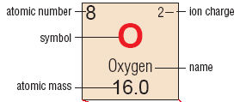

Atomic Number = the number of positive protons found in the nucleus of an atom. e.g. Oxygen has the atomic number of 8 = it has 8 protons.

Since all atoms are neutral, their positive and negative charges must be balanced. In other words, atoms contain an equal number of electrons and protons. Therefore, oxygen has 8 electrons.

Atomic Mass = the total number of protons and neutrons in an atom.
Number of protons + Number of neutrons = Atomic mass
example: 8 protons + 8 neutrons = 16
If you know the number of protons and the atomic mass, you can determine the number of neutrons using the following formula.
Atomic mass – Atomic number = Number of neutrons.
example: 16 – 8 = 8

Ionic Charge: when neutral atoms collide, a negative electron is transferred from one atom to another, and both atoms become particles called ions, which have an electrical charge. If an atom has lost electrons, the overall charge becomes positive (cation) and if it gains electrons the overall charge is negative (anion).
Na⁺ means that sodium has lost one electron. This means that sodium still has 11 protons (its atomic number) but only 10 electrons.
O²⁻ means that oxygen has gained two electrons. This means that oxygen has 8 protons (its atomic number) and 10 electrons.
Note: The number of protons and electrons helps determine the properties of the element.

Atomic Models
Science in Action Pages 113 to 120

Solid Sphere or “Billiard Ball” Model: John Dalton
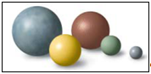
- All matter is made up of small particles called atoms that cannot be created, destroyed, or divided.
- All atoms of the same element are identical in mass and size.
- Elements can combine together in definite proportions to form compounds.
- Dalton’s model is basis of today’s particle theory.
Plum Pudding Model: J.J. Thomson
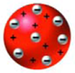
- Negatively charged particles are embedded in a positively charged mass.

Planetary Model: Hantaro Nagaoka
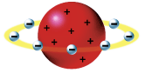
- At the centre of the atom was a large positive charge.
- The negatively charged electrons orbited around this charge like planets orbiting around the Sun.

Nuclear Model: Ernest Rutherford
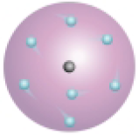
- Mass of the atom is found in the center and is called the atomic nucleus.
- Very small electrons occupy the remaining space of the atom.

Atomic Model: Neils Bohr
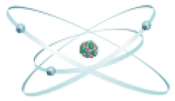
- Electrons move around fixed pathways called electron shells.

Electron Cloud or Quantum Mechanical Model: Louis de Broglie and Erwin Schrodinger
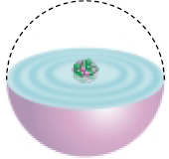
- Electrons have distinct electron energy levels.
- There is an area around the nucleus where electrons are most likely to be found called the electron cloud.

Current Atomic Theory:
- Atoms are made up of a positive nucleus that contains protons and neutrons.
- Negative electrons orbit the nucleus in specific energy levels and occupy most of the volume of the atom.
- Atoms are electrically neutral because of the equal amount of protons and electrons.

Atomic Structure:
Subatomic Particle | Location in the Atom | Charge | Symbol | Mass (a.m.u.)
Proton | Inside nucleus | 1+ | p⁺ | 1
Electron | In electron orbital | 1− | e⁻ | 0
Neutron | Inside nucleus | 0 | n⁰ | 1

NOTES:
- The atomic number indicates the number of protons.
- Atomic mass for an element is the sum of both protons and neutrons.
- a.m.u stands for atomic mass unit. Electrons have such small mass that they are not considered in atomic mass calculations.

Chemical Nomenclature and Formulas
Science in Action Pages 144 to 153

Ionic Compounds | Molecular Compounds
Bonds are created by the transfer of electrons | Bonds are created by the sharing of electron
High melting point | Low melting point
Distinct crystal shape  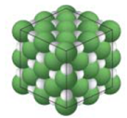 | Does not always form crystals  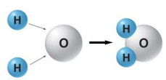
Formed from metallic and non-metallic elements | Usually formed from only non-metallic elements
Forms ions in solution | Does not form ions in solution
Conducts electricity | Usually does not conduct electricity
Solid at room temperature | Solid, liquid, or gas at room temperature.

Diatomic Molecular Elements: Molecules that are made of two or more atoms of the same element.
ex: iodine (I₂), hydrogen (H₂), nitrogen (N₂), bromine (Br₂), oxygen (O₂), chlorine (Cl₂), phosphorus (P₄), sulfur (S₈), and fluorine (F₂).

The Atomic Theory states that compounds are made up of atoms in definite proportions. For example;
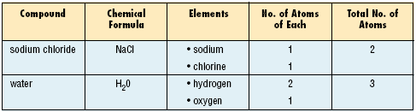

Naming Chemical Compounds
- Ionic Compounds:
- The name includes both elements in the compound, with the name of the metallic element first. If the metal has more than one charge, the charge used must be indicated in Roman numerals within a set of brackets after the name of the metal.
- The non-metallic element is second. Its ending is changed to -ide
Example: CaCl₂
1. calcium (M) and chlorine (NM)
2. calcium chloride

Note that no prefixes are used in ionic nomenclature.

Example: Fe₂O₃ and FeO
1. iron (III) and oxygen 1. iron (II) and oygen
2. iron (III) oxide 2. iron (II) oxide
Note: iron (III) means Fe³⁺ and iron (II) means Fe²⁺

- Molecular Compounds:
      - Write the entire name of the first element. If only one atom is used, no prefix is used. If more than one is present, a prefix must be used.
      - Change the ending of the second element to –ide. Always use a prefix for the second element.
mono = 1 hexa = 6
di =2 hepta = 7
tri = 3 octa = 8
tetra = 4 nona = 9
penta = 5 deca = 10

Note that mono is only used for the 2nd element. e.g. carbon monoxide (CO)

Example: CCl₄
1. carbon
2. chlorine → chloride
3. carbon tetrachloride

Example: N₂S₅
1. nitrogen
2. sulfur → sulfide
3. dinitrogen pentasulfide

Writing Chemical Formulas
- Ionic Compounds:
- Print the metal element’s symbol with its ion charge. Next to it, print the non-metal element’s symbol with its ion charge.
- Balance the ion charges. The positive ion charges must balance the negative ion charges.
- Write the formula by indicating how many atoms of each element are in it. Do not include the ion charge in the formula. Place the number of atoms of each element in a subscript after the element’s symbol. If there is only one atom only the symbol is used.

Example:
1. Ca²⁺ and Cl¹⁻ Drop and Swap Method
2. Ca ²⁺ = Cl¹⁻ Cl¹⁻ Ca²⁺ Cl¹⁻
2+ = 2−
3. CaCl₂ CaCl₂

Example:
1. Al³⁺ and S²⁻
2. Al³⁺ Al³⁺ = S²⁻ S²⁻ S²⁻
6+ = 6−
3. Al₂S₃

Example:
1. Ti⁴⁺ and O²⁻
2. Ti⁴⁺ = O²⁻ O²⁻
4+ = 4−
3. TiO₂

- Molecular Compounds:
- Write the symbols for the elements in the same order as they appear in the name.
- Use subscripts to indicate the numbers of each type of atom (use the prefixes given)

Example:
1. carbon dioxide
2. C and O₂ → CO₂

Example:
1. tricarbon octafluoride
2. C₃ and F₈ → C₃F₈

Some common household chemicals and their formulas include:
- Baking soda NaHCO₃
- Salt NaCl
- Sucrose C₁₂H₂₂O₁₁
- Ethanol C₃H₈OH
- Rock salt CaCl₂
- Ammonia NH₃
- Methane CH₄

Chemical Reactions
Chemical Reactions = when two or more substances combine to form two or more new substances.
Reactants = Substances that undergo the reaction or are combined in the reaction.
Products = Substances that are produced in the reaction.

Science in Action Pages 157 to 169
Oxidation = a chemical reaction in the presence of oxygen

Corrosion = the oxidation of metals and rocks in the presence of oxygen and moisture. e.g. rust.
4Fe_{(s)} + 3O_{2(g)} → 2Fe₂O_{3(s)}
iron + oxygen → iron(III) oxide

Combustion = the highly exothermic (heat releasing) combination of a substance with oxygen resulting in the production of carbon dioxide, water, and energy. e.g. burning methane gas
CH_{4(g)} + 2O_{2(g)} → CO_{2(g)} + 2H₂O_{(g)} + energy
methane + oxygen → carbon dioxide + water + energy

Endothermic Reactions = a chemical reaction that absorbs energy and feels cold. e.g. cold pack
Exothermic Reactions = a chemical reaction that releases energy and feels warm. e.g. burning natural gas in a furnace.

The Law of Conservation of Mass = in a chemical change, the total mass of the new substances is always the same as the total mass of the original substance(s).
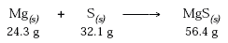
If a gas is produced, occasionally the product mass will appear to be less than it should. This law still applies as the gas has the missing mass, but it was not collected.
Conditions that Affect the Rates of Reaction:
- Heat: the greater the temperature, the faster the reaction. e.g. banana left on a table will ripen faster than one put in the fridge.
- Concentration: the greater the concentration of the substances, the faster the reaction. e.g. strong vinegar will produce a faster reaction with baking soda than weak vinegar.
- Surface Area: increasing the surface area of the reactants will increase the rate of reaction. e.g. crushed Alka Seltzer tablets will react faster than a solid tablet with water.
- Catalyst: a substance that helps increase the reaction rate by lowering the amount of energy needed to make the reaction occur. Catalysts are present with the reactants but are not consumed in the reaction. e.g. enzymes speed up food digestion

Types of Chemical Reactions:
- Formation, Composition, or Synthesis Reactions = two or more substances combine to form one new substance.
A + B → AB 2H₂ + O₂ → 2H₂O
hydrogen and oxygen produces water
- Decomposition Reactions = One substance breaks down into two or more substances.
AB → A + B 2NH₃ → N₂ + 3H₂
ammonia decomposes to produce nitrogen and hydrogen (word equation)
- Single Replacement Reactions = An element switches place with its same type of element in a compound to form a new substance.
Metal Example:
MB + M_{p} → M_{p}B + M NaCl + Li → LiCl + Na
sodium chloride and lithium react to give lithium chloride and sodium
Non-metal Example:
AN + N_{p} → AN_{p} + N 6NaCl + N₂ → 2Na₃N + 3Cl₂
sodium chloride and nitrogen react to give sodium nitride and chlorine
- Double Replacement Reactions = two metal elements switch places to form two new compounds
MB + M_{p}A → M_{p}B + MA NaCl + LiBr → LiCl + NaBr
sodium chloride and lithium bromide produce lithium chloride and sodium bromide
Unit C: Environmental Chemistry

Chemical Substances Entering Environment
Science in Action Pages 186, 225 and 243 to 248
- Fertilizer application = nitrates and phosphates are added to the soil as fertilizer, dissolve in water forming leachate. Some of this will run off into streams and lakes.
- Fertilizer labels: 15-30-15 means 15% N, 30% P, 15% K
- High phosphorus aids in root and flower growth, high nitrogen aids in leaf and stem growth, and high potassium aids in disease resistance and early growth
- Solid Waste = garbage, big and small. Chemicals can move into the soil when it rains. Gases from incinerators can pollute the air.
- Landfills use plastic liners and compacted clay (low porosity) to eliminate any leaching of chemicals
- Wastewater = sewage = dissolved and undissolved materials from your house. Treated water may contain nitrogen or phosphorus from the breakdown of sewage during treatment.
- Sewage treatment involves three stages – primary (physical processes such as filtration and sedimentation), secondary (biological processes such as bacteria biodegradation), and tertiary (chemical processes such as chlorination, nutrient removal and exposure to ultraviolet radiation)
- Spraying = herbicides/fungicides are used to control weeds, and pesticides/insecticides are used to control unwanted insects. Spraying is not very precise, and some of these chemicals end up in the atmosphere and water system.
- Combustion = incomplete combustion of fossil fuels (oil, gas, coal) produces smog. Smog can react with water vapour to produce acid rain. Combustion produces carbon dioxide, water and energy.
- Industrial Processes = electrical power generation, mineral processing and fertilizer production. In Alberta, there is natural gas processing to remove sour gas (hydrogen sulfide), which releases sulphur dioxide into the air. Sulfur dioxide combines with water vapor to create acid rain.

Chemical concentrations in the environment are changed from these processes. In rivers and lakes, nitrate and phosphate levels increase aquatic plant growth to the point where it can be harmful to the fish, insects, and other organisms dependent on oxygen.

Herbicides and pesticides can build up in the food chain as you go from producers to consumers. At the higher levels in the food chain, this can become toxic. This is called biomagnification.
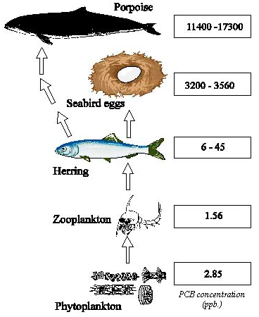

Role of Chemical Substances in Living Things
Science in Action Pages 196 to 204
Organic substances = contain Carbon (C)
- Carbohydrates = provide energy for cells in all organisms. Major sources include rice, grains, potatoes, and fruits. Plants and some microorganisms can produce their own carbohydrates through photosynthesis. (contains carbon, hydrogen, and oxygen)
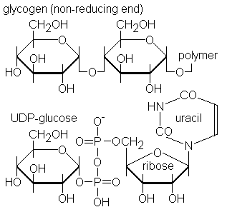
- Proteins = made up of amino acids; used for growth and repair of tissues as well as for making cell components (cell membrane) and cell products (hormones, enzymes). Major sources include meats, eggs, dairy products, legumes, and nuts. (contains carbon, hydrogen, oxygen, and nitrogen)
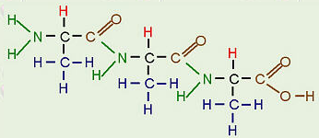
- Fats (Lipids) = used for energy storage and protection of organs. Major sources include oils, dairy products, and animal tissue (contains carbon, hydrogen, and oxygen)
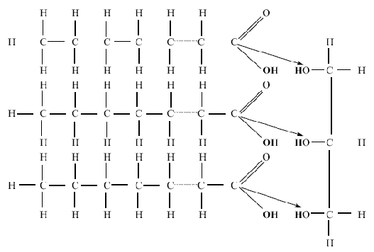
- Nucleic acids = control cell activities. Includes DNA and RNA. (contains carbon, hydrogen, oxygen, nitrogen, and phosphorus)
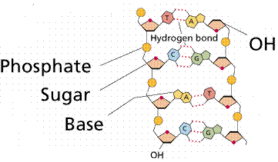

Inorganic substances (also called minerals or elements) = do not contain carbon
Macronutrients = needed in relatively large amounts
Nutrient | Plants | Animals
*Nitrogen (N) | - Composition of protein and chlorophyll  - Leaf and stem growth  - Nitrogen cycle | - Composition of proteins and nucleic acids  - Growth and repair of tissues
*Phosphorus (P) | - Root and flower growth  - Cellular respiration and photosynthesis | - Composition of bones, teeth, DNA  - Metabolic reactions
*Potassium (K) | - Disease resistance  - Chlorophyll production | - Muscle contraction and nerve impulses
Magnesium (Mg) | - Composition of chlorophyll and photosynthesis | - Formation of bones and teeth  - Absorption of calcium and potassium
Calcium (Ca) | - Cell wall  - Cell division | - Bones and teeth  - Blood clotting  - Muscle and nerve function
Sulfur (S) | - Fruit and grain production | - Protein synthesis  - Enzyme activation  - detoxification
Other important inorganic substances: sodium, iron, iodine (micronutrients or trace elements = needed in small amounts)

Nitrogen Cycle
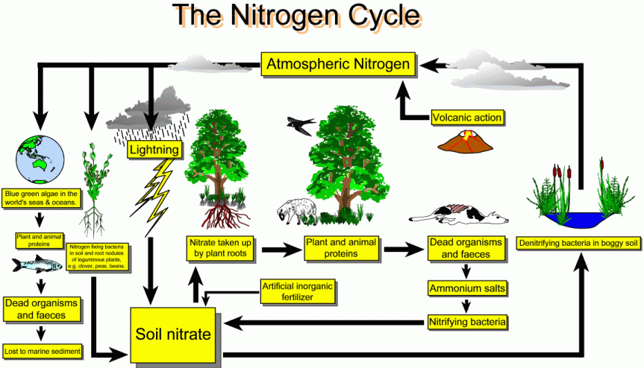

Plants synthesize carbohydrates through photosynthesis. This occurs in the chloroplasts inside the plant cells of the leaves primarily. Examples include glucose, sucrose (table sugar) and starch. Plants also make proteins, amino acids, fats and nucleic acids from nutrients in the soil through various mechanisms inside the cell.

Photosynthesis increases oxygen in atmosphere and serves as a carbon sink. It also produces glucose for ingestion through the food chain.
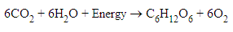

Animals can synthesize a few carbohydrates (glycogen for energy storage), but must consume most of what they need by eating food. Animals synthesize the proteins, amino acids, fats and nucleic acids that they need from nutrients in food. These substances are all made inside the cell.

Cellular respiration uses oxygen and glucose to produce carbon dioxide, water vapor, and energy (i.e. heat).
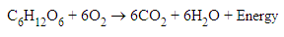

Science in Action Pages 204 to 209
Ingestion = how animals take in food (eating). Food is broken down by a digestive system.
- Mechanical breakdown in the mouth (increases surface area)
- Chemical breakdown in stomach and intestines (high acid concentration, catalysts)
- Hydrolysis (addition of water) is used to break down nutrients
- Maltose + water → glucose

Absorption = how plants take in food and water. Animals may also receive substances from the environment through absorption through their body surface or through the tissues of their lungs. (example: spray pesticides)

Diffusion = movement of a substance from an area of high concentration to an area of low concentration (with the gradient)  Facilitated diffusion = a protein helps molecules that are too large move across the membrane | 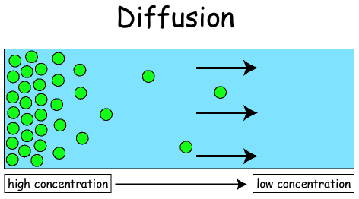
Osmosis = diffusion of water across a membrane from an area of high concentration to an area of low concentration (with the gradient) | 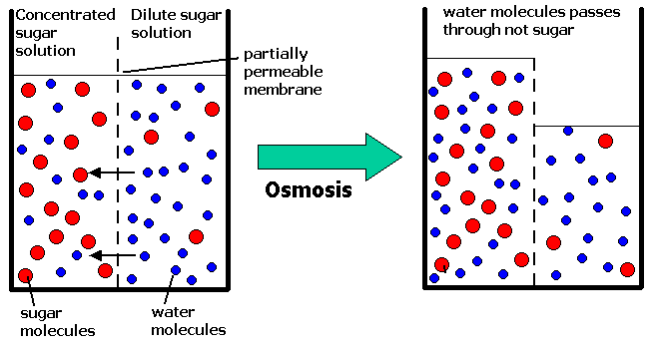
Active Transport = movement of molecules across a membrane from an area of low concentration to an area of high concentration. This requires ENERGY. (against the gradient) | 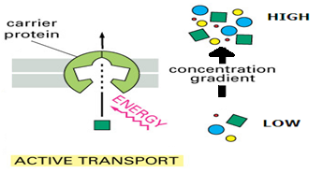
DDT = a pesticide that was used to control body lice, fleas and mosquitoes. It was also used to treat malaria. DDT does not break down and becomes stored in fat cells. DDT accumulated in insects, and then in the fish and birds that consumed the insects (an example of biomagnification). An unexpected outcome of DDT use was that birds of prey (hawks, eagles, peregrine falcons) developed problems with their eggshells. They would lay their eggs, but the eggs would crack when they were incubating. As a result, many birds of prey almost became extinct. DDT is now banned in most countries. Another example of this is mercury in aquatic food chains, which causes mercury poisoning in humans.

Water Quality
Science in Action Pages 214 to 215
Biological monitoring (also called biological indicators) = organisms whose presence or absence can be used to indicate how polluted an environment is. For example, in a healthy lake environment you will find a large variety of vertebrates (fish), invertebrates (insects, shrimp) and plants. In a polluted lake environment, you will find fewer fish and invertebrates, and more worms.

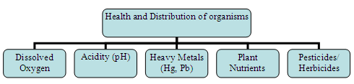
The level of dissolved oxygen depends on:
- Temperature (temperature, dissolved oxygen)
- Turbulence due to wind or the speed of moving water (turbulence, dissolved oxygen)
- The amount of photosynthesis by plants and algae in the water (photosynthesis, dissolved oxygen)
- The amount of chemical pollution (pollution, dissolved oxygen)
- The number of organisms using up the oxygen (organisms, dissolved oxygen)
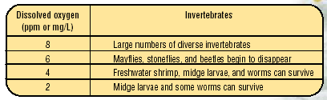

Acidity = Normal rain has a pH of 5.6. When the pH falls to less then 4.5, most fish disappear. In some areas, acidic precipitation builds up as snow and ice in the winter, which can cause spring acidic shock.

Heavy Metals = metals with a density of 5 or higher. Acidic water can dissolve lead in pipes. Cadmium is present in some fertilizers as an impurity. Heavy metals affect normal development and can cause brain damage.

Pesticides/Herbicides = Insects can be resistant to the chemical – whole populations could become resistant. Several substances could combine to produce an even more toxic one.

Acids and Bases
Science in Action Pages 197 to 200
pH scale = logarithmic scale which measures how acidic or basic (alkaline) a substance is; each decrease in pH by one pH unit means a tenfold increase in the concentration of hydrogen ions (i.e. pH 4 is ten times more acidic than pH 5 and 100 times more acidic than pH 6); each increase in pH by one pH unit means a tenfold deccrease in the concentration of hydrogen ions (i.e. pH 10 is ten times more alkaline than pH 9 and 100 times more alkaline than pH 8.)
- Acids = between 0 (strong acids) and 7 (neutral); taste sour; gives sharp stinging pain to cut or wound; reacts with metals to produce hydrogen gas
- Bases = between 7 (neutral) and 14 (strong base); taste bitter; feel slippery
- Neutral substances = measure 7.
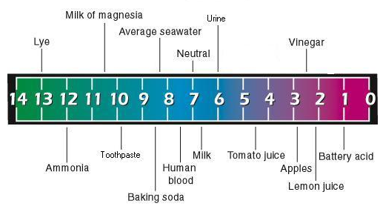
Indicators = substances that change color when they are placed in solutions.
- Blue litmus paper stays blue in a base and changes to red in an acid. Red litmus paper stays red in an acid and changes to blue in a base.
- Universal pH indicator changes color in any solution. It can determine an acid, base or neutral substance using only one type of paper
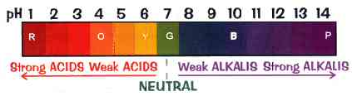

Science in Action Pages 206 to 212
When acids and bases are mixed together, a neutralization reaction takes place. The neutralization reaction produces water and a compound called a salt.
Neutralization Reaction Acid + Base → Salt + Water

Example: Ca(OH)₂ + H₂SO₄ → CaSO₄ + 2H₂O
Calcium hydroxide + Sulfuric Acid → Calcium sulfate and water

Science in Action Pages 191 and 195
Acid rain = When fossils fuels are burned, gases are produced (sulfur oxides and nitrogen oxides). These gases then react with water vapour in the air and produce acids (nitric acid and sulfuric acid). If rain has a pH of less than 5.6, it is considered acid rain. Acidified lakes and soils can be returned to the proper pH by adding bases (calcium hydroxide).

Upset stomach = When your stomach is upset, it often has an excessive amount of stomach acid. An antacid (Tums) is a mild base, and it can neutralize the acid in your stomach.

We use bases everyday to help us stay clean: soap, toothpaste, shampoo

Distribution of Substances into Environment
Science in Action Pages 237 to 243

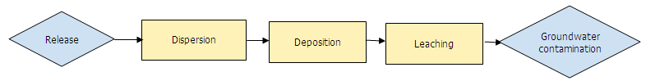

The pollutant is released from a source (a factory), is scattered in various directions (dispersion), and then falls to the ground or water (deposition). Wind direction and speed will influence where the pollution lands. When pollution combines with rain or snow it is not usually carried as far.

Pollutants are carried through the soil by the process of leaching. The pollutant dissolves in water and then moves downward through the soil. The type of soil will affect how much leaching occurs.
- Soils with a lot clay (not porous) do not allow water to soak through (prevents leaching).
- Soils that are very porous (sandy soils) allow water to soak through (allow leaching).
- Some pollutants react with substances in the soil and are neutralized. Acid rain can be neutralized by basic soils (soils high in calcium carbonate).

Pollutants that move through the soil can then enter the groundwater. Groundwater is water held within porous rock below the soil. If you use water from a well, you are using groundwater. The porous nature of the rock allows the groundwater to move great distances and carry pollutants with it.
- The more porous the rock, the faster the pollutants will move.
- Pollutants can also move in surface water (runoff, rivers, streams). Pollutants that dissolve easily in water will be carried a long way. Pollutants that don’t dissolve easily will settle in the river or stream bottom and accumulate there, causing problems for the organisms nearby.

Dilution = reduces the concentration of a pollutant by mixing the polluting substance with large quantities of air or water.

Environmental Chemistry Issues
Science in Action Pages 220 to 222
Consumer practices: Any time consumers dispose of hazardous waste in an improper way it could lead to contaminated landfill sites and contaminated groundwater. Examples: sending car batteries and oil filters to the landfill. These should be sent to a hazardous waste collection site.

Industrial processes: waste water treatment is not completed according to standards

Local, provincial and federal governments set standards and guidelines for emissions from factories and refineries. There are heavy fines for companies that do not comply with these standards.

In order to compare toxins, scientists use a measurement called LD50. LD stands for lethal dose and 50 represents 50%. LD50 = the amount of a substance found to be lethal to 50 percent of a population if the entire dose was given at one time. If rats were fed 3000mg table salt per kg of rat, 50 percent of the rats would die. If rats were fed DDT, the LD50 is 87mg per kg. This means that DDT is more toxic than table salt to rats, and a smaller dose of DDT will kill 50 percent of a rat population.

Hazardous chemical = a chemical that is toxic (poisonous) to an organism. Paints, oils and industrial waste are hazardous chemicals. These substances can leach out of landfill sites and contaminate groundwater. The contaminated groundwater can be toxic to organisms that drink it.

Heavy metals (mercury, lead, nickel) can be ingested by fish and plants. When humans ingest these toxic fish and plants, they can experience numbness in arms and legs, nerve and brain damage and death.

People living closest to the pollution source will experience the most severe effects, but pollution can also travel globally through ocean currents and air currents. The pollution from a local factory will not only affect people living nearby, it can also affect people living in other countries or around the world.
Science in Action Pages 227 to 232
Carbon dioxide released into the air by combustion can cause global warming through the greenhouse effect. Atmospheric gases that trap heat from the Sun’s radiant energy in the atmosphere to ensure the temperature is warm enough to sustain life are called greenhouse gases. The enhanced release of greenhouse gases causes the temperature of the Earth to increase beyond normal because there are more gases to absorb the energy reflected by the surface of the Earth.

Ozone in the stratosphere is being depleted by chlorofluorocarbons (CFC’s). CFC’s move from the lower atmosphere to the upper atmosphere. U.V. light from the sun releases chlorine from the CFC’s. The free chlorine reacts with ozone breaking it down into oxygen. This creates a lower concentration of ozone in the upper atmosphere; this is called an ozone “hole”. This “hole” allows more dangerous UV light to reach ground level. The increased U.V. light can cause increased in skin cancer and cataracts, and decrease plankton growth affecting other marine organism populations.

Calculations
Science in Action Pages 216
The concentration of chemicals in the environment can be measured in parts per million, parts per billion or parts per trillion.

Parts per million (ppm) = one unit of an element or chemical can be found in one million units of solution. 1 ppm equals 1 milligram per litre (1 mg/L). One drop of water in a full bathtub is about 1ppm.

Parts per billion (ppb) = one unit of an element or chemical can be found in one billion units of solution. One drop of water in a swimming pool is about 1 ppb.

Parts per trillion (ppt) = one unit of an element or chemical can be found in one trillion units of solution. One drop of water in one thousand swimming pools is about 1 ppt.

Example: Put 1 mL of food coloring and 999 mL of water in a beaker. Now, 1 in every 1000 units of solution is food coloring. To get 1 ppm, put 1 mL of this solution into a beaker with 999 mL of water.

Example: What mass of mercury particles are in a 250g glass of water if the concentration is 7ppb?

Example: What is the concentration in ppm of sodium in a bottle of water if a 500mL bottle contains 0.004mL of sodium?

Miscellaneous
Science in Action Pages 242 to 243
Biodegradation = when living organisms break up material. An example of this is when bacteria break down a dead animal. Other organisms that biodegrade are algae, fungi, protozoans and earthworms.
- These organisms produce enzymes to break apart most organic substances. This can be done aerobically (in oxygen) or anaerobically (not in oxygen).
- Factors that affect biodegradability: temperature, moisture, pH. Biodegradation slows down in cold temperatures, and when moisture is scare. In very acidic or basic environments, biodegradation will slow down.
- Paper, grass clippings, and food wastes are biodegradable. Plastics, metals and glass are not biodegradable.

Phytoremediation = clean up of the environment by growing plants to absorb the pollutant and then remove the plants from the area; “phyto-“ means plant and “remediation” means cleanup; plants have been used to clean up metals, hydrocarbons and other chemicals
Photolysis = breakdown of compounds by sunlight; “photo: means light and “lysis” means break down

Aerobic = refers to processes or environments that require or contain oxygen air
Anaerobic = refers to processes or environments that do not require or contain oxygen
Science in Action Pages 208 to 209
Substrate = the material on which an organism moves or lives.
Nutrient source = where an organism gets its nutrients from.

Organism | Substrate | Nutrient Source
Mould | Loaf of bread | Carbohydrates in the bread
Anemones | Rocks in the ocean | Water-borne organisms (using tentacles)
Grasslands | Soil | Decaying plant and animal material and minerals
Fish | Freshwater pond | Smaller fish and other organisms
Algae | Snow or other freezing material | Photosynthesis

Unit D: Electrical Principles and Technologies

Energy Transfer and Transformations

Science in Action Page 319 to 321
There are two main types of energy: kinetic and potential. Kinetic energy is the energy of motion. Any object or particle that is moving has kinetic energy. Potential energy is stored energy. Any object or particle that has energy but is not using it has potential energy. The unit of energy is the Joule (J).
- mechanical energy- the combined total of kinetic and potential energies of an object or particle
- chemical energy- a type of potential energy; the energy stored in the bonds of molecules
- thermal energy- a type of kinetic energy; the energy of vibrating particles in a material
- electrical energy- a type of potential energy; the energy carried by charged particles

Law of Conservation of Energy:
Energy cannot be created or destroyed but can only change forms.

Science in Action Page 321 to 324
- An electric motor is a device that used to turn something. It converts electrical energy to mechanical energy.
  - By winding current-carrying wire into a coil and wrapping it around an iron core, you can make an electromagnet. An electromagnet will move to line up with the magnetic field of a nearby permanent magnet. To keep the electromagnet spinning, motors use a commutator (split ring) and brushes. The commutator breaks the connection of the coil (changes the direction of current) and thus the magnetic force. The armature continues to spin because of momentum. The commutator then reconnects!
  - Several ways to change the speed at which the armature in a motor spins:
- increasing the strength of the magnets increases the speed of the armature
- increasing the current increases the speed of the armature
- increasing the number of coils of wire between the magnets increases the speed of the armature
- changing the orientation of the magnets so that like poles are against each other will stop the armature
DC Motor AC Motor
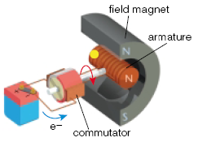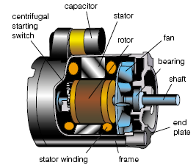

- A generator is a device that produces electricity. It converts mechanical energy to electrical energy.
- A generator works in reverse compared to a motor. Instead of pumping an electric current into the armature and the armature turning as a result, you turn the armature and current is generated as a result.

DC Generator AC Generator
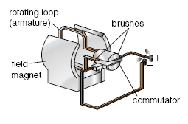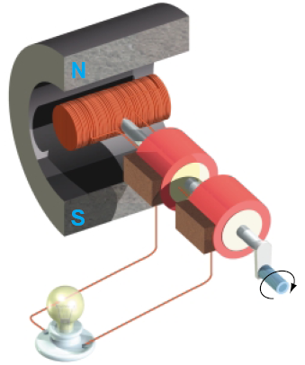

- A thermocouple is a device that produces electricity. It converts thermal energy to electrical energy.
- A cell/battery is a device that produces electricity. It converts chemical energy to electrical energy.

Science in Action Page 325
Direct Current (DC) = current that flows in only one direction

Alternating Current (AC) = current that flows back and forth 60 times per second; this is the current used in homes

Transformer = device that changes electricity at one voltage into electricity at a different voltage; a step-up transformer increases the voltage; a step-down transformer decreases the voltage
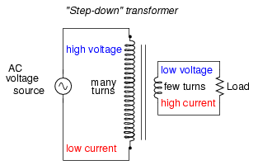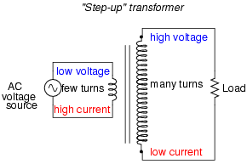

Application/Device | Input Energy | Output Energy
Lightbulb | Electrical | Light/Heat
Battery | Chemical | Electrical
Water wheel | Mechanical | Electrical
CD player | Electrical | Sound/Kinetic

Static Electricity
Science in Action Pages 274 to 278
Static electricity = the build-up of electric charges (protons and electrons are not equal!). Charged objects cause charge separation when they are brought close to neutral objects. [e.g. the build-up of charges in your hair when you put a wool sweater on; these charges are transferred from the wool to your hair; e.g. lightning results from a build-up of charges in clouds; when the build-up becomes too large, the charges jump discharge) to the ground]
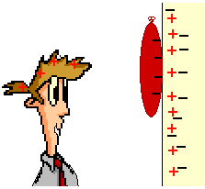
When the teacher rubbed the balloon on his hair, the electrons from his hair moved to the balloon and gave it a negative charge. When he moves the balloon towards the neutrally-charged wall, charge separation occurs. That is, the electrons move away from the negatively charged balloon, leaving the positive charges close to the wall’s surface. Since unlike charges attract, the balloon sticks to the wall.
Laws of Static Electricity
1. Like charges repel.
2. Unlike charges attract.
3. A charged object will attract a neutral object due to charge separation in the neutral object.

Current Electricity
Science in Action Pages 274 to 278
Current electricity = the flow of electric charges; the more charges that flow per second, the higher the current. In general, electrical current carries electrical potential energy which is used to operate electrical devices (e.g. electrical energy carrying charges flow through a light bulb; the electrical energy from the charges is converted to light and heat)
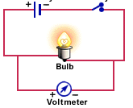

Science in Action Page 298
Electrical conductor = a material that allows charges to flow through it; some materials are better conductors that others in that they allow charges to flow easier (e.g. most metals are good conductors; copper is a very good conductor and is used to carry charges through your house, while nichrome metal conducts charges but not as well)

Superconductor = have almost no resistance to electron flow (e.g. mercury at absolute zero)

Resistance = the property of something that hinders the motion of electric charge and converts electric energy into other forms of energy such as light, heat, and sound. The symbol for resistance is the letter R and the units are Ohms (Ω). (e.g. the filament in a light bulb generates heat because of resistance; e.g. distilled water is a resistor; e.g. lie detectors measure skin resistance because sweat is a salty and conductive solution)

Factors that affect resistance:
- the diameter of the resistor – the wider the resistor, the smaller is the resistance
- the length of the resistor – the longer the resistor, the greater is the resistance
- the material of which the resistor is composed – insulators are better resistors than conductors
- the temperature of the resistor – as the temperature increases, the resistance increases (usually – there are exceptions to this rule)

Electrical insulator = a material that does not allow charges to flow through it; insulators offer resistance to the flow of electric charge. If something is a good insulator, it is a poor conductor. (e.g. rubber and plastic are good insulators)

Science in Action Page 288 to 292
Electrochemical cell = a package of chemicals designed to produce small amounts of electricity e.g. a battery.

Dry cell = a device that converts chemical energy to electrical energy. They consist of two electrodes (two different pieces of metal) and an electrolyte (a conducting solution). Charges leave the negative electrode, pass through the electrolyte, and return to the positive electrode. They are called dry cells because the electrolyte is in the form of a paste.
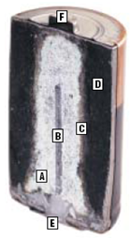
Wet cell- Same as above, but the electrolyte is a liquid that is usually an acid.
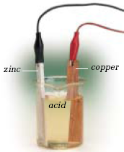

Dry cells and wet cells are both examples of primary cells. The reaction cannot be reversed, and as a result, the cells can only be used once. Rechargeable cells are known as secondary cells. Two examples of rechargeable cells are Ni-Cd and Nickel metal-hydride.

Electrical Circuits
Science in Action Pages 311 to 313
An electrical circuit is a system made up of 4 subsystems:
1. Source – cell or battery
2. Conductor – wire
3. Control – switch
4. Load – lamp/motor

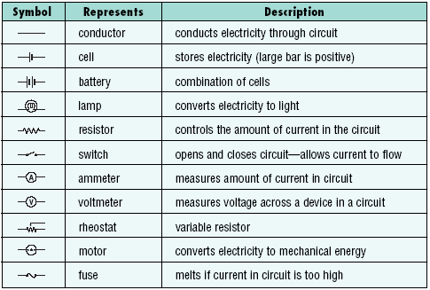

Science in Action Page 298 to 302
Switch = something that will start or stop electric current

Resistor = something that has resistance; something that resists the flow of electric charge and takes electrical potential energy from charges and converts it to some other type of energy, such as light, heat, sound, etc.

Rheostat = variable resistor = a resistor whose resistance value can be changed. (e.g. volume knob on a stereo, a dimmer switch on dining room lights)

Series circuit = only one pathway for current to flow so if one load is breaks in the circuit, the circuit shuts down
- As you add light bulbs (or other loads) in series, the resistance in the circuit increases and causes the current to decrease and this will cause the light bulbs to become dimmer as each new one is added.
- series circuits are used in households so that you can turn off all electricity in a circuit at once with a switch (or fuse).

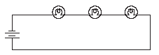

Parallel circuit = has more than one path, so current does not necessarily pass through each load. In this case, if one path is broken there is still at least one other path for current to come through.
- Adding a new pathway with an extra resistor does not affect the resistance of any of the other pathways.
- adding more resistors in parallel decreases the total resistance of the circuit (Analogy: it is easier to drink from two straws than one – less resistance)
- the voltage is the same throughout the circuit – so the voltage of the battery is equal to the voltage drop across each load (roughly – there may be a slight drop)
- as you increase the number of loads placed in parallel, the amount of current drawn from the energy source increases.
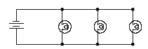

Science in Action Page 315
The similarity between household circuits and microelectronic circuits is that they perform the same basic function: to power an electrical device.

The primary difference between household circuits and microelectronic circuits is the scale. Household circuits are on a much bigger scale. In a typical house, you might have dozens of electrical components. On a typical microelectronic (integrated circuit), there may be millions of transistors and resistors.

Calculations
Science in Action Pages 304 to 307
Voltage = the energy of each individual charge. The symbol for voltage is the letter V and the units are Volts (V). Volts are measured with a voltmeter.

Pretend an electric circuit is a race track. Each car represents a charge. Each car has a certain amount of gasoline that provides its energy. The gasoline that each car has would represent the voltage. The number of cars that pass by the starting line every second would represent the current. As cars (charges) go up hills (resistors), each one of them uses up gasoline (voltage). Each car needs to get more gasoline (voltage) at the pit stop (battery). → See Unit 4 Lesson 11 for Water Model

Amperage = current = the number of charges (electrons) passing through a conductor per second. The symbol for amperage is the letter I and the units are Amps (A). Amperage is measured with an ammeter. Smaller currents are measured with galvanometers.

Ohm’s law provides for the relationship between voltage across a resistor (the energy that each charge loses across the resistor), the current through the resistor (the amount of charges that are flowing through the resistor each second), and the resistance of the resistor. Ohm’s law can be written as a mathematical equation:
$$R=\frac{V}{I}$$

- A 9.0 V battery is plugged into a circuit. A 5.0Ω resistor is also installed into this circuit. What will be the reading on an ammeter which is plugged into this circuit?
Variables List

V = 9.0V
R = 5.0Ω
I = ?
Formula:

- A 10.0V battery is plugged into a circuit. If 2.0A of current run through it, how much resistance is there?
Variables List

V = 10.0V
I = 2.0A
R = ?
Formula:
- A 20.0Ω resistor is installed into a circuit through which 5.0A is flowing. Calculate the amount of voltage.
Variables List

R = 20.0Ω
I = 5.0A
V = ?
Formula:

Science in Action Pages 332 to 333
Power = the rate at which a device converts energy. The symbol is P and the units are Watts (W). 1 Watt is equal to 1.0 J/s.

There are two equations that describe power relationships:

- A toaster connected to 100V power source has 5.0A of current flowing through it. How much power is dissipated as heat?

- A light bulb draws 1.25A of current when a generator produces 150 W of power. What is the voltage of the generator?

- A 200V generator produces 100W of power. How much current is running through?

- A 100 W light bulb is plugged into a 120 V outlet and is on for 5 minutes.
- What is the current?
Given:
P=100 W
V=120 V
t=5 minutes=300 seconds

Find: $P=\text{IV}⇒I=\frac{P}{V}=\frac{\text{100}W}{\text{120}V}=0\text{.}\text{83}A$

- What the energy used?

Find: E=?

- How much energy does a 100W light bulb consume if you leave it on for two hours when you’re not in the room? Calculate the answer in Joules and kilowatt-hours.
P = 100W
t = 2h = 7200s
E = ?

E = Pt = (100W)(7200s) = 720000J = 720kJ
kWh = (0.100kW)(2h) = 0.2 kWh

6. An average refrigerator uses 800W and runs for an average of 4 hours a day. Determine the amount of energy the refrigerator will consume in 1 month (31 days). Do the calculation in both joules and kilowatt-hours. If power costs $0.07 per kWh, how much does it cost to run the refrigerator for the month?
P = 800W
t = 4h/day for 31 days
cost = $0.07/kWh
E = ? Cost for one month = ?

E = Pt
kWh = (power in kilowatts)(number of hours)

E = Pt = (800W)(4h/day)(31days)(3600s) = 357120000J = 357120kJ
kWh = (0.800kW)(4h/day)(31days) = 99.2kWh
Cost = ($0.07/kWh)(99.2kWh) = $6.94
7. A toaster operates at 120V and draws 8.75A of current. If it takes 45s to toast a slice of bread, how much electrical energy is used?
V = 120V
I = 8.75A
t = 45s
E = ?

P = IV
E = Pt

P = IV = (8.75A)(120V) = 1050W
E = Pt = (1050W)(45s) = 47250J = 47.25kJ

8. A home stereo runs at 200W through a 120V outlet. If it is played for 3hours per day and electricity costs $0.15 per kWh, how much does it cost to run the stereo for 10 days?
P= 200W
V = 120V
t = 3h/day for 10 days
cost = $0.15/kWh
Cost for 10days = ?

kWh = (power in kW)(number of hours)
cost = (kWh)(cost/kWh)

kWh = (0.200kW)(3h/day)(10days) = 6kWh
cost = (6kWh)($0.15/kWh) = $0.90

9. If a motor can do 100J of work in 10s when plugged in, how much power can it develop?
E= 100J
t = 10s
P = ?

P = E/t = 100J/10s = 10W

Science in Action Pages 335 to 338
The law of conservation of energy states that energy cannot be created or destroyed, but that it can be transformed from one type to another.
Efficiency refers to the percentage of original energy (input) that remains after an energy conversion (output). No device is 100% efficient. This does not mean that energy is destroyed; it was simply converted to an unusable form such as heat.

1. You do 15,000 J of work with a screw jack. If the screw jack does 14,500 J of work, what is the efficiency of the screw jack?
Variables List

E_{in} = 15000J

E_{out} = 14500kJ

FORMULA: Efficiency = output energy x 100
input energy

SOLVE:
= _14500J x 100
15000J

= 97%

2. A pulley system operates with 40% efficiency. If the work put in is 200J, how much useful energy is produced?
Variables List

E_{in} = 200J

Efficiency = 40%

FORMULA: Efficiency = output energy x 100
input energy

SOLVE:

Alternative Energy Sources
Science in Action Pages 345 to 350

Renewable source = a source of energy that can replenished naturally in a relatively short period of time
- Tides/Water = moving water turns turbine that run generators; There are not a lot of tidal power stations in the world because of the difficulty in finding a suitable location. They are considered environmentally friendly.
- Wind = use the wind to turn a turbine that run generators; Modern windmills are more efficient than older ones because of the propeller shaped blades. They are not particularly efficient, but are environmentally friendly. They are usually grouped together.

Sunlight = uses the Sun to generate electricity; Modern silicon materials have made sunlight a more efficient way of producing current. This source of electricity is very environmentally friendly.
- Batteries = Convenient source of electricity for portable devices, but they only produce energy after being charged using electricity from an external source. They actually use more energy than they produce!
- Biomass = biodegradable waste as it decomposes produces combustible gases that are used for steam-driven generators
- Nuclear power = Heavy element atoms are split in a chain reaction, which produces energy that is used for steam-driven generators
- Geothermal energy = Earth’s heat drives turbines attached to generators

Non-renewable source = a source of energy that cannot be replenished naturally in a relatively short period of time.
- Fossil fuels = coal, oil, and natural gas;reasonable choice in areas that have a large deposit that is easy to excavate. This non-renewable source of electricity is not environmentally friendly.

Cogeneration involves the use of waste energy from a process for another purpose, such as heating or generating electricity.

Social and Environmental Issues of Electrical Energy
Science in Action Pages 351 to 352
Air pollution from burning fossil fuels:
- Fly ash = released into air after burning coal; contains mercury, a poisonous metal that can damage the nervous system.
sulfur dioxide- has been identified as causing acid rain
nitrogen oxides- major cause of air pollution and acid rain
carbon dioxide- has been identified as causing global warning
- Strip-mining = used when deposits are near the surface; removes all plants and animals from the area. The natural environment is never fully restored.
- Oil and gas fired generators = Oil or gas is burned to heat water, which becomes steam and turns a turbine to generate electricity. This process releases poisonous gases and warm water into nearby lakes and rivers. Oil is pumped from wells, sometimes by injecting water into the ground. A significant amount of fresh water goes into the ground, out of the water cycle forever. Natural gas wells produce sour gas which is poisonous.

Science in Action Pages 352 to 353
Issues related to Energy
- shrinking natural resource reserves
- increasing demand on natural resources
- environmental concerns with the means in which resources are obtained, used, and discarded

Ways to improve the sustainability of energy use
- manage resources according to what we have rather than what we use
- improve the efficiency of machines and appliances
- use more renewable sources of energy and avoid use of non-renewable energy sources
- make good personal choices

Miscellaneous
Science in Action Pages 354 to 358
Some technologies based on electricity:
- computers may make tasks more time efficient; more instant communication; lots of waste produced when computers are discarded
- lasers are used in cd players, medical applications such as surgeries, dental work, communication; cost is a downside although it is decreasing
- cell phones provide instant communication of words and pictures; a person is almost always reachable

In general, many people would argue that technology had made our lives easier. Some would argue, however, that we are experiencing an information overload and are working harder than ever as a result of technology.

Science in Action Pages 339 to 343
Energy Conservation Tips
- pick appliances that are energy efficient
- don’t leave lights on when not in the room
- use full loads of laundry and dishes
- improve bearings and lubricants in devices to reduce friction
- add more insulation around stoves, refrigerators, and walls
Unit E: Space Exploration

Perspectives from History about Space
Science in Action Pages 368 to 376
The celestial bodies and events, such as eclipses, comets, meteors, aurora borealis, stars, solstice and equinox, have fuelled the human imagination, marked the passage of time and foretold changes in seasons. The information was passed from generation to generation and from culture to culture as legends and folklore.
- Summer solstice (June 21) = the longest period of daylight; the start of summer; Winter solstice (December 21) = the shortest period of daylight; the start of winter
  - Solstices are reversed in the southern hemisphere
  - The Celts created Stonehenge to mark winter and summer solstices.
  - African cultures made large stone pillars into patterns to predict the timing of the solstices
  - Useful to know when to plant and harvest crops
    - Equinox: day and night are of equal length (March 21 and September 22)
      - In 1000 A.D. the Mayans built a cylindrical-shaped tower to celebrate the equinox.
        - Inuit, in the high Arctic, used the width of a mitt held at arm’s length to gauge the height of the sun above the horizon. When the sun rose to the height of one mitt width, it meant the seal pups would be born in two lunar cycles.
        - The First Nations people of the Pacific Northwest thought the night sky was a pattern on a great blanket overhead. This blanket was held by a spinning world pole, the bottom of which rested on the chest of a woman underground named Stone Ribs.
        - The sun played a prominent role in mythology of several ancient cultures, namely the North American native, the Aborigines of Australia, the Aztecs, the Chinese, the Inuit, the Greeks, the Norse, and the Japanese.
        - The Ancients used rock structures and buildings to align with stars (eg. 2700 BC pyramids built in Ancient Egypt).

Models of Planetary Motion
2000 years ago Aristotle developed the geocentric model (Earth-centered model) to explain planetary motion.
- Earth was at the center with concentric spheres encircling it
- The distant stars were fixed on the outermost or celestial sphere
- It correctly predicted the phases of the moon, but little else
- Ptolemy added epicycles, which were smaller spheres attached to the main spheres. This helped make predictions more accurate.
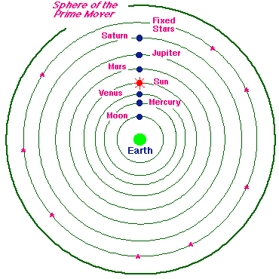

In 1530 Copernicus developed the heliocentric model (sun centered with planets revolving in orbits around it)
- In the 1600s, Galileo used a telescope to provide observations to back up this model
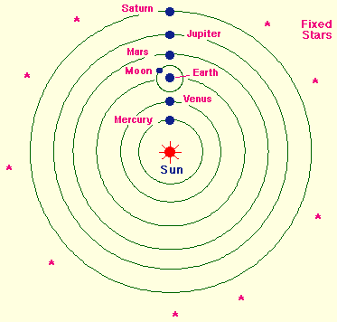

A German mathematician, Johannes Kepler, using the observations on movement of the planets recorded by Danish astronomer Tycho Brahe, discovered that the orbits of the planets were elliptical.
- Epicycles were no longer needed
- He figured out the shape and scaled the entire solar system from the same observations
- Sir Isaac Newton explained the elliptical orbits by proving that there is a gravitational attractive force between all objects that pulls them together in an orbit.
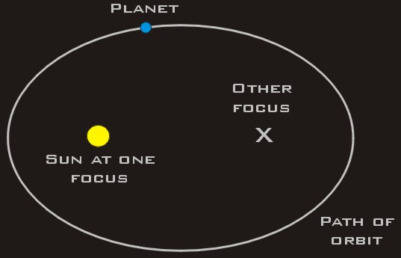

Ancestral contributions to today’s knowledge:
- stars make unchanging patterns in the sky which looked like objects that they named
- they could use the movement of stars to mark months and seasons which led to the development of the calendar
- the Sun, Moon and Planets rise and set at different rates from the stars

Science in Action Pages 374 to 378
- 7000 years ago, sundials were used to measure the passage of time
- Egyptians invented a device called a merkhet to chart astronomical positions and to predict the movement of the stars.
- In the second century, Egyptians designed a quadrant to measure a star’s height above the horizon.
- Arabian astronomers used the astrolabe to make accurate charts for star position.
- In the 14th century, Levi ben Gurson invented the cross staff to measure angle between the moon and any given star.
- Hans Lippershey invented the telescope in the late16th century. Galileo Galilei improved the telescope and it revolutionized astronomy. Galileo could see more in the night sky than had ever been possible (details about Earth’s planetary neighbours, solar system and galaxy). Galileo was able to observe planets in some detail but not stars. From this observation he concluded that the stars are much farther away than planets.
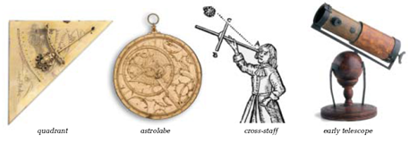
Distribution of Matter in Space
Science in Action Pages 379 to 390
Astronomical Units (AU) = measures “local” distances, those inside our solar system. One AU is equal to the average distance from the center of the earth to the center of the sun (149 599 000 km).
Light-year = equals the distance light (300 000 000m/s) travels in one year. Used for measures beyond our solar system.

Stars: Classification and Life Cycle
Nebula = area of space where huge accumulations of gas and dust collect and where stars are formed; composed of 75% hydrogen and 23% helium

Star = a hot glowing ball of gas (mainly hydrogen) that gives off light energy.
- vary greatly in characteristics e.g. the color of a star depends on its temperature. A very hot star looks blue. A very cool star looks red.
- Hertzsprung and Russell diagram = compared the surface temperature with brightness (luminosity). Star distribution in their diagram is not random
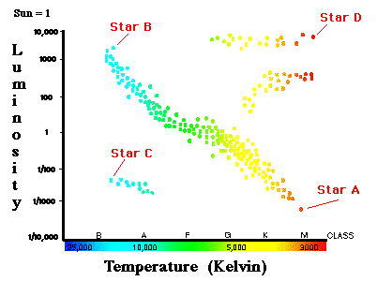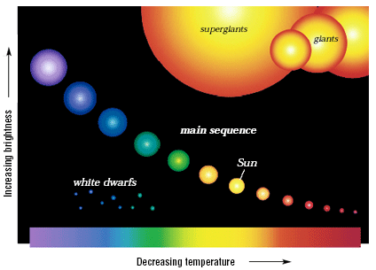
Star A would be cool and very dim. Star B would be very hot and very bright. Star C (white dwarf) would be very hot and dim. Star D (giant/supergiant) would be cool and very bright.
- Two Paths for Star Development
  - Nebula → sun-like stars (main sequence) → red giant → white dwarf → black dwarf
  - Nebula → massive stars (main sequence) → red supergiant → supernova → black hole
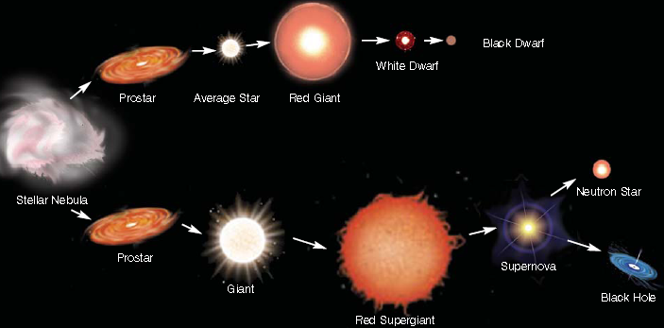
Prostar = a contracting mass of gas in the first stage of a star’s formation; depending on the mass of the star formed from a particular nebula, the star will be sun-like (in terms of mass) or massive; both types of stars spend most of their lives in main sequence converting hydrogen to helium
Red Giant/Red Supergiant = stage in the life cycle on a sun-like star during which the star increases in size and becomes very bright.
White Dwarf = the latter stage in the life-cycle of a sun-like star during which the star collapses; white dwarfs are very hot but very faint.
Black Dwarf = when a white dwarf fades
Supernova = an enormous explosion that marks the death of a massive star
Black Hole = a super dense left-over of a super nova; an object around which gravity is so intense even light cannot escape.
Neutron Star = If the supernova does not destroy a star, the core is left as a neutron star

Constellations = groupings of stars we see as patterns in the night sky
Asterism = distinctive star grouping that is not one of the 88 constellations (e.g. Big Dipper which is part of the Ursa Major constellation)
Galaxy = grouping of billions of stars, gas and dust held together by gravity.
- Spiral = long curved arms radiating out from a bright central core(e.g. our galaxy, Milky Way)
- Elliptical = football or egg-shaped which is made up of old stars
- Irregular = no shape and smaller than the other 2; made up of young and old stars
Science in Action Pages 392 to 400
Protoplanet hypothesis (explains the birth of solar systems):
- A cloud of gas and dust in space begins swirling.
- Most of the material (more than 90%) accumulates in the centre, forming the sun.
- The remaining material accumulates in smaller clumps circling the centre. These form the planets.
Sun = at centre of our solar neighbourhood; 110 times wider than the Earth.
Solar Wind = streams of electrically charged particles discharged by the sun in every direction. Solar wind passes the Earth at 400 km/s. These are the result of solar flares, which are explosions that force particles from the sun into space. Some of these particles spiral down the Earth’s magnetic field and enter the atmosphere to produce the Northern and Southern lights (Aurora Borealis and Aurora Australis).

The solar system can be divided into two distinct planetary groups
Terrestrial/Inner/Earth-Like Planets | Jovian/Outer Planet
Closer to the sun | Further from the sun
Rocky surface | Gaseous surface
Few or no moons | More than one moon
No ring systems | Ring systems
Higher Temperatures | Lower Temperatures
Small in size | Large in size

Asteroids = small, rocky or metallic bodies travelling in space which range in size from a few meters to several hundred kilometres across and are found between the orbits of Mars and Jupiter
Comets = “dirty snowballs” = objects made of dust and ice that travel through space; has a bright center and a long faint tail that always points away from the Sun (e.g. Halley’s comet)
Meteoroids = small pieces of rocks flying through space with no particular path and vary greatly in size.
- Meteor = shooting star = When a meteoroid gets pulled into the atmosphere by Earth’s gravity, the heat of atmospheric friction causes it to give off light.
- Meteorite = a meteor that hits the Earth’s surface

A solar eclipse occurs when the moon passing between the Sun and Earth casts a shadow on Earth. A lunar eclipse occurs when Earth passes between the Sun and Moon, casting its shadow over the Moon.

Position and Motion of Objects in Space
Science in Action Pages 401 to 407 and 450 to 451
To locate the position of an object in space two questions must be answered, “How high in the sky is it?” and “In which direction?”
- azimuth = compass direction, with north as 0°
- altitude = how high in the sky, which ranges from 0° to 90°
- zenith = highest point directly overhead.
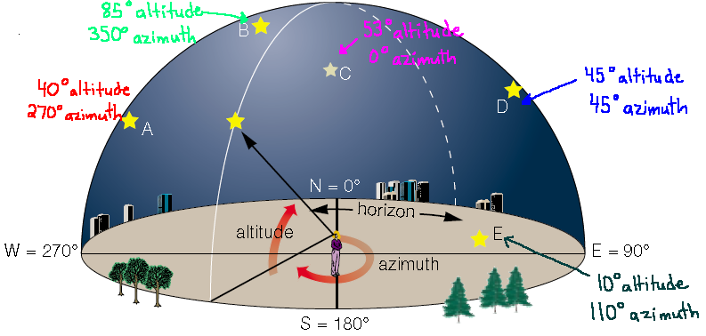

Spectroscopes = spectrometers can tell us how fast a celestial body, such as a star, is moving toward or away from us using the Doppler Effect.
Light refracted from stars creates a ‘fingerprint’ for each star. Astronomers compare the spectra of a star with known spectra of elements (H, He, Na, Ca) to determine the star’s composition
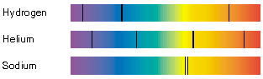

- The Doppler Effect occurs when sound waves are compressed (shorter wavelength/higher pitch) in front of a vehicle as it speeds along. Behind the vehicle, sound waves stretch out (longer wavelength/lower pitch). It is used in radar guns to show how fast a vehicle is moving.
- The Doppler Effect can be used to apply to light-emitting objects such as stars.
  - When a star is approaching you, its wavelengths of light become blue-shifted (shorter wavelength)
  - If a star is moving away from you, its spectral lines will be red shifted (shorter wavelength)
  - The amount of shift showing up in observations indicates the speed at which the star is approaching or receding.
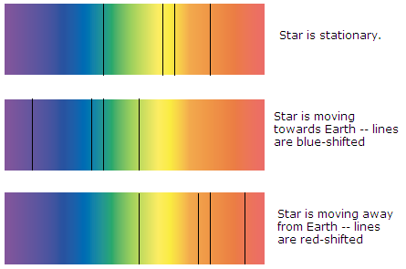

Stars as the frame of reference instead of the Earth. Example: Note which bright stars are around Venus and take note of the location of Venus relative to these bright stars. The next night, repeat the above procedure. Where is Venus in relation to these bright stars? If you continue to take note of the location of Venus in relation to the same bright stars, you will find that it is moving.

Triangulation = based on the geometry of a triangle. Measuring the angle between the baseline and the target object allows you to determine the distance to that object.
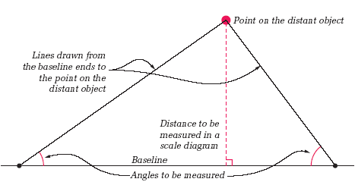

Adaptive Optics = Stars twinkle because their light is refracted randomly by the motion of the Earth, which makes it difficult for astronomers to see them. Due to this twinkling or blurring effect, computers have been attached to telescopes in order to sense when the Earth’s atmosphere moves; the computers communicate with devices under the objective mirror so that the mirror is distorted to cancel out this effect

Parallax = apparent shift in position of a nearby object when the object is viewed from 2 different places (e.g. passenger versus driver view of the speedometer)
- a star’s parallax is used to determine what angles to use when they triangulate the star’s distance from Earth
- we use the diameter of Earth’s orbit as a baseline which means measurements are taken 6 months apart
Ecliptic = apparent path of the sun through the sky during the year. It crosses the celestial equator at the vernal (spring) and autumn (fall) equinoxes. The Sun’s northerly position on the ecliptic marks summer solstice and its most southerly position marks winter solstice.
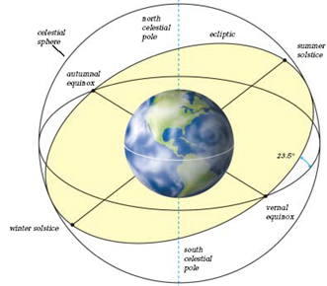
Because astronomers understand the geometry behind the movement of planets and their moons and the fact that they travel in ellipses, they can accurately predict lunar eclipses and solar eclipses via observation and mathematics.

Technological Devices to Gain Knowledge of Space
Science in Action Pages 435 to 439

Optical telescopes
- gather and focus light from stars so that we can see it
- the larger the area of the lenses or mirrors in a telescope, the greater the ability of the telescope to see the faint light of objects that are very distant
  - Refracting telescope = uses 2 lenses to gather and focus starlight; limited size as any diameter over 1 metre will cause the glass to warp
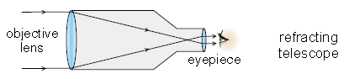
- Reflecting telescope = use mirrors to gather and focus starlight; newer models use segmented mirrors (segments to form one large mirror) because they have enormous light-gathering ability and resolving power
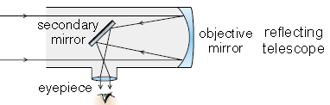
- Combination telescope = uses mirrors and a correcting lens to focus and gather light
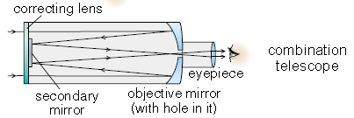

Interferometry is the technique of using telescopes in combination; detect objects in space more clearly and at greater distances
Hubble Space Telescope = reflecting telescope, orbiting 600 km above Earth, uses a series of mirrors to focus light from extremely distance objects

** Earth-based telescopes are limited in their viewing ability by interference from moisture, clouds, air pollution and light pollution

Science in Action Pages 440 to 445 and 452 to 454
Electromagnetic energy = energy travelling at the speed of light but having different wavelengths (measurement of distance from one point on a wave to the same point on next wave) and frequencies (equals the number of waves that pass a single point in 1 second) than those of light

Radio telescopes =study radio waves emitted by objects in space → millions of times longer than light waves
- advantages over optical telescopes – not affected by weather and can be detected day and night
- not distorted by clouds, pollution or atmosphere
- interferometry is used to enhance the performance, measurement of position, accuracy and detail of the radio images
- because radio waves cannot be seen, computers are attached to the radio telescopes to produce color-coded images that correspond to the strength or intensity of the signal (from low intensity to high intensity, the colors are blue, green, yellow, red, white)
- Very long baseline interferometry = when 2 or more radio telescopes are connected without wires to produce images 100 times as detailed as the largest optical telescopes (each telescope’s signal is recorded with timing marks; signals are transferred to computer disks, loaded onto a central computer, and combined to form one image)

Variety of radiation
- fluctuations in microwave energy that remains after the formation of the universe
- X-rays emitted from black holes and pulsating stars
- huge bursts of gamma rays that appear without warning and then fade

Space Probes = unmanned satellites or remote-controlled landers that put equipment on or close to planets too difficult or dangerous to send humans to (sample soil/nature of rings and moons/atmospheric composition/geological tests/how planets form in the solar system and how characteristics of other planets compare with Earth’s)

Issues of Space Exploration and Living in Space
Science in Action Pages 464 to 468
Social, Political, Ethical, and Environmental Issues
- Who owns space?
- property of the first nation to land on it
- eco-tourists who observe or pioneers who settle and change the planet
- owned only be rich nations who can afford the costs to reach the site
  - Who is entitled to use its resources?
    - space resources could satisfy our energy needs on Earth for a long time
    - minerals from asteroids
    - capturing solar energy and beaming it to Earth
    - cost of space travel could be cut substantially by creating space vehicles, supplies, etc directly in space
    - the Moon can supply hydrogen as fuel for lunar bases and space travel/oxygen for life support/both hydrogen and oxygen used for water supply
      - Is a space treaty needed?
        - use space exclusively for peaceful purposes
        - not used as the scene or object of international discord
        - maybe have nations collaborating similar to the Antarctica Treaty System
          - Who is responsible for cleaning up the space environment?
          - How can we justify spending billions of dollars to send a few people into space when millions of people on Earth do not have clean drinking water?
            - looking for extra space to home people as the population keeps growing
            - increase in employment available as other planets are colonized
            - send robots instead of humans as less danger and cost are involved (lose first-hand experience of humans if we do this)

Science in Action Pages 420 to 426
Space Suit = self-contained living system of air, water, a heating system, a cooling system … a portable toilet; flexible enough to allow fine motor control

Water = water will need to be recycled over and over because they can only bring a limited supply of water; technology to filter, purify and recycle the same water (this same technology is used on Earth to provide environmentally safe sewage treatment for houses)

Life Support System Functions of Station
- recycle wastewater to produce drinking water
- use recycled water to produce oxygen
- remove carbon dioxide from air
- filter micro-organisms and dust from air
- keep air pressure, temperature and humidity stable

Oxygen = process of electrolysis uses electricity to split water molecules into their component elements H₂ and O₂ → hydrogen is vented into space

Science in Action Pages 408 and 419 to 420

Challenges of Space Exploration:
- go fast enough to achieve orbit around Earth or break free of Earth’s gravity and travel to other planets
- keep equipment operating in extreme environment of space
- to transport people out and back safely

Environmental Hazards:
- space is a vacuum, with no air or H₂O
- damaging effects of cosmic rays and solar radiation
- risk of being hit by debris or meteoroids
- no air pressure
- massive temperature variations

Psychological Challenges
- long trips in a confined living space

Effects of Space on Body
- Microgravity is a condition in which the gravitational forces that act on mass are extremely reduced :
- bones expand
- loss of bone mass and density
- loss of body mass
  - Heart does not have to pump as hard to circulate blood, which decreases the production of red blood cells
  - muscles become weaker as less walking and lifting occurs
  - loss of calcium, electrolytes and plasma with excretion of body fluids

Science in Action Pages 456 to 460
Hazards of Space Travel
- destructive effects of solar radiation on life and equipment
- danger of possible collision with comets and asteroids
- loss of life
- immense economic loss
- loss of time spent on work
- cosmic radiation causes extreme damage to human cells
- Space Junk = pieces of debris that have fallen off rockets, satellites, space shuttles and space stations and remain floating in space; threat to orbiting space craft satellites, etc as the impact could cause severe damage to their structural integrity; threat to Earth as junk can re-enter Earth’s atmosphere and destroy lives and geographical damage

Space Transport Technologies
Science in Action Pages 409 to 412
- to get an object into space, scientists needed to determine at what speed an object could overcome the force of gravity which was 28000 km/h
- a rocket is a tube that contains combustible material in on end. The other end is the payload or the device or material that the rocket carries.
- Robert Goddard, an American physics professor, was the first scientist to successfully launch a liquid fuel rocket in 1926. He also discovered that if a rocket had more than one stage (a staged rocked) would fly higher and faster. A stage is a section of a rocket that drops off once the fuel is used up.
- 1942 Werner von Braun (a German scientist) developed the first ballistic missile (V-R rocket) during World War II – a bomb powered by a rocket engine. It had the ability to hit a target 200 km away from the launch site.
- 1960’s Werner von Braun’s team developed the rockets that took the first U.S. astronauts into space
  - Rocketry relies on a fundamental law of physics: for every action there is an equal and opposite reaction. An opening in the chamber allows gas to be released producing thrust (push) and causing the rocket to be propelled in the opposite direction. The speed at which the exhaust leaves the rocket is called exhaust velocity.
    - There are three basic parts to a rocket: the machinery, the fuel and the payload. The machinery is everything from the rocket itself to the engines, storage, tanks and fins.
    - Computers in the air and on the ground work together to control the flight of spacecraft. They calculate orbits, keep track of other satellites (and pieces of space junk from other flights so the satellites don’t hit each other in space), collect, store, and analyze data, and to execute orbital maneuvers of the satellites.
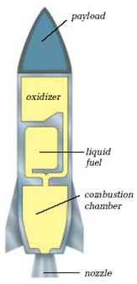
Gravitational assist = a method of acceleration which enables a spacecraft to gain extra speed by using the gravity of a planet. The planet’s gravity attracts the craft, causing it to speed up and change direction. The craft “slingshots” away from the planet at a higher or lower speed than it had before its encounter with the planet.

Canadian Contributions to Space Exploration
Science in Action Pages 460 to 463
Magnetic observatory – 1839 Sir Edward Sabine established the first magnetic observatory; discovered the aurora borealis was related to sunspot activity

Alouette 1 – 1962 Canada launched Alouette 1, a satellite for non-military use

Anik 1 Satellite – 1972 Anik 1 satellite gave the entire country telecommunications coverage for the first time

Satellite TV – 1973 Canada is the first country in the world to use satellites to broadcast television

Canadarm 1 – debuted on space shuttle Columbia in 1981; robotic arm manipulated by remote control; launched and retrieved satellites; fixed optical apparatus on Hubble Space Telescope; put together modules of International Space Station

Canadarm 2 (also called Canadian Space Station remote manipulator system SSRMS) – 2001 bigger, stronger and smarter than its predecessor Canadarm 1; attached to the end of the arm is the Canada Hand (also called the special purpose dexterous manipulator SPDM)

Miscellaneous
Science in Action Pages 427 to 430

Artificial Satellites = objects built and sent into Earth’s orbit by humans

Natural Satellites = small body orbiting a larger body (i.e. moon orbiting a planet)

Functions of Satellites
- help us communicate, observe and forecast weather, predict magnetic storms and even find our location on the planet
  - weather satellites stay in one position above Earth (geosynchronous orbit means it moves at the same rate as the Earth spins and therefore the same area is observed at all times); result is a 24 hour per day monitoring of weather conditions
  - observation satellites take photographs, monitor weather, LANDSAT and RADARSAT follows ships at sea, monitor soil quality, tracks forest fires, reports on environmental change and searches for natural resources (not in geosynchronous orbit)
    - REMOTE SENSING = process in which imaging devices in a satellite make observations of Earth’s surface and send this information back to Earth (information can be in the form of photographs or data from sensing energy waves); provides information on the condition of the environment on Earth, natural resources and effects of urbanization
    - Global Positioning System (GPS) = 24 GPS satellites are in orbit around Earth, which means there are at least 3 above any given location in the world at any given moment; radio signals from satellites are picked up by a hand-held receivers; signals are translated by a computer in the receiver, which shows on a digital display the operator’s position in relation to the satellites (this is calculated by triangulation)
      - watch TV and make long distance phone calls (communication satellites use digital systems for clearer transmitters and allow a large number of uses at one time)

Science in Action Page 431
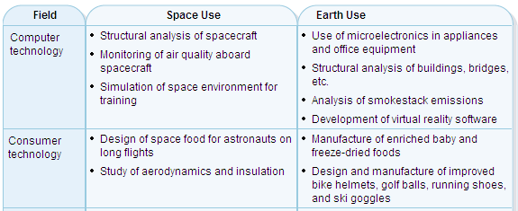
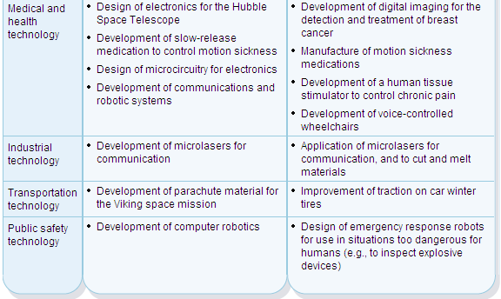
Appendix 1: General Scientific Information

Safety in Science
Science in Action Pages 93 to 96
Chemicals should be handled with care at all times, especially if they are caustic (corrosive), explosive, or poisonous.

Two methods of identifying hazardous materials that can be found in school laboratories:

Household Hazardous Safety Symbols:
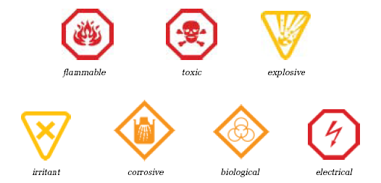
NOTE: Octagonal shape indicates danger. Diamond shape indicates warning. Inverted triangular shape indicates caution.

Workplace Hazardous Material Information System (WHMIS):
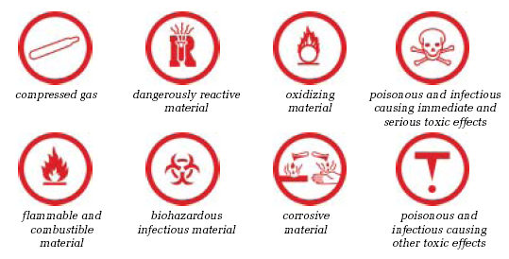

Science in Action Pages 284 to 288
The voltage is the energy of individual charges. Ultimately it is the total energy that provides the danger, so a high voltage does not present a significant danger if there are not a lot of charges (low current). It becomes dangerous when the current (number of charges per second) is also increased to a high level, providing more overall energy.
To assess the danger of an electrical device, check the manufacturer’s label for voltage and current rating. Remember that it is the combination of high voltage and high current that provides the danger.
Some electrical safety pointers:
- Never handle electrical devices when you are wet or near water unless they are specially designed and approved for use in wet areas.
- Don’t use any power cord that is frayed or broken.
- Always unplug electrical devices before looking inside or servicing them.
- Don’t put anything into an electrical outlet other than proper plugs for electrical devices.
- Don’t overload circuits by plugging in and operating too many devices.
- Stay away from power lines.
- Don’t bypass safety features built into home wiring, appliances, and other electrical devices.
- When unplugging a device, pull on the plug, not on the electrical cord.
- Never remove the third prong from a three-prong plug.

Science in Action Pages 253 to 259
Hazardous household chemicals: include household cleaners, gardening chemicals, paint and paint products, pesticides, fertilizers, car products (antifreeze, car oil), hair spray, aerosols, and pet care products.

Any hazardous chemical has a Materials Safety Data Sheet (MSDS). These sheets describe how the hazardous materials should be transported, stored and disposed of. All hazardous materials are labeled with WHMIS symbols to describe the type of hazard.

Transport | Storage | Disposal
Always transport hazardous chemicals in a sealed container in the trunk of your car. Make sure it does not fall over, and is not in a breakable container. Do not mix chemicals together. | Leave them in the original container with the correct label on it. Keep them out of reach of children. Container must be in good condition and have a secure lid. Store products in a cool, dry, ventilated area, away from heaters or flames. | Never pour hazardous chemicals down the drain or into soil. Don’t put them in the garbage. Take them to a hazardous waste collection site, toxic round up or your local fire hall.

Interpreting and Creating Graphs
Science in Action Pages 492 to 494
A graph is the most visual way to present data. A graph can help you to see patterns and relationships among the data. The type of graph you choose depends on the type of data you have and how you want to present it.
- Drawing a Line Graph – A line graph is used to show the relationship between two variables.
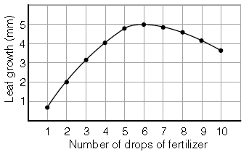
This graph shows that as the drops of fertilizer increased to 6, the amount of leaf growth increased. However, after 6 drops, the fertilizer started to decrease leaf growth.
- Constructing a Bar Graph – Bar graphs are most useful when you have numerical values associated with categories of places or things.
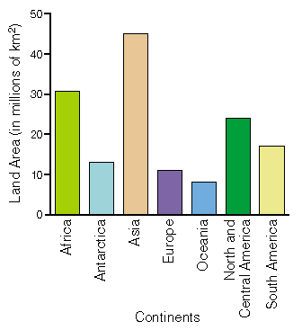
This graph shows us that Asia has the largest land area and Oceania has the smallest land area.
- Constructing a Histogram – Histograms are very similar to bar graphs except that the x-axis represents a continuous category; thus, no space between bars.
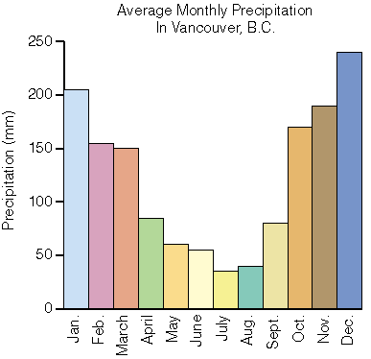
This graph shows that precipitation is greatest through the winter months and is least in the summer months.
- Constructing a Circle Graph – Circle graphs are an excellent way to communicate categories in terms of percentages of a whole.
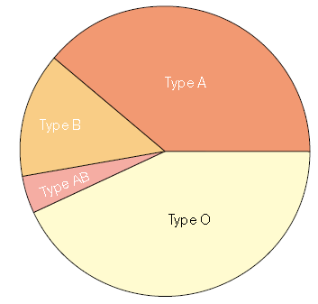
This pie chart or circle graph shows that Blood Type O is the most common blood type and Blood Type AB is the least common.

Scientific Inquiry
Science in Action Pages 479 to 481
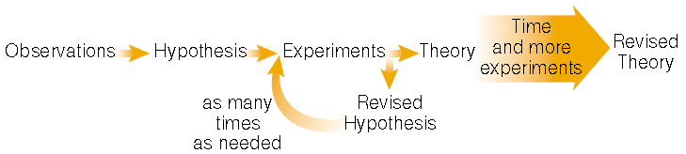

Laws = Describe and summarize what happens in a natural system.
Theories = Imaginative ways to explain why something happens in a natural system.
Models = Help picture structures or processes that cannot be directly seen.
Observations = Thousands of observations must be made before the scientific community accepts theories.

Technological Problem Solving
Science in Action Pages 482 to 483
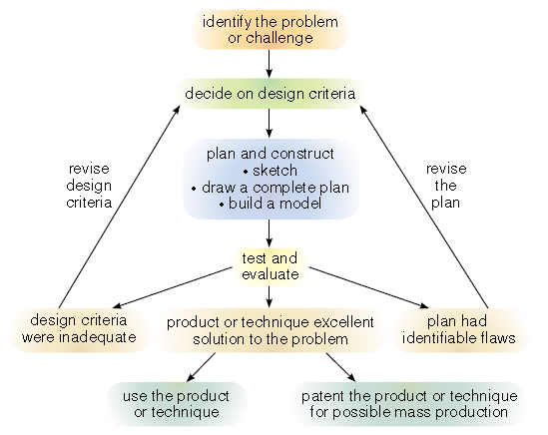

Societal Decision Making
Science in Action Pages 484 to 485
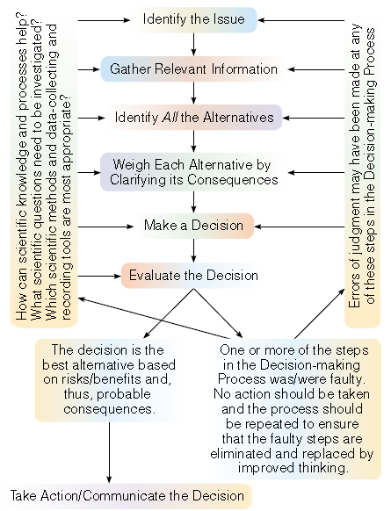

Experimental Variables
Independent variable = manipulated variable = variable that is changed by the scientist. In an experiment there is only one independent variable. As the scientist changes the independent variable, he or she observes what happens.
Dependent variable = responding variable = variable that changes in response to the change the scientist makes to the independent variable. The new value of the dependent variable is caused by and depends on the value of the independent variable.

Control variables = quantities that a scientist wants to remain constant, and he must observe them as carefully as the dependent variables.

