UNIT 4 – YEAR END REVIEW #1

- Which of the following would best define a structure?
A) an assembly of more than one part that performs a function
B) the shape and the manner in which parts are put together to form a whole
C) anything made from one or more parts that performs a function
D) the manner in which parts are put together to perform a function

- What is the one thing that all of the following have in common?
1) a snowflake 3) an automobile
2) the Calgary Tower 4) a tree
A) They are all structures.
B) They are all natural structures.
C) They are all manufactured structures.
D) They are all patterned structures.

- Any structure that is designed and constructed by humans could best be described as which of the following?
A) natural
B) manufactured
C) technological
D) simple

- What is the name used to describe a push or pull on a structure?
A) load
B) force
C) weight
D) mass

- A batter is about to hit a baseball that has been thrown by a pitcher. Which of the following can happen to the baseball after it has been hit?
A) it can speed up
B) it can slow down
C) it can change direction
D) all of the above
E) none of the above

- What term best describes the weight that a structure must support?
A) load
B) force
C) mass
D) weight

- Which of the following is not present in a frame structure, such as a house?
A) a skeleton of strong material
B) an interior that is mostly empty space
C) primarily mobile joints
D) walls that divide rooms but bear little load

- A building is an example of a frame structure. What are the parts of this frame structure that hold it up?
A) partition walls
B) load-bearing walls
C) external walls
D) roof trusses

- What are partition walls?
A) walls that separate the outside and inside of the house
B) walls that have windows and doors built into them
C) walls that separate the upstairs and downstairs areas of a house
D) walls that divide rooms within a house structure

- Use the following graphic to answer the next question(s).
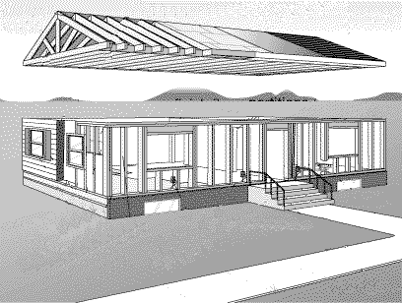

In this diagram, what is the feature labelled X?
A) roof-bearing wall
B) partition wall
C) load-bearing wall
D) mass-bearing wall

- In this diagram, what is the feature labelled Y?
A) roof-bearing wall
B) partition wall
C) load-bearing wall
D) mass-bearing wall

- On which of the following structures are mobile joints not found?
A) bicycle chain
B) human body
C) doors
D) desk chairs in a school
E) zippers

- Why do buildings designed as shell structures have an advantage over those designed as frame structures?
A) Shell structures take up less space than frame structures.
B) Shell structures are constructed with greater ease then frame structures.
C) Shell structures are better able to compensate for structural flaws then frame structures.
D) Shell structures provide enclosed open space and use very little building material.

- Which of the following is not a frame structure?
A) house
B) balloon
C) bicycle
D) tent
E) communication tower

- In this diagram of a plane under construction, a lightweight metal will cover the framework. This covering increases the strength of the framework by acting as which of the following?
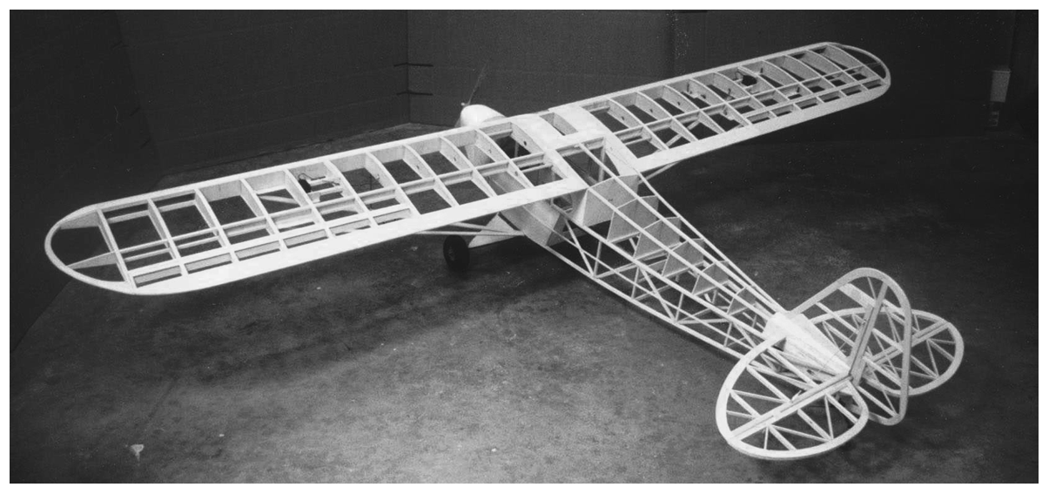
A) brace
B) skin
C) shell
D) layer

- Any building material that is made from two or more other materials is said to be which of the following?
A) mixed material
B) manufactured material
C) combined material
D) composite material

- By altering the shape of a structure you change its _______________________ .
A) function
B) mass
C) design
D) load

- What is the name for a shape that can be folded to fit exactly on top of itself?
A) functional
B) symmetrical
C) classical
D) aesthetically pleasing

- Why would someone design a structure stronger than it needs to be?
A) to waste money
B) to overbuild the structure
C) to allow for a greater margin of safety
D) to not allow for an adequate margin of safety

- Why is plywood stronger than normal wood?
A) it is laminated
B) it is reinforced
C) it is functional
D) it is polarized

- What is the correct unit of measurement for weight?
What is the correct unit of measurement for weight?
A) pound
B) gram
C) kilogram
D) Newton

- What is the name of the legendary scientist who is rumoured to have based his theory of gravity on an apple falling from a tree?
A) Copernicus
B) Galileo
C) Newton
D) Einstein

- Steel is made from particles that have a very strong attraction for a few other particles around them, which allows for a strong directional force. This gives steel a high level of which kind of strength?
A) torsion strength
B) compressive strength
C) tensile strength
D) shear strength

- Why is the Leaning Tower of Pisa tipping?
A) The weight of the structure is causing the soil on one side to compress and slip sideways.
B) One side of the tower is heavier than the other side.
C) The foundation hole was dug unevenly.
D) Water drained into one side of the base.
E) none of the above

- Which of the following structures was developed to provide less weight without compromising strength?
A) solid steel beams
B) corrugated cardboard
C) marble columns
D) massive stone walls

- What is the major force that holds the bricks in place in all brick walls?
A) friction
B) gravity
C) tension
D) adhesion to the mortar

- You must drag a large gym mat across the gym floor. How could you reduce the friction and make the job easier?
A) Have a person stand on the edge of the mat.
B) Use a lever and fulcrum to move the mat.
C) Get air under the mat to act as a lubricant.
D) Attach ropes to the corners of the mat.

- A businessman is trying to walk quickly on a hard tiled floor to get to an office meeting on time. As he turns a corner he slips and falls due to a lack of grip between the floor and his leather-soled shoes. How could you increase the friction to prevent this kind of problem?
A) Have the man walk more slowly in the building.
B) Change the soles to a rubber compound.
C) Change the soles to a hard plastic compound.
D) Polish floor to a high-gloss shine.

- What does spin stabilization allow you to do?
A) increase your stability by crouching down low
B) balance a stack of plates in your hands
C) walk upright
D) carry large loads
E) ride a fast-moving bicycle with no hands on the handlebars

- You are meeting with a designer to plan a huge monument to your favourite teacher. What do designers do to create a firm foundation?
A) Find a solid base to build on.
B) Create a solid layer to build on.
C) Spread the load of a structure over a large area.
D) Balance forces.
E) all of the above

- An object was placed on a table and caused the table to collapse. In this case, the table was not able to support the _______________________ placed on it.
A) gravity
B) impact
C) force
D) load

- A car windshield is made by sandwiching a piece of plastic film between pieces of glass. What type of design consideration is this?
A) safety
B) cost
C) aesthetics
D) ease of manufacturing
E) all of the above

- Which of the following is a health hazard associated with the use of adhesives?
A) body parts getting stuck together
B) toxic fumes
C) asthma complications
D) allergic reactions
E) all of the above

- The shape and manner in which a structure is put together are both elements of _______________________ .
A) design
B) foundation
C) aesthetics
D) composition

- Lucy, an architect with a Calgary firm, is responsible for designing a new public library. She has been told what the function will be and she knows the safety regulations. As well as function and safety, she wants the building to be beautiful. What is another word for "looking good" in structure design?
A) balanced
B) composition
C) symmetry
D) aesthetics

- By placing more insulation in our homes we are doing which of the following?
A) increasing the resale value of the structure
B) making the structure safer to live in
C) making the structure more aesthetically pleasing
D) making the structure more energy efficient

- Which internal force would be involved in stabilizing the CN Tower in a high wind?
A) tension
B) compression
C) torsion
D) shear
E) none of the above

- Pieces of some materials flake off. This happens because the materials have a low level of one kind of strength. Which one?
A) compressive strength
B) shear strength
C) tensile strength
D) torsion strength

- In order to spread out the weight of a structure, foundation walls are set on which of the following?
A) loose gravel
B) packed sand
C) packed top soil
D) concrete footings

