Mechanical Systems Topic 1-3

V O C A B
Fixed point on a lever | = Force x distance | The science of designing machines to suit people | 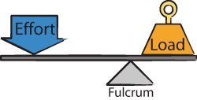 | “Energy is neither created or destroyed, it is only transformed and transferred”
A simple machine that changes the amount of force you must exert in order to move an object | Machine consisting of 2 turning objects attached at their centres | Canada’s very valuable addition to the space shuttle program | 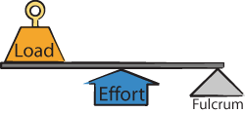 | A gear with teeth that fit into the links of a chain
Energy of motion | The distance between the fulcrum and the load | A simple machine used to lift heavy objects using smaller force, but over a greater distance | 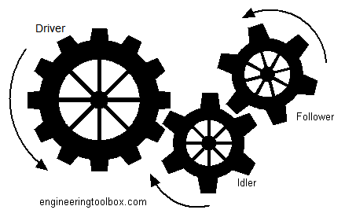  (name and type) | Energy is transferred from one place to another, and no energy is changed or converted
Stored Energy | A combination of several pulleys working together | Consists of a small cylinder and crank or handle | # of driver gear teeth__  # of follower gear teeth | The mass of an object that is moved by a machine
Distance between the fulcrum and the effort force | A main gear that causes other gears to move | The second gear whose movement is caused by another gear | A simple machine that is fixed or moveable. It is a rope or cable moving on a grooved wheel | Load Force  Effort Force
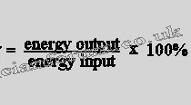 | A simple machine used to split an object | The type of gear train used to gain a force advantage | 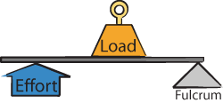 | A simple machine that is basically a spiraled inclined plane

