Unit C: Environmental Chemistry

Science 9 Review

Wherever necessary, answer questions on a separate sheet of paper.

1. Why are nitrogen-fixing bacteria important in the nitrogen cycle?

2. Imagine that a tanker truck has spilled a strong base. Explain how this spill can be cleaned up.

Use the following information to answer question 3.
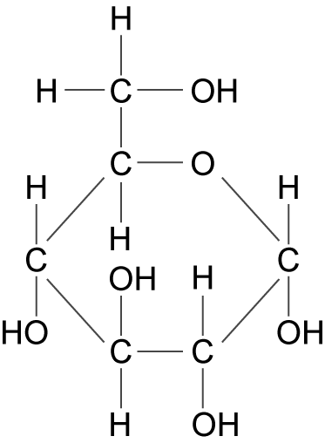 | 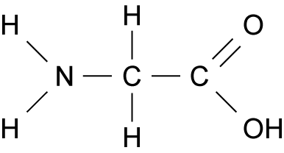
X | Y

3. a) State the name of the organic molecule that contains many units of “X.”

b) State the name of the organic molecule that contains many units of “Y.”

4. In an experiment conducted to show the effect of pH on the rate of hydrolysis of starch, identify the manipulated and responding variables.
5. Why are sulfur dioxide and nitrogen oxides major air pollutants?

6. Predict two effects of global warming.

7. What is the concentration in ppm of sulfur in a water supply if there are 0.002 mL of sulfur in each litre of solution?

Use the following information to answer question 8.
Your community council proposed several ways to clean up an organic spill in a park.
Proposal 1: using bacteria to break up organic substances
Proposal 2: using green plants to remove pollutants from the soil
Proposal 3: using sunlight to break down organic compounds.
8. Match the number of the proposal to the term that it defines.
Use each number only once.

______________ __________________ ________________
photolysis biodegradation phytoremediation
9. How were the local people affected by the Exxon Valdez oil spill?

10. What do product labels indicate that helps people use the products safely?

11. Why should hazardous household waste not be poured down a drain?

12. Explain why most nutrients are required in “optimum amounts.”

13. Describe two ways that lichens and red snow algae are similar.

14. If the soil is magnesium deficient, predict two ways that that a plant will be affected. (Hint: Magnesium is found in the chemical make-up of chlorophyll.)

15. If 0.45 mL of food colouring are placed in 2 L of water, what is the concentration in ppm?

16. If the plants used in phytoremediation are not harvested, how might they affect the food chain in which they are located?

17. Describe two ways that oil spills affect living things.

18. Mercury-contaminated fish have been a problem in parts of Canada. Identify the possible sources of the mercury, the method of transport, and the way it accumulates in fish.

19. Describe two ways of controlling mosquito populations.

Use the following information to answer question 20.
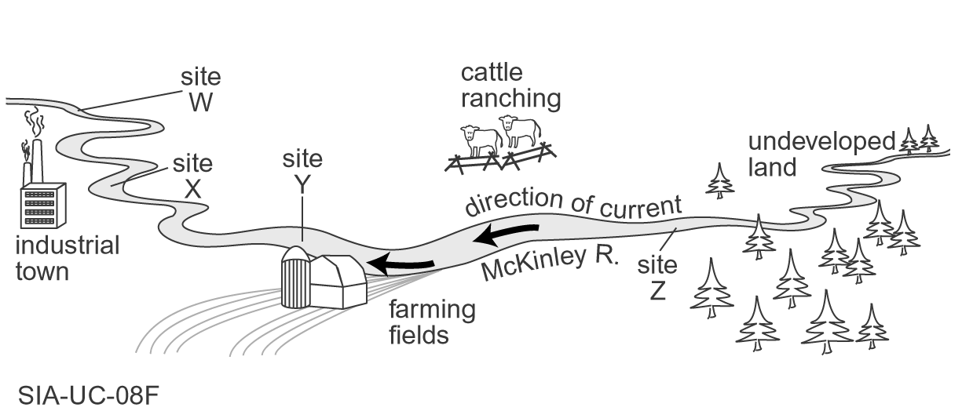
Map of a portion of the McKinley River. Biological water sampling
was done at sites W, X, Y, and Z.
20. What site will probably have the greatest diversity of organisms? Give a reason for your answer.

